Supplemental Table 1 Significance comparison between each pair of groups.
 | Immunocompetent vs. SOT | Immunocompetent vs. Cancer | SOT  vs. Cancer
Demographics
Age (years) | <0.001 | <0.001 | <0.001
Male sex (%) | 0.293 | 0.896 | 0.499
BMI (kg/m²⁾ | 0.295 | 0.914 | 0.459
Smoking history (%) | 0.485 | 0.793 | 0.519
Time from onset to dyspnea (days) | <0.001 | 0.200 | 0.004
Time from onset to ICU admission (days) | <0.001 | 0.830 | 0.001
PaO₂/FiO₂ (mmHg) | 0.893 | 0.978 | 0.869
APACHE II score | 0.014 | 0.335 | 0.008
SOFA score | 0.490 | 0.534 | 0.321
Medical History
Chronic heart disease (%) | 0.001 | 0.299 | 0.042
Chronic liver disease (%) | 1.000 | 0.183 | 0.539
Chronic lung disease (%) | 0.053 | 0.860 | 0.094
Chronic renal disease (%) | <0.001 | 0.814 | <0.001
Diabetes (%) | 0.172 | 0.161 | 0.055
Hypertension (%) | 1.000 | 0.010 | 0.087
Laboratory Parameters
White blood cell count (× 10⁹ /L) | 0.517 | 0.210 | 0.819
Neutrophil count (× 10⁹ /L) | 0.694 | 0.197 | 0.565
Lymphocyte count (× 10⁹ /L) | <0.001 | 0.791 | <0.001
Hemoglobin (g/L) | 0.004 | 0.005 | 0.628
Platelet count (× 10⁹ /L) | 0.054 | 0.227 | 0.481
D-dimer (μg/mL) | 0.707 | 0.948 | 0.842
Aspartate aminotransferase (IU/L) | <0.001 | 0.099 | <0.001
Creatinine (μmol/L) | <0.001 | 0.002 | <0.001
Albumin (g/L) | 0.830 | 0.020 | 0.115
Lactate dehydrogenase (U/L) | 0.287 | 0.393 | 0.942
C-reactive protein (mg/L) | 0.022 | 0.179 | 0.615
Interleukin-6 (pg/mL) | 0.018 | 0.705 | 0.024
Serum ferritin (μg/L) | 0.430 | 0.511 | 1.000
Anti-inflammatory treatment
Corticosteroids (%) | 0.033 | 0.690 | 0.148
Tocilizumab (%) | 0.032 | 0.141 | 0.516
Baricitinib (%) | 0.749 | 0.479 | 0.664
Antiviral treatment
Paxlovid (%) | 0.006 | 0.046 | 0.320
Intravenous immunoglobin (%) | 0.004 | 0.376 | 0.101
Anticoagulation (%) | 0.423 | 0.811 | 0.429
Respiratory support
High flow nasal cannula (%) | 0.024 | 0.021 | 0.667
Non-invasive mechanical ventilation (%) | 0.324 | 0.025 | 0.017
Invasive mechanical ventilation (%) | 0.627 | 0.394 | 0.330
ECMO (%) | 0.045 | 0.649 | 0.344
Secondary infection (%) | 0.576 | 0.487 | 1.000
Bacteria (%) | 0.556 | 0.465 | 1.000
Fungus (%) | 0.002 | 0.195 | 0.129
Virus (%) | 0.057 | 0.493 | 0.284
ICU mortality (%) | 0.036 | 0.008 | 0.001
Duration of ICU stay (days) | 0.086 | 0.181 | 0.684
COVID-19, coronavirus disease 2019; SOT, Solid organ transplantation; Other, persons with other causes of immunosuppression; BMI, body mass index; ICU, intensive care unit; PaO2/FiO2, partial pressure of oxygen/fraction of inspiration oxygen; APACHE, acute physiology and chronic health evaluation; SOFA, sequential organ failure assessment; ECMO, extracorporeal membrane oxygenation

Supplemental Table 2 Baseline demographic characteristics, medical history and laboratory findings of patients with other causes of immunosuppression.
 | Immunocompetent | A | B | C | D
n | 1788 | 57 | 34 | 28 | 4
Demographics
Age (years), median [IQR] | 76[68, 84] | 70[60, 78] | 64[54, 73] | 71[66, 77] | 60[51, 70]
Male sex (%) | 1296 (72.5) | 30(52.6) | 24(70.6) | 19(67.9) | 3(75.0)
BMI (kg/m²⁾ | 23.4[20.8, 25.8] | 23.5[21.3, 26.1] | 24.8[21.5, 26.3] | 21.6[18.7, 23.8] | 24.7[18.7, 23.8]
Smoking history (%) | 473 (26.5) | 14(24.6) | 12(35.3) | 11(39.3) | 2(50.0)
Time from onset to dyspnea (days), median [IQR] | 10[5, 16] | 15[9, 20] | 12[7, 18] | 13[7, 19] | 33[33, 33]
Time from onset to ICU admission (days), median [IQR] | 9[5, 14] | 13[8, 20] | 10[7, 17] | 10[6, 14] | 16 [10, 23]
PaO₂/FiO₂ (mmHg), median [IQR] | 103.0[56.0, 188.0] | 108.9[35.0, 183.8] | 162.8[87.5, 286.4] | 82.6[33.4, 165.6] | 227.1[227.1, 227.1]
APACHE II score, median [IQR] | 16.0[11.0, 23.0] | 13.5[10.3, 19.0] | 14.0[8.0, 19.0] | 16.0[11.0, 25.0] | 9.0[8.5, 11.0]
SOFA score, median [IQR] | 5.0[3.0, 8.0] | 4.0[3.0, 6.5] | 5.0[3.0, 7.8] | 5.0[3.0, 8.0] | 4.0[2.5, 4.5]
Medical History
Chronic heart disease (%) | 501 (28.0) | 47(82.5) | 28(82.4) | 22(78.6) | 4(100)
Chronic liver disease (%) | 17 (1.0) | 1(1.8) | 0(0.0) | 1(3.6) | 0(0.0)
Chronic lung disease (%) | 221 (12.4) | 10(17.5) | 11(32.4) | 4(14.3) | 2(50.0)
Chronic renal disease (%) | 113 (6.3) | 49(86.0) | 25(73.5) | 27(96.4) | 3(75.0)
Diabetes (%) | 535 (29.9) | 18(31.6) | 6(17.6) | 6(21.4) | 0(0.0)
Hypertension (%) | 1000 (55.9) | 32(56.1) | 17(50.0) | 12(42.9) | 2(50.0)
Laboratory Parameters
White blood cell count (× 10⁹ /L), median [IQR] | 9.5 [6.4, 13.8] | 8.5[5.6, 11.7] | 8.3[5.2, 12.1] | 7.8[4.3, 12.7] | 4.0[3.4, 6.0]
Neutrophil count (× 10⁹ /L), median [IQR] | 8.3[5.3, 12.5] | 7.3[5.1, 10.4] | 6.8[4.2, 8.4] | 6.3[3.3, 8.3] | 10.4[6.0, 181.2]
Lymphocyte count (× 10⁹ /L), median [IQR] | 0.6 [0.3, 0.9] | 0.4[0.2, 0.6] | 0.6[0.3, 1.4] | 0.5[0.3, 0.8] | 0.3[0.2, 0.4]
Hemoglobin (g/L), median [IQR] | 122.0[105.0, 138.0]
Platelet count (× 10⁹ /L), median [IQR] | 173.0[120.0, 245.0] | 167.0[98.8, 219.0] | 178.5[118.3, 221.8] | 111.5[59.3, 180.8] | 83.0[50.5, 156.0]
D-dimer (μg/mL), median [IQR] | 2.2[1.0, 6.2] | 2.9[0.9, 7.8] | 1.5[0.5, 4.9] | 1.5[0.8, 7.0] | 2.1[1.9, 4.5]
Aspartate aminotransferase (IU/L), median [IQR] | 38.7[25.6, 64.0] | 40.5[23.9, 52.8] | 28.0[24.2, 36.6] | 31.0[22.3, 39.0] | 61.1[29.8, 95.3]
Creatinine (μmol/L), median [IQR] | 87.6[63.2, 152.0] | 89.3[61.5, 119.2] | 92.3[58.5, 196.5] | 62.8[48.3, 71.9] | 102.7[86.4, 107.2]
Albumin (g/L), median [IQR] | 31.0[27.9, 34.2] | 31.3[28.5, 33.1] | 29.4[27.4, 36.9] | 29.5[27.5, 34.4] | 32.8[32.0, 32.9]
Lactate dehydrogenase (U/L), median [IQR] | 396.0[287.0, 548.0] | 395.3[311.0, 580.0] | 368.5[279.3, 668.8] | 393.3[302.3, 601.6] | 426.5[413.8, 439.3]
C-reactive protein (mg/L), median [IQR] | 14.9[6.8, 55.4] | 35.0[3.2, 88.1] | 14.0[3.7, 50.4] | 22.7[14.3, 51.6] | 23.7[17.1, 114.7]
Interleukin-6 (pg/mL), median [IQR] | 69.3[19.6, 272.0] | 26.2[5.7, 114.4] | 53.7[15.4, 149.5] | 51.5[13.1, 92.5] | 339.6[175.9, 515.3]
Serum ferritin (μg/L), median [IQR] | 802.0[394.0, 1458.0] | 445.0[367.0, 502.2] | 2608.5[1678.2, 3538.7] | 247.3[233.9, 260.8] | NA
A, patients with connective tissue diseases receiving disease-modifying antirheumatic drugs, corticosteroid therapy at a dose ≥20 mg of prednisone or equivalent daily for ≥14 days or a cumulative dose > 600 mg of prednisone, or other immunosuppressive drugs; B, patients receiving corticosteroid therapy at a dose ≥20 mg of prednisone or equivalent daily for ≥14 days or a cumulative dose > 600 mg of prednisone, or other immunosuppressive drugs for reasons other than connective tissue diseases; C, patients with stable tumor undergoing cancer chemotherapy; D, patients with primary immune deficiency diseases, HIV infection with a CD4⁺T lymphocyte count < 200 cells/mL or percentage < 14%, hematopoietic stem cell transplantation; COVID-19, coronavirus disease 2019; BMI, body mass index; ICU, intensive care unit; PaO₂/FiO₂, partial pressure of oxygen/fraction of inspiration oxygen; APACHE, acute physiology and chronic health evaluation; SOFA, sequential organ failure assessment

Supplemental Table 3 Treatments, respiratory support and outcomes of patients with other causes of immunosuppression.
 | Immunocompetent | A | B | C | D
n | 1788 | 57 | 34 | 28 | 4
Anti-inflammatory treatment
Corticosteroids (%) | 1291 (73.1) | 51(89.5) | 30(90.9) | 21(77.8) | 3(75.0)
Tocilizumab (%) | 77 (4.3) | 6(10.5) | 0(0.0) | 2(7.1) | 0(0.0)
Baricitinib (%) | 114 (6.4) | 7(12.3) | 4(11.8) | 1(3.6) | 0(0.0)
Antiviral treatment
Paxlovid (%) | 377 (21.1) | 18(31.6) | 10(29.4) | 8(28.6) | 1(25.0)
Intravenous immunoglobin (%) | 218 (12.2) | 8(14.0) | 8(23.5) | 1(3.6) | 0(0.0)
Anticoagulation (%) | 1116 (62.4) | 40(70.2) | 20(58.8) | 11(39.3) | 1(25.0)
Respiratory support
High flow nasal cannula (%) | 258(14.4) | 12(21.1) | 6(17.6) | 4(14.3) | 2(50.0)
Non-invasive mechanical ventilation (%) | 348(19.5) | 10(17.5) | 5(14.7) | 8(28.6) | 0(0.0)
Invasive mechanical ventilation (%) | 630(35.2) | 15(26.3) | 10(29.4) | 9(32.1) | 1(25.0)
ECMO (%) | 32(1.8) | 0(0.0) | 1(2.9) | 0(0.0) | 0(0.0)
Secondary infection (%) | 403 (22.5) | 14(24.6) | 10(29.4) | 5(17.9) | 1(25.0)
Bacteria (%) | 353 (19.7) | 13(22.8) | 9(26.5) | 5(17.9) | 1(25.0)
Fungus (%) | 35 (2.0) | 0(0.0) | 2(5.9) | 0(0.0) | 0(0.0)
Virus (%) | 15 (0.8) | 0(0.0) | 0(0.0) | 0(0.0) | 0(0.0)
ICU mortality (%) | 1106 (61.9) | 32(56.1) | 19(55.9) | 17(60.7) | 2(50.0)
Duration of ICU stay (days), median [IQR] | 8[4, 14] | 9[6, 15] | 11[6, 17] | 5[4, 8] | 9[7, 13]
A, patients with connective tissue diseases receiving disease-modifying antirheumatic drugs, corticosteroid therapy at a dose ≥20 mg of prednisone or equivalent daily for ≥14 days or a cumulative dose > 600 mg of prednisone, or other immunosuppressive drugs; B, patients receiving corticosteroid therapy at a dose ≥20 mg of prednisone or equivalent daily for ≥14 days or a cumulative dose > 600 mg of prednisone, or other immunosuppressive drugs for reasons other than connective tissue diseases; C, patients with stable tumor undergoing cancer chemotherapy; D, patients with primary immune deficiency diseases, HIV infection with a CD4⁺T lymphocyte count < 200 cells/mL or percentage < 14%, hematopoietic stem cell transplantation; COVID-19, coronavirus disease 2019; ECMO, extracorporeal membrane oxygenation; ICU, intensive care unit

Supplemental Table 4 ICU mortality rate after adjustment.
(A)
 | Immunocompetent | Cancer | p value
n | 201 | 67
Age (years), median [IQR] | 69(59, 77) | 69(59, 77) | 0.956
APACHE II score, median [IQR] | 17.0(13.0, 22.0) | 17.0(13.0, 21.0) | 0.905
ICU mortality (%) | 118(58.7) | 50(74.6) | 0.020
(B)
 | Immunocompetent | SOT | p value
n | 120 | 40
Age (years), median [IQR] | 54[48, 60] | 54[48, 61] | 0.916
APACHE II score, median [IQR] | 13.0[8.0, 21.0] | 12.0[8.0, 20.0] | 0.813
ICU mortality (%) | 49(40.8) | 18(45.0) | 0.644
- Mortality rate of cancer patients and immunocompetent patients after age and APACHE II score adjustment. (B) Mortality rate of SOT patients and immunocompetent patients after age and APACHE II score adjustment. APACHE, acute physiology and chronic health evaluation; ICU, intensive care unit; SOT, Solid organ transplantation

Supplemental Table 5 Baseline information and outcome on whether patients with active tumors are undergoing chemotherapy.
 | Cancer | Receiving chemotherapy | Non- receiving chemotherapy | p value
n | 77 | 43 | 34
Age (years), median [IQR] | 69[59,77] | 66[58, 71] | 76(67, 80) | 0.006
APACHE II score, median [IQR] | 17.0[13.0,21.0] | 17.0[11.5, 21.0] | 17.0[13.0, 21.8] | 0.891
SOFA score, median [IQR] | 6.0[3.0,8.0] | 7.0[4.0, 9.0] | 5.5[3.0, 7.0] | 0.159
ICU mortality (%) | 59(76.6) | 32(74.4) | 27(79.4) | 0.607
APACHE, acute physiology and chronic health evaluation; SOFA, sequential organ failure assessment; ICU, intensive care unit

Supplemental Table 6 Comparison of cytokine between survival and death groups in immunocompetent patients.
 | Immunocompetent | Survival | Death | p value
n | 1788 | 682 | 1106
White blood cell count (× 109 /L), median [IQR] | 9.4[6.4,13.7] | 7.9[5.5,11.0] | 10.5[6.9,14.9] | < .001
Lymphocyte count (× 109 /L), median [IQR] | 0.6[0.3,0.9] | 0.7[0.4,1.1] | 0.5[0.3,0.8] | < .001
C-reactive protein (mg/L), median [IQR] | 14.9[6.8,55.4] | 12.6[5.3,50.5] | 15.9[7.7,64.9] | 0.034
Erythrocyte sedimentation rate (mm/h), median [IQR] | 44.0[25.0,70.0] | 41.0[25.0,65.8] | 46.0[23.3,76.0] | 0.183
Serum ferritin (μg/L), median [IQR] | 773.0[418.0,1498.0] | 598.0[314.0,1071.0] | 899.0[572.0,1678.0] | 0.002
Interleukin-1β (pg/mL), median [IQR] | 2.5[2.1,5.2] | 2.4[2.1,7.4] | 2.6[2.1,4.6] | 0.600
Interleukin-2R (pg/mL), median [IQR] | 2.4[1.3,2.5] | 2.4[1.2,2.4] | 2.1[1.3,2.7] | 0.822
Interleukin-6 (pg/mL), median [IQR] | 69.3[19.6,272.0] | 34.9[9.8,91.5] | 111.0[33.6,606.0] | < .001
Interleukin-8 (pg/mL), median [IQR] | 21.2[3.9,78.1] | 6.5[3.8,23.1] | 38.8[11.7,108.0] | < .001
Interleukin-10 (pg/mL), median [IQR] | 6.0[3.0,14.3] | 3.7[2.4,8.9] | 7.8[3.8,21.5] | < .001
Tumor necrosis factor-α (pg/ml), median [IQR] | 2.1[0.8,2.7] | 2.0[0.6,2.4] | 2.1[0.9,3.2] | 0.075
Procalcitonin (ng/mL), median [IQR] | 0.4[0.1,2.2] | 0.2[0.1,0.8] | 0.7[0.2,3.6] | < .001
CD4+ T lymphocyte (cell/ul), median [IQR] | 161.0[75.0,290.0] | 184.0[105.0,347.0] | 129.0[62.0,258.0] | 0.003
CD8+ T lymphocyte (cell/ul), median [IQR] | 105.0[50.0,185.0] | 125.0[65.0,236.0] | 90.0[40.3,170.0] | 0.002

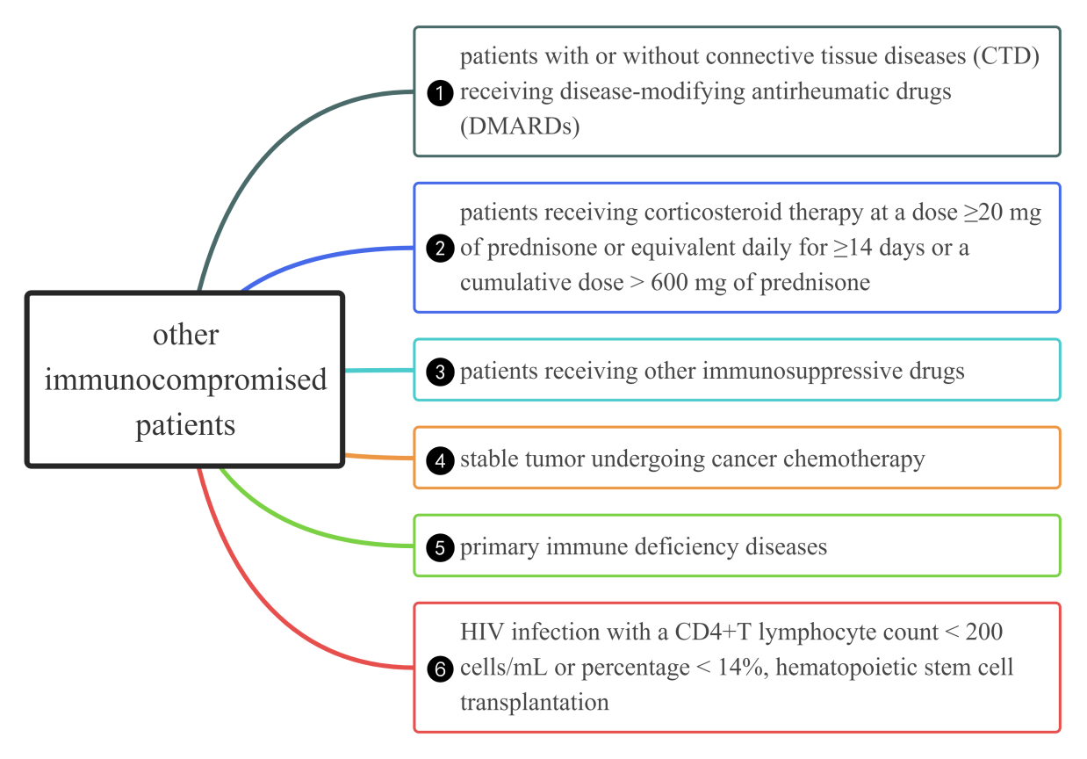

Supplementary Fig. 1 Specific classifications of other immunocompromised patients. CTD, connective tissue diseases; DMARDs, disease-modifying antirheumatic drugs; HIV, human immunodeficiency virus

Supplementary Fig. 2 Proportion of other cytokine 24h, 72 h and 7 days after ICU admission. ICU, intensive care unit; SOT, Solid organ transplantation; Other, persons with other causes of immunosuppression; ESR, erythrocyte sedimentation rate; IL-1β, interleukin-1β; IL-8, interleukin-8; IL-10, interleukin-10; TNF-α, tumor necrosis factor-α; PCT, procalcitonin

