SUPPLEMENTAL MATERIAL

Effects of pulmonary rehabilitation on respiratory function in mechanically ventilated patients：a systematic review and meta-analysis

Table of Contents

- Supplementary Table 1 PRISMA 2020 Checklist
- Supplementary Table 2 Detailed search strategy
- Supplementary Figure 1 Detailed risk of bias assessment
- Supplementary Figure 2. Pairwise meta-analysis of direct comparisons
- Supplementary Table 3Egger’s test
- Supplementary Figure.3 Sensitivity analyzes
- Supplementary Table4 Subgroup analysis
- Supplementary Table 5 Evidence profile

Supplementary Table 1 PRISMA 2020 Checklist
 | Item # | Checklist item | Location
TITLE
Title | 1 | Identify the report as a systematic review. | Manuscript P1
ABSTRACT
Abstract | 2 | See the PRISMA 2020 for Abstracts checklist. | Manuscript P1-3
INTRODUCTION
Rationale | 3 | Describe the rationale for the review in the context of existing knowledge. | Manuscript P3-4
Objectives | 4 | Provide an explicit statement of the objective(s) or question(s) the review addresses. | Manuscript P4
METHODS
Eligibility criteria | 5 | Specify the inclusion and exclusion criteria for the review and how studies were grouped for the syntheses. | Manuscript P5-6
Information sources | 6 | Specify all databases, registers, websites, organisations, reference lists and other sources searched or consulted to identify studies. Specify the date when each source was last searched or consulted. | Manuscript P6
Search strategy | 7 | Present the full search strategies for all databases, registers and websites, including any filters and limits used. | Supplemental file P4
Selection process | 8 | Specify the methods used to decide whether a study met the inclusion criteria of the review, including how many reviewers screened each record and each report retrieved, whether they worked independently, and if applicable, details of automation tools used in the process. | Manuscript P7
Data collection process | 9 | Specify the methods used to collect data from reports, including how many reviewers collected data from each report, whether they worked independently, any processes for obtaining or confirming data from study investigators, and if applicable, details of automation tools used in the process. | Manuscript P8
Data items | 10a | List and define all outcomes for which data were sought. Specify whether all results that were compatible with each outcome domain in each study were sought (e.g. for all measures, time points, analyses), and if not, the methods used to decide which results to collect. | Manuscript P8
Data items | 10b | List and define all other variables for which data were sought (e.g. participant and intervention characteristics, funding sources). Describe any assumptions made about any missing or unclear information. | Manuscript P8
Study risk of bias assessment | 11 | Specify the methods used to assess risk of bias in the included studies, including details of the tool(s) used, how many reviewers assessed each study and whether they worked independently, and if applicable, details of automation tools used in the process. | Manuscript P7
Effect measures | 12 | Specify for each outcome the effect measure(s) (e.g. risk ratio, mean difference) used in the synthesis or presentation of results. | Manuscript P8
Synthesis methods | 13a | Describe the processes used to decide which studies were eligible for each synthesis (e.g. tabulating the study intervention characteristics and comparing against the planned groups for each synthesis (item #5)). | Manuscript P5
Synthesis methods | 13b | Describe any methods required to prepare the data for presentation or synthesis, such as handling of missing summary statistics, or data conversions. | Manuscript P8-9
Synthesis methods | 13c | Describe any methods used to tabulate or visually display results of individual studies and syntheses. | Figure 2, Table 1
Synthesis methods | 13d | Describe any methods used to synthesize results and provide a rationale for the choice(s). If meta-analysis was performed, describe the model(s), method(s) to identify the presence and extent of statistical heterogeneity, and software package(s) used. | Manuscript P8-9
Synthesis methods | 13e | Describe any methods used to explore possible causes of heterogeneity among study results (e.g. subgroup analysis, meta-regression). | Manuscript P9
Synthesis methods | 13f | Describe any sensitivity analyses conducted to assess robustness of the synthesized results. | Manuscript P9
Reporting bias assessment | 14 | Describe any methods used to assess risk of bias due to missing results in a synthesis (arising from reporting biases). | Manuscript P18
Certainty assessment | 15 | Describe any methods used to assess certainty (or confidence) in the body of evidence for an outcome. | Manuscript P7
RESULTS
Study selection | 16a | Describe the results of the search and selection process, from the number of records identified in the search to the number of studies included in the review, ideally using a flow diagram. | Figure 1
Study selection | 16b | Cite studies that might appear to meet the inclusion criteria, but which were excluded, and explain why they were excluded. | Manuscript P15
Study characteristics | 17 | Cite each included study and present its characteristics. | Table 1
Risk of bias in studies | 18 | Present assessments of risk of bias for each included study. | Supplemental file P5
Results of individual studies | 19 | For all outcomes, present, for each study: (a) summary statistics for each group (where appropriate) and (b) an effect estimate and its precision (e.g. confidence/credible interval), ideally using structured tables or plots. | Figure 2
Results of syntheses | 20a | For each synthesis, briefly summarise the characteristics and risk of bias among contributing studies. | Manuscript P16-18
Results of syntheses | 20b | Present results of all statistical syntheses conducted. If meta-analysis was done, present for each the summary estimate and its precision (e.g. confidence/credible interval) and measures of statistical heterogeneity. If comparing groups, describe the direction of the effect. | Figure 2
Results of syntheses | 20c | Present results of all investigations of possible causes of heterogeneity among study results. | Manuscript P16-18
Results of syntheses | 20d | Present results of all sensitivity analyses conducted to assess the robustness of the synthesized results. | Manuscript P18
Reporting biases | 21 | Present assessments of risk of bias due to missing results (arising from reporting biases) for each synthesis assessed. | Manuscript P18
Certainty of evidence | 22 | Present assessments of certainty (or confidence) in the body of evidence for each outcome assessed. | Manuscript P19
DISCUSSION
Discussion | 23a | Provide a general interpretation of the results in the context of other evidence. | Manuscript P23-24
Discussion | 23b | Discuss any limitations of the evidence included in the review. | Manuscript P24-25
Discussion | 23c | Discuss any limitations of the review processes used. | Manuscript P24-25
Discussion | 23d | Discuss implications of the results for practice, policy, and future research. | Manuscript P25-26
OTHER INFORMATION
Registration and protocol | 24a | Provide registration information for the review, including register name and registration number, or state that the review was not registered. | Manuscript P5
Registration and protocol | 24b | Indicate where the review protocol can be accessed, or state that a protocol was not prepared. | Manuscript P5
Registration and protocol | 24c | Describe and explain any amendments to information provided at registration or in the protocol. | Manuscript P5
Support | 25 | Describe sources of financial or non-financial support for the review, and the role of the funders or sponsors in the review. | Manuscript P27
Competing interests | 26 | Declare any competing interests of review authors. | Manuscript P27
Availability of data, code and other materials | 27 | Report which of the following are publicly available and where they can be found: template data collection forms; data extracted from included studies; data used for all analyses; analytic code; any other materials used in the review. | Manuscript P27
Table S1 PRISMA 2020 Checklist From: Page MJ, McKenzie JE, Bossuyt PM, Boutron I, Hoffmann TC, Mulrow CD, et al. The PRISMA 2020 statement: an updated guideline for reporting systematic reviews. BMJ 2021;372:n71. doi: 10.1136/bmj.n71
Supplementary Table 2 Detailed search strategy
Database | Search strategy
PubMed | #1”breathing exercise”[MeSH Terms] OR ” pulmonary rehabilitation”[MeSH Terms] OR “neuromuscular electrical stimulation”[MeSH Terms] OR “NMES”[Title/Abstract] OR “respiratory training”[MeSH Terms]  #2”mechanical ventilation”[MeSH Terms] OR “ICU”[Title/Abstract] OR “critically ill patients”[MeSH Terms] OR “intensive care unit”[MeSH Terms]  #3 #1 AND #2
Cochrane Library | #1(breathing exercise):ti,ab,kw OR (pulmonary rehabilitation):ti,ab,kw OR (neuromuscular electrical stimulation):ti,ab,kw OR (NMES):ti,ab,kw OR (respiratory training):ti,ab,kw  #2(mechanical ventilation):ti,ab,kw OR (ICU):ti,ab,kw OR (critically ill patients):ti,ab,kw OR (intensive care unit):ti,ab,kw  #3 #1 AND #2
EMBASE | #1”breathing exercise”/exp OR ” pulmonary rehabilitation”/exp OR “neuromuscular electrical stimulation”/exp OR “NMES”/exp OR “respiratory training”/exp  #2”mechanical ventilation”/exp OR “ICU”/exp OR “critically ill patients”/exp OR “intensive care unit/exp  #3 #1 AND #2
Web of Science | #1TS=(breathing exercise) OR TS=(pulmonary rehabilitation) OR TS=(neuromuscular electrical stimulation) OR TS=(NMES) OR TS=(respiratory training)  #2TS=(mechanical ventilation) OR TS=(ICU) OR TS=(critically ill patients) OR TS=(intensive care unit)  #3 #1 AND #2
Joanna Briggs Institute(JBI) | #1”breathing exercise”[Keywords] OR ” pulmonary rehabilitation”[Keywords] OR “neuromuscular electrical stimulation”[Keywords] OR “NMES”[Keywords] OR “respiratory training”[Keywords]  #2”mechanical ventilation”[Keywords] OR “ICU”[Keywords] OR “critically ill patients”[Keywords] OR “intensive care unit”[Keywords]  #3 #1 AND #2
Taking PubMed as an example the search strategy is:("breathing exercises"[MeSH Terms] OR (("lung"[MeSH Terms] OR "lung"[All Fields] OR "pulmonary"[All Fields]) AND "rehabilitation"[MeSH Terms]) OR ("neuromuscular"[All Fields] AND "electric stimulation"[MeSH Terms]) OR (("eur med j respir"[Journal] OR "respiratory"[All Fields]) AND "education"[MeSH Terms]) OR "NMES"[Title/Abstract]) AND "loattrfree full text"[Filter] AND (("ICU"[Title/Abstract] OR "respiration, artificial"[MeSH Terms] OR (("critical illness"[MeSH Terms] OR ("critical"[All Fields] AND "illness"[All Fields]) OR "critical illness"[All Fields] OR ("critically"[All Fields] AND "ill"[All Fields]) OR "critically ill"[All Fields]) AND "patients"[MeSH Terms]) OR "intensive care units"[MeSH Terms])

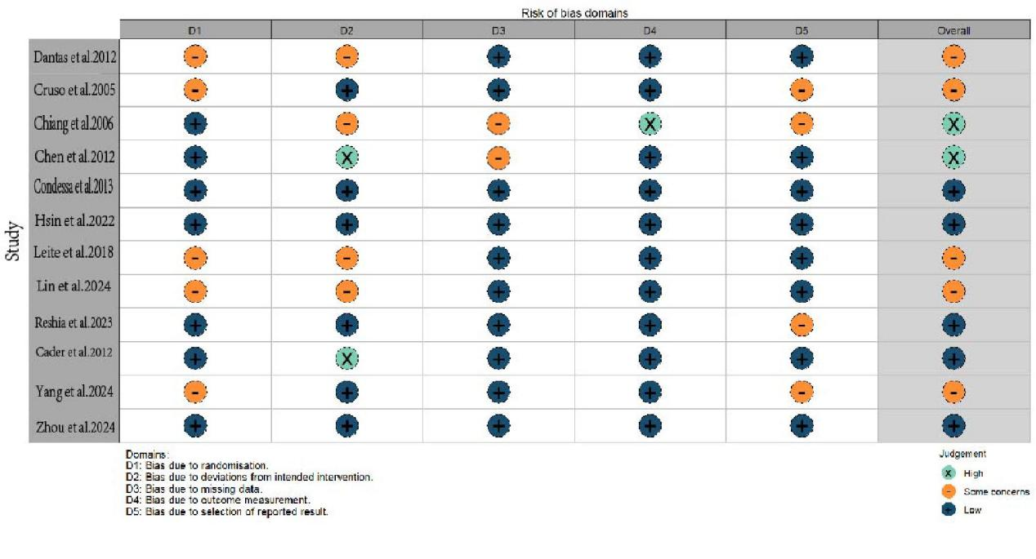
Supplementary Figure 1a Detailed risk of bias assessment
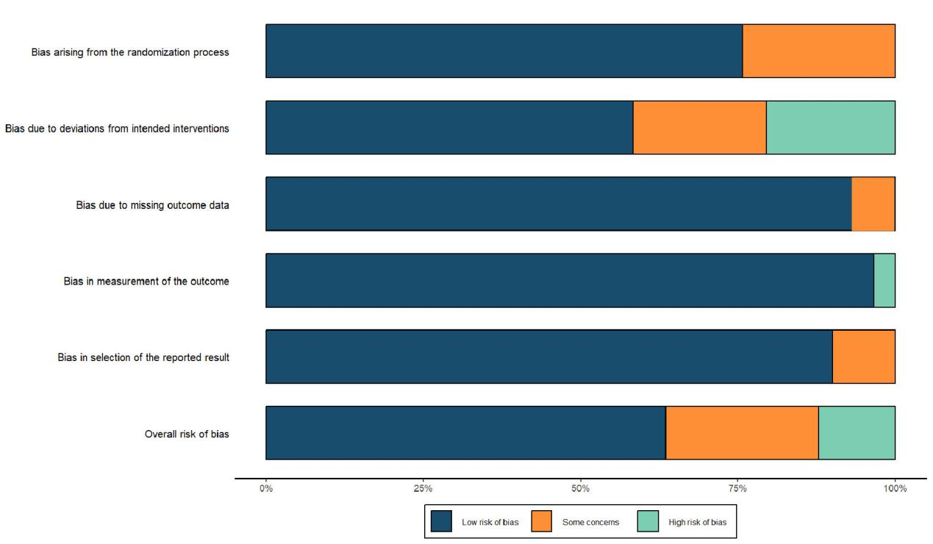
Supplementary Figure 1b. Risk of bias graph of the included studies.

A.RR
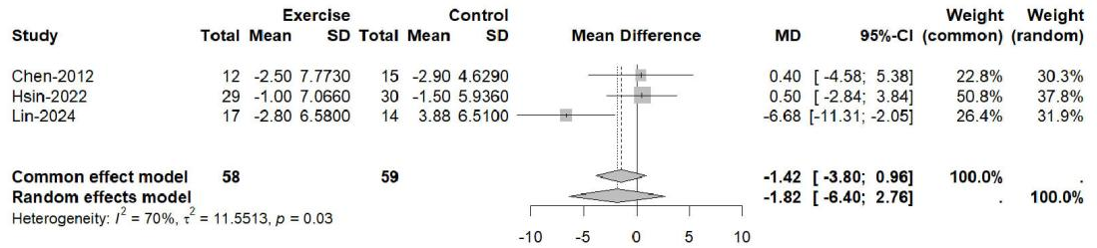
B.DT
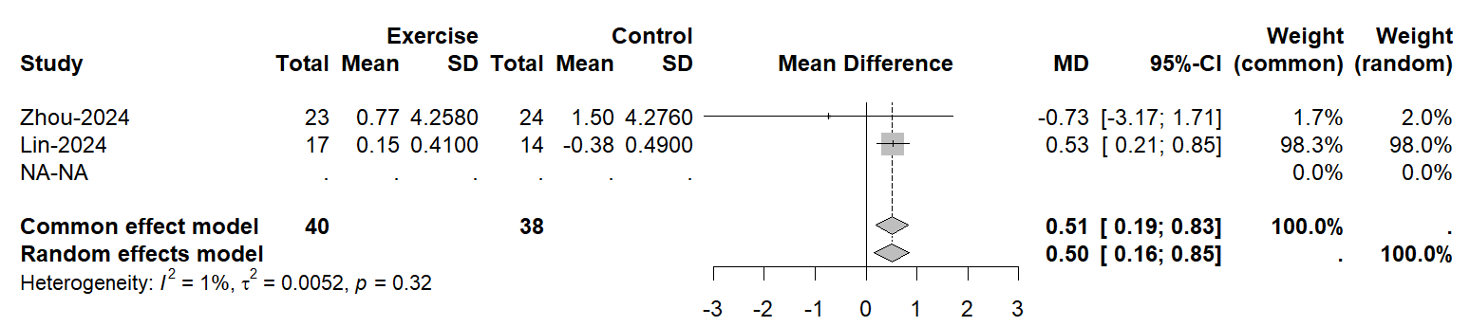
C.DM
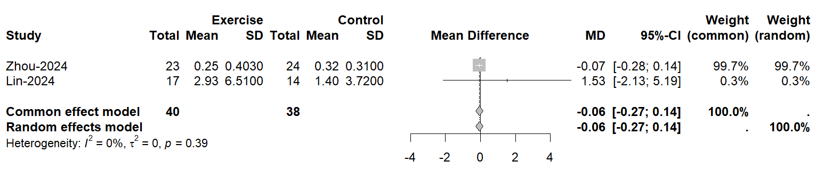
Supplementary Figure 2. Pairwise meta-analysis of direct comparisons
A: Forest plot of the RR
B: Forest plot of the DT
C: Forest plot of the DM

Supplementary Table 3 Egger’s test
Std_Eff | Coef. | Std. Err. | t | P>|t| | df
bias | 0.4706 | 1.1172 | 0.42 | 0.6835 | 9

A.Sensitivity analyzes of MIP
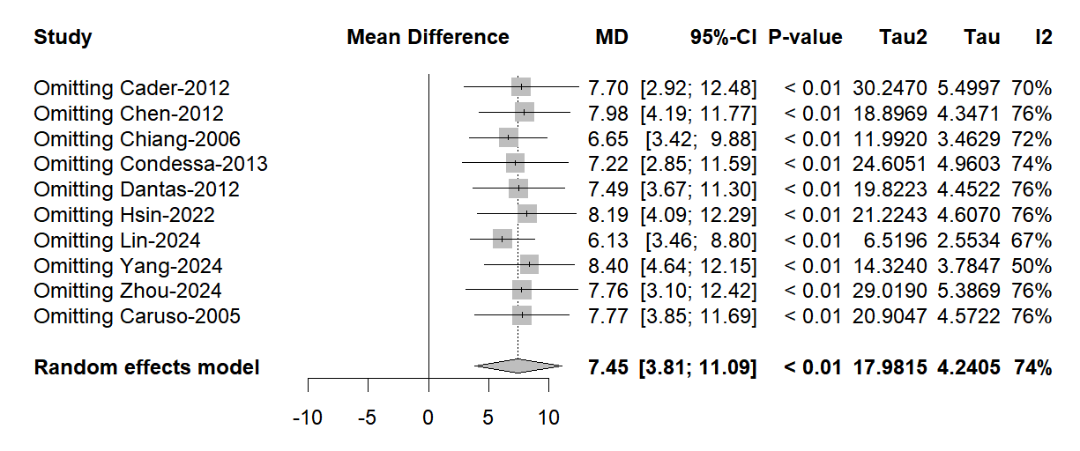
B.Sensitivity analyzes of MEP
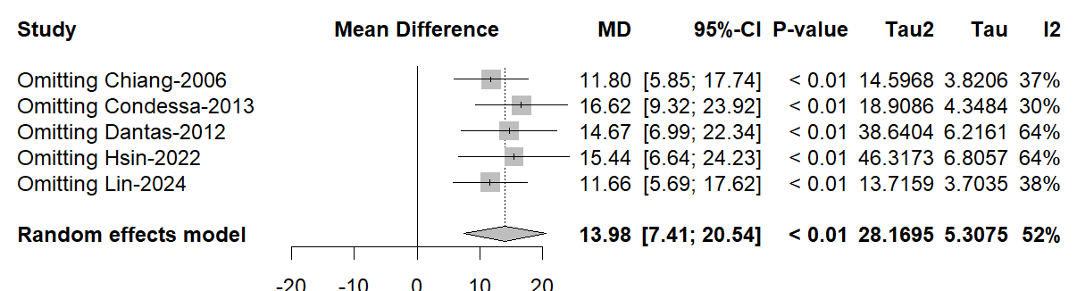
C.Sensitivity analyzes of RSBI
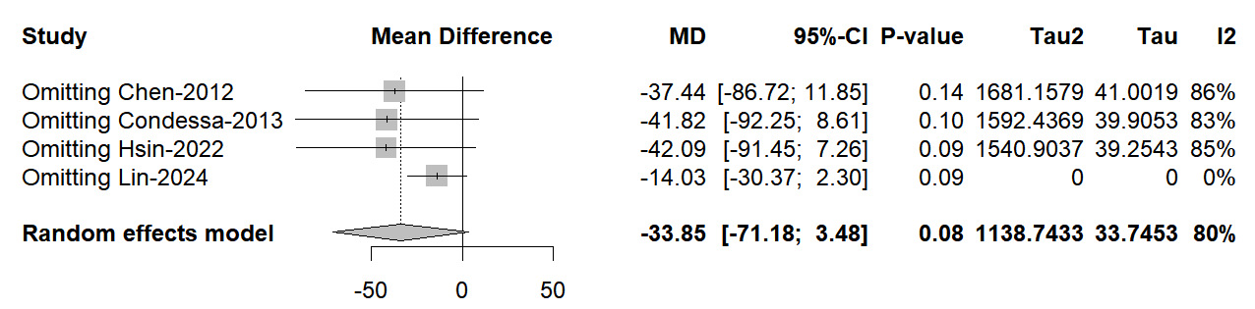
D.Sensitivity analyzes of VT
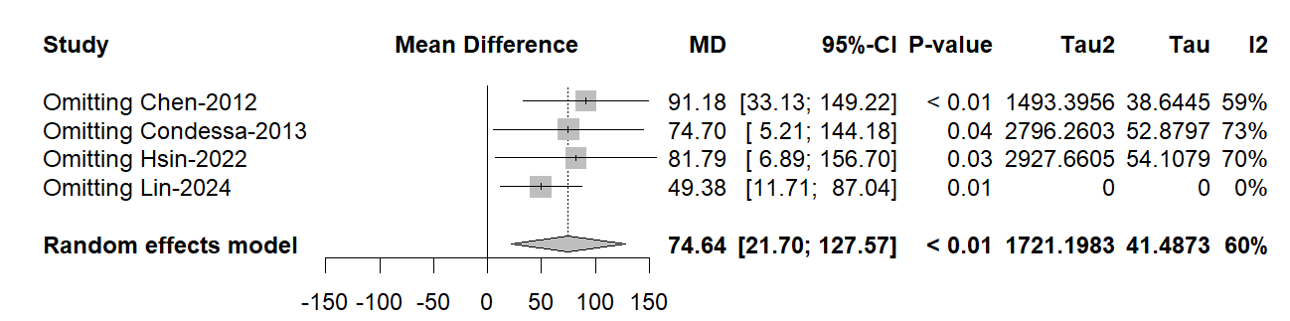
Supplementary Figure. 3 Sensitivity analyzes
- Sensitivity analyzes of MIP
- Sensitivity analyzes of MEP
- Sensitivity analyzes of RSBI
- Sensitivity analyzes of VT

Supplementary Table 4 Subgroup analysis
 |  |  |  | Each results |  | Between subgroups
Outcomes | Trials | Sample Size(Intervention/Control) | SMD[95%CI] | P-value | I²(%) | P-value | I²(%)
MIP
Intervened until extubation | 2 | 52/53 | 7.93[5.97;9.86] | 0.40 | 0% | ＜001 | 74%
Intervened 42 days | 2 | 31/29 | 17.56[5.50;29.62] | 0.29 | 11% | ＜001 | 74%
Intervened 7 days | 2 | 69/70 | 3.03[1.61;4.44] | 0.88 | 0% | ＜001 | 74%
Setting at ICU | 4 | 89/91 | 7.78[6.01;9.55] | 0.84 | 0% | ＜001 | 74%
Setting at RCC | 3 | 58/60 | 6.76[-6.77;20.28] | 0.03 | 71% | ＜001 | 74%
Interventions was IMT | 4 | 104/106 | 6.15[2.47;9.82] | ＜001 | 82% | ＜001 | 74%
Interventions was EMT | 2 | 31/29 | 17.56[5.50;29.62] | 0.29 | 11% | ＜001 | 74%
Interventions was NMES | 2 | 46/56 | -5.44[-21.02;10.14] | ＜001 | 90% | ＜001 | 74%
MV duration ≥48h | 4 | 89/91 | 1.09[0.21;1.97] | ＜001 | 77% | ＜001 | 74%
MV duration ≥504h | 2 | 41/45 | 0.08[-0.34;0.51] | 0.49 | 0% | ＜001 | 74%
MV duration ≥24h | 2 | 57/66 | -0.08[-2.08;1.91] | ＜001 | 96% | ＜001 | 74%
MEP
Setting at ICU | 2 | 52/53 | 8.24[3.20;13.27] | 0.76 | 0% | 0.08 | 52%
Setting at RCC | 2 | 46/45 | 16.36[3.81;28.90] | 0.10 | 63% | 0.08 | 52%
Abbreviations:SMD, standardized mean difference; 95% CI, 95% confidence interval;MIP,Maximum Inspiratory Pressure;ICU,Intensive care unit;RCC,Respiratory Care Center;IMT,Inspiratory muscle training;EMT,Extremity muscle training;NMES,Neuromuscular electrical stimulation.

Supplementary table 5 Evidence profile
Certainty assessment |  |  |  |  |  |  | № of patients |  | Effect |  | Certainty | Importance
№ of studies | Study design | Risk of bias | Inconsistency | Indirectness | Imprecision | Other | Intervention | Control | Relative  (95% CI) | Absolute  (95% CI) | Certainty | Importance
MIP
10 | randomized trials | not serious | not serious | not serious | serious^{b} | none | 216 | 218 | - | MD 7.45 higher  (3.81 higher to 11.09 higher) | ⨁⨁⨁◯  Moderate | CRITICAL
MEP
5 | randomized trials | not serious | not serious | not serious | serious^{b} | none | 115 | 112 | - | MD 13.98 higher  (7.41 higher to 20.54 higher) | ⨁⨁⨁◯  Moderate | CRITICAL
RSBI
4 | randomized trials | serious^{c} | serious^{e} | not serious | very serious^{b,d} | none | 96 | 98 | - | MD 33.85 lower  (71.18 lower to 3.48 higher) | ⨁◯◯◯  Very low | CRITICAL
VT
4 | randomized trials | serious^{c} | not serious | not serious | serious^{b} | none | 96 | 98 | - | MD 74.64 higher  (21.70 higher to 127.57 higher) | ⨁⨁◯◯  Low | CRITICAL
RR
3 | randomized trials | not serious | not serious | not serious | very serious^{b,d} | none | 58 | 59 | - | MD 1.82 lower  (6.40 lower to 2.76 higher) | ⨁⨁⨁◯  Moderate | CRITICAL
DT
2 | randomized trials | seriousª | not serious | not serious | serious^{b} | none | 40 | 38 | - | MD 0.51 higher  (0.19 higher to 0.83 higher) | ⨁⨁◯◯  Low | CRITICAL
DM
2 | randomized trials | seriousª | not serious | not serious | very serious^{b,d} | none | 40 | 38 | - | MD 0.06 lower  (0.27 lower to 0.14 higher) | ⨁⨁◯◯  Low | CRITICAL
Abbreviations:SMD, standardized mean difference; 95% CI, 95% confidence interval;MIP,Maximum Inspiratory Pressure;MEP,Maximum Expiratory Pressure;RSBI,Rapid Shallow Breathing Index;VT,Tidal Volume;RR,Respiratory Rate;DM,Diaphragm Motion;DT,Diaphragm Thickness.

Explanations
a. Downgrade one level due to >50% some concerns in overall.
b. Downgraded one level due to insufficient sample size.(fewer than 400 patients included)
c. Downgraded one levels due to >50% high risk of bias in overall.
d. Downgraded one level due to no effect in 95% CI.
e. Downgraded one level due to I²＞80% with 95% CI overlap.

