Heterogeneity in Clinical Patterns of adult Lung Abscess patients: an 8-year retrospective study in a tertiary hospital
Rongling Zhang^{1,2}, Jiapei Yu², Xiao Shang³, Zeyi Wang¹, Hui Li^{2*}, Bin Cao^{1,2,3*}
1 Chinese Academy of Medical Sciences, Peking Union Medical College, Beijing 100730, China
2 Department of Pulmonary and Critical Care Medicine, China-Japan Friendship Hospital, Center of Respiratory Medicine, National Clinical Research Center for Respiratory Diseases, Beijing, China; Institute of Respiratory Medicine, Chinese Academy of Medical Sciences and Peking Union Medical College, Beijing, China
3 Tsinghua University-Peking University Joint Centre for Life Sciences, Tsinghua University, Beijing, China.

Corresponding authors
*Correspondence to Bin Cao (caobin_ben@163.com)
Department of Pulmonary and Critical Care Medicine, China-Japan Friendship Hospital, Center of Respiratory Medicine, National Clinical Research Center for Respiratory Diseases, Beijing, China; Institute of Respiratory Medicine, Chinese Academy of Medical Sciences and Peking Union Medical College, Beijing, China)
Hui Li (lihui123000@126.com)
Department of Pulmonary and Critical Care Medicine, China-Japan Friendship Hospital, Center of Respiratory Medicine, National Clinical Research Center for Respiratory Diseases, Beijing, China; Institute of Respiratory Medicine, Chinese Academy of Medical Sciences and Peking Union Medical College, Beijing, China).

Supplemental table 1 Sources of biological specimen and distribution of microbiological classifications in patients with lung abscesses
Source | Biological specimen | Biological Classification | count
Conventional test | BALF | Aerobic GNB | 87
 | BALF | Aerobic GNC | 1
 | BALF | Aerobic GPB | 9
 | BALF | Aerobic GPC | 7
 | BALF | Anaerobe | 7
 | BALF | Facultative anaerobe | 5
 | BALF | Fungi | 9
 | BALF | Mycobacterium | 1
 | BALF | Nocardia | 2
 | Blood | Aerobic GNB | 19
 | Blood | Aerobic GPC | 12
 | Blood | Facultative anaerobe | 4
 | Blood | Fungi | 1
 | Others | Aerobic GNB | 8
 | Others | Aerobic GPC | 5
 | Others | Fungi | 2
 | Pleural effusion | Aerobic GNB | 23
 | Pleural effusion | Aerobic GNC | 1
 | Pleural effusion | Aerobic GPB | 10
 | Pleural effusion | Aerobic GPC | 39
 | Pleural effusion | Anaerobe | 8
 | Pleural effusion | Facultative anaerobe | 22
 | Pleural effusion | Fungi | 5
 | Pleural effusion | Mycobacterium | 1
 | Sputum | Aerobic GNB | 160
 | Sputum | Aerobic GNC | 1
 | Sputum | Aerobic GPB | 3
 | Sputum | Aerobic GPC | 10
 | Sputum | Anaerobe | 5
 | Sputum | Facultative anaerobe | 23
 | Sputum | Fungi | 37
 | Sputum | Nocardia | 4
 | Tissue | Aerobic GNB | 59
 | Tissue | Aerobic GNC | 2
 | Tissue | Aerobic GPB | 6
 | Tissue | Aerobic GPC | 42
 | Tissue | Anaerobe | 25
 | Tissue | Facultative anaerobe | 32
 | Tissue | Fungi | 12
 | Tissue | Mycobacterium | 1
 | Tissue | Nocardia | 2
Total count |  |  | 712
mNGS | BALF | Aerobic GNB | 41
 | BALF | Aerobic GNC | 8
 | BALF | Aerobic GPB | 7
 | BALF | Aerobic GPC | 25
 | BALF | Anaerobe | 158
 | BALF | Facultative anaerobe | 41
 | BALF | Fungi | 16
 | BALF | Mycobacterium | 2
 | BALF | Nocardia | 2
 | Pleural effusion | Aerobic GNB | 4
 | Pleural effusion | Aerobic GPC | 4
 | Pleural effusion | Anaerobe | 20
 | Pleural effusion | Facultative anaerobe | 4
 | Pleural effusion | Fungi | 1
 | Tissue | Aerobic GNB | 6
 | Tissue | Aerobic GNC | 2
 | Tissue | Aerobic GPC | 4
 | Tissue | Anaerobe | 37
 | Tissue | Facultative anaerobe | 4
 | Tissue | Fungi | 4
Total count |  |  | 390
Abbreviations: GNB： gram-negative bacilli, GPB: gram-positive bacilli, GPC: gram-positive cocci, GNC: gram-negative cocci. The Others includes catheters(n=9) and tissue fluids from other organs (n=6).

Supplemental table 2: Conventional microbiologic test available in China-Japan Friendship Hospital
 | conventional microbiologic methods
Methods for bacteria | Smear stain, culture, modified acid-fast bacilli stain for Nocardia; streptococcus pneumoniae antigen tests on urine samples
Methods for mycobacteria | Acid-fast bacilli smear stain, culture, PCR assays for mycobacterium tuberculosis complex (GeneXpert)
Methods for atypical pathogen | PCR assays for M. pneumoniae, C. pneumoniae, Ureaplasma urealyticum, and legionella pneumophila
Methods for virus | PCR assays for influenza A (H1N1, H7N9) virus, influenza B virus, respiratory syncytial virus, parainfluenza virus, adenovirus, Epstein-Barr virus, herpes simplex virus, human cytomegalovirus, and SARS-CoV-2
Methods for fungi | Smear stain, culture, Gomori methenamine silver (GMS) staining for P. jirovecii, PCR assays for P. jirovecii, Cryptococcus antigen tests on serum samples
PCR: Polymerase Chain Reaction. P. jirovecii: Pneumocystis jirovecii

Supplemental table 3. Culture media used at China-Japan Friendship Hospital
for conventional pathogen testing methods
 | Media
Blood / Pleural fluid /Pus/Tissue Culture | BACTEC™ Myco/F Lytic culture vials (BD, 442288)  Aerobic/ facultative anaerobe: BACT/ALERT® FA PLUS (BioMérieux, 410851)  Anaerobe: BACT/ALERT® FA PLUS (BioMérieux, 424071)
Sputum/BALF Culture
Bacteria | Columbia Agar with Sheep Bloodsolution (Oxoid, PB0123A)  Chocolate Agar plate (Oxoid, PO8124A)  Chocolate Agar plate+ Vancomycin (Oxoid, PB8001A)  Anaerobic Blood Agar Plate (Oxoid, PO8111A)  China blue lactose agar plate+rosolic acid (Oxoid, PO8060A)
Fungi | Sabouraud's Agar (Tianjin Jinzhang Science Technology Development. CO. LTD)  Chromogenic Candida Agar Plate (Autobio, 30060201M01)
Mycobacterium culture | BACTEC™ MGIT™ Mycobacterial Growth Indicator Tubes (BD, 442288)

Supplementary Figure 1 The flowchart for participants included in the analysis
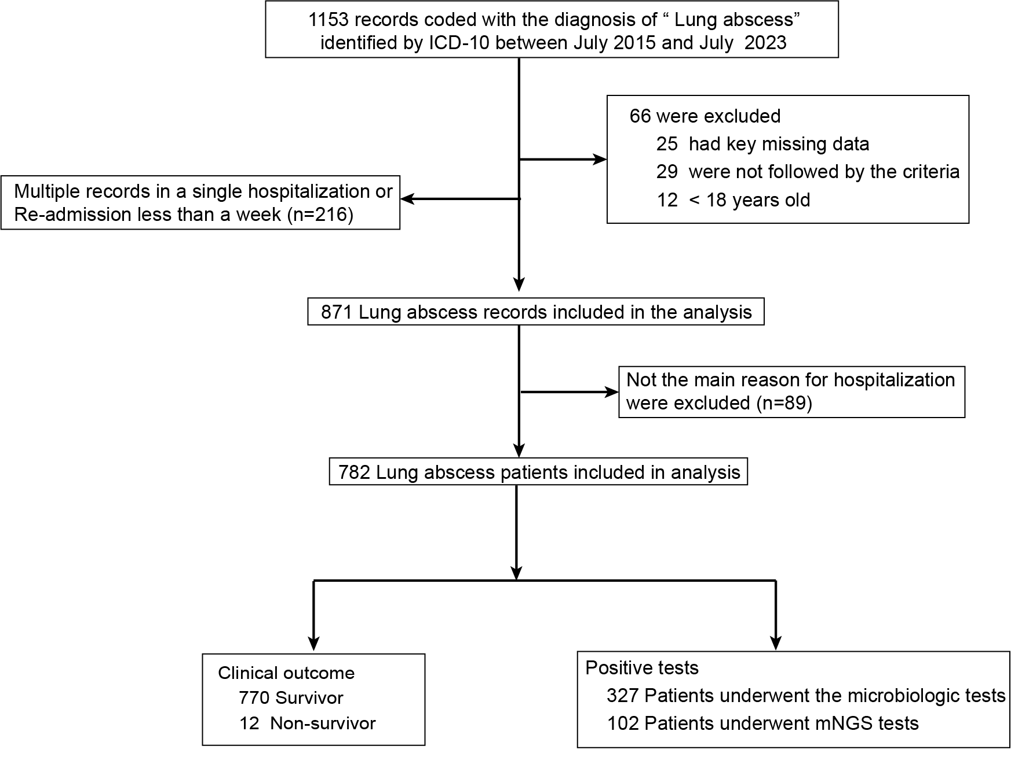

Supplementary Figure 2 Distribution of conventional tests in patients with lung abscess according to bacterial classifications: A. Aerobic Gram-negative bacilli; B. Aerobic Gram-positive cocci; C. Anaerobe; D. Facultative anaerobe; E. Fungi; F. Aerobic Gram-positive bacilli; G. Mycobacterium, aerobic Gram-negative cocci and nocardia.
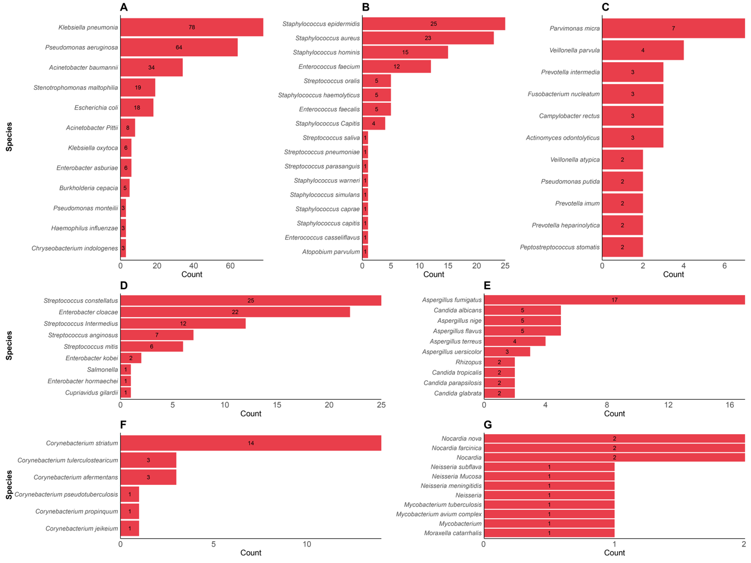

Supplementary Figure 3 Distribution of mNGS in patients with lung abscess according to bacterial classifications: A. Aerobic Gram-negative bacilli; B. Aerobic Gram-positive cocci; C. Anaerobe; D. Facultative anaerobe; E. Fungi; F. Aerobic Gram-positive bacilli; G. Mycobacterium, aerobic Gram-negative cocci and nocardia. mNGS: Metagenomic next-generation sequencing.
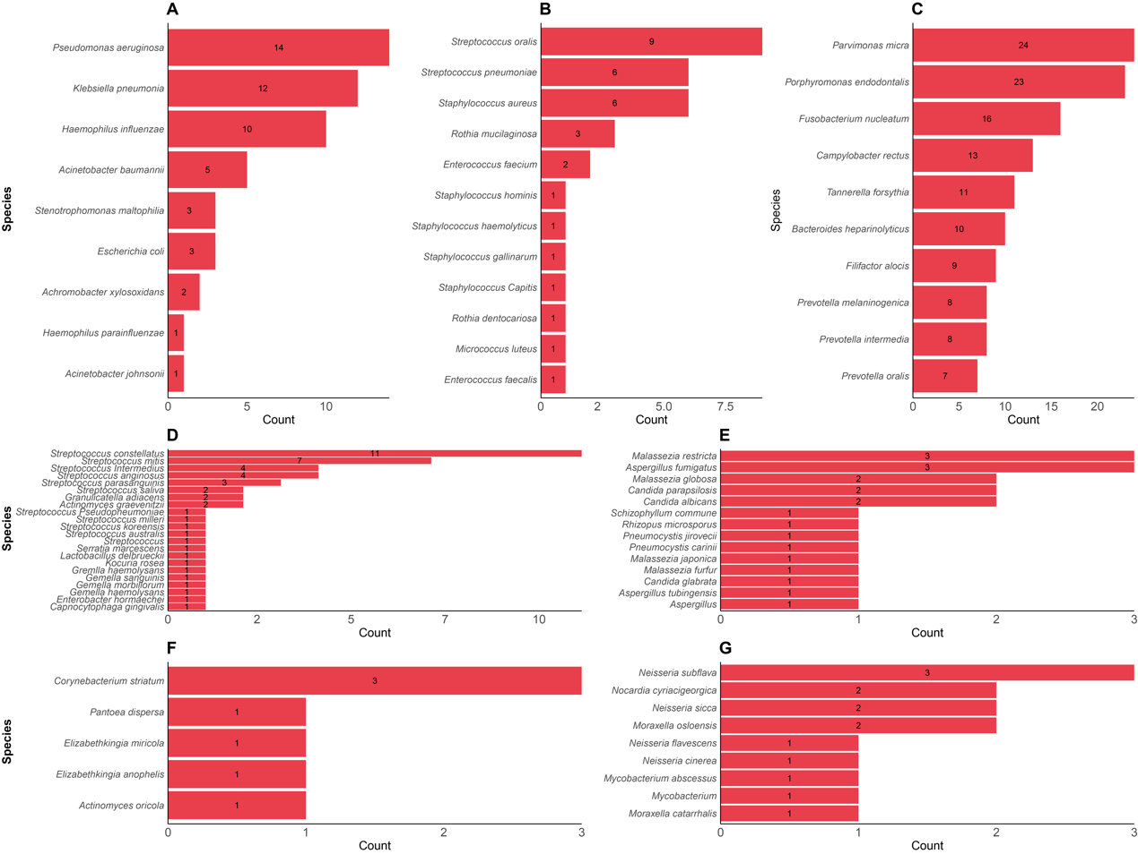

Supplementary Figure 4 Infection patterns across patients with lung abscess.
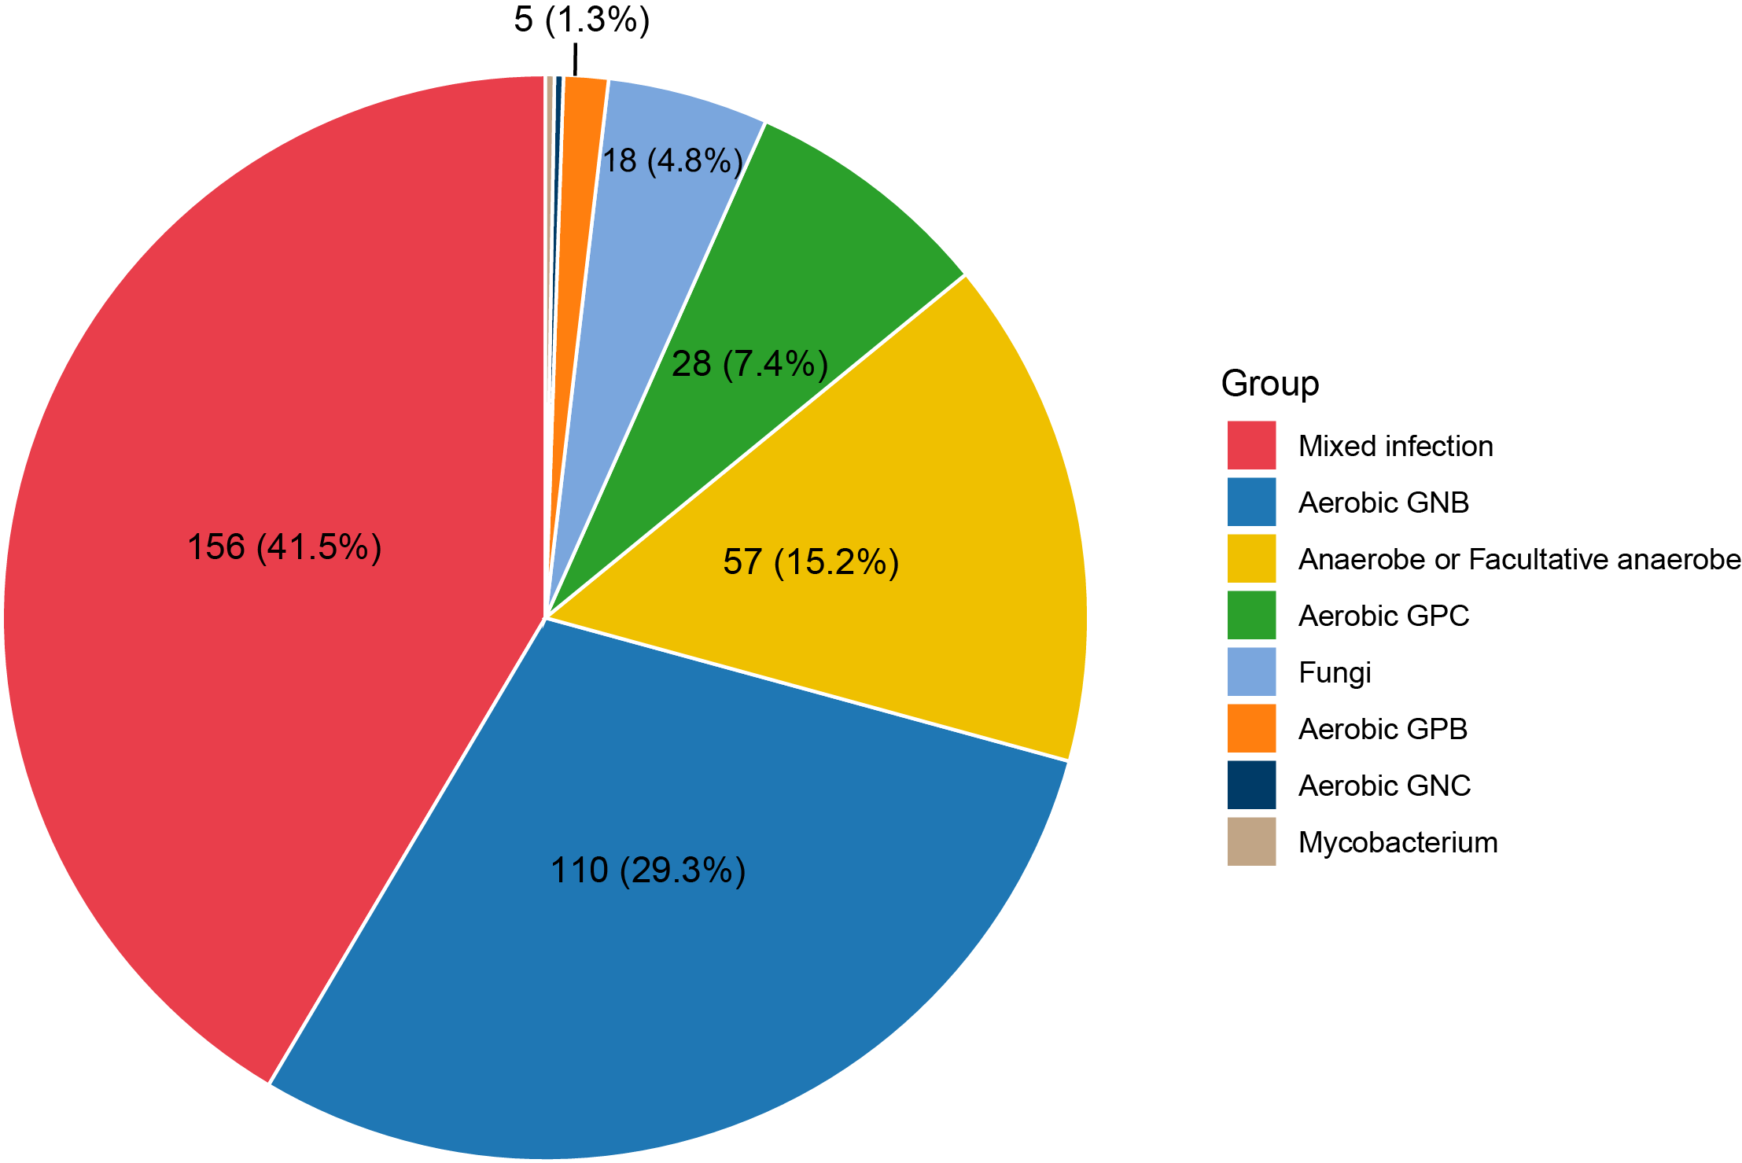
Abbreviations: GNB: gram-negative bacilli; GPB: gram-positive bacilli; GPC: gram-positive cocci; GNC: gram-negative cocci.

