Supplementary Data
Methods
Sampling cycles and cross-validation
To avoid sampling errors, we conducted 10 random sampling cycles. In each cycle, clusters were ranked based on their exacerbation rates, with the cluster having the lowest exacerbation rate being labeled as cluster 1. To evaluate the stability of clustering results, cross validation was applied to each cycle. In this process, we first calculated principal component score formula and cluster centers using the training set to derive clustering solutions for the validation set. Then, we calculated principal component score formula and cluster centers using the validation set to derive clustering solutions for the training set. Consequently, both the training and validation sets had two clustering results: one derived from their own data and the other derived from another independent data sample. We used normalized mutual information (NMI) to compare the two clustering solutions for each independent dataset. (Fig. S3)
To further describe the clustering results, we output visualization graphs of the two clustering solutions for each independent dataset. Additionally, as shown in Fig. S6, each data point was continuously distributed along the rotated principal component coordinate axis. In addition, the dispersion of each cluster was not high in independent samples, but the overall distribution of each cluster showed high stability in independent samples and cross validation. In addition, the overall data structure also showed high stability in rotated principal component coordinate system, which partially explained the stability of the principal component results.

Table S1 Variables included in principal component analysis
Pi10 | Air-trapping | Emphysema | Spirometric  measures | Wall area percent | Other indicators
Pi10_total | Exp_LAA856_total | Insp_LAA950_total | FEV1_post | Wall area percent _RB1 | BMI
Pi10_LEFT_LUNG | Exp_density_mean_total | Insp_density_mean_total | FEV6_post | Wall area percent _RB2 | Age
Pi10_RIGHT_LUNG | Exp_ density StdDev_total | Insp _Intensity StdDev_total | FVC_post | Wall area percent _RB3 | CAT
Pi10_RUL | Exp_Lowest 15% HU location_total | Insp _Lowest 15% HU location_total | FEV1/FVC_post | Wall area percent _RB4 | Smoking pack-year
Pi10_RML | Exp_LAA856_TLL | Insp _LAA950_TLL | FEF2575_post | Wall area percent _RB5 | Exp_kurtosis
Pi10_RLL | Exp_LAA856_TLM | Insp _LAA950_TLM | PEFR_post | Wall area percent _RB6 | Exp_skewness
Pi10_LUL | Exp_LAA856_TLU | Insp _LAA950_TLU | FEV3_post | Wall area percent _RB7 | Insp_kurtosis
Pi10_LLL | Exp_LAA856_TRL | Insp _LAA950_TRL | FEV3/FVC_post | Wall area percent _RB8 | Insp_skewness
 | Exp_LAA856_TRM | Insp _LAA950_TRM | FEV1_pre | Wall area percent _RB9
 | Exp_LAA856_TLU | Insp _LAA950_TLU | FEV6_pre | Wall area percent_RB10
 | Exp_Lowest 15% HU location_TLL | Insp _Lowest 15% HU location_TLL | FVC_pre | Wall area percent _LB1
 | Exp_Lowest 15% HU location_TLM | Insp _Lowest 15% HU location_TLM | FEV1/FVC_pre | Wall area percent _LB2
 | Exp_Lowest 15% HU location_TLU | Insp _Lowest 15% HU location_TLU | FEF2575_pre | Wall area percent _LB3
 | Exp_Lowest 15% HU location_TRL | Insp _Lowest 15% HU location_TRL | PEFR_pre | Wall area percent _LB4
 | Exp_Lowest 15% HU location_TRM | Insp _Lowest 15% HU location_TRM | FEV3_pre | Wall area percent _LB5
 | Exp_Lowest 15% HU location_TRU | Insp _Lowest 15% HU location_TRU | FEV3/FVC_pre | Wall area percent _LB6
 |  |  | FEV1% predicted | Wall area percent _LB8
 |  |  | FVC% predicted | Wall area percent _LB9
 |  |  |  | Wall area percent_LB10
Abbreviation: exp, expiratory; insp, inspiratory; wall area percent = wall area / total bronchial area; TLU, upper left third of the lung; TLM, left middle third of the lung; TLL, lower left third of the lung; TRU, upper right third of the lung; TRM, right middle third of the lung; TRL, lower right third of the lung; kurtosis, kurtosis of lung density histogram; skewness; skewness of lung density histogram; StdDev, standard deviation of mean lung density; BMI, body mass index; HU, Hounsfield units; FDEF2575, forced expiratory flow at 25-75%; PEFR, peak expiratory flow rate; HU, Hounsfield units.

Table S2 Baseline characteristics of the training and validation data
Characteristic |  | Training | Validation | P-value
N | 939 |  | 940
Age | 65.00 (57.00, 70.00) |  | 64.50 (56.00, 70.00) | 0.645
BMI | 27.00 (24.00, 32.00) |  | 28.00 (24.00, 32.00) | 0.552
Gender, % female | 430 (46%) |  | 457 (49%) | 0.220
Smoking pack-year | 40.00 (30.00, 56.00) |  | 41.00 (30.00, 57.13) | 0.986
FEV1 | 2.15 (1.51, 2.81) |  | 2.16 (1.51, 2.77) | 0.688
FVC | 3.41 (2.78, 4.15) |  | 3.34 (2.70, 4.13) | 0.266
FEV1/FVC | 0.67 (0.53, 0.77) |  | 0.67 (0.53, 0.77) | 0.964
FEV1% predicted | 0.80 (0.57, 0.94) |  | 0.80 (0.57, 0.95) | 0.622
BODE index | 1.00 (0.00, 2.00) |  | 1.00 (0.00, 2.00) | 0.859
GOLD stage |  |  |  | 0.071
0 | 304 (32%) |  | 293 (31%)
1 | 134 (14%) |  | 139 (15%)
2 | 256 (27%) |  | 270 (29%)
3 | 153 (16%) |  | 118 (13%)
4 | 32 (3%) |  | 51 (5%)
Unknown* | 60 (6%) |  | 69 (7%)
Pi10_total | 3.73 (3.66, 3.80) |  | 3.73 (3.67, 3.80) | 0.566
Exp_LAA856_total | 15.21 (5.48, 36.03) |  | 15.43 (5.67, 36.67) | 0.671
Insp_LAA950_total | 2.69 (0.94, 9.33) |  | 2.71 (0.94, 9.57) | 0.760
Wall area† | 34.14 (30.06, 38.43) |  | 34.06 (29.77, 37.58) | 0.199
Wall area percent† | 0.60 (0.58, 0.62) |  | 0.60 (0.58, 0.62) | 0.857
Lumen area† | 23.53 (19.81, 28.76) |  | 23.54 (19.62, 27.91) | 0.332
Total bronchial area† | 57.75 (50.30, 67.34) |  | 57.64 (49.70, 65.15) | 0.240
Notes: values are median (IQR) unless otherwise noted;
p-value obtained by Wilcoxon rank sum tests or Pearson’s Chi-squared tests;
*GOLD unknown: control group with less than 1 pack-year;
†: each subject's value is replaced by the mean value for 19 bronchi of lung segments.
Abbreviation: exp, expiratory; insp, inspiratory; wall area = total bronchial area - lumen area; wall area percent = (total bronchial area - lumen area) / total bronchial area; BMI, body mass index.

Table S3 Cluster characteristics in validation set, k=5
Characteristic | Cluster 1 | Cluster 2 | Cluster 3 | Cluster 4 | Cluster 5
N | 248 | 125 | 358 | 106 | 103
Age | 63.00 (55.00, 69.00) | 54.00 (48.00, 61.00) | 67.00 (61.00, 72.00) | 65.00 (59.00, 70.00) | 65.00 (58.00, 72.00)
BMI | 27.00 (24.00, 30.25) | 31.00 (28.00, 35.00) | 29.00 (25.00, 33.00) | 26.00 (22.00, 29.00) | 24.00 (21.00, 27.00)
GENDER % female | 50 (20%) | 96 (77%) | 230 (64%) | 52 (49%) | 29 (28%)
CAT | 6.00 (3.00, 13.00) | 13.00 (7.00, 20.00) | 12.50 (7.00, 19.00) | 14.00 (10.00, 20.00) | 18.00 (12.00, 23.00)
BODE index | 0.00 (0.00, 0.00) | 0.00 (0.00, 1.00) | 1.00 (0.00, 2.00) | 3.00 (1.00, 4.00) | 4.00 (2.00, 5.00)
FEV1/FVC | 0.75 (0.67, 0.81) | 0.81 (0.75, 0.85) | 0.65 (0.56, 0.73) | 0.47 (0.37, 0.58) | 0.38 (0.31, 0.45)
FEV1% predicted | 0.97 (0.85, 1.08) | 0.91 (0.82, 0.98) * | 0.75 (0.60, 0.89) | 0.50 (0.33, 0.68) | 0.39 (0.29, 0.49)
FVC% predicted | 1.03 (0.94, 1.11) | 0.91 (0.83, 0.97) | 0.90 (0.79, 1.01) | 0.83 (0.70, 0.98) | 0.84 (0.68, 0.95)
Insp_LAA950_total | 2.24 (1.21, 4.07) | 0.47 (0.28, 0.72) | 2.31 (0.98, 4.79) | 23.29 (14.10, 29.05) | 20.39 (13.03, 30.52)
Exp_density StdDev | 173.47 (166.32, 179.36) | 173.60 (165.66, 180.30) | 168.92 (162.14, 177.59) | 180.58 (171.54, 194.28) | 163.86 (153.75, 169.42)
Exp_skewness | 1.92 (1.66, 2.14) | 1.58 (1.35, 1.83) | 2.11 (1.84, 2.43) | 2.07 (1.71, 2.41) | 2.82 (2.33, 3.11)
Exp_kurtosis | 3.75 (2.08, 5.18) | 2.22 (0.98, 3.70) | 4.58 (2.77, 6.40) | 4.02 (2.43, 6.39) | 8.63 (5.45, 11.02)
Exp_LAA856_TLU | 7.19 (2.18, 17.33) | 1.36 (0.49, 4.38) | 13.12 (6.16, 26.44) | 61.54 (45.24, 73.80) | 52.98 (37.02, 71.01)
Exp_LAA856_TLL | 6.75 (2.24, 14.61) | 1.10 (0.54, 3.51) | 9.78 (4.77, 21.26) | 22.20 (8.14, 35.81) | 53.74 (45.60, 68.41)
Exp_LAA856_TRU | 6.14 (1.65, 16.66) | 1.24 (0.40, 4.20) | 11.27 (4.69, 25.14) | 63.33 (53.16, 78.99) | 54.80 (32.33, 71.90) *
Exp_LAA856_TRL | 11.22 (4.99, 20.96) | 2.13 (0.73, 6.52) | 15.19 (8.41, 27.74) | 33.12 (19.86, 44.85) | 61.04 (50.64, 68.72)
Wall area† | 38.08 (35.11, 41.93) * | 33.00 (29.90, 35.81) | 31.36 (28.58, 35.10) | 33.38 (28.91, 36.36) | 33.36 (29.60, 37.03)
Wall area percent† | 0.58 (0.57, 0.60) | 0.60 (0.58, 0.62) | 0.61 (0.60, 0.63) | 0.61 (0.58, 0.62) | 0.61 (0.59, 0.63)
Lumen area† | 28.60 (25.31, 33.37) * | 23.45 (19.61, 26.15) | 20.94 (18.10, 23.93) | 22.70 (19.95, 26.92) | 22.61 (18.13, 28.46)
Total bronchial area† | 66.76 (60.57, 74.87) * | 56.04 (50.02, 61.82) | 52.64 (47.36, 59.05) | 57.20 (48.92, 62.40) | 56.31 (48.53, 64.92)
Notes: values are median (IQR) unless otherwise noted;
*: p Value comparing mean in training to validation <0.05 for Wilcoxon rank sum tests;
†: Each subject's value is replaced by the mean value for 19 bronchi of lung segments.
Abbreviation: exp, expiratory; insp, inspiratory; wall area = total bronchial area - lumen area; wall area percent = wall area / total bronchial area; TLU, upper left third of the lung; TLL, lower left third of the lung; TRU, upper right third of the lung; TRL, lower right third of the lung; kurtosis, kurtosis of lung density histogram; skewness, skewness of lung density histogram; StdDev, standard deviation of mean lung density; BMI, body mass index; HU, Hounsfield units.

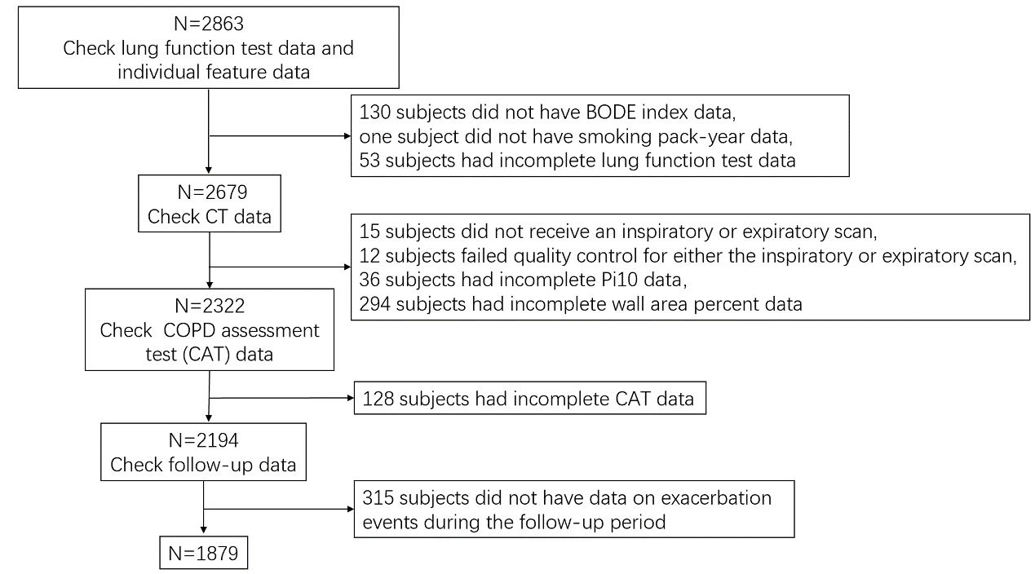
Fig. S1 Data filtering process flowchart.

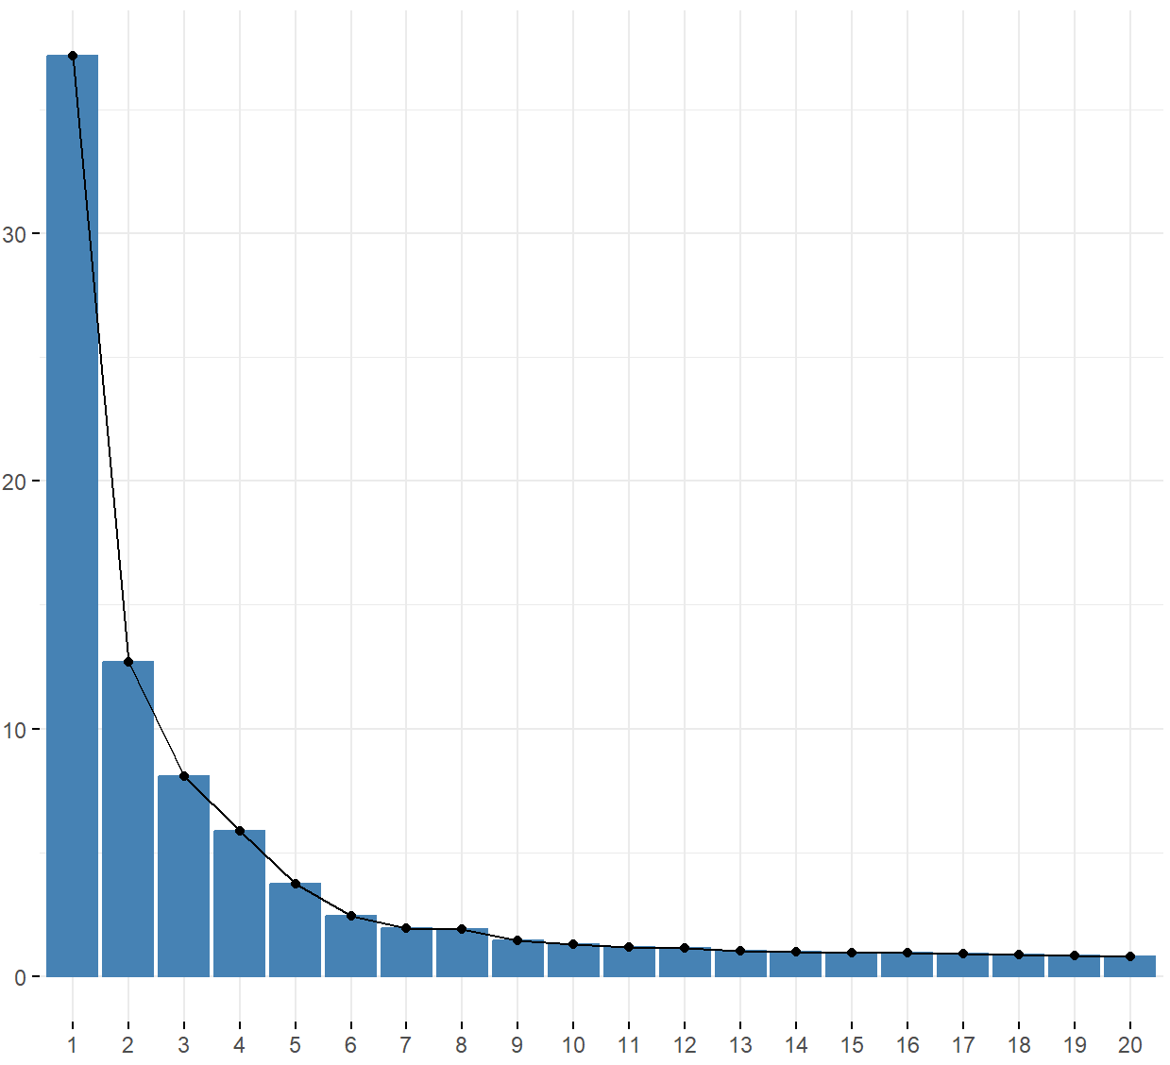
Fig. S2 Scree plot showing the ratios of explained variance by principal components

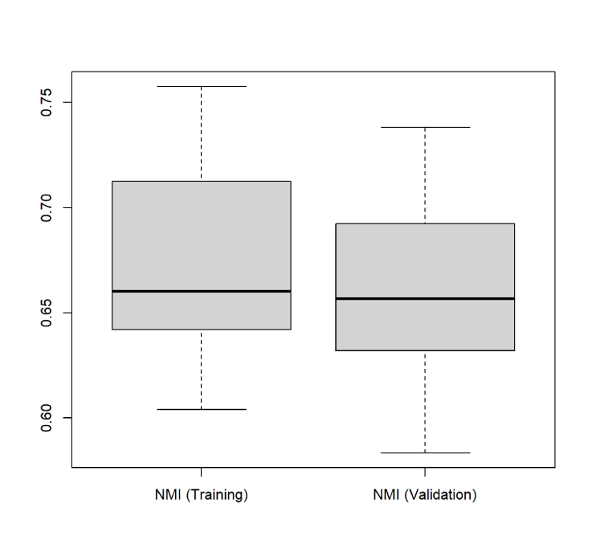
Fig. S3 The NMI of the training and validation sets in 10 random sampling cycles. The median NMI value in the training set was 0.66, and the median NMI value in the validation set was 0.66.

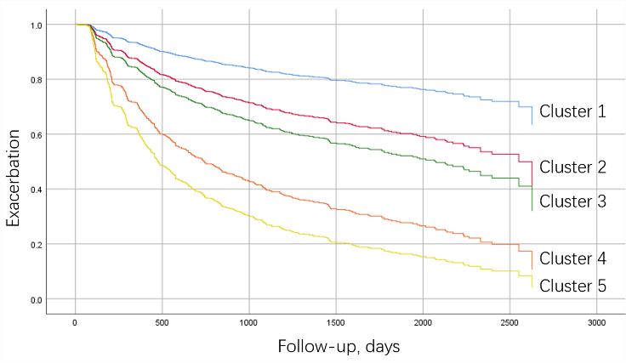
Fig. S4 The COX proportional hazards survival curves for each cluster in training set.

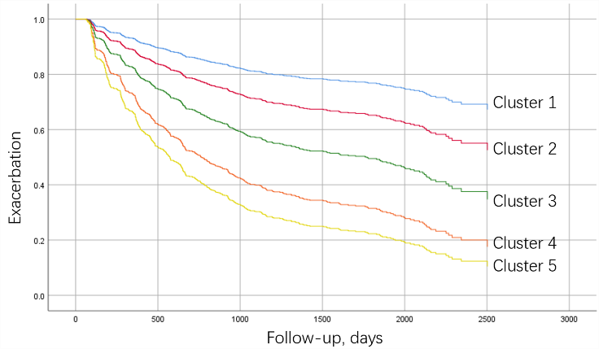
Fig. S5 The COX proportional hazards survival curves for each cluster in validation set.

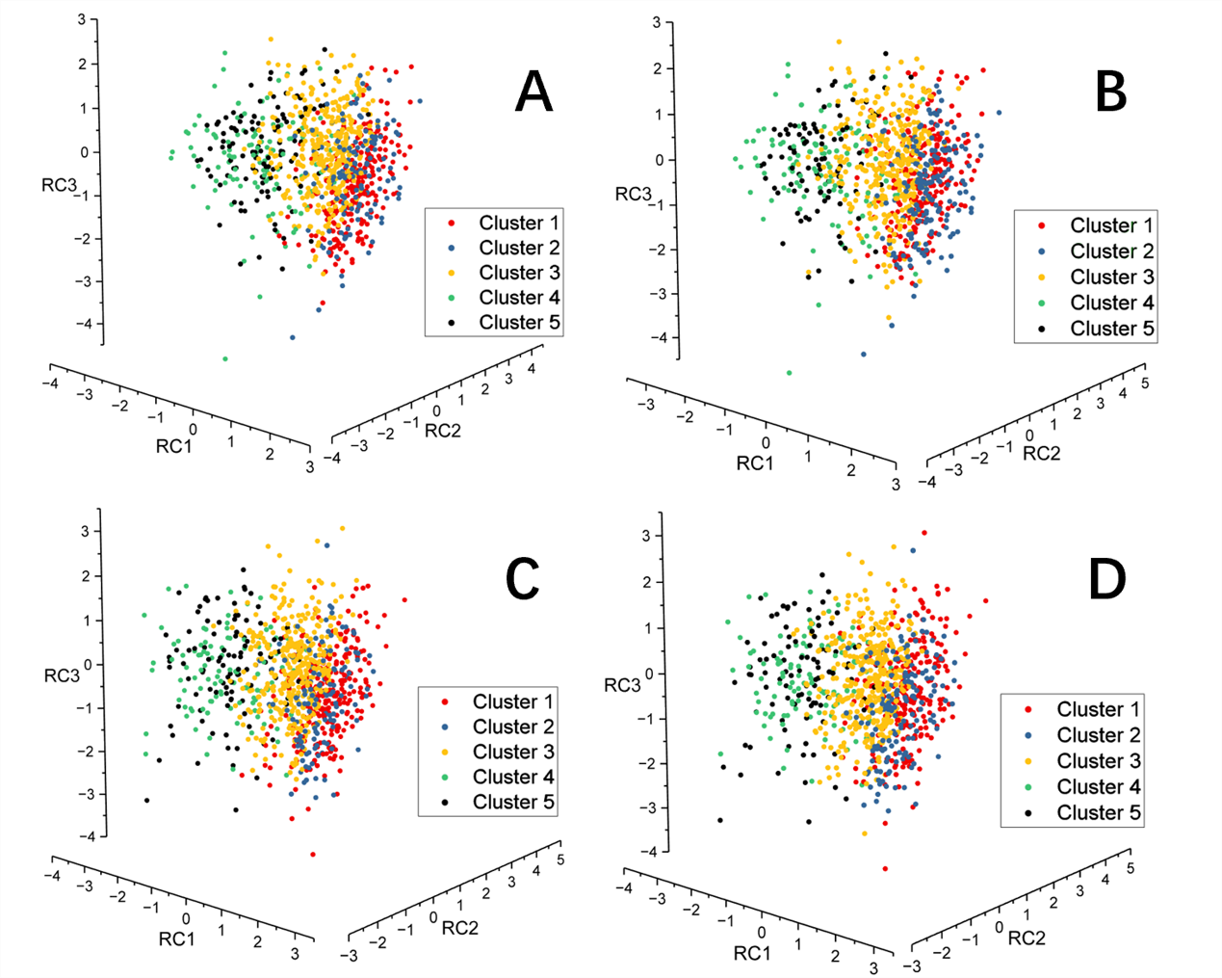
Fig. S6 The visualization diagram of clustering. Panel A: the visualization diagram of the training set clustering. Panel B: the visualization of training set clustering in cross validation, the clustering of data is based on the central point division derived from the validation set. Panel C: the visualization diagram of the validation set clustering. Panel D: the visualization of validation set clustering in cross validation, the clustering of data is based on the central point division derived from the validation set.

