Frailty and the Associated Risk of Exacerbation, Hospitalization, and Death Among Individuals with COPD: A Systematic Review and Meta-Analysis

Mathew Cherian MD
Pourya Masoudian MD
Kednapa Thavorn PhD
Jacqueline Sandoz MD MSc
Risa Shorr MLS
Sunita Mulpuru MD MSc

Online Supplement

Association between Pre-Frailty and Outcomes
Modified Medical Research Council (mMRC)l Dyspnea Scale
Five studies compared mMRC dyspnea scale between pre-frail and non-frail participants. Three studies reported mean mMRC scores with standard deviations and were pooled in metanalysis. It revealed a standardize mean difference of 0.65 [95% CI: (0.42-0.89); I²=35%] favoring higher scores in the pre-frail group. Dias et al reported an increased median mMRC among pre-frail participants. Finally, Medina-Mirepeix et al reported that 34% of participants reported an mMRC ≥2 in the pre-frail group compared to 17% in the non-frail group.

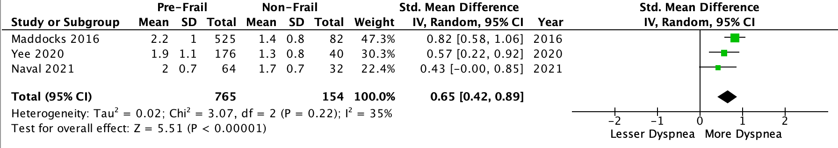

COPD Assessment Test (CAT) Score
Five studies compared CAT scores between pre-frail and non-frail participants. Four studies presented mean CAT scores with standard deviation and were pooled in metanalysis. It revealed a mean difference of 5.00 [95% CI: (3.95-6.05); I²=83%] favoring higher scores in the pre-frail group. Dias et al reported an increased median CAT score among pre-frail participants

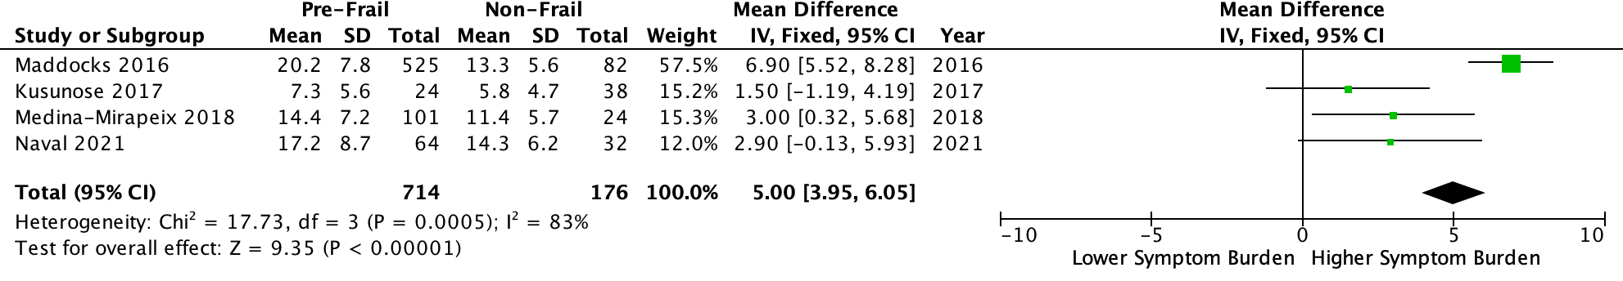

Saint George’s Respiratory Questionnaire (SGRQ) Score
Only one study compared SGRQ between pre-frail and non-frail participants. It revealed a mean SGRQ score of 13.8 (SD 10.1) among non-frail participants compared to a mean SGRQ score of 20.8 (SD 12.3) among pre-frail participants.

Acute Exacerbations of COPD (AECOPD)
Five studies compared AECOPD between pre-frail and non-frail participants. Four of these studies looked at data retrospectively and one study provided prospective longitudinal data over 2 years (Yee).

Among the 4 studies with retrospective data, two studies (Maddocks and Naval), reported the mean number of AECOPD in each group during the past 1 year. Data from these two studies were pooled in metanalysis and revealed no significant mean difference in number of reported exacerbation in the preceding year [Mean Difference (95% CI): 0.27 (-0.51-1.05); I²=78%]. Medina-Mirapeix et al reported that 58.4% of pre-frail participants and 62.5% of non-frail participants reported 2 moderate-severe AECOPD in the preceding year. Dias et al reported no difference in the in the median AECOPD between prefrail and non-frail groups.

Yee et al reported a statistically non-significant increased risk of AECOPD among pre-frail participants compared to non-frail participants [HR 1.13; 95% CI (0.74-1.72)].

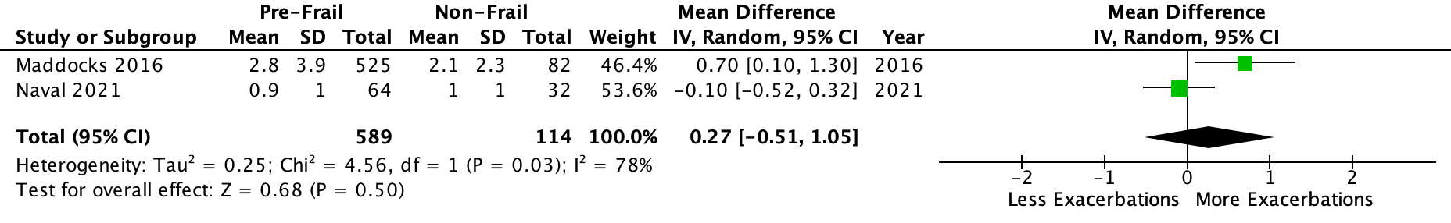

Hospitalizations
Four studies compared COPD related hospitalizations between pre-frail and non-frail participants: two reported retrospective data, one reported prospective data, and one reported both.

All three studies that reported data retrospectively reported the percentage of participants who had 1 or more COPD related hospitalization in the past 1 year. When pooled in metanalysis, this revealed no statistically significant difference in odds of being hospitalized between pre-frail and non-frail groups [OR (95% CI): 1.57 (0.88-2.79); I²=0] (Fig X).

Among the two studies (Yee and Kennedy) with prospective data, Yee et al reported a statistically non-significant Incident Rate Ratio of 1.36 (95% CI: 0.70-2.64), and Kennedy et al identified a statistically non-significant difference in all cause hospitalizations in frail participants [HR (95% CI):1.1 (0.8-1.5)].

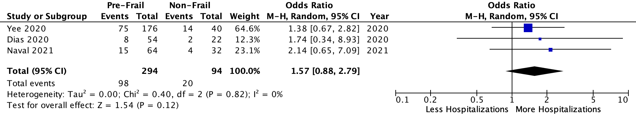

Mortality
Two studies compared mortality between pre-frail and non-frail participants. Both examined mortality over 2 years. When combined in metanalysis, no statistically significant difference in mortality [HR (95% CI): 1.06 (0.78-1.45); I²=0] between pre-frail and non-frail participants was identified.
