Appendix 1 Search Strategies
Appendix 2 Meta-analysis of the pooled effect of patient survival in patients who were transplanted for SSC vs. non-CTD
Appendix 3 Meta-analysis of the pooled effect of patient survival in patients who were transplanted for CTD vs. IPF
Appendix 4 Meta-analysis of the incidence of rejection in patients who post-transplant for CTD vs non-CTD
Appendix 5 Sensitivity analysis for the ICU LOS, hospital LOS, and extubation time in patients who post-transplant for CTD vs. non-CTD
Appendix 6 Funnel plot for the post-survival in patients who post-transplant for CTD vs. non-CTD

Appendix 1 Search Strategies
Pumbed:
#1 ("Connective Tissue Diseases"[Mesh]) OR ((Disease, Connective Tissue[Title/Abstract]) OR (Diseases, Connective Tissue[Title/Abstract]) OR (Connective Tissue Diseases[Title/Abstract]))
#2 ("Lupus Erythematosus, Systemic"[Mesh]) OR ((Lupus Erythematosus Disseminatus[Title/Abstract]) OR (Libman-Sacks Disease[Title/Abstract]) OR (Disease, Libman-Sacks[Title/Abstract]) OR (Libman Sacks Disease[Title/Abstract]) OR (Lupus Erythematosus, Systemic[Title/Abstract]))
#3 ("Mixed Connective Tissue Disease"[Mesh]) OR ((Sharp Syndrome[Title/Abstract]) OR (Syndrome, Sharp[Title/Abstract]) OR (MCTD[Title/Abstract]) OR (Mixed Connective Tissue Disease[Title/Abstract]))
#4 ("Scleroderma, Systemic"[Mesh]) OR ((Sclerosis, Systemic[Title/Abstract]) OR (Systemic Scleroderma[Title/Abstract]) OR (Scleroderma, Systemic[Title/Abstract]))
#5 ("Arthritis, Rheumatoid"[Mesh]) OR (Rheumatoid rthritis[Title/Abstract])
#6 ("Sjogren's Syndrome"[Mesh]) OR ((Syndrome, Sjogren's[Title/Abstract]) OR (Sjogren Syndrome[Title/Abstract]) OR (Sicca Syndrome[Title/Abstract]) OR (Syndrome, Sicca[Title/Abstract]) OR (Sjogren's Syndrome[Title/Abstract]))
#7 ("Polymyositis"[Mesh]) OR ((Myositis, Multiple[Title/Abstract]) OR (Multiple Myositis[Title/Abstract]) OR (Myositides, Multiple[Title/Abstract]) OR (Polymyositis, Idiopathic[Title/Abstract]) OR (Idiopathic Polymyositides[Title/Abstract]) OR (Idiopathic Polymyositis[Title/Abstract]) OR (Polymyositides, Idiopathic[Title/Abstract]) OR (Polymyositis Ossificans[Title/Abstract]) OR (Ossificans, Polymyositis[Title/Abstract]) OR (Polymyositis[Title/Abstract]))
#8 ("Dermatomyositis"[Mesh]) OR ((Polymyositis-Dermatomyositis[Title/Abstract]) OR (Polymyositis Dermatomyositis[Title/Abstract]) OR (Dermatomyositis[Title/Abstract]))
#9 #1 or #2 or #3 or #4 or #5 or #6 or #7 or #8
#10 ("Lung Transplantation"[Mesh]) OR ((Grafting, Lung[Title/Abstract]) OR (Graftings, Lung[Title/Abstract]) OR (Lung Grafting[Title/Abstract]) OR (Lung Graftings[Title/Abstract]) OR (Transplantation, Lung[Title/Abstract]) OR (Lung Transplantations[Title/Abstract]) OR (Transplantations, Lung[Title/Abstract]))
#11 #9 and #10

Embase:
#1 'connective tissue disease'/exp OR 'connective tissue disease'
#2 'disease, connective tissue':ab,kw,ti OR 'diseases, connective tissue':ab,kw,ti OR 'connective tissue diseases':ab,kw,ti
#3 'systemic lupus erythematosus'/exp OR 'systemic lupus erythematosus'
#4 'lupus erythematosus disseminatus':ab,kw,ti OR 'libman-sacks disease':ab,kw,ti OR 'disease, libman-sacks':ab,kw,ti OR 'libman sacks disease':ab,kw,ti OR 'lupus erythematosus, systemic':ab,kw,ti
#5 'mixed connective tissue disease'/exp OR 'mixed connective tissue disease'
#6 'mixed connective tissue disease'/exp OR 'mixed connective tissue disease'
#7 'systemic sclerosis'/exp OR 'systemic sclerosis'
#8 'sclerosis, systemic':ab,kw,ti OR 'systemic scleroderma':ab,kw,ti OR 'scleroderma, systemic':ab,kw,ti
#9 'rheumatoid arthritis'/exp OR 'rheumatoid arthritis'
#10 'arthritis, rheumatoid':ab,kw,ti
#11 'sjoegren syndrome'/exp OR 'sjoegren syndrome'
#12 'syndrome, sjogren':ab,kw,ti OR 'sicca syndrome':ab,kw,ti OR 'syndrome, sicca':ab,kw,ti OR 'sjogren syndrome':ab,kw,ti
#13 'polymyositis'/exp OR 'polymyositis'
#14 'myositis, multiple':ab,kw,ti OR 'multiple myositis':ab,kw,ti OR 'myositides, multiple':ab,kw,ti OR 'polymyositis, idiopathic':ab,kw,ti OR 'idiopathic polymyositides':ab,kw,ti OR 'idiopathic polymyositis':ab,kw,ti OR 'polymyositides, idiopathic':ab,kw,ti OR 'polymyositis ossificans':ab,kw,ti OR 'ossificans, polymyositis':ab,kw,ti OR 'polymyositis':ab,kw,ti
#15 'dermatomyositis'/exp OR 'dermatomyositis'
#16 'polymyositis-dermatomyositis':ab,kw,ti OR 'polymyositis dermatomyositis':ab,kw,ti OR 'dermatomyositis':ab,kw,ti
#17 #1 OR #2 OR #3 OR #4 OR #5 OR #6 OR #7 OR #8 OR #9 OR #10 OR #11 OR #12 OR #13 OR #14 OR #15 OR #16
#18 'lung transplantation'/exp OR 'lung transplantation'
#19 'grafting, lung':ab,kw,ti OR 'graftings, lung':ab,kw,ti OR 'lung grafting':ab,kw,ti OR 'lung graftings':ab,kw,ti OR 'transplantation, lung':ab,kw,ti OR 'lung transplantations':ab,kw,ti OR 'transplantations, lung':ab,kw,ti
#20 #18 OR #19
#21 #17 AND #20

Web Of Science:
TS=(Connective Tissue Diseases OR Disease, Connective Tissue OR Diseases, Connective Tissue OR Connective Tissue Diseases OR Lupus Erythematosus, Systemic OR Lupus Erythematosus Disseminatus OR Libman-Sacks Disease OR Disease, Libman-Sacks OR Libman Sacks Disease OR Lupus Erythematosus, Systemic OR Mixed Connective Tissue Disease OR Sharp Syndrome OR Syndrome, Sharp OR MCTD OR Mixed Connective Tissue Disease OR Scleroderma, Systemic OR Sclerosis, Systemic OR Systemic Scleroderma OR Scleroderma, Systemic OR Arthritis, Rheumatoid OR Rheumatoid Arthritis OR Sjogren's Syndrome OR Syndrome, Sjogren's OR Sjogren Syndrome OR Sicca Syndrome OR Syndrome, Sicca OR Sjogren's Syndrome OR Polymyositis OR Myositis, Multiple OR Multiple Myositis OR Myositides, Multiple OR Polymyositis, Idiopathic OR Idiopathic Polymyositides OR Idiopathic Polymyositis OR Polymyositides, Idiopathic OR Polymyositis Ossificans OR Ossificans, Polymyositis OR Polymyositis OR Dermatomyositis OR Polymyositis-Dermatomyositis OR Polymyositis Dermatomyositis OR Dermatomyositis) AND TS=(Lung Transplantation) or (Grafting, Lung) or (Graftings, Lung) or (Lung Grafting) or (Lung Graftings) or (Transplantation, Lung) or (Lung Transplantations) or (Transplantations, Lung)

Cochrane:
#1 MeSH descriptor: [Connective Tissue Diseases] explode all trees
#2 ((Disease, Connective Tissue) OR (Diseases, Connective Tissue) OR (Connective Tissue Diseases)):ti,ab,kw
#3 MeSH descriptor: [Lupus Erythematosus, Systemic] explode all trees
#4 ((Lupus Erythematosus Disseminatus) OR (Libman-Sacks Disease) OR (Disease, Libman-Sacks) OR (Libman Sacks Disease) OR (Lupus Erythematosus, Systemic)):ti,ab,kw
#5 MeSH descriptor: [Mixed Connective Tissue Disease] explode all trees
#6 ((Sharp Syndrome) OR (Syndrome, Sharp) OR (MCTD) OR (Mixed Connective Tissue Disease)):ti,ab,kw
#7 MeSH descriptor: [Scleroderma, Systemic] explode all trees
#8 ((Sclerosis, Systemic) OR (Systemic Scleroderma) OR (Scleroderma, Systemic)):ti,ab,kw
#9 MeSH descriptor: [Arthritis, Rheumatoid] explode all trees
#10 ((Rheumatoid rthritis)):ti,ab,kw
#11 MeSH descriptor: [Sjogren's Syndrome] explode all trees
#12 ((Syndrome, Sjogren's) OR (Sjogren Syndrome) OR (Sicca Syndrome) OR (Syndrome, Sicca) OR (Sjogren's Syndrome)):ti,ab,kw
#13 MeSH descriptor: [Polymyositis] explode all trees
#14 ((Myositis, Multiple) OR (Multiple Myositis) OR (Myositides, Multiple) OR (Polymyositis, Idiopathic) OR (Idiopathic Polymyositides) OR (Idiopathic Polymyositis) OR (Polymyositides, Idiopathic) OR (Polymyositis Ossificans) OR (Ossificans, Polymyositis) OR (Polymyositis)):ti,ab,kw
#15 MeSH descriptor: [Dermatomyositis] explode all trees
#16 ((Polymyositis-Dermatomyositis) OR (Polymyositis Dermatomyositis) OR (Dermatomyositis)):ti,ab,kw
#17 #1 or #2 or #3 or #4 or #5 or #6 or #7 or #8 or #9 or #10 or #11 or #12 or #13 or #14 or #15 or #16
#18 MeSH descriptor: [Lung Transplantation] explode all trees
#19 ((Grafting, Lung) OR (Graftings, Lung) OR (Lung Grafting) OR (Lung Graftings) OR (Transplantation, Lung) OR (Lung Transplantations) OR (Transplantations, Lung)):ti,ab,kw
#20 #18 or #19
#21 #17 and #20

CNKI/VIP/Wanfang/CBM: 结缔组织疾病 + 硬皮病, 系统性 + 关节炎, 类风湿 + 皮肌炎 + 多发性肌炎 + 干燥综合征 + 系统性红斑狼疮 + 混合性结缔组织病And肺移植 + 肺移植术（主题）

Appendix 2 Meta-analysis of the pooled effect of patient survival in patients who were transplanted for SSC vs. non-CTD
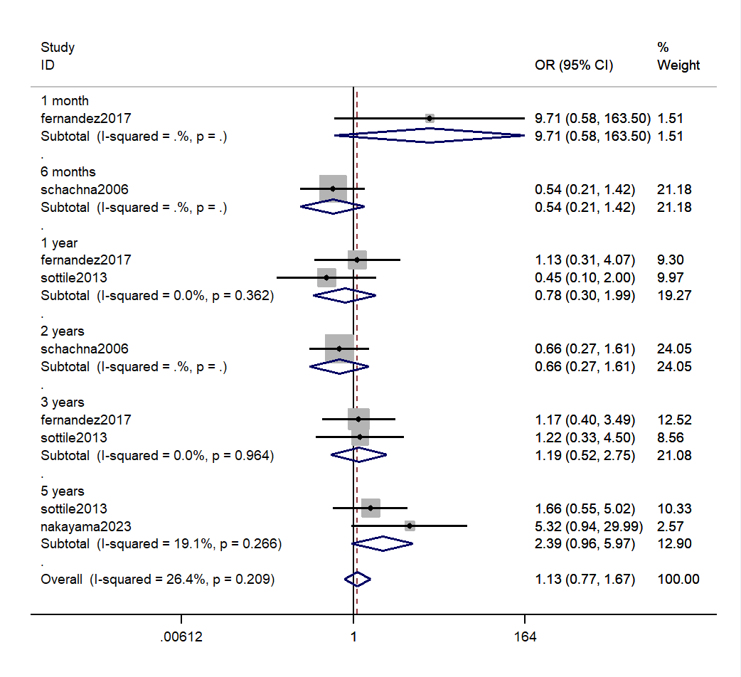
Appendix 3 Meta-analysis of the pooled effect of patient survival in patients who were transplanted for CTD vs. IPF
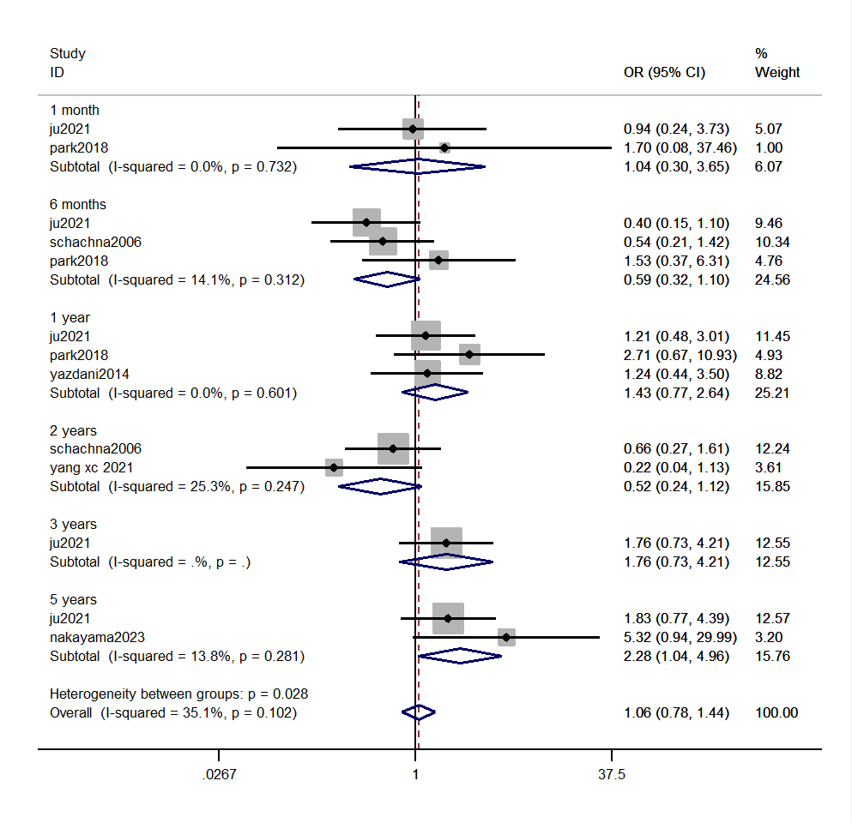
Appendix 4 Meta-analysis of the incidence of rejection in patients who post-transplant for CTD vs non-CTD
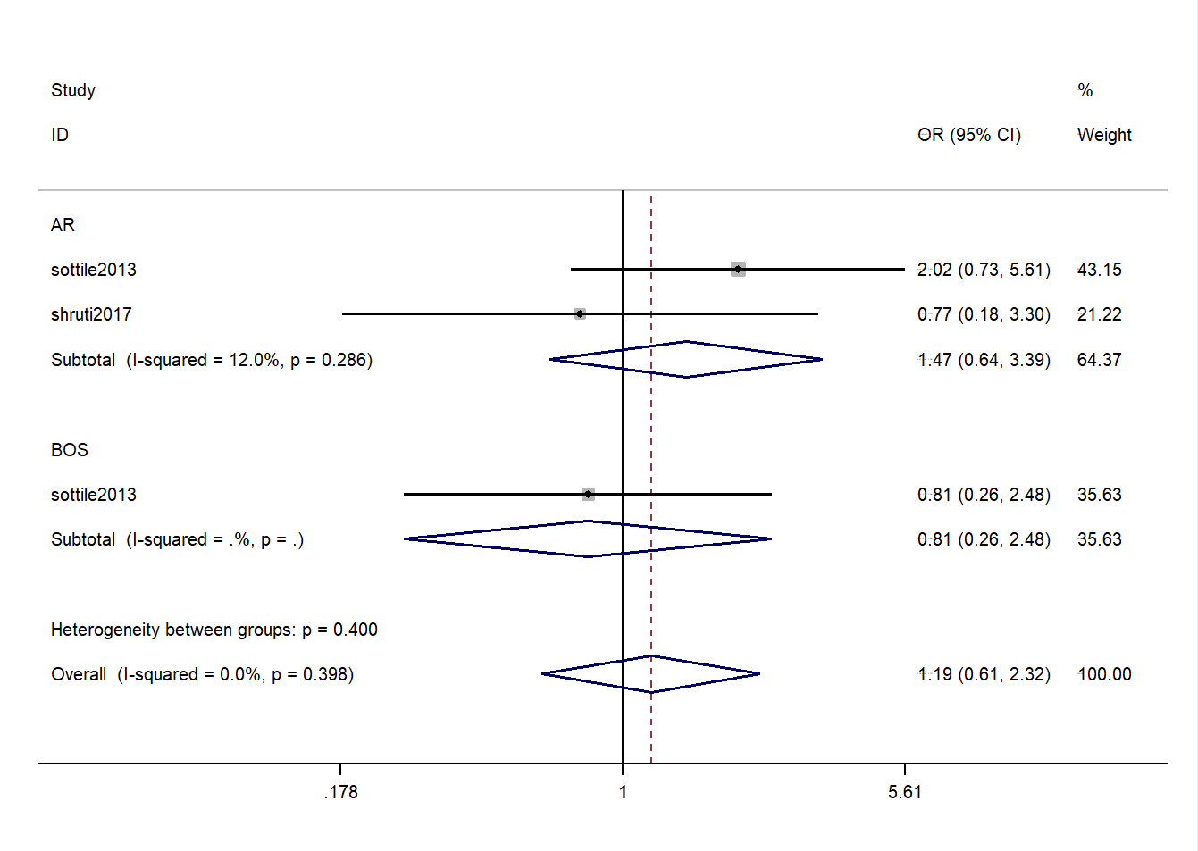
Appendix 5 Sensitivity analysis for the ICU LOS, hospital LOS, and extubation time in patients who post-transplant for CTD vs. non-CTD
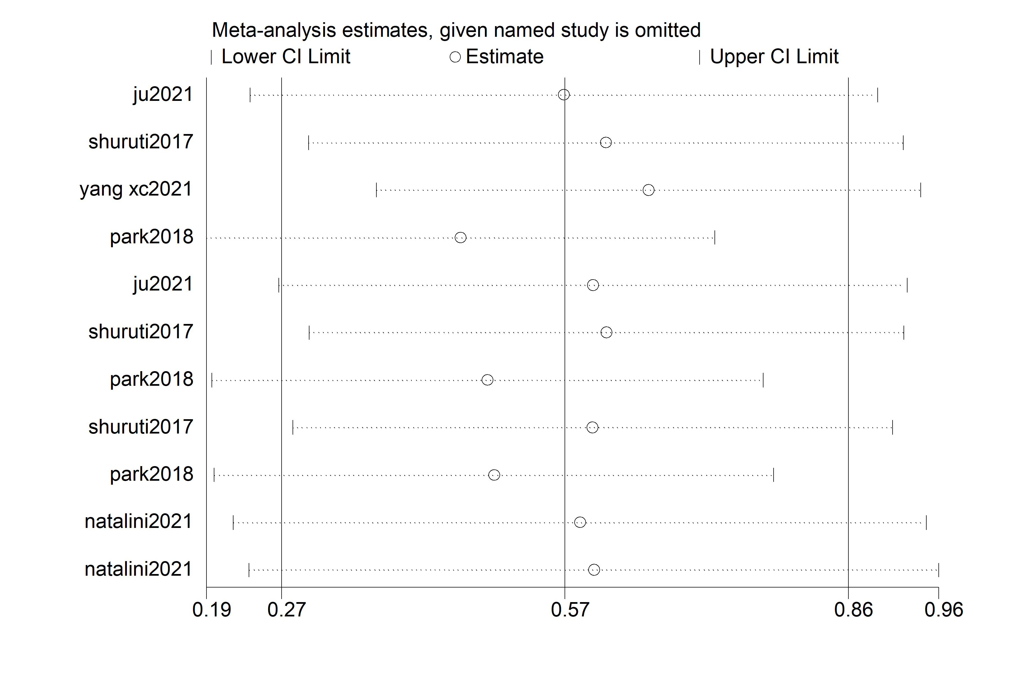
Appendix 6 Funnel plot for the post-survival in patients who post-transplant for CTD vs. non-CTD
