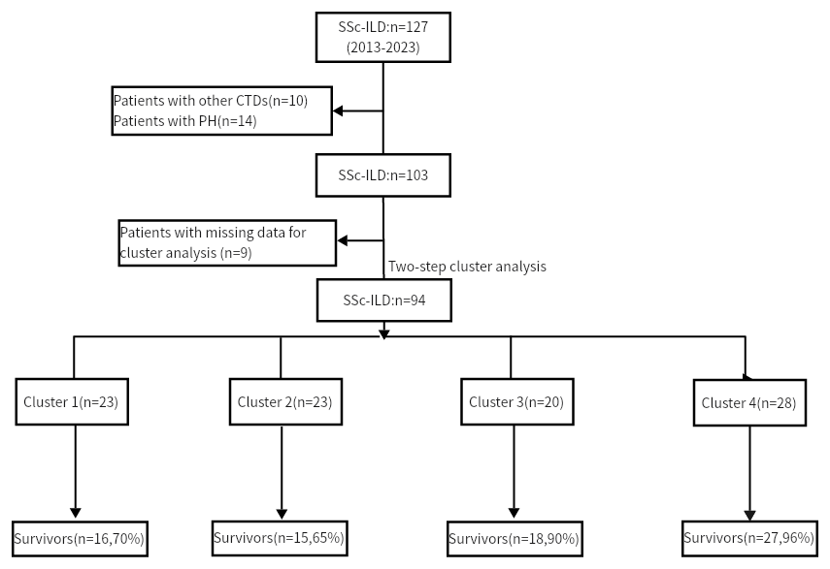
Supplementary material 1: Selection of research subjects.
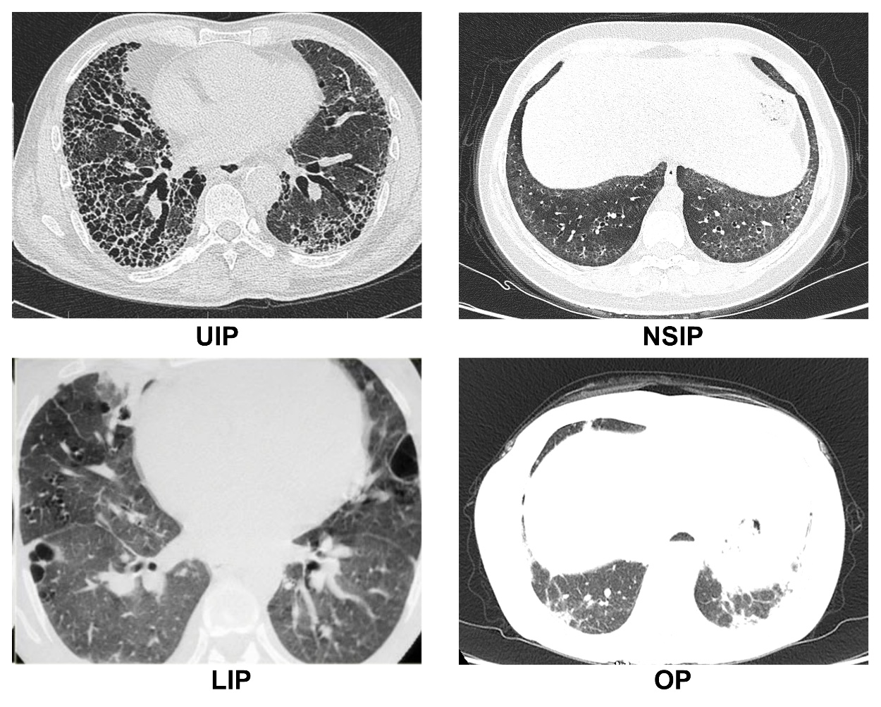 Supplementary material 2: Representative HRCT images of UIP, NSIP, OP, and LIP
Supplementary material 3: Clinical prediction model and ROC analysis of severe ILD
Variable | Single factor logistic analysis |  |  | Multi-factor logistic analysis
Variable | OR | 95%CI | p |  | OR | 95%CI | p
Smoke | 0.216 | 0.053-0.881 | 0.033* |  | 2.830 | 0.216-37.10 | 0.428
Gender | 0.243 | 0.080-0.740 | 0.013* |  | 0.122 | 0.016-0.944 | 0.044*
Disease duration | 1.010 | 1.004-1.017 | 0.002* |  | 1.016 | 1.006-1.026 | 0.001*
Joint contractures | 0.383 | 0.148-0.992 | 0.048* |  | 0.415 | 0.119-1.448 | 0.168
Basophil percentage | 0.046 | 0.003-0.613 | 0.020* |  | 0.021 | 0.001-0.839 | 0.040*
RBC | 0.381 | 0.133-1.095 | 0.073 |  | 0.206 | 0.052-0.809 | 0.024*
RBC: red blood cell *P < 0.05 ***P < 0.001
Variable | AUC | p | Optimal thresholds | Sensitivities% | Specificity%
Gender | 0.613 | 0.091 | - | - | -
Disease duration | 0.723 | 0.001* | 102month | 48.0% | 86.7%
Basophil percentage | 0.354 | 0.029* | 0.15% | 48.0% | 30.7%
RBC | 0.382 | 0.078 | - | - | -
RBC: red blood cell *P < 0.05 ***P < 0.001
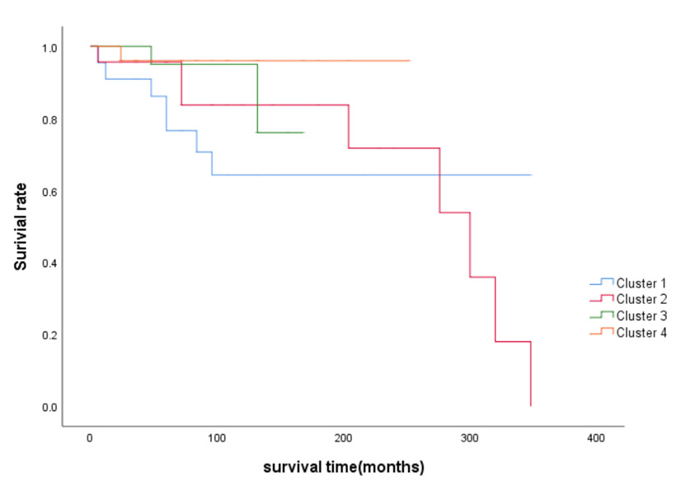
Supplementary material 4: Survival analysis curves for four clustering groups
The graphs show the survival curves of the four clustering groups of Cluster 1-4 with survival time (months) as the horizontal axis and survival rate as the vertical axis. The trend and position of the curves visualise the survival status of patients in each cluster group at different time points. At the beginning of the survival time, the four curves may be close to each other, but the differences gradually appear as time passes. The higher the position of the curve, the higher the survival rate of the cluster group at the corresponding time point; the faster the curve falls, means the faster the mortality rate of the patients in the cluster group increases. By observing the curves, the difference in prognosis between the clusters can be clearly seen: Cluster 2 curve is the fastest declining, with a significant decrease in survival rate in a short period of time, indicating that the prognosis of the patients in this group is the worst; while the Cluster 4 curve is relatively flat and in a higher position, implying that the survival rate of the patients in this group is high and the prognosis is better. This is consistent with the results of the characterisation of each cluster group in the main study.

Supplementary material 5: Cox analysis of SSc-ILD patients
Variable | Single factor cox analysis |  |  | Multi-factor cox analysis
Variable | HR | 95%CI | p |  | HR | 95%CI | p
Age | 1.045 | 0.999-1.092 | 0.053 |  | 1.169 | 1.010-1.352 | 0.036*
ALB | 0.885 | 0.797-0.982 | 0.022* |  | 0.219 | 0.062-0.770 | 0.018*
CRP | 1.014 | 1.001-1.028 | 0.036* |  | 0.890 | 0.792-1.000 | 0.050
Lymphocyte percentage | 0.936 | 0.882-0.993 | 0.028* |  | 1.249 | 0.345-11.593 | 0.448
Absolute neutrophil value | 1.227 | 1.063-1.416 | 0.005* |  | 2.001 | 0.703-2.217 | 0.439
IgM | 0.405 | 0.177-0.928 | 0.033* |  | 1.077 | 1.007-1.893 | 0.040*
RAR | 277.492 | 4.554-16910 | 0.007* |  | 0.000 | 0.000-0.089 | 0.080
PNI | 0.930 | 0.858-1.008 | 0.077 |  | 1.060 | 0.434-2.587 | 0.899
ALB: albumin, CRP: c-reactive protein, IgM: immunoglobulin M, RAR: red cell distribution width to albumin ratio, PNI: prognostic nutritional index, *P < 0.05 ***P < 0.001

