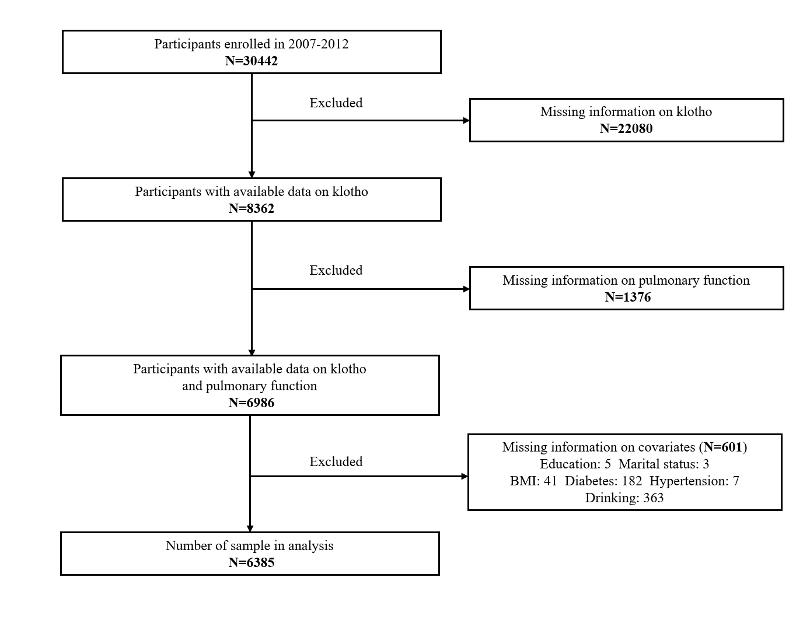
Figure S1. Flow chart of the study design.
Table S1. Baseline characteristics of NHANES participants and weighted mean (SD of klotho, pulmonary function parameters (N=6385)
Characteristics | N | % | klotho  (pg/mL) | FEV1  (mL) | FVC  (mL) | PEF  (mL/s) | FEF25-75%  (mL/s)
Age (years)
40-59 | 3551 | 55.6% | 869.70  (306.03) | 3127.34  (791.51) | 4088.99  (1012.80) | 8291.74  (2133.44) | 2819.06  (1112.51)
60-79 | 2834 | 44.4% | 828.16  (277.29) | 2494.98  (739.02) | 3448.07  (1016.54) | 7106.81  (2174.96) | 1882.25  (904.20)
p |  |  | *** | *** | *** | *** | ***
Gender
Male | 3183 | 49.9% | 837.88  (276.73) | 3419.42  (760.57) | 4591.09  (902.23) | 9248.45  (2052.18) | 2844.17  (1232.15)
Female | 3202 | 50.1% | 872.31  (314.44) | 2436.00  (568.97) | 3194.26  (680.01) | 6610.80  (1491.91) | 2178.67  (929.39)
p |  |  | *** | *** | *** | *** | ***
Ethnicity
Mexican American | 959 | 15.0% | 854.93  (293.60) | 2924.23  (719.43) | 3712.06  (935.86) | 7829.82  (2180.43) | 2915.63  (1071.20)
Other Hispanic | 699 | 10.9% | 876.43  (287.10) | 2844.22  (807.43) | 3613.48  (1001.70) | 7698.32  (2284.02) | 2815.96  (1152.01)
Non-Hispanic White | 3026 | 47.4% | 847.69  (285.54) | 2979.88  (840.72) | 3998.37  (1058.51) | 8006.15  (2215.65) | 2471.37  (1144.15)
Non-Hispanic Black | 1301 | 20.4% | 923.98  (385.61) | 2518.81  (716.91) | 3259.98  (906.68) | 7259.09  (2155.99) | 2404.82  (1101.62)
Other Race | 400 | 6.3% | 835.16  (284.67) | 2649.44  (738.82) | 3456.18  (933.41) | 7494.26  (2135.31) | 2371.17  (990.19)
p |  |  | *** | *** | *** | *** | ***
Education
9-11th grade and below | 1787 | 28.0% | 843.24  (293.21) | 2663.25  (798.39) | 3555.35  (1009.32) | 7135.59  (2208.22) | 2319.20  (1136.32)
High school graduate | 1451 | 22.7% | 841.26  (286.87) | 2868.60  (861.63) | 3830.69  (1070.11) | 7740.16  (2276.41) | 2464.62  (1219.49)
Some college or associates degree | 1723 | 27.0% | 855.53  (309.02) | 2905.74  (814.18) | 3863.26  (1050.61) | 7905.20  (2144.81) | 2503.25  (1132.59)
College graduate or above | 1424 | 22.3% | 873.39  (294.96) | 3091.41  (796.66) | 4085.69  (1035.62) | 8406.09  (2116.54) | 2628.28  (1058.15)
p |  |  | >0.05 | *** | *** | *** | ***
Marital Status
Never married | 497 | 7.8% | 886.79  (349.63) | 3028.51  (870.90) | 3977.88  (1099.66) | 8074.92  (3317.16) | 2721.34  (1173.16)
Married | 3862 | 60.5% | 851.95  (285.23) | 2977.61  (813.17) | 3951.57  (1043.73) | 8104.16  (2186.88) | 2552.53  (1129.42)
Other | 2026 | 31.7% | 856.35  (310.22) | 2725.99  (830.36) | 3650.34  (1051.49) | 7322.71  (2173.08) | 2320.08  (1121.81)
p |  |  | >0.05 | *** | *** | *** | ***
BMI (kg/m²)
Underweight | 55 | 0.9% | 881.01  (312.68) | 2498.80  (676.83) | 3379.60  (665.26) | 6327.65  (1854.53) | 2048.17  (1005.55)
Normal weight | 1435 | 22.5% | 870.52  (320.89) | 2850.77  (793.31) | 3887.61  (1014.89) | 7518.47  (2080.19) | 2262.95  (1041.01)
Overweight | 2304 | 36.1% | 850.88  (304.23) | 3042.77  (828.27) | 4048.25  (1060.60) | 8234.99  (2235.36) | 2579.58  (1123.39)
Obesity | 2591 | 40.6% | 850.21  (273.69) | 2838.05  (840.59) | 3705.53  (1061.28) | 7830.88  (2239.63) | 2586.59  (1185.16)
p |  |  | >0.05 | *** | *** | *** | ***
Current smoking
Yes | 1292 | 20.2% | 834.42  (307.12) | 2865.62  (852.93) | 3993.49  (1068.14) | 7454.08  (2234.81) | 2189.17  (1143.60)
No | 5093 | 79.8% | 899.96  (325.83) | 2525.18  (727.48) | 3291.73  (907.12) | 6920.06  (2014.15) | 2329.20  (1063.75)
p |  |  | >0.05 | *** | *** | *** | ***
Drinking
Yes | 4650 | 72.8% | 843.57  (287.82) | 3018.19  (824.81) | 4029.13  (1041.64) | 8153.29  (2199.60) | 2548.16  (1151.19)
No | 1735 | 27.2% | 899.96  (325.83) | 2525.18  (727.48) | 3291.73  (907.12) | 6920.06  (2014.15) | 2329.20  (1063.75)
p |  |  | *** | *** | *** | *** | ***
Diabetes
Yes | 1023 | 16.0% | 848.01  (300.54) | 2547.84  (808.53) | 3378.04  (1028.28) | 7169.19  (2273.99) | 2273.65  (1169.38)
No | 5362 | 84.0% | 856.62  (296.79) | 2961.25  (820.70) | 3937.02  (1045.08) | 7985.37  (2194.68) | 2531.56  (1128.79)
p |  |  | >0.05 | *** | *** | *** | ***
Hypertension
Yes | 2810 | 44.0% | 850.40  (296.75) | 2732.69  (841.64) | 3659.90  (1071.53) | 7557.93  (2267.14) | 2308.02  (1135.27)
No | 3575 | 56.0% | 858.96  (297.52) | 3028.60  (801.35) | 4007.59  (1027.29) | 8103.07  (2161.97) | 2625.53  (1120.08)
p |  |  | >0.05 | *** | *** | *** | ***
Wheeze
Yes | 1252 | 19.6% | 851.04  (287.58) | 2619.60  (866.76) | 3661.21  (1101.86) | 7057.05  (2268.41) | 2037.07  (1096.69)
No | 5133 | 80.4% | 856.34  (298.83) | 2959.50  (814.48) | 3905.28  (1047.56) | 8021.88  (2182.94) | 2575.10  (1125.68)
p |  |  | >0.05 | *** | *** | *** | ***
Asthma
Yes | 1100 | 17.2% | 855.83  (321.17) | 2626.03  (820.19) | 3627.82  (1048.73) | 7149.53  (2176.26) | 2084.49  (1099.45)
No | 5285 | 82.8% | 855.66  (293.51) | 2955.98  (823.20) | 3907.92  (1055.58) | 8001.03  (3205.12) | 2564.60  (1129.06)
p |  |  | >0.05 | *** | *** | *** | ***
COPD
Yes | 1236 | 19.4% | 828.14  (282.44) | 2509.12  (807.85) | 3939.14  (1139.60) | 6761.01  (2213.44) | 1249.73  (574.91)
No | 5149 | 80.6% | 862.75  (300.57) | 3017.80  (803.10) | 3854.14  (1035.70) | 8183.19  (2125.35) | 2826.52  (1014.31)
p |  |  | *** | *** | 0.141 | *** | ***
BMI: body mass index; COPD: chronic obstructive pulmonary disease. ***: p＜0.001.

Table S2. Association between log 2-transformed klotho and log 2-transformed pulmonary function parameters
 | Crude model |  | Adjusted model 1 |  | Adjusted model 2
 | β (95%CI) | P | β (95%CI) | P | β (95%CI) | P
FEV1(ml) | 0.036 (0.004, 0.067) | 0.026 | 0.033 (0.012, 0.055) | 0.002 | ª 0.029 (0.010, 0.048) | 0.003
FVC (ml) | 0.008 (-0.022, 0.040) | 0.565 | 0.018 (0.001, 0.035) | 0.036 | 0.021 (0.004, 0.038) | 0.015
PEF (ml/s) | 0.031 (0.002, 0.061) | 0.036 | 0.032 (0.010, 0.055) | 0.005 | 0.029 (0.008, 0.049) | 0.007
FEF25-75% (ml/s) | 0.113 (0.054, 0.172) | <0.001 | 0.071 (0.018, 0.123) | 0.010 | 0.042 (0.004, 0.081) | 0.032
Adjusted model1：age, gender, ethnicity, education, marital status.
Adjusted model2：age, gender, ethnicity, education, marital status, BMI, current smoking, drinking, diabetes, hypertension, wheeze, asthma, COPD (chronic obstructive pulmonary disease).
a: For every 2-fold increase in klotho concentration,
FEV1 increase: (exp (0.029×ln (2))-1≈2.0%. FVC increase: (exp (0.021×ln (2))-1≈1.5%.
PEF increase: (exp (0.029×ln (2))-1≈2.0%. FEF25-75% increase: (exp (0.042×ln (2))-1≈2.9%.

Table S3. Subgroup analysis for the association between log 2-transformed klotho and log 2-transformed pulmonary function parameters by gender and age group
 | Male |  | Female |  | 40-59 years old |  | >60 years old
 | Adjusted β (95%CI) | P | Adjusted β (95%CI) | P | Adjusted β (95%CI) | P | Adjusted β (95%CI) | P
FEV1 (ml) | ª 0.026 (0.001, 0.051) | 0.042 | 0.022 (-0.014, 0.059) | 0.231 | 0.023 (-0.005, 0.053) | 0.119 | ^{b} 0.054 (0.025, 0.083) | <0.001
FVC (ml) | 0.015 (-0.013, 0.042) | 0.284 | 0.013 (-0.001, 0.053) | 0.054 | 0.014 (-0.009, 0.517) | 0.227 | 0.048 (0.020, 0.077) | 0.001
PEF (ml/s) | 0.035 (0.006, 0.064) | 0.020 | 0.012 (-0.021, 0.046) | 0.451 | 0.027 (-0.007, 0.062) | 0.119 | 0.041 (0.000, 0.082) | 0.050
FEF25-75% (ml/s) | 0.017 (0.013, 0.086) | 0.009 | 0.036 (-0.024, 0.096) | 0.230 | 0.037 (-0.021, 0.095) | 0.205 | 0.073 (0.020, 0.125) | 0.008
Model adjusted for age, gender, ethnicity, education, marital status, BMI, current smoking, drinking, diabetes, hypertension, wheeze, asthma, COPD (chronic obstructive pulmonary disease).
a: For every 2-fold increase in klotho concentration,
FEV1 increase: (exp (0.026×ln (2))-1≈1.8%. PEF increase: (exp (0.035×ln (2))-1≈2.4%. FEF25-75% increase: (exp (0.017×ln (2))-1≈1.2%.
b: For every 2-fold increase in klotho concentration,
FEV1 increase: (exp (0.054×ln (2))-1≈3.8%. FVC increase: (exp (0.048×ln (2))-1≈3.4%. FEF25-75% increase: (exp (0.073×ln (2))-1≈5.2%.

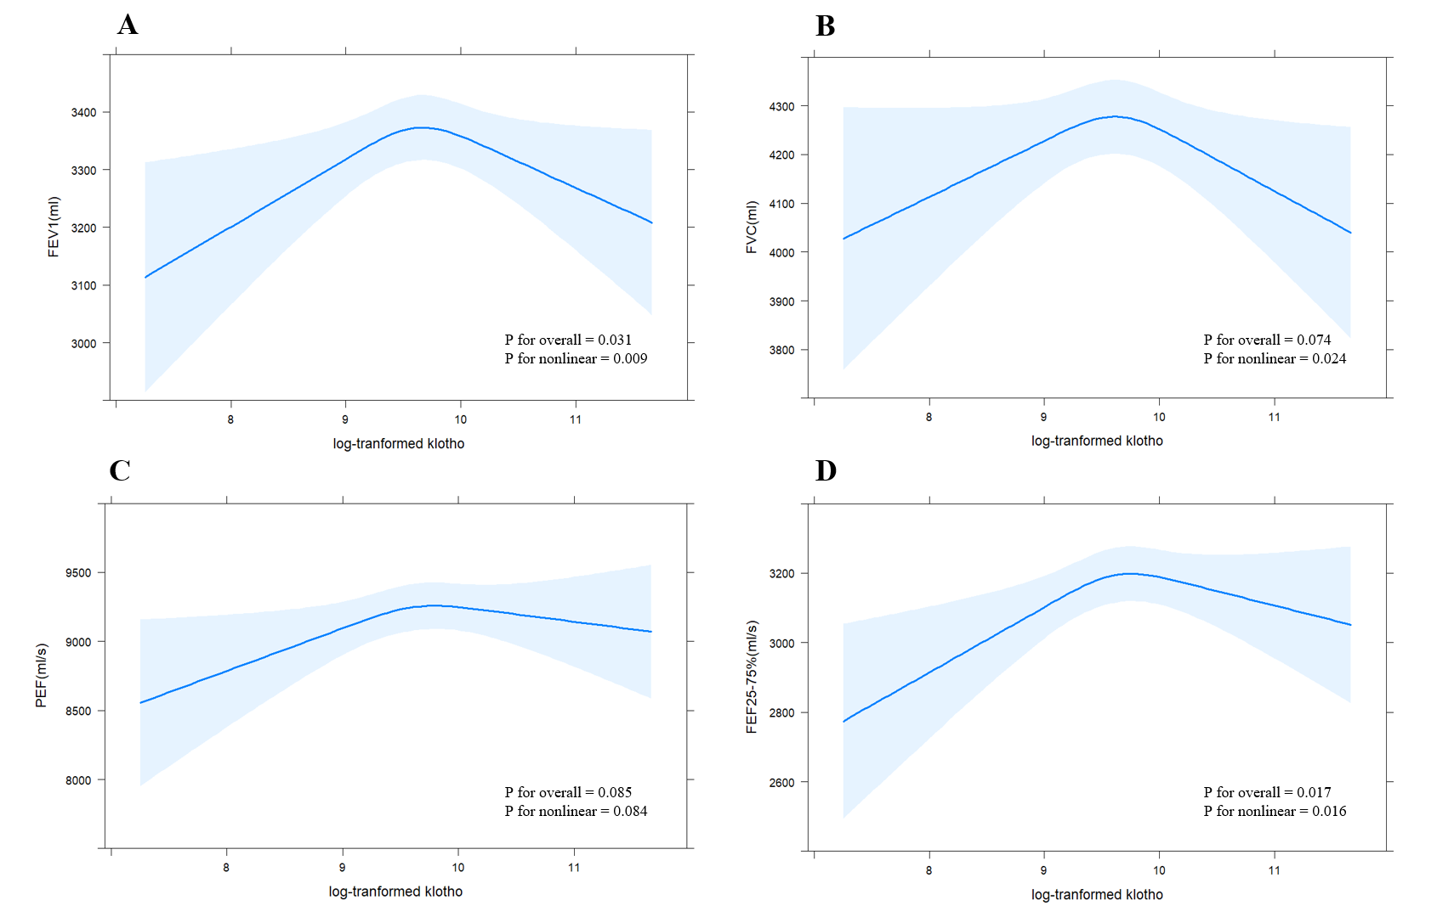
Figure S2. Restricted cubic spline of log transformed klotho and pulmonary function parameters among males adjusted for: age, gender, ethnicity, education, marital status, BMI (body mass index), current smoking, drinking, diabetes, hypertension, wheeze, asthma, COPD (chronic obstructive pulmonary disease).
(A): FEV1, (B): FVC, (C): PEF, (D): FEF25-75%.

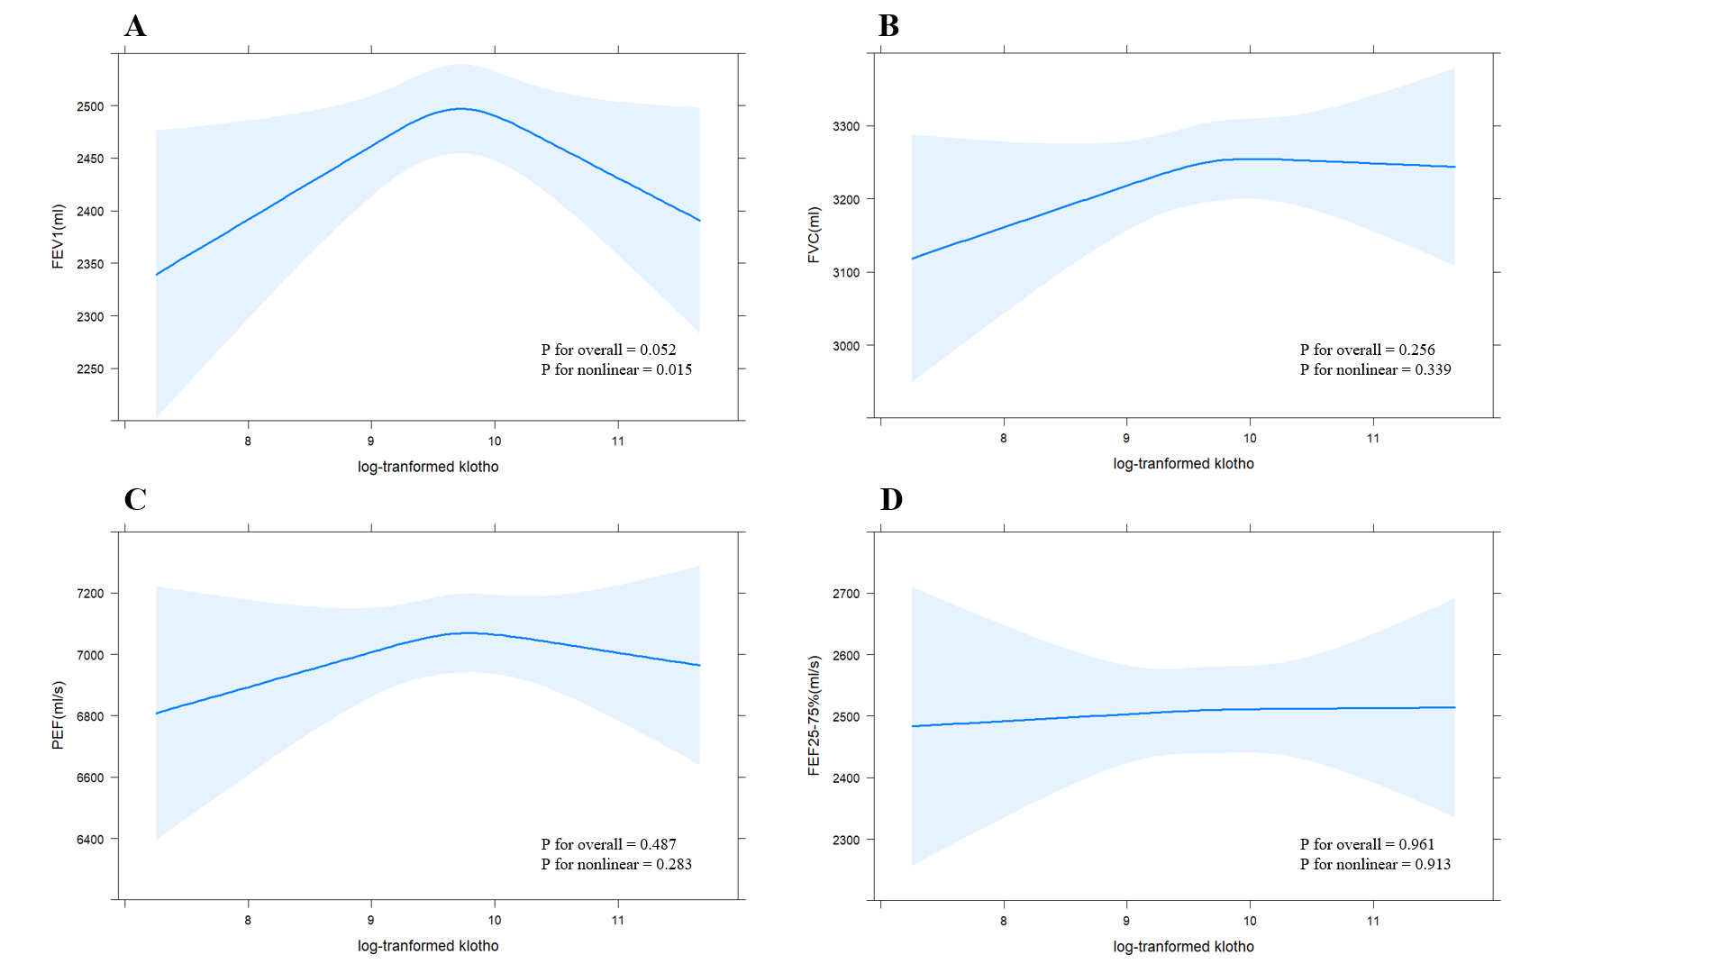
Figure S3. Restricted cubic spline of log transformed klotho and pulmonary function parameters among females adjusted for: age, gender, ethnicity, education, marital status, BMI (body mass index), current smoking, drinking, diabetes, hypertension, wheeze, asthma, COPD (chronic obstructive pulmonary disease).
(A): FEV1, (B): FVC, (C): PEF, (D): FEF25-75%.

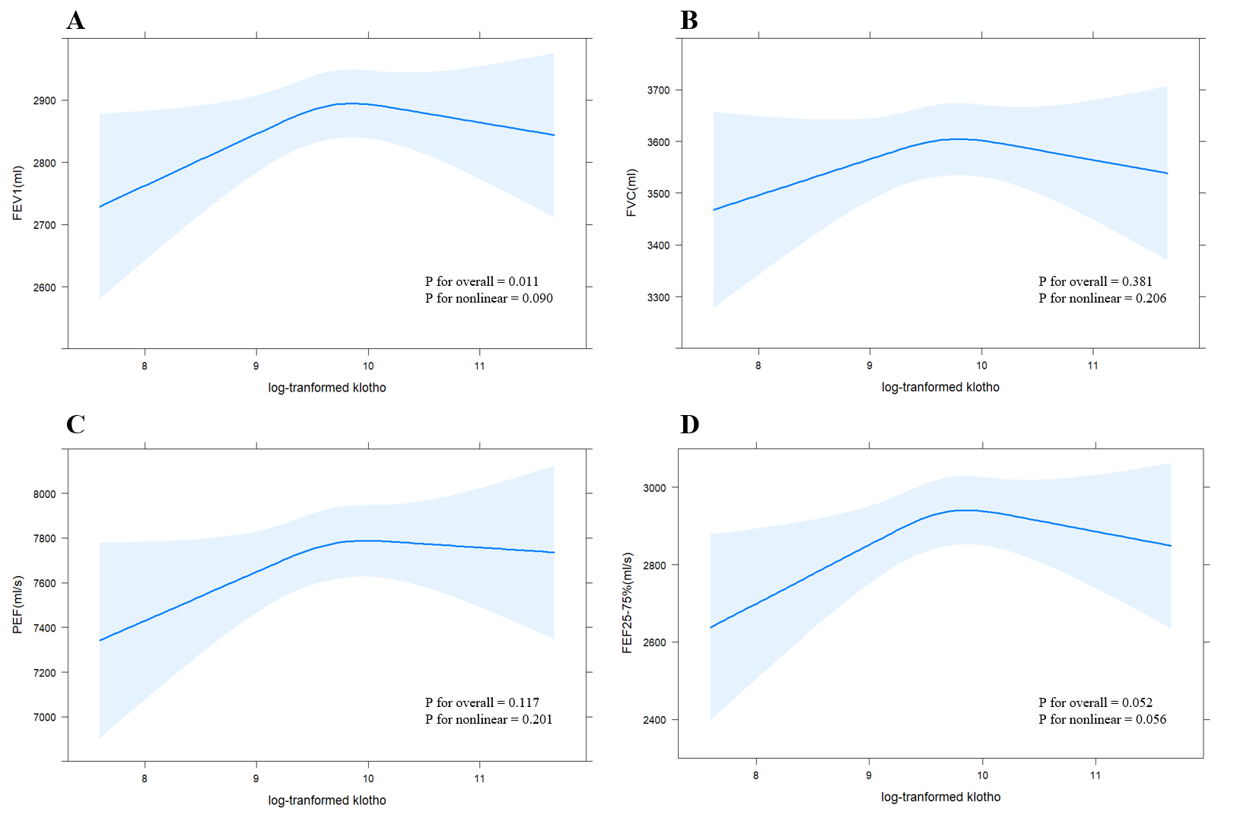
Figure S4. Restricted cubic spline of log transformed klotho and pulmonary function parameters among 40-59-year-old participants adjusted for: age, gender, ethnicity, education, marital status, BMI (body mass index), current smoking, drinking, diabetes, hypertension, wheeze, asthma, COPD (chronic obstructive pulmonary disease).
(A): FEV1, (B): FVC, (C): PEF, (D): FEF25-75%.

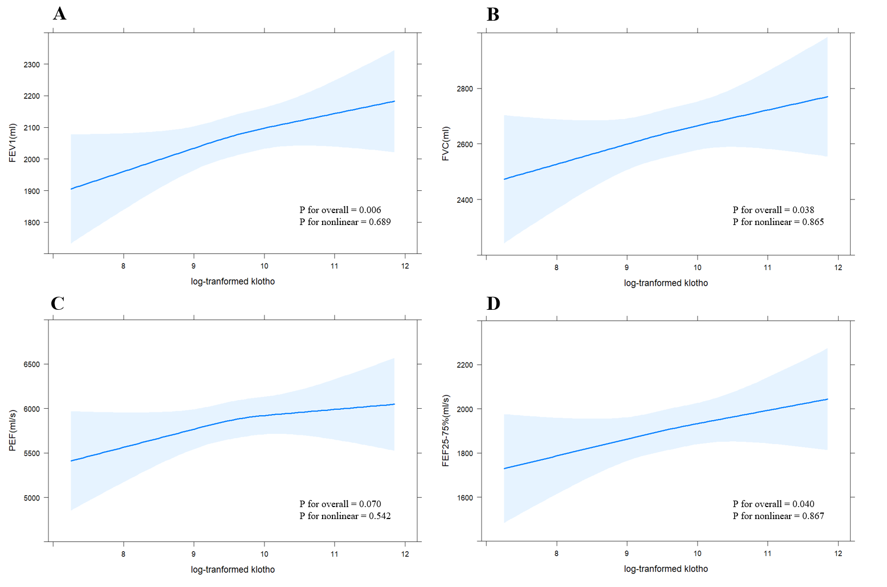
Figure S5. Restricted cubic spline of log transformed klotho and pulmonary function parameters among 60-79-year-old participants adjusted for: age, gender, ethnicity, education, marital status, BMI (body mass index), current smoking, drinking, diabetes, hypertension, wheeze, asthma, COPD (chronic obstructive pulmonary disease).
(A): FEV1, (B): FVC, (C): PEF, (D): FEF25-75%

