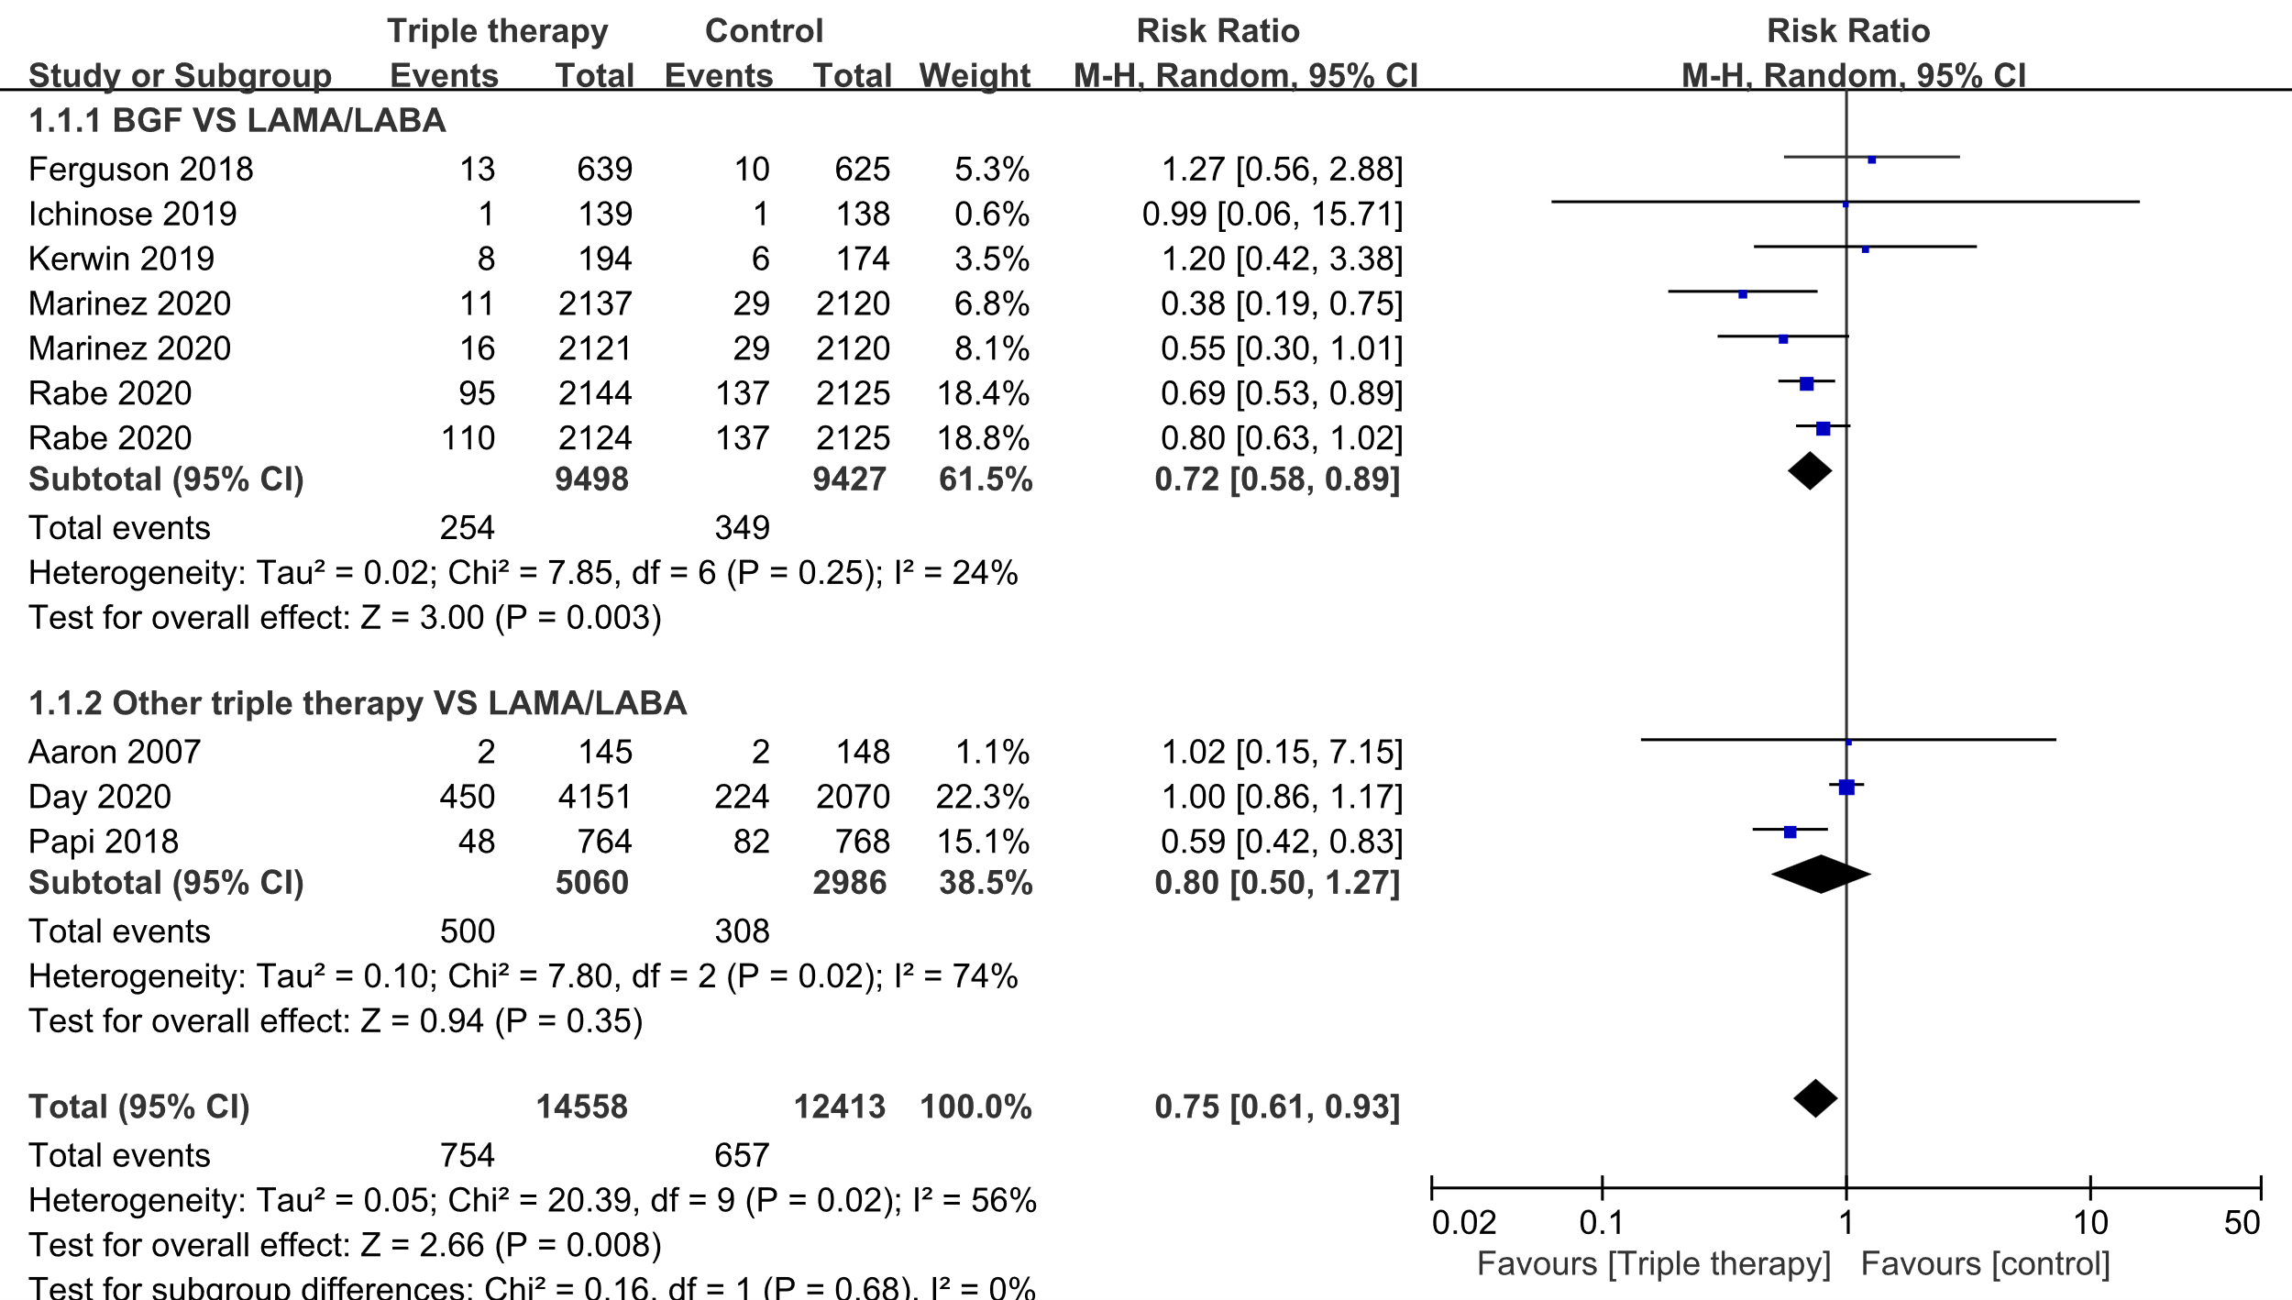
Fig S1. Forest plot for subgroup analysis of CVAESI
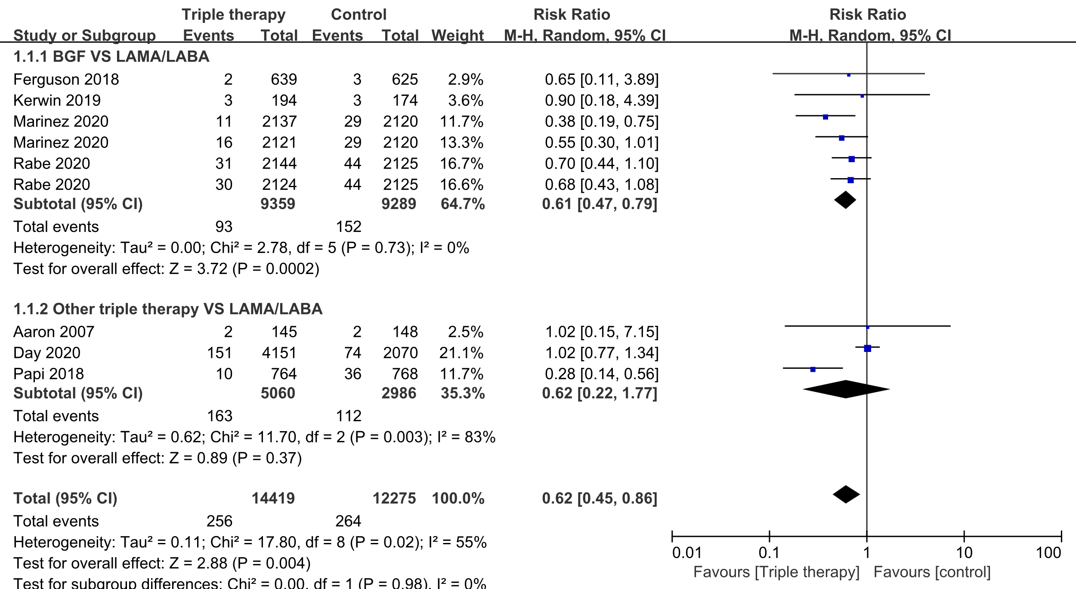
Fig S2. Forest plot for subgroup analysis of serious CVAESI.

(A)
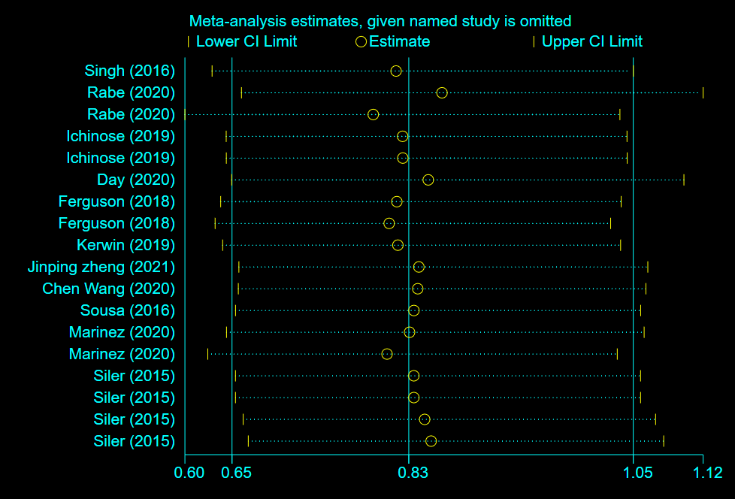
(B)
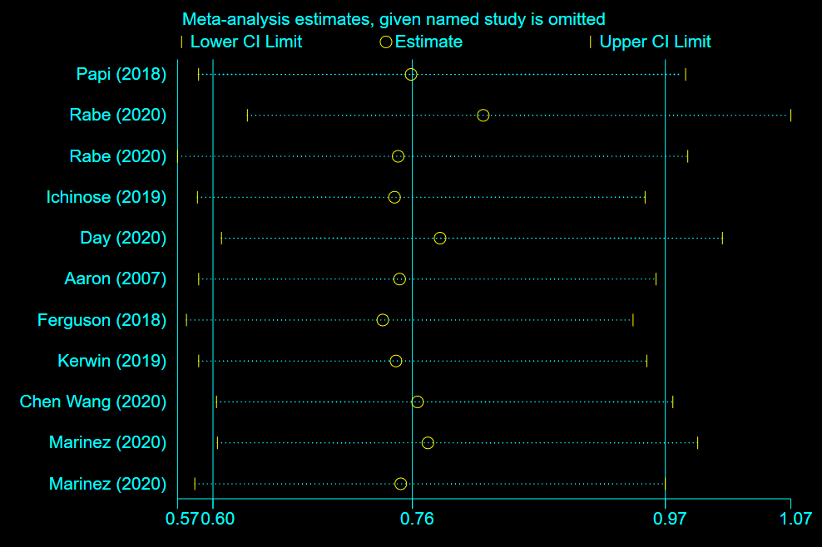
Fig S3. Sensitivity analysis for all-cause mortality. (A) Single inhaler triple therapy VS ICS/LABA, (B) Single inhaler triple therapy VS LAMA/LABA.

(A)
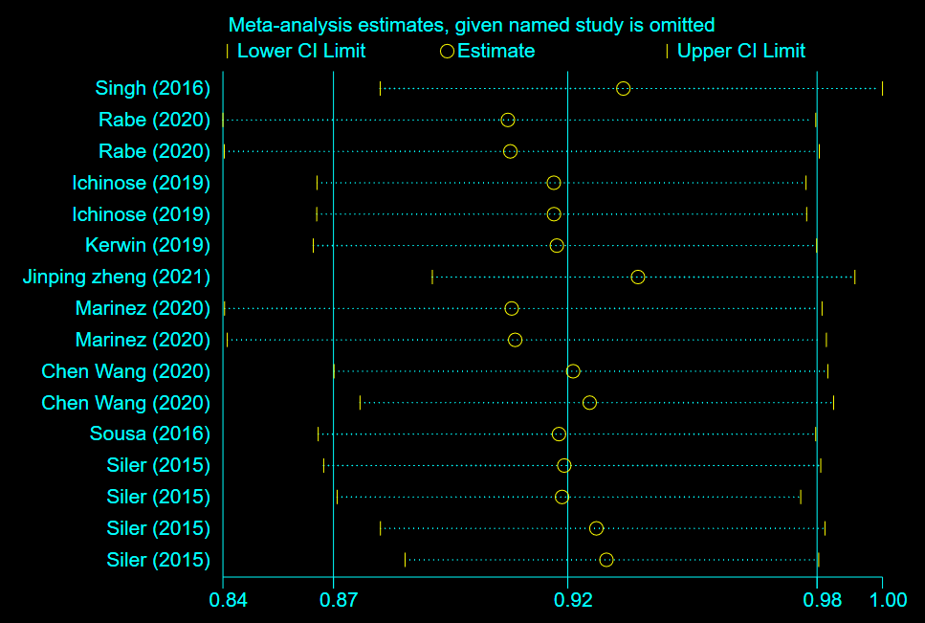
(B)
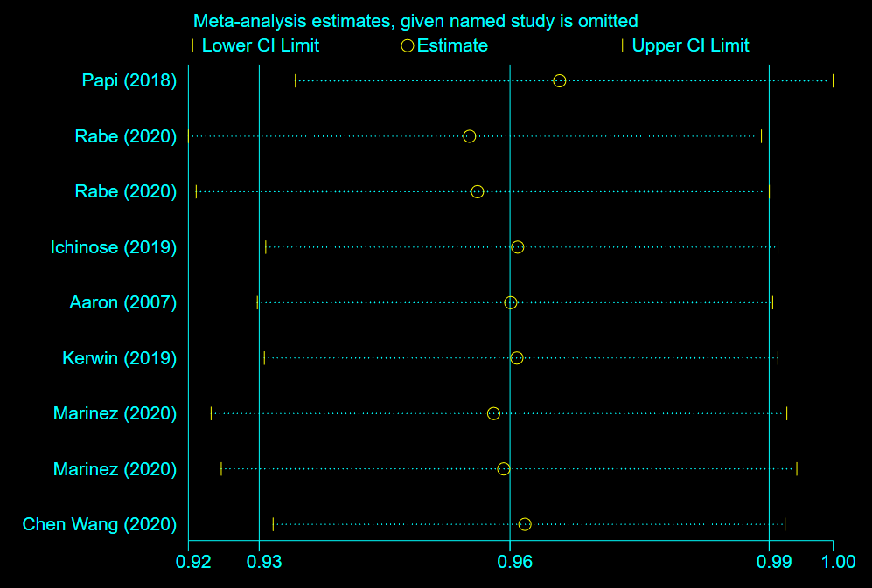
Fig S4. Sensitivity analysis for exacerbations. (A) Single inhaler triple therapy VS ICS/LABA, (B) Single inhaler triple therapy VS LAMA/LABA.

(A)
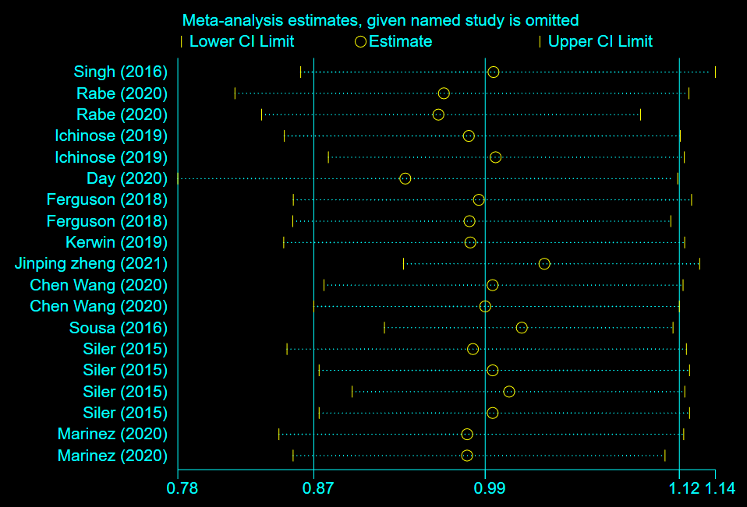
(B)
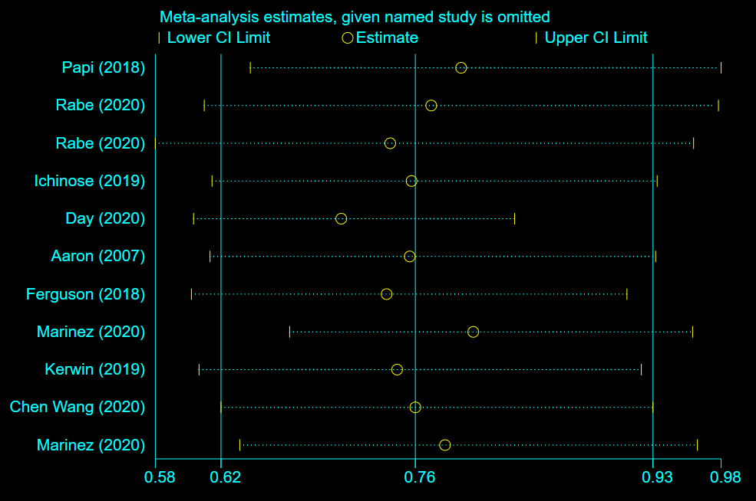
Fig S5. Sensitivity analysis for CVAESI. (A) Single inhaler triple therapy VS ICS/LABA, (B) Single inhaler triple therapy VS LAMA/LABA.

(A)
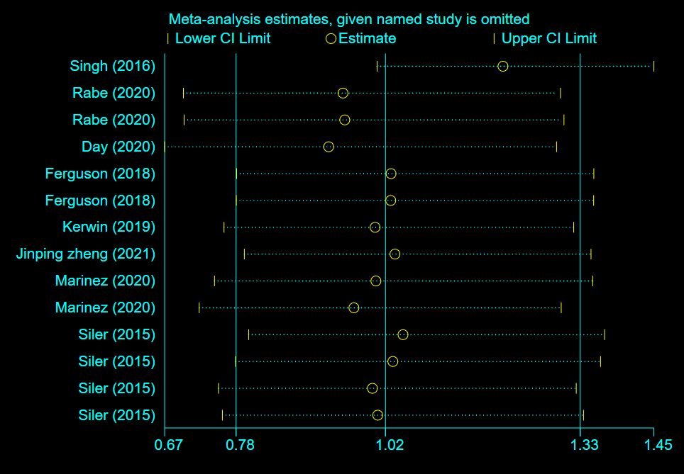
(B)
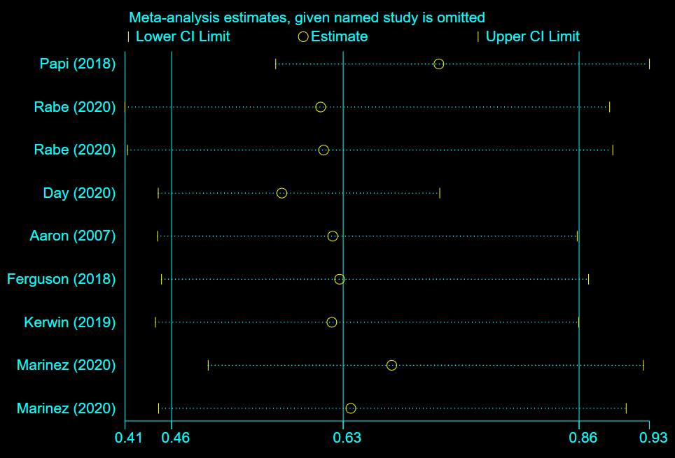
Fig S6. Sensitivity analysis for serious CVAESI. (A) Single inhaler triple therapy VS ICS/LABA, (B) Single inhaler triple therapy VS LAMA/LABA.

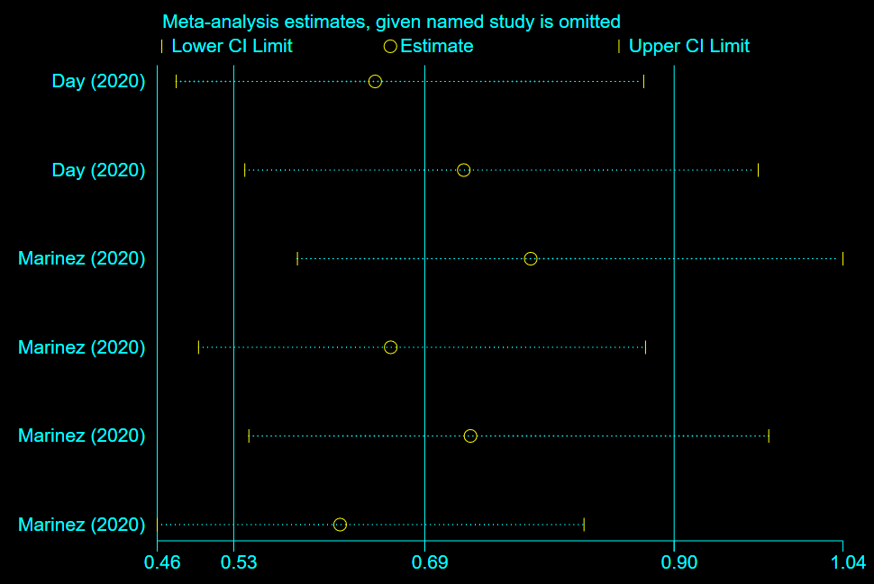
Fig S7. Sensitivity analysis for fatal serious CVAESI.

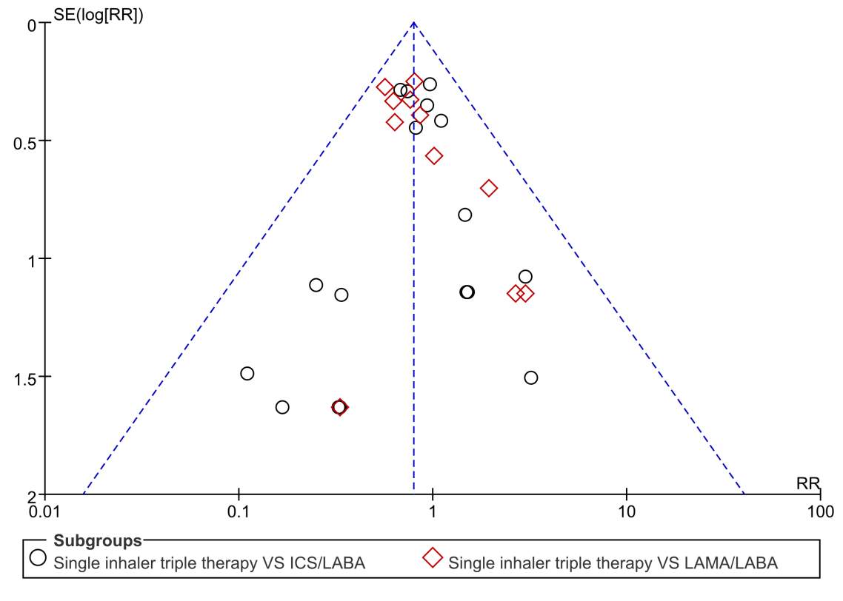
Fig S8. Funnel plots for mortality.

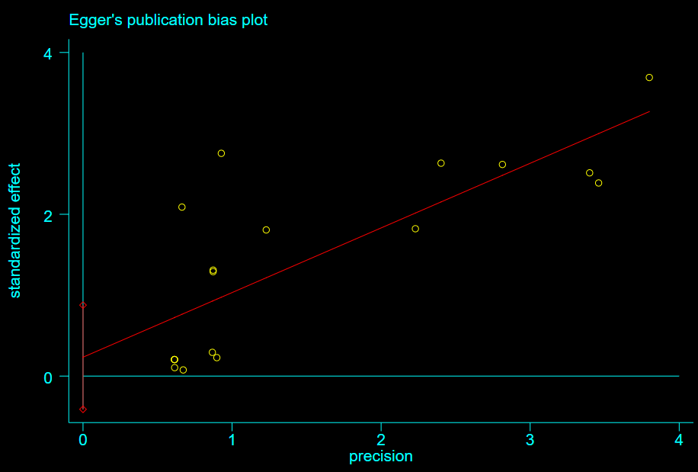
Fig S9. Egger's publication bias plot for mortality (Single inhaler triple therapy vs ICS/LABA) .
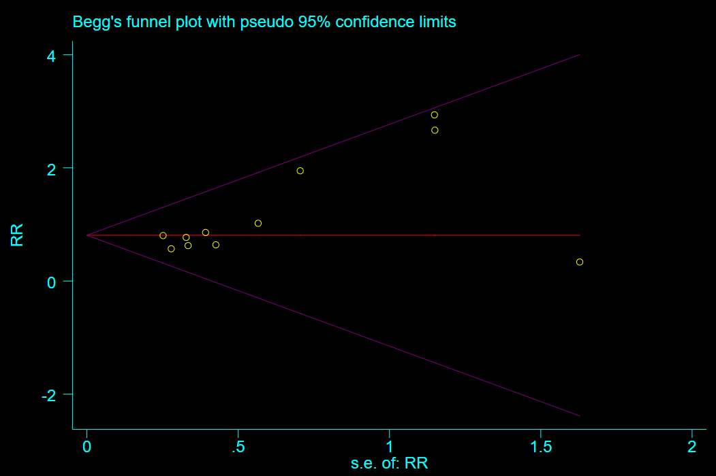
Fig S10. Begg's funnel plot for mortality (Single inhaler triple therapy vs LAMA/LABA) .

（A）
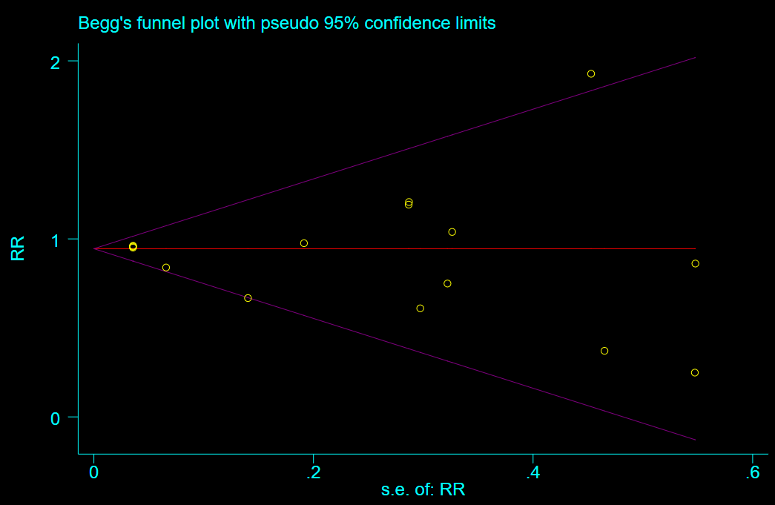
（B）
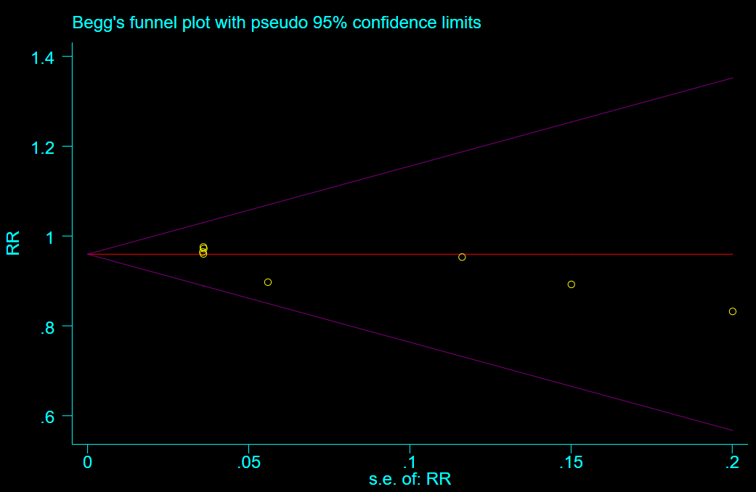
Fig S11. Begg's funnel plot for exacerbations. (A) (Single inhaler triple therapy vs ICS/LABA) and (B) (Single inhaler triple therapy vs LAMA/LABA).

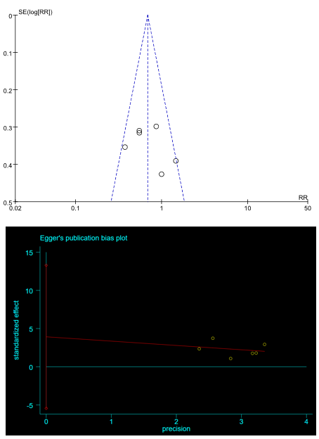
Fig S12. The funnel plot and Egger's publication bias plot for fatal serious CVAESI.

(A)
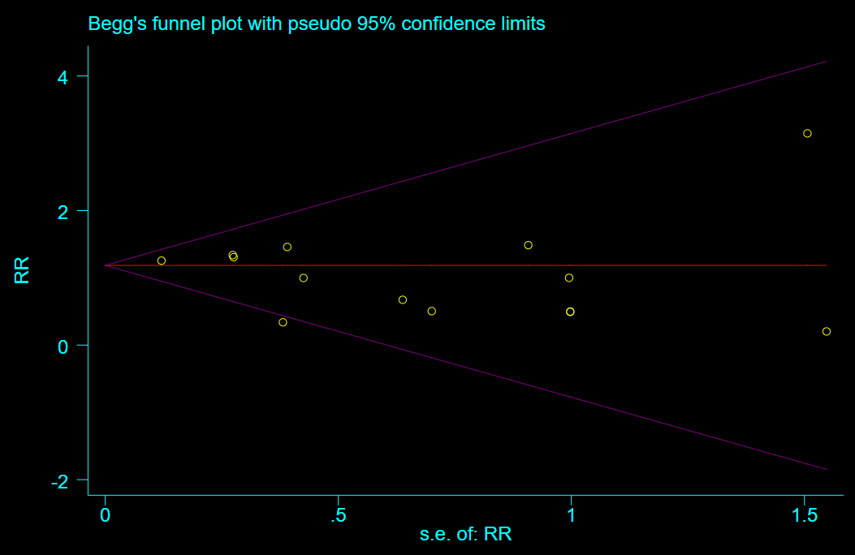
(B)
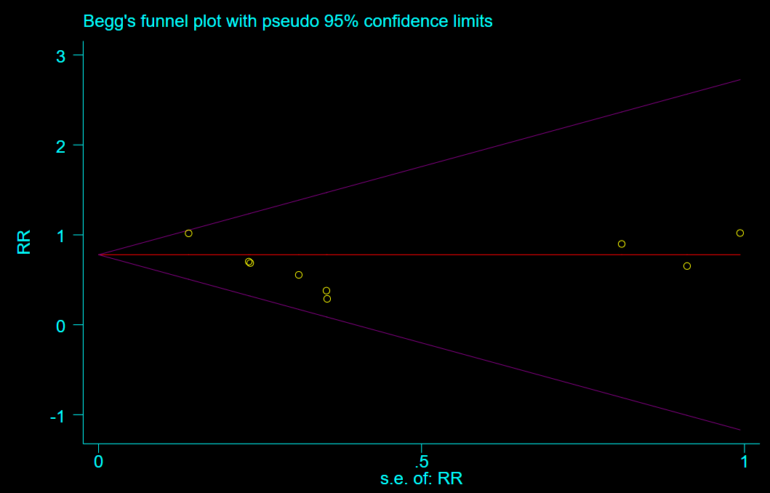
Fig S13. Begg's funnel plot for serious CVAESI. (A) (Single inhaler triple therapy vs ICS/LABA) and (B) (Single inhaler triple therapy vs LAMA/LABA).

（A）
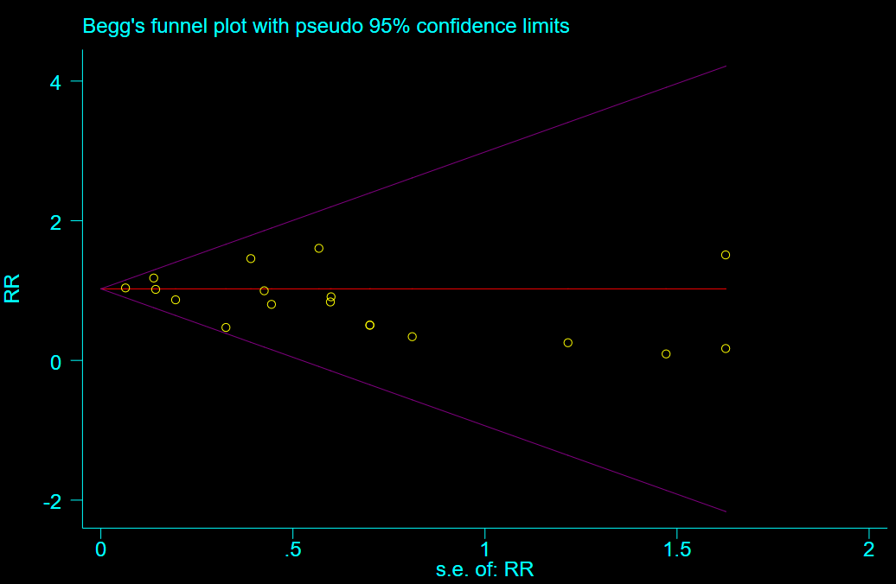
（B）
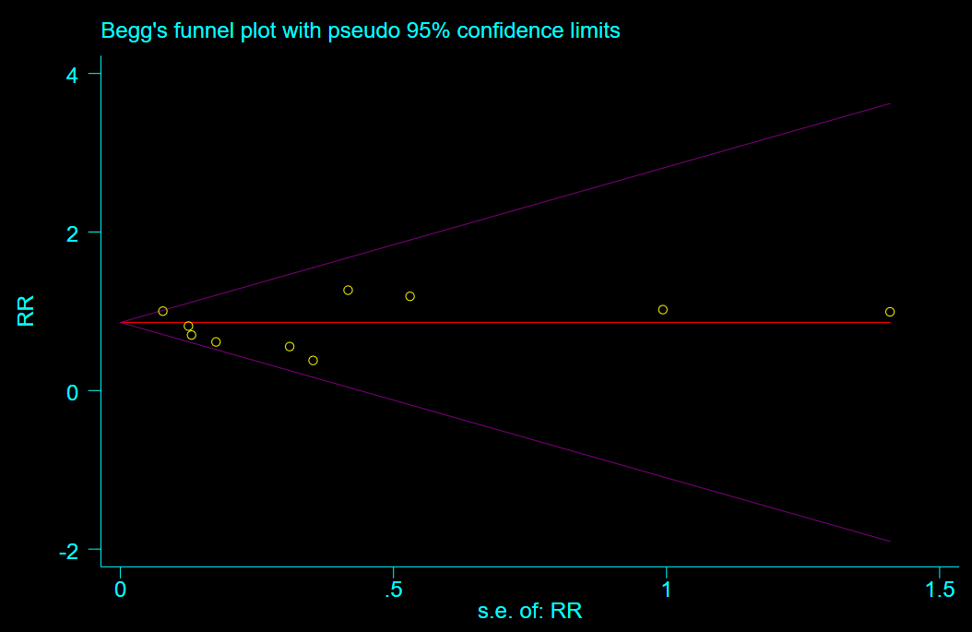
Fig S14. Begg's funnel plot for CVAESI. (A) (Single inhaler triple therapy vs ICS/LABA) and (B) (Single inhaler triple therapy vs LAMA/LABA).
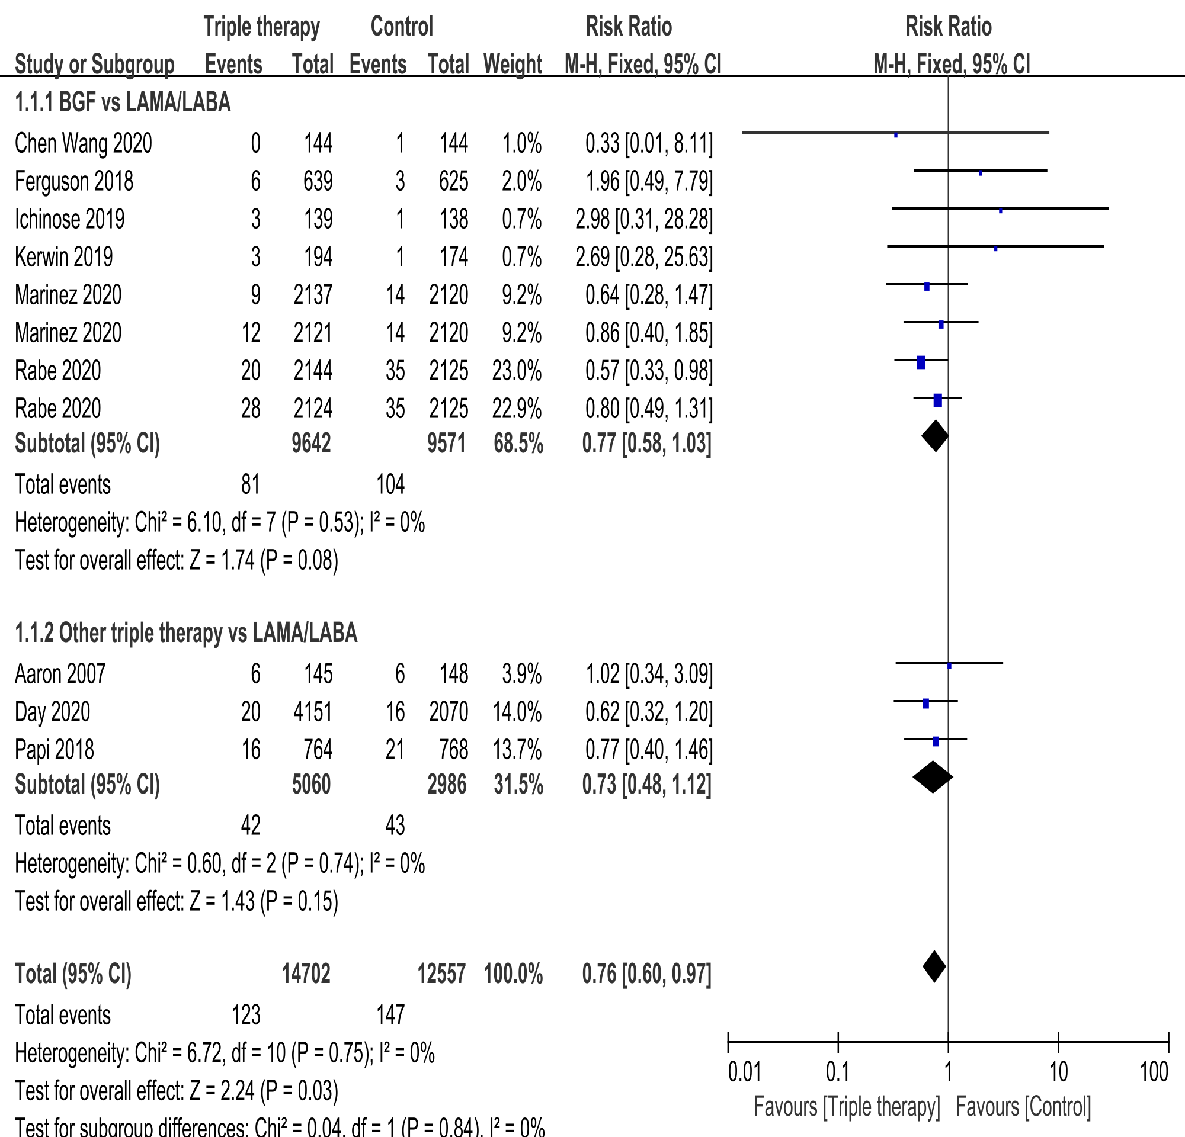
Fig S15. Forest plot for subgroup analysis of mortality.

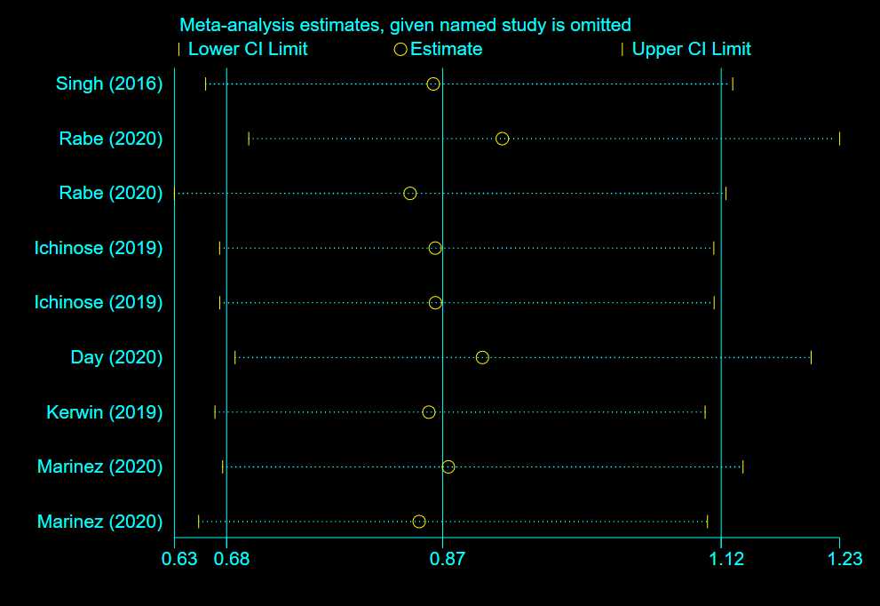
Fig S16. Sensitivity analysis of all-cause mortality (follow-up > 6 months)

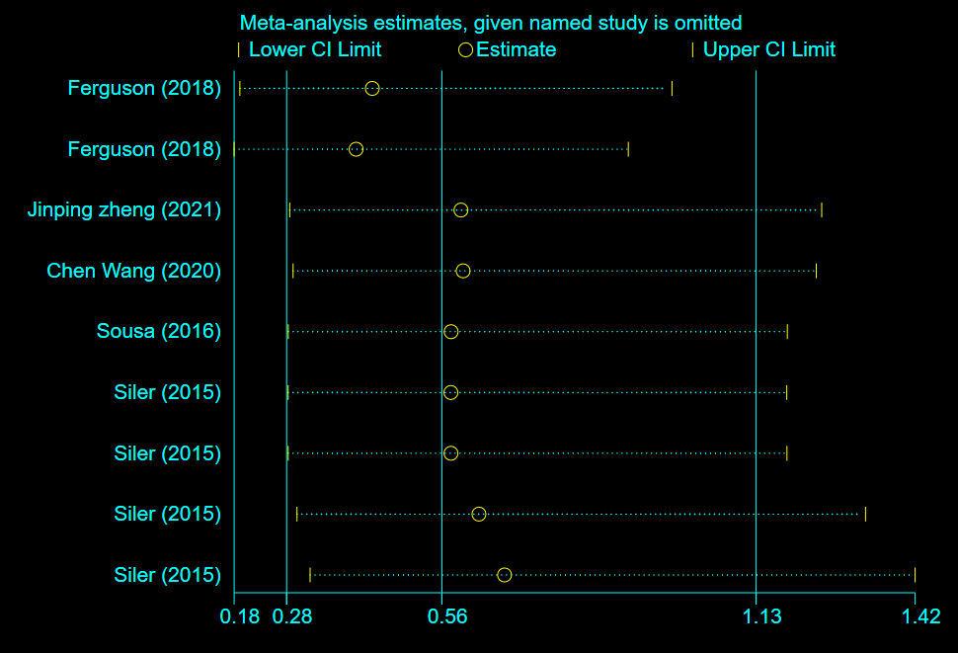
Fig S17. Sensitivity analysis of all-cause mortality (follow-up ≤6 months)
Table 3. Search strategy
Database | No | PICOS | Strategy
PubMed | #1 | P | ("COPD"[MeSH] OR "Pulmonary Disease, Chronic Obstructive"[MeSH] OR "chronic obstructive pulmonary disease"[tiab] OR "COPD"[tiab] OR "chronic bronchitis"[tiab] OR "emphysema"[tiab]) AND ("FEV1/FVC <0.70"[tiab] OR "FEV1 25-80% predicted"[tiab]) AND ("exacerbation"[tiab] OR "acute worsening"[tiab] OR "hospitalization"[tiab] OR "emergency visit*"[tiab]) AND ("smoking"[MeSH] OR "smoking"[tiab] OR "pack-year"[tiab] OR "current smoker"[tiab] OR "former smoker"[tiab])
 | #2 | I | ("triple therapy"[tiab] OR "ICS/LAMA/LABA"[tiab] OR "inhaled corticosteroid"[tiab] OR "fluticasone furoate"[tiab] OR "fluticasone propionate"[tiab] OR "budesonide"[tiab] OR "vilanterol"[tiab] OR "umeclidinium"[tiab] OR "glycopyrrolate"[tiab] OR "tiotropium"[tiab] OR "formoterol fumarate"[tiab])
 | #3 | C | ("dual therapy"[tiab] OR "LABA/LAMA"[tiab] OR "ICS/LABA"[tiab] OR "indacaterol"[tiab] OR "glycopyrronium"[tiab] OR "salmeterol"[tiab] OR "formoterol"[tiab] OR "olodaterol"[tiab] OR "aclidinium"[tiab] OR "ipratropium"[tiab] OR "beclomethasone"[tiab])
 | #4 | O | ("mortality"[MeSH] OR "mortality"[tiab] OR "all-cause mortality"[tiab] OR "cardiovascular mortality"[tiab] OR "cardiovascular events"[tiab] OR "myocardial infarction"[tiab] OR "stroke"[tiab] OR "arrhythmia"[tiab] OR "exacerbation rate"[tiab] OR "hospitalization rate"[tiab] OR "FEV1 decline"[tiab] OR "quality of life"[tiab])
 | #5 | S | ("randomized controlled trial"[Publication Type] OR "RCT"[tiab] OR "randomized"[tiab] OR "randomised"[tiab] OR "randomly"[tiab] OR "placebo"[tiab] OR "control group"[tiab])  NOT ("Review"[Publication Type] OR "Meta-Analysis"[Publication Type] OR "Comment"[Publication Type] OR "Editorial"[Publication Type] OR "Case Report"[Publication Type])
‌ | #6 | NA | (#1) AND (#2 OR #3) AND (#4) AND (#5)  (("COPD"[MeSH] OR "Pulmonary Disease, Chronic Obstructive"[MeSH] OR "chronic obstructive pulmonary disease"[tiab] OR "COPD"[tiab]) AND ("FEV1/FVC <0.70"[tiab] OR "FEV1 25-80% predicted"[tiab]) AND ("exacerbation"[tiab] OR "hospitalization"[tiab] OR "emergency visit*"[tiab]) AND ("smoking"[MeSH] OR "pack-year"[tiab] OR "current smoker"[tiab]) AND ( "triple therapy"[tiab] OR "ICS/LAMA/LABA"[tiab] OR "dual therapy"[tiab] OR "LABA/LAMA"[tiab] OR "fluticasone"[tiab] OR "budesonide"[tiab] OR "umeclidinium"[tiab] OR "tiotropium"[tiab] ) AND ("mortality"[tiab] OR "cardiovascular events"[tiab] OR "FEV1 decline"[tiab]) AND ("randomized controlled trial"[Publication Type] OR "RCT"[tiab] OR "randomized"[tiab]))NOT ("Review"[Publication Type] OR "Meta-Analysis"[Publication Type] OR "Comment"[Publication Type])
Embase | #1 | P | ('chronic obstructive lung disease'/exp OR 'copd':ab,ti OR 'chronic obstructive pulmonary disease':ab,ti OR 'chronic bronchitis':ab,ti OR 'emphysema':ab,ti) AND ('FEV1/FVC <0.70':ab,ti OR 'FEV1 25-80% predicted':ab,ti) AND ('exacerbation':ab,ti OR 'acute worsening':ab,ti OR 'hospitalization':ab,ti OR 'emergency visit*':ab,ti) AND ('smoking'/exp OR 'smoking':ab,ti OR 'pack-year':ab,ti OR 'current smoker':ab,ti OR 'former smoker':ab,ti)
 | #2 | I | ('triple therapy':ab,ti OR 'ICS/LAMA/LABA':ab,ti OR 'inhaled corticosteroid':ab,ti OR 'fluticasone furoate':ab,ti OR 'fluticasone propionate':ab,ti OR 'budesonide':ab,ti OR 'vilanterol':ab,ti OR 'umeclidinium':ab,ti OR 'glycopyrrolate':ab,ti OR 'tiotropium':ab,ti OR 'formoterol fumarate':ab,ti)
 | #3 | C | ('dual therapy':ab,ti OR 'LABA/LAMA':ab,ti OR 'ICS/LABA':ab,ti OR 'indacaterol':ab,ti OR 'glycopyrronium':ab,ti OR 'salmeterol':ab,ti OR 'formoterol':ab,ti OR 'olodaterol':ab,ti OR 'aclidinium':ab,ti OR 'ipratropium':ab,ti OR 'beclomethasone':ab,ti)
 | #4 | O | ('mortality'/exp OR 'mortality':ab,ti OR 'all-cause mortality':ab,ti OR 'cardiovascular mortality':ab,ti  OR 'cardiovascular event':ab,ti OR 'myocardial infarction':ab,ti OR 'stroke':ab,ti OR 'arrhythmia':ab,ti  OR 'exacerbation rate':ab,ti OR 'hospitalization rate':ab,ti OR 'FEV1 decline':ab,ti OR 'quality of life':ab,ti)
 | #5 | S | ('randomized controlled trial'/exp OR 'RCT':ab,ti OR 'randomized':ab,ti OR 'randomised':ab,ti OR 'randomly':ab,ti OR 'placebo':ab,ti OR 'control group':ab,ti) NOT ('review'/exp OR 'meta-analysis'/exp OR 'comment'/exp OR 'editorial'/exp OR 'case report'/exp)
‌ | #6 | NA | (#1) AND (#2 OR #3) AND (#4) AND (#5)  (('chronic obstructive lung disease'/exp OR 'copd'ab,ti) AND ('FEV1/FVC <0.70'ab,ti OR 'FEV1 25-80% predicted'ab,ti) AND ('exacerbation'ab,ti OR 'hospitalization'ab,ti OR 'emergency visit*'ab,ti) AND ('smoking'/exp OR 'pack-year'ab,ti OR 'current smoker'ab,ti) AND ('triple therapy'ab,ti OR 'ICS/LAMA/LABA'ab,ti OR 'dual therapy'ab,ti OR 'LABA/LAMA'ab,ti OR 'fluticasone'ab,ti OR 'budesonide'ab,ti OR 'umeclidinium'ab,ti OR 'tiotropium'ab,ti) AND ('mortality'ab,ti OR 'cardiovascular events'ab,ti OR 'FEV1 decline'ab,ti) AND ('randomized controlled trial'/exp OR 'RCT'ab,ti OR 'randomized'ab,ti)) NOT ('review'/exp OR 'meta-analysis'/exp OR 'comment'/exp)
Cochrane library | #1 | P | (MH "Pulmonary Disease, Chronic Obstructive" OR "COPD" OR "chronic obstructive pulmonary disease" OR "chronic bronchitis" OR "emphysema") AND (TI/AB "FEV1/FVC <0.70" OR "FEV1 25-80% predicted") AND (TI/AB "exacerbation" OR "acute worsening" OR "hospitalization" OR "emergency visit*") AND (MH "Smoking" OR TI/AB "smoking" OR "pack-year" OR "current smoker" OR "former smoker")
 | #2 | I | (TI/AB "triple therapy" OR "ICS/LAMA/LABA" OR "inhaled corticosteroid" OR "fluticasone furoate" OR "fluticasone propionate" OR "budesonide" OR "vilanterol" OR "umeclidinium" OR "glycopyrrolate" OR "tiotropium" OR "formoterol fumarate")
 | #3 | C | (TI/AB "dual therapy" OR "LABA/LAMA" OR "ICS/LABA" OR "indacaterol" OR "glycopyrronium" OR "salmeterol" OR "formoterol" OR "olodaterol" OR "aclidinium" OR "ipratropium" OR "beclomethasone")
 | #4 | O | (MH "Mortality" OR TI/AB "mortality" OR "all-cause mortality" OR "cardiovascular mortality" OR TI/AB "cardiovascular events" OR "myocardial infarction" OR "stroke" OR "arrhythmia" OR TI/AB "exacerbation rate" OR "hospitalization rate" OR "FEV1 decline" OR "quality of life")
 | #5 | S | (MH "Randomized Controlled Trials" OR TI/AB "RCT" OR "randomized" OR "randomised" OR "randomly" OR "placebo" OR "control group") NOT (PT "Review" OR "Comment" OR "Editorial" OR "Case Report")
‌ | #6 | NA | (#1) AND (#2 OR #3) AND (#4) AND (#5)  ((MH "Pulmonary Disease, Chronic Obstructive" OR TI/AB "COPD") AND (TI/AB "FEV1/FVC <0.70" OR TI/AB "FEV1 25-80% predicted") AND (TI/AB "exacerbation" OR TI/AB "hospitalization" OR TI/AB "emergency visit*") AND (MH "Smoking" OR TI/AB "pack-year" OR TI/AB "current smoker") AND (TI/AB "triple therapy" OR TI/AB "ICS/LAMA/LABA" OR TI/AB "dual therapy" OR TI/AB "LABA/LAMA" OR TI/AB "fluticasone" OR TI/AB "budesonide" OR TI/AB "umeclidinium" OR TI/AB "tiotropium") AND (TI/AB "mortality" OR TI/AB "cardiovascular events" OR TI/AB "FEV1 decline") AND (MH "Randomized Controlled Trials" OR TI/AB "RCT" OR TI/AB "randomized")) NOT (PT "Review" OR PT "Meta-Analysis" OR PT "Comment")
Abbreviation: NA, not applicable

