SUPPLEMENTARY MATERIAL
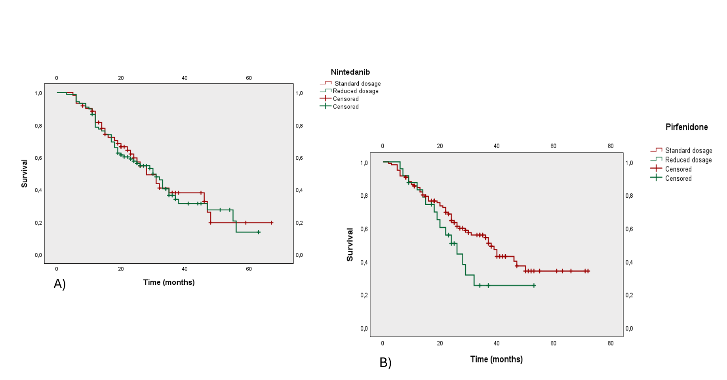

Figures 1. A) Kaplan-Meier curves for progression-free survival (PFS) in patients treated with Nintedanib by dosage (standard dosage in red, reduced dosage in green). The median PFS in patients treated with standard dosage was 28 months (95% CI: 21.5–34.5), whereas for patients under reduced dosage the median PFS was 30 months (95% CI: 24.3–35.7), with no statistical significance (p = 0.744). B) Kaplan-Meier survival curves for progression-free survival (PFS) in patients treated with Pirfenidone, stratified by dose reduction status. While standard dosage group (red) demonstrated a longer median PFS (38 months) compared to the dose reduction group (green, 26 months), the difference was not statistically significant (Log-Rank test, p = 0.095).

Figure 2. Change from Baseline over 5 years of observational period in Forced Vital Capacity (FVC) according to dosage group (reduced and standard dosage) expressed in mL. No significant difference between groups (p=0.82) over the follow-up period.

Clinical outcomes | Overall population  (N=267) | Nintedanib  (N=137) | Pirfenidone  (N=130) | Log Rank  p-value
Progression-Free survival (months)  95% CIs | 32  27.5-36.5 | 31  25.7-36.3 | 37  30.2-43.8 | 0.12
Overall survival (months)  95% CIs | 63  56.4-69.6 | 63  57.1-69.0 | 54  41.2-67.0 | 0.97
Time to LTOT initiation (months)  95% CIs | 17  10.2-24.0 | 18  11.0-25.2 | 15  5.6-24.4 | 0.87
Time to dose reduction (months)  95% CIs | 50  36.4-63.6 | 25  20.6-29.3 | 68 | < 0.001

Table 1. Clinical outcomes in patients treated with Nintedanib (N=137) and Pirfenidone (N=130), excluding the 25 patients who switched therapy during follow-up time. Median time is expressed for progression-free survival (PFS), overall survival (OS), time to initiation of long-term oxygen therapy (LTOT), and time to dose reduction. Results are reported in months, with their 95% confidence intervals (95% CIs) and p-values from the Log Rank test.

