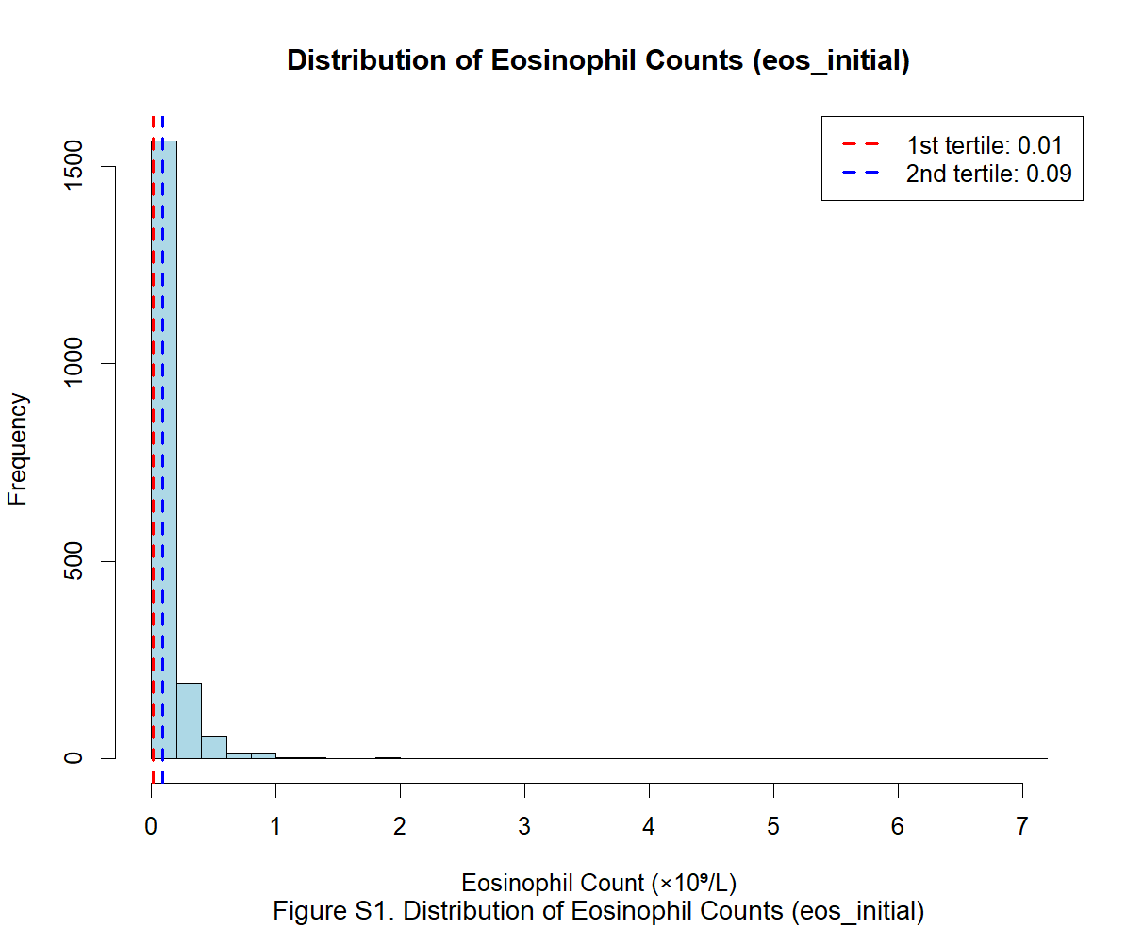

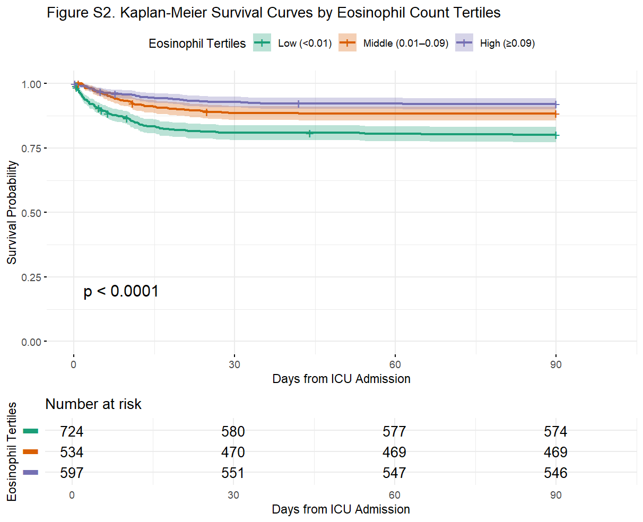

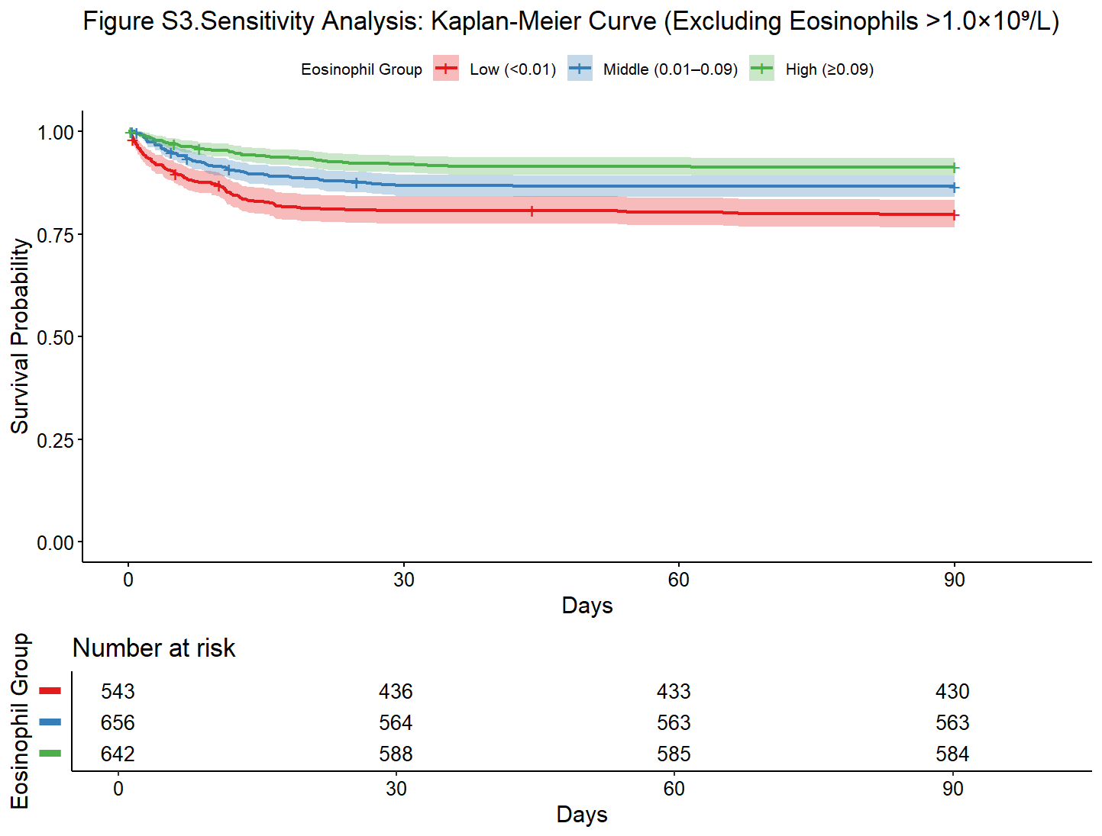

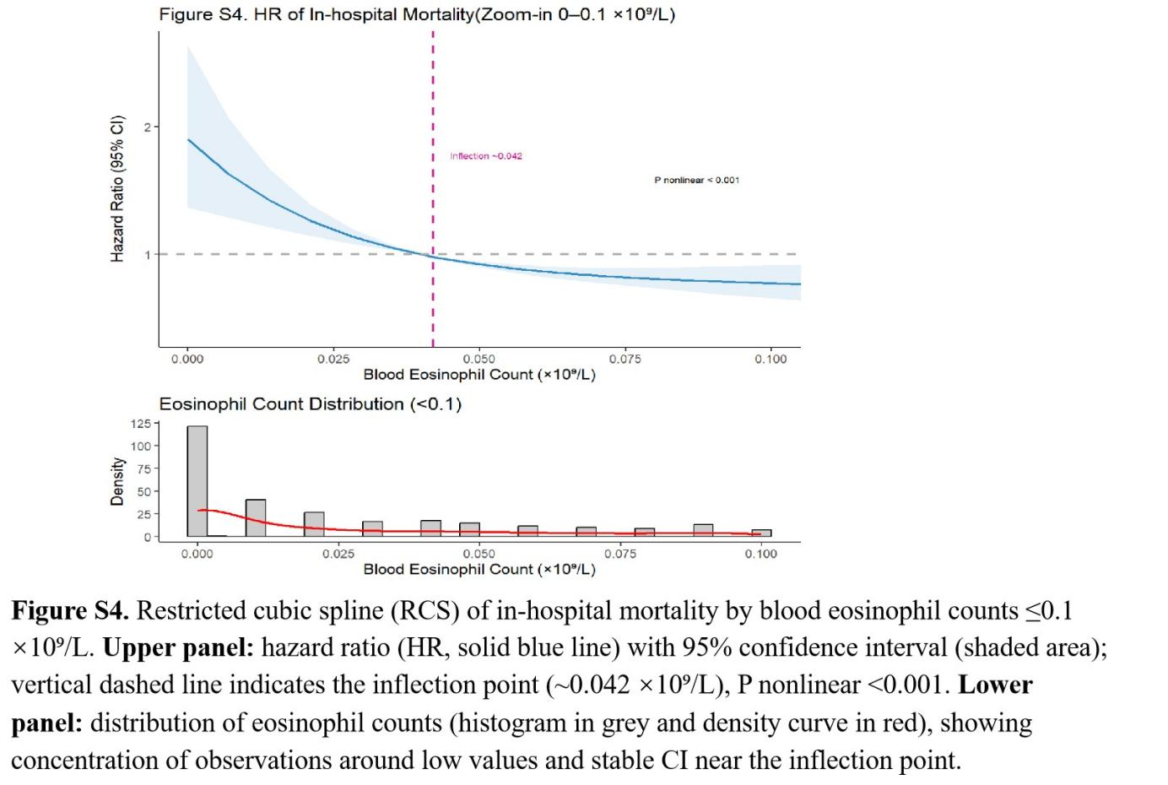

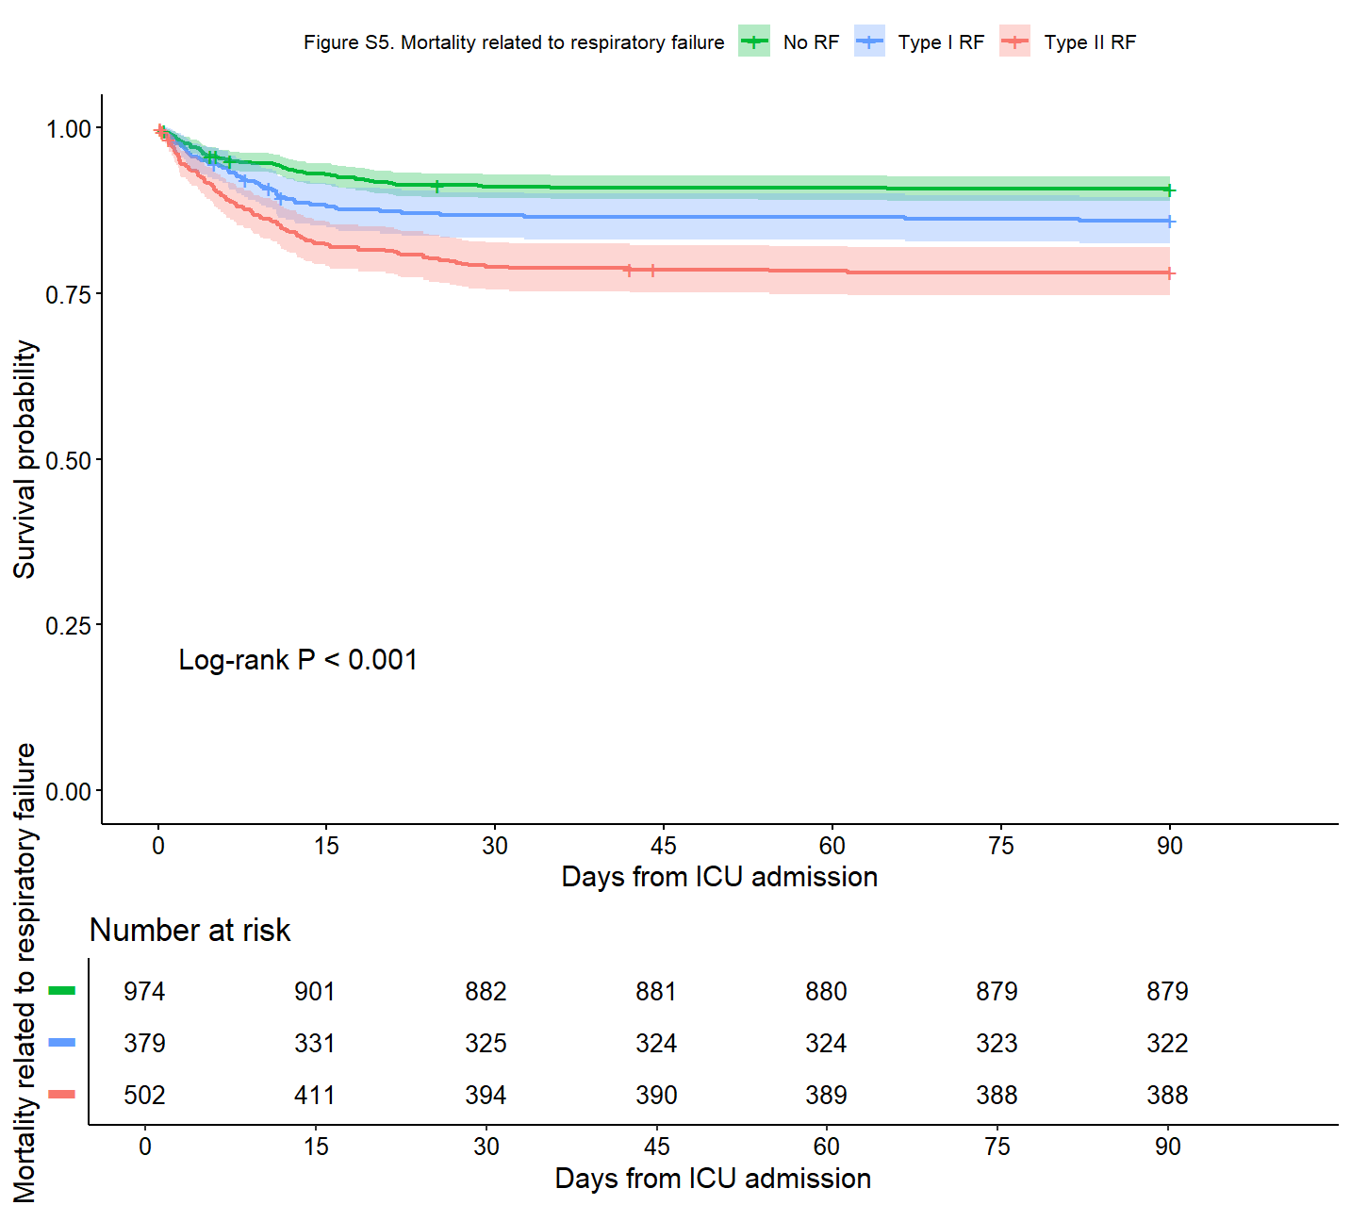

Table 1. Baseline characteristics of patients stratified by blood eosinophil inflection point (0.042 × 10⁹/L).
Characteristic | <0.042¹ | ≥0.042¹ | p-value²
admission_age | 72 ± 11 | 72 ± 11 | 0.2
1 male 0 female | 518 (52%) | 480 (56%) | 0.13
sepsis | 612 (62%) | 359 (42%) | <0.001
asthma | 63 (6.3%) | 72 (8.4%) | 0.11
vaso_user | 428 (43%) | 330 (38%) | 0.044
heart_rate_mean | 88 ± 16 | 83 ± 14 | <0.001
sbp_mean | 116 ± 16 | 119 ± 17 | 0.002
dbp_mean | 64 ± 11 | 64 ± 11 | 0.3
resp_rate_mean | 20.6 ± 3.9 | 19.5 ± 3.2 | <0.001
temperature_mean | 36.88 ± 0.43 | 36.79 ± 0.38 | <0.001
spo2_mean | 95.65 ± 3.07 | 96.18 ± 2.22 | <0.001
wbc_initial K/uL 4-10 | 14 ± 10 | 12 ± 11 | <0.001
sofa | 5.6 ± 3.8 | 4.6 ± 3.2 | <0.001
Neut_initial K/uL 1.6-6.1 | 11.5 ± 6.6 | 8.7 ± 5.6 | <0.001
0 survivors 1 Non-survivors | 174 (18%) | 78 (9.1%) | <0.001
¹Mean ± SD; n (%)
²Wilcoxon rank sum test; Pearson's Chi-squared test

