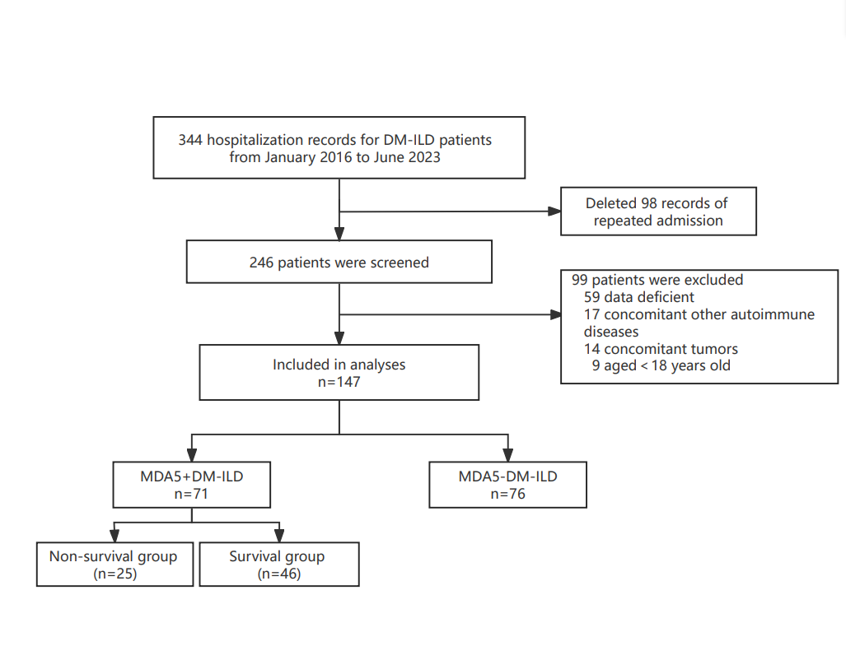
Figure S1 Flow diagram of study enrollment

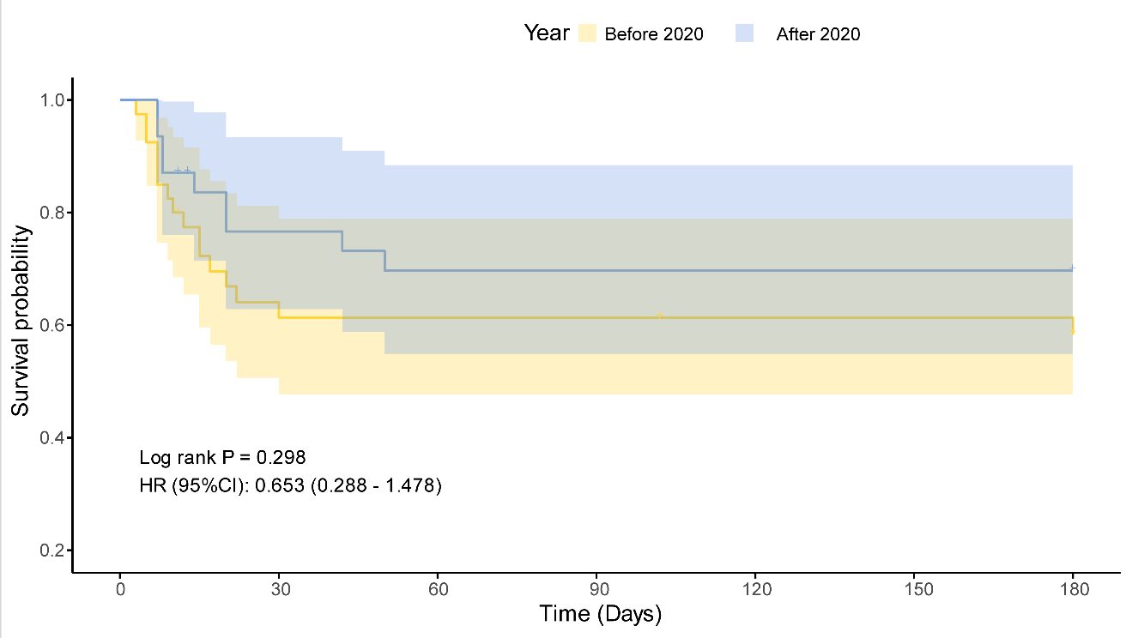
Figure S2. Kaplan-Meier survival curves stratified by year of diagnosis in patients with MDA5⁺DM-ILD
Kaplan-Meier analysis comparing survival outcomes in patients diagnosed before and after 2020. No significant difference in survival probability was observed between groups (Log-rank P = 0.298; HR 0.653, 95% CI 0.288–1.478). Shaded areas indicate 95% confidence intervals. HR: Hazard Ratio, CI: Confidence Interval.

Figure S3. Proportional hazards assumption testing using Schoenfeld residuals
Plots of scaled Schoenfeld residuals against time for each covariate included in the final Cox proportional hazards model. The solid line represents the smoothed estimate of the time-dependent effect, and dashed lines indicate the 95% confidence interval. Most variables satisfied the proportional hazards assumption, whereas some variables (neutrophil-to-lymphocyte ratio and antibiotic use) showed evidence of time-varying effects.
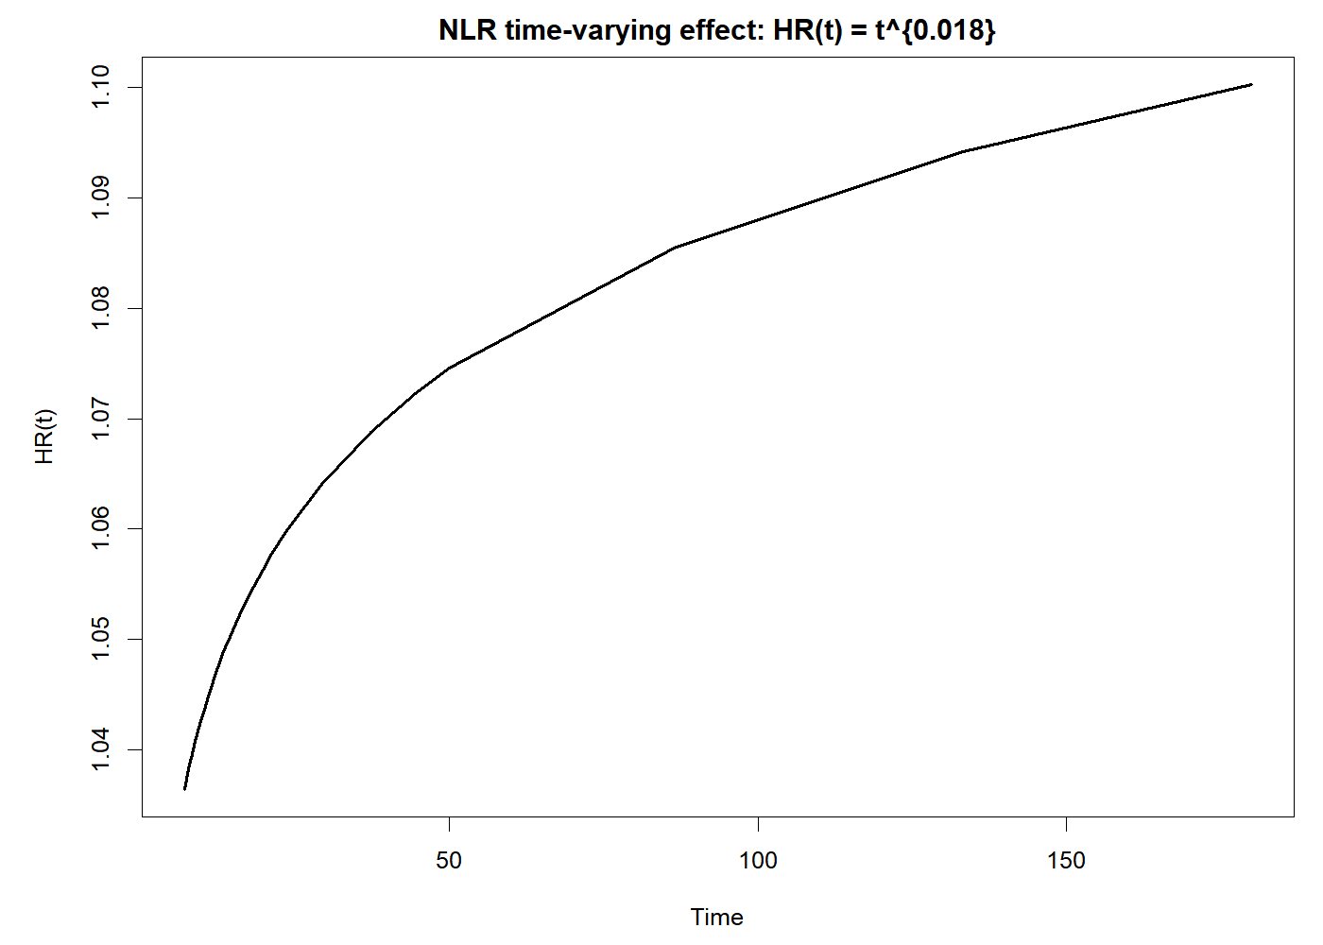
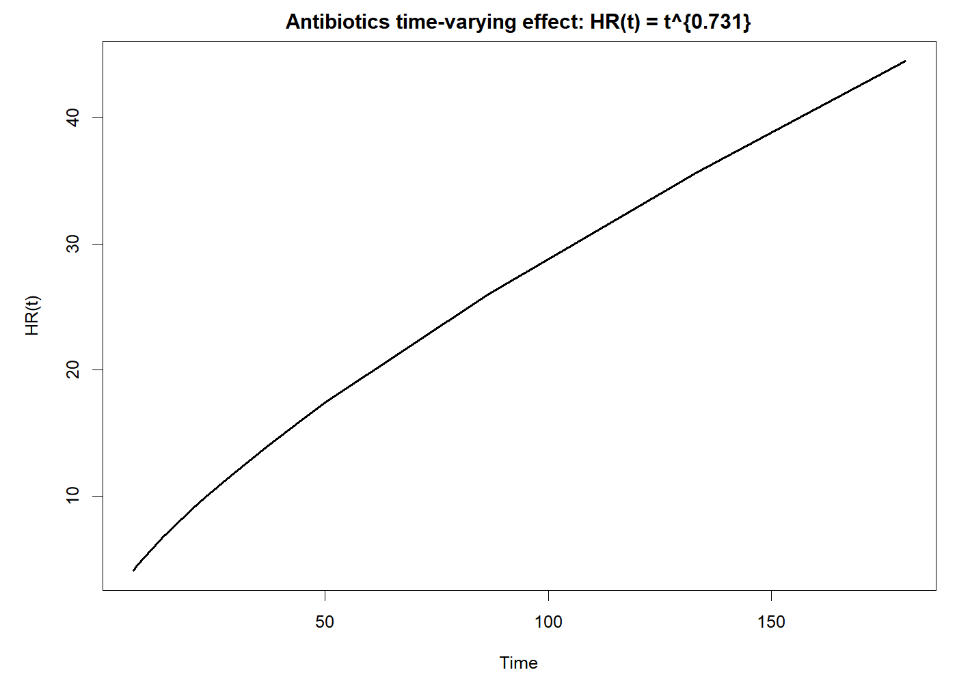
A B

Figure S4. Time-varying effects of covariates violating the proportional hazards assumption.
(A) Time-varying hazard ratio (HR) of neutrophil-to-lymphocyte ratio (NLR), showing a gradual increase in risk over time.
(B) Time-varying hazard ratio (HR) of antibiotic use, demonstrating a strong time-dependent effect with increasing hazard across follow-up.

A B
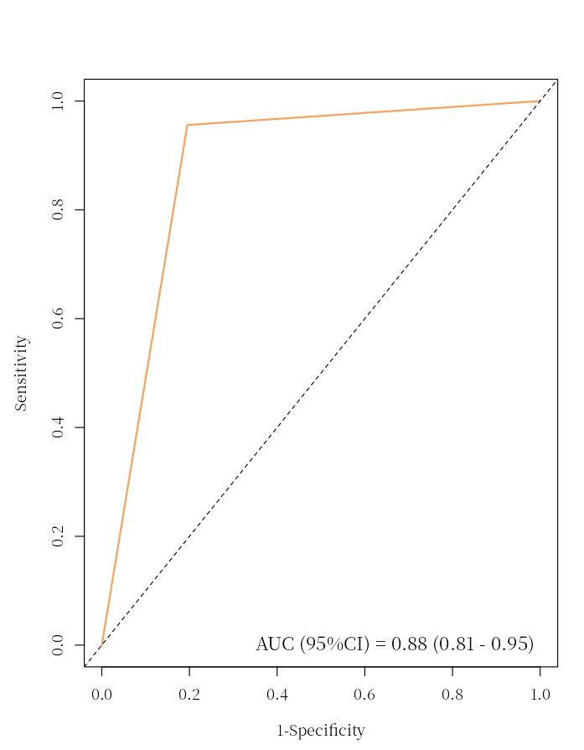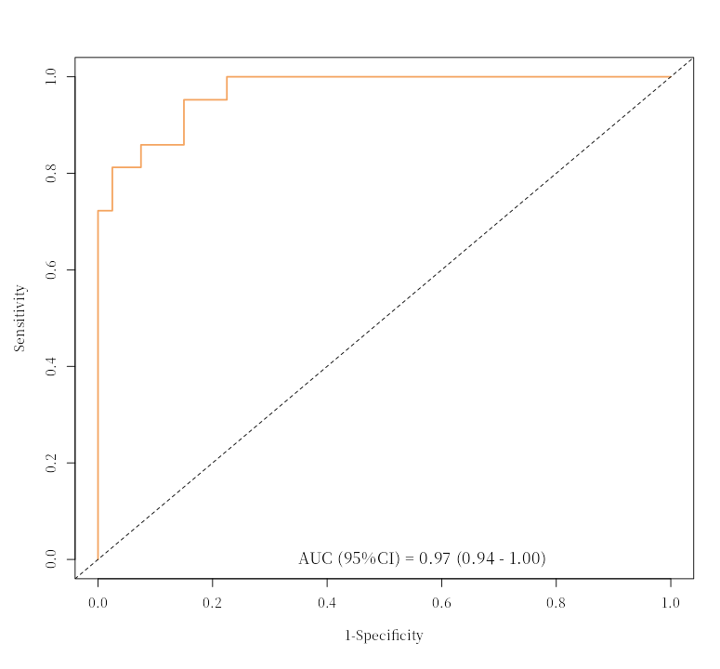
Figure S5. Incremental discrimination gained by adding laboratory markers on top of RP-ILD.
- ROC curve for the model using RP-ILD alone, showing AUC = 0.88 (95% CI 0.81–0.95).
- ROC curve for the combined model (RP-ILD + ferritin, CRP, ALB, and NLR), showing AUC = 0.97 (95% CI 0.94–1.00). The solid orange line denotes the ROC curve and the grey dashed line indicates the no-discrimination reference (AUC = 0.50). RP-ILD, rapidly progressive interstitial lung disease; ROC, receiver operating characteristic; AUC, area under the curve; CI, confidence interval; CRP, C-reactive protein; ALB, albumin; NLR, neutrophil-to-lymphocyte ratio.
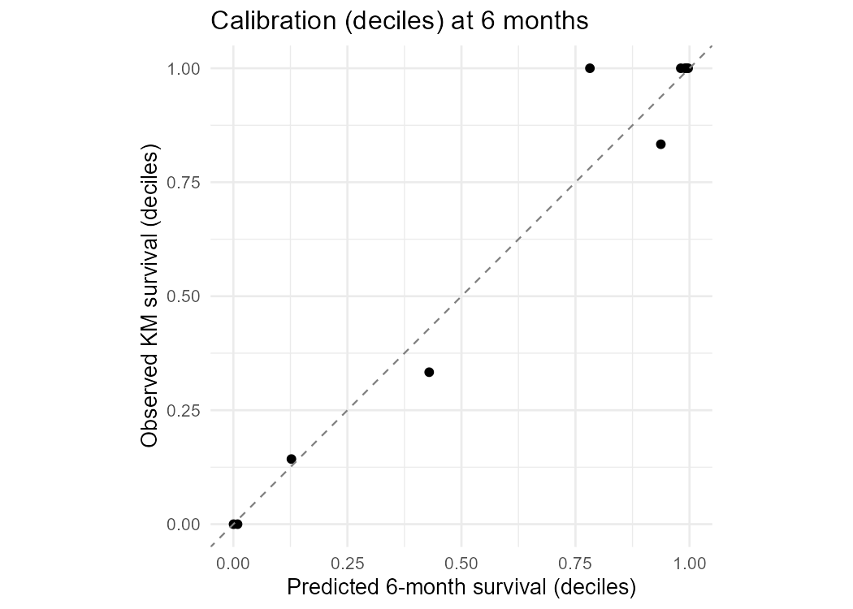
Figure S6. Calibration plot for the prognostic model at 6 months
Calibration of the Cox regression–based nomogram for predicting 6-month survival in patients with MDA5⁺DM-ILD. The x-axis shows predicted survival probabilities (by deciles), while the y-axis shows observed Kaplan-Meier survival. The dashed diagonal line represents perfect calibration, and the solid line indicates model performance.
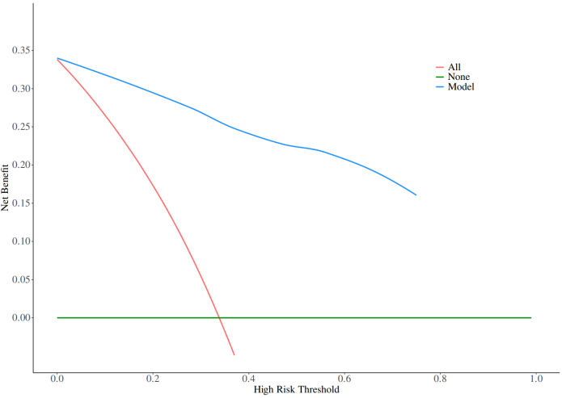
A B
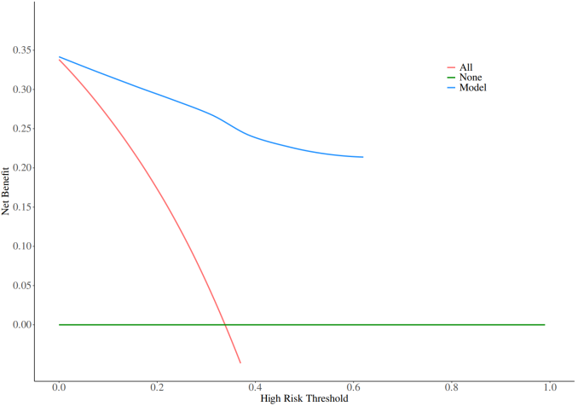

Figure S7. Decision curve analysis (DCA) of the prognostic model
(A) DCA at 3 months. (B) DCA at 6 months. Legend: Decision curve analysis evaluating the net clinical benefit of the prognostic model compared with “treat all” and “treat none” strategies across a range of threshold probabilities. The blue line represents the net benefit of the model, the red line represents the assumption of treating all patients, and the green line represents treating none.

