Supplementary Material
Associations of Weight-Derived Markers with Mortality in Patients with Corona Virus Disease 2019: Evidence from hospitals and patients
Yanqiu Li^{1*}; Shuang-Shuang Song^{1*}; Hang Ruan²; Cancan Gong³; Yingjie Chen^{1#}
¹ Department of Respiratory and Critical Care Medicine, Yantai Yuhuangding Hospital, Affiliated with the Medical College of Qingdao, Yantai 264200, Shandong, China.
² Department of Critical-care Medicine, Tongji Hospital, Tongji Medical College, Huazhong University of Science and Technology, Wuhan, 430030, Hubei Province, China;
³ Department of Infectious Diseases, Yantai Shan Hospital, Yantai, 264001, Shandong Province, China
* These authors contributed equally to this work.
#Corresponding authors:
Yingjie Chen: 20 Yuhuangding East Road, Yantai 264200 People’s Rep. of China; Tel. 86- 13695355990; Email: y13695355990@126.com
Key words: Critical care; Cohort study; Risk factors; Triglyceride-glucose index; Corona Virus Disease 2019

Content
Supplementary Figure 1 3
Supplementary Figure 2 4
Supplementary Figure 3 5
Supplementary Table 1: Formulas for Calculating Weight-Derived Markers and Serum Osmolarity. 6
Supplementary Table 2: Testing for collinearity between BMI and Covariates. 7
Supplementary Table 3: Testing for collinearity between Weight and Covariates. 8
Supplementary Table 4: Testing for collinearity between WBFM and Covariates. 9
Supplementary Table 5: Testing for collinearity between BMR and Covariates. 10
Supplementary Table 6: Testing for collinearity between BFP and Covariates. 11
Supplementary Table 7: Testing for collinearity between LBM and Covariates. 12
Supplementary Table 8: Effect size of Weight-Derived Markers on secondary outcomes. 13

Supplementary Figure 1

Supplementary Figure 2

Supplementary Figure 3
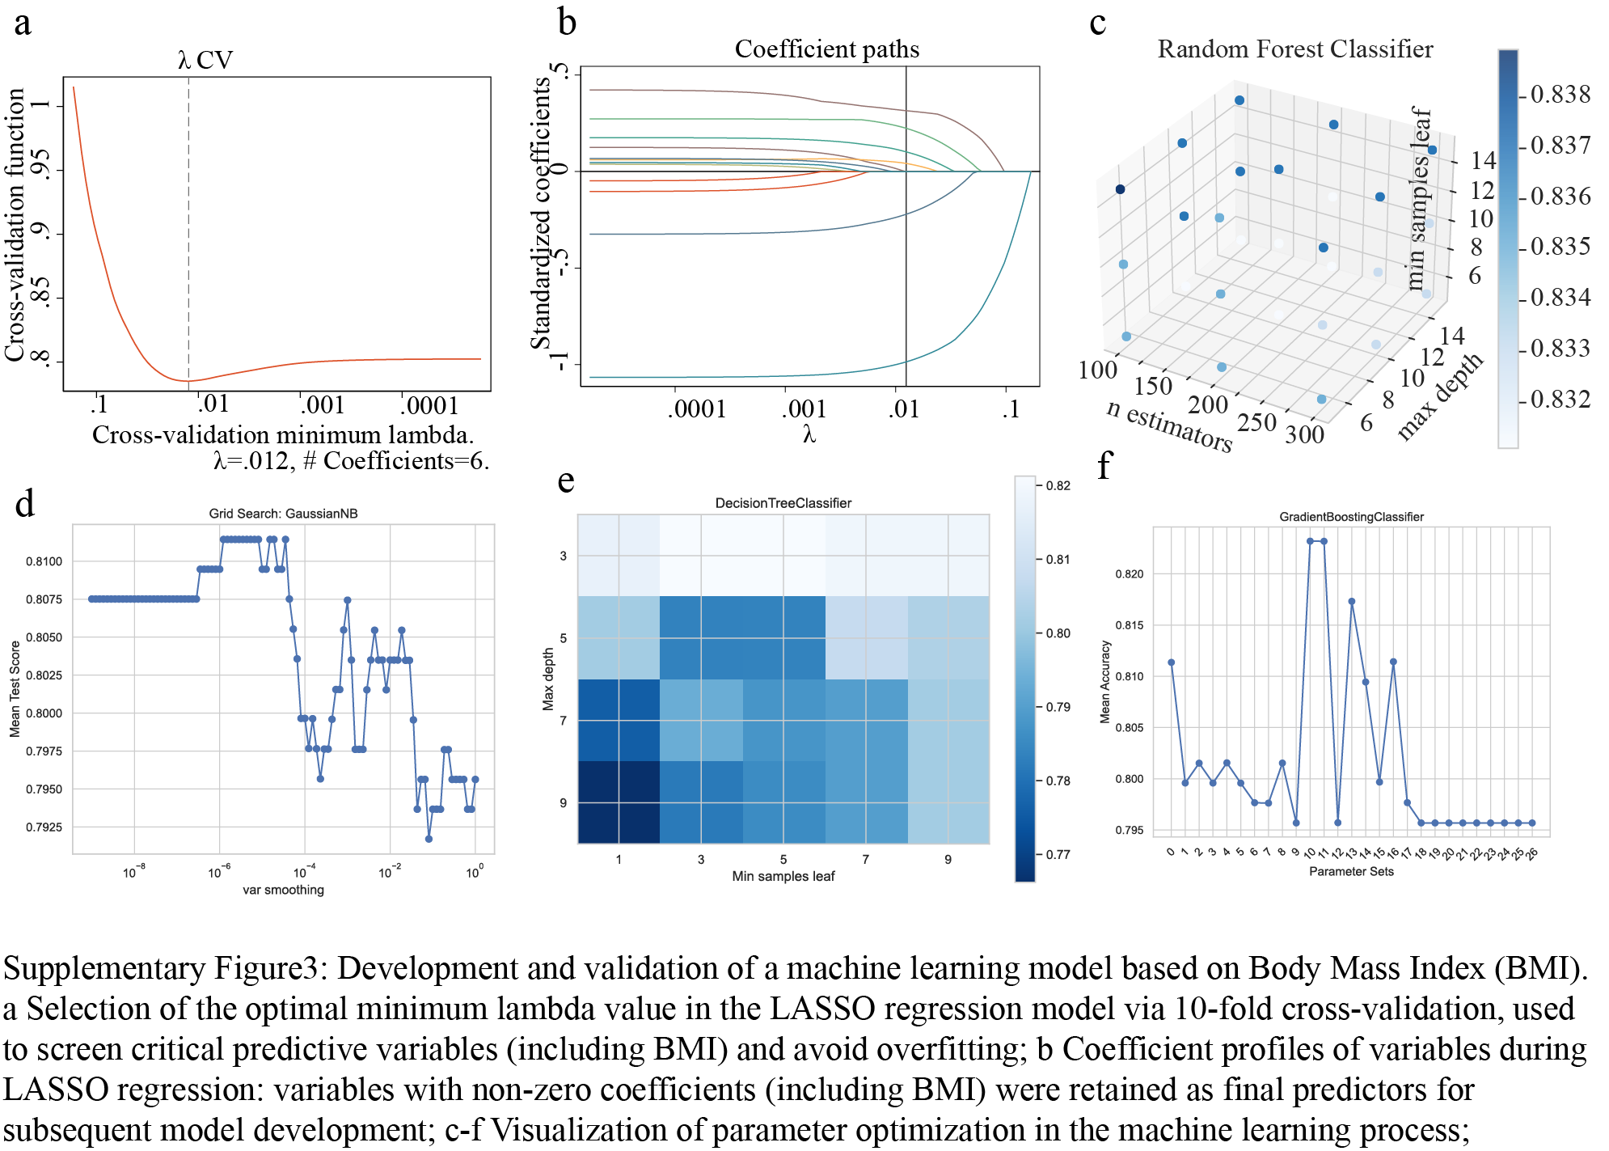

Supplementary Table 1: Formulas for Calculating Weight-Derived Markers and Serum Osmolarity.
Marker Name | Calculation Formula | Ref.
BMI | BMI (kg/m²) = Weight/(Height*Height) | [1]
LBM | LBM (kg) = (0.29569 × Wt) + (0.41813 × Ht) – 43.2933 | [2]
BFP | BFP (%) = 1.20 × BMI + 0.23 × Age – 16.2 × Sex – 5.4 | [3]
WBFM | WBFM (kg) = Wt × (BFP / 100) | [4]
BMR | Male: BMR (kcal/day) = (10 × Wt) + (6.25 × Ht) – (5 × Age) + 5  Female: BMR (kcal/day) = (10 × Wt) + (6.25 × Ht) – (5 × Age) – 161 | [5]
Osmolarity | Osmolarity, mmol/L = 2 × (Na⁺ + K⁺) + (Glu / 18) + (Urea / 2.8) | [6]
Abbreviations: BFP: Body Fat Percentage; BMI: Body Mass Index; BMR: Basal Metabolic Rate; LBM: Lean Body Mass; WBFM: Whole-Body Fat Mass.

Supplementary Table 2: Testing for collinearity between BMI and Covariates.
Adjusted model 2 |  |  | Adjusted model 3 |  |  | Adjusted model 1
Variable | VIF |  | Variable | VIF |  | Variable | VIF
BMI | 1.05 |  | BMI | 1.02 |  | BMI | 1.05
Osmolarity | 1.99 |  | Cerebrovascular | 1.49 |  | Age | 1
BUN | 2.06 |  | Cardiovascular | 1.18 |  | Sex | 1.22
Creatinine | 3.42 |  | Diabetes | 1.19 |  | Smoker | 1.18
PaCO₂ | 1.02 |  | Hypertension | 1.31
SpO₂/FiO₂ ratio | 1.5 |  | Hypoproteinemia | 1.02
CPIS | 1.43 |  | Hyperlactatemia | 1.01
aCCI | 1.13
MAP | 1.03
Abbreviations: BMI: Body Mass Index; BUN: Blood Urea Nitrogen; PaCO₂: Partial Pressure of Carbon Dioxide in Arterial Blood; SpO₂/FiO₂ ratio: Oxygen Saturation/Fraction of Inspired Oxygen Ratio; CPIS: Clinical Pulmonary Infection Score; aCCI: age-Adjusted Charlson Comorbidity Index; MAP: Mean Arterial Pressure.

Supplementary Table 3: Testing for collinearity between Weight and Covariates.
Adjusted model 2 |  |  | Adjusted model 3 |  |  | Adjusted model 1
Variable | VIF |  | Variable | VIF |  | Variable | VIF
Weight | 1.04 |  | Weight | 1.01 |  | Weight | 1.18
Osmolarity | 1.97 |  | Cerebrovascular | 1.49 |  | Age | 1
BUN | 2.05 |  | Cardiovascular | 1.18 |  | Sex | 1.31
Creatinine | 3.38 |  | Diabetes | 1.19 |  | Smoker | 1.17
PaCO2 | 1.03 |  | Hypertension | 1.31
SpO₂/FiO₂ ratio | 1.5 |  | Hypoproteinemia | 1.02
CPIS | 1.43 |  | Hyperlactatemia | 1.01
aCCI | 1.14
MAP | 1.03
Abbreviations: BMI: Body Mass Index; BUN: Blood Urea Nitrogen; PaCO₂: Partial Pressure of Carbon Dioxide in Arterial Blood; SpO₂/FiO₂ ratio: Oxygen Saturation/Fraction of Inspired Oxygen Ratio; CPIS: Clinical Pulmonary Infection Score; aCCI: age-Adjusted Charlson Comorbidity Index; MAP: Mean Arterial Pressure.

Supplementary Table 4: Testing for collinearity between WBFM and Covariates.
Adjusted model 2 |  |  | Adjusted model 3 |  |  | Adjusted model 1
Variable | VIF |  | Variable | VIF |  | Variable | VIF
WBFM | 1.04 |  | WBFM | 1.02 |  | WBFM | 2.53
Osmolarity | 1.98 |  | Cerebrovascular | 1.49 |  | Age | 1
BUN | 2.06 |  | Cardiovascular | 1.18 |  | Sex | 2.78
Creatinine | 3.43 |  | Diabetes | 1.19 |  | Smoker | 1.18
PaCO2 | 1.02 |  | Hypertension | 1.31
SpO₂/FiO₂ ratio | 1.5 |  | Hypoproteinemia | 1.02
CPIS | 1.43 |  | Hyperlactatemia | 1.01
aCCI | 1.13
MAP | 1.03
Abbreviations: BMI: Body Mass Index; BUN: Blood Urea Nitrogen; PaCO₂: Partial Pressure of Carbon Dioxide in Arterial Blood; SpO₂/FiO₂ ratio: Oxygen Saturation/Fraction of Inspired Oxygen Ratio; CPIS: Clinical Pulmonary Infection Score; aCCI: age-Adjusted Charlson Comorbidity Index; MAP: Mean Arterial Pressure.

Supplementary Table 5: Testing for collinearity between BMR and Covariates.
Adjusted model 2 |  |  | Adjusted model 3 |  |  | Adjusted model 1
Variable | VIF |  | Variable | VIF |  | Variable | VIF
BMR | 1.02 |  | BMR | 1.01 |  | BMR | 3.21
Osmolarity | 1.95 |  | Cerebrovascular | 1.49 |  | Age | 1
BUN | 2.06 |  | Cardiovascular | 1.18 |  | Sex | 3.27
Creatinine | 3.39 |  | Diabetes | 1.18 |  | Smoker | 1.17
PaCO₂ | 1.03 |  | Hypertension | 1.31
SpO₂/FiO₂ ratio | 1.49 |  | Hypoproteinemia | 1.02
CPIS | 1.43 |  | Hyperlactatemia | 1.01
aCCI | 1.13
MAP | 1.03
Abbreviations: BMI: Body Mass Index; BUN: Blood Urea Nitrogen; PaCO₂: Partial Pressure of Carbon Dioxide in Arterial Blood; SpO₂/FiO₂ ratio: Oxygen Saturation/Fraction of Inspired Oxygen Ratio; CPIS: Clinical Pulmonary Infection Score; aCCI: age-Adjusted Charlson Comorbidity Index; MAP: Mean Arterial Pressure.

Supplementary Table 6: Testing for collinearity between BFP and Covariates.
Adjusted model 2 |  |  | Adjusted model 3 |  |  | Adjusted model 1
Variable | VIF |  | Variable | VIF |  | Variable | VIF
BFP | 1.07 |  | BFP | 1.02 |  | BFP | 4.33
Osmolarity | 1.96 |  | Cerebrovascular | 1.49 |  | Age | 1.3
BUN | 2.06 |  | Cardiovascular | 1.18 |  | Sex | 4.36
Creatinine | 3.41 |  | Diabetes | 1.19 |  | Smoker | 1.18
PaCO2 | 1.02 |  | Hypertension | 1.32
SpO₂/FiO₂ ratio | 1.49 |  | Hypoproteinemia | 1.02
CPIS | 1.43 |  | Hyperlactatemia | 1.01
aCCI | 1.16
MAP | 1.03
Abbreviations: BMI: Body Mass Index; BUN: Blood Urea Nitrogen; PaCO₂: Partial Pressure of Carbon Dioxide in Arterial Blood; SpO₂/FiO₂ ratio: Oxygen Saturation/Fraction of Inspired Oxygen Ratio; CPIS: Clinical Pulmonary Infection Score; aCCI: age-Adjusted Charlson Comorbidity Index; MAP: Mean Arterial Pressure.

Supplementary Table 7: Testing for collinearity between LBM and Covariates.
Adjusted model 2 |  |  | Adjusted model 3 |  |  | Adjusted model 1
Variable | VIF |  | Variable | VIF |  | Variable | VIF
LBM | 1.02 |  | LBM | 1.01 |  | LBM | 1.17
Osmolarity | 1.95 |  | Cerebrovascular | 1.49 |  | Age | 1.00
Creatinine | 3.4 |  | Diabetes | 1.18 |  | Smoker | 1.17
PaCO2 | 1.03 |  | Hypertension | 1.31
SpO₂/FiO₂ ratio | 1.49 |  | Hypoproteinemia | 1.02
CPIS | 1.43 |  | Hyperlactatemia | 1.01
aCCI | 1.13
MAP | 1.03
Abbreviations: LBM, Lean Body Mass. Note: Due to the covariance between LBM and the gender variable, only LBM, Age, Smoking was included in the adjusted model 3.

Supplementary Table 8: Effect size of Weight-Derived Markers on secondary outcomes.
Characteristics | OR/Coef. | Lower | Upper | P-value
Need for IMV (n=153, 30.1%)
LBM | 1.01 | 0.95 | 1.06 | 0.775
BMR | 1.00 | 1.00 | 1.00 | 0.951
BFP | 0.99 | 0.90 | 1.08 | 0.758
Weight | 0.97 | 0.90 | 1.04 | 0.390
WBFM | 0.93 | 0.84 | 1.03 | 0.168
BMI | 0.86 | 0.69 | 1.07 | 0.166
Length of hospital stay, 9 (7, 14) days
LBM | 0.05 | -0.01 | 0.11 | 0.089
BMR | 0.00 | 0.00 | 0.00 | 0.126
BFP | -0.08 | -0.18 | 0.02 | 0.118
Weight | 0.03 | -0.06 | 0.11 | 0.519
WBFM | -0.07 | -0.17 | 0.04 | 0.223
BMI | 0.00 | -0.26 | 0.26 | 0.993
Length of Oxygen therapy time, 8 (6, 12) days
LBM | 0.04 | 0.00 | 0.09 | 0.070
BMR | 0.00 | 0.00 | 0.00 | 0.092
BFP | -0.04 | -0.11 | 0.03 | 0.289
Weight | 0.03 | -0.04 | 0.09 | 0.430
WBFM | -0.06 | -0.14 | 0.02 | 0.158
BMI | -0.01 | -0.21 | 0.19 | 0.909
Abbreviations: BFP: Body Fat Percentage; BMI: Body Mass Index; BMR: Basal Metabolic Rate; LBM: Lean Body Mass; WBFM: Whole-Body Fat Mass.

References:

1. Ruan H, Li S-S, Zhang Q, Ran X: Elevated MMP-8 levels, inversely associated with BMI, predict mortality in mechanically ventilated patients: an observational multicenter study. Critical care (London, England) 2023, 27(1):290-290.
2. Li J, Shang J, Guo B, Gong J, Xu H: Establishment of Prediction Equations of Lean Body Mass Suitable for Chinese Adults. Biomed Research International 2019, 2019.
3. Deurenberg-Yap M, Schmidt G, van Staveren WA, Deurenberg P: The paradox of low body mass index and high body fat percentage among Chinese, Malays and Indians in Singapore. International Journal of Obesity 2000, 24(8):1011-1017.
4. Umapathysivam K, Tufanaru C, Visvanathan R, Yu S: Anthropometric prediction equations for estimating body mass composition: a scoping review protocol. JBI database of systematic reviews and implementation reports 2017, 15(10):2427-2432.
5. Camps SG, Wang NX, Tan WSK, Henry CJ: Estimation of basal metabolic rate in Chinese: are the current prediction equations applicable? Nutrition Journal 2016, 15.
6. Shen Y, Cheng X, Ying M, Chang H-T, Zhang W: Association between serum osmolarity and mortality in patients who are critically ill: a retrospective cohort study. Bmj Open 2017, 7(5).

