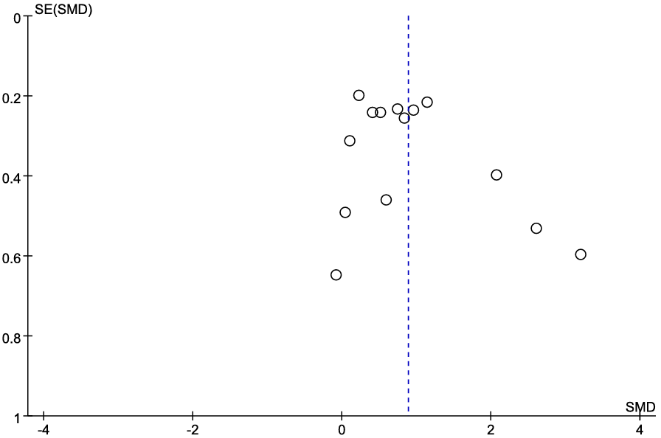
Fig.S1. Funnel plot for publication bias assessment of studies reporting maximum inspiratory pressure.
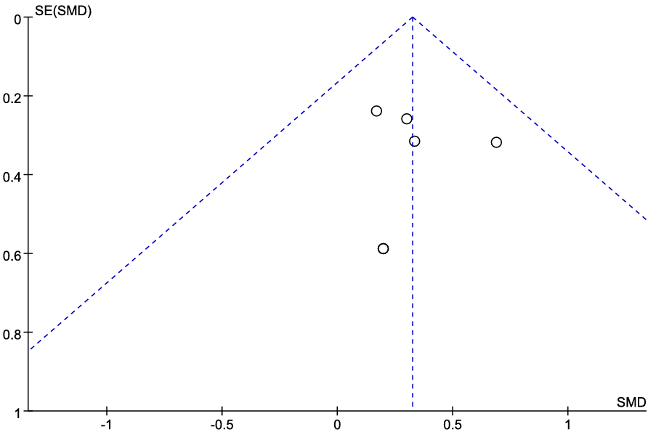
Fig.S2. Funnel plot for publication bias assessment of studies reporting forced vital capacity.
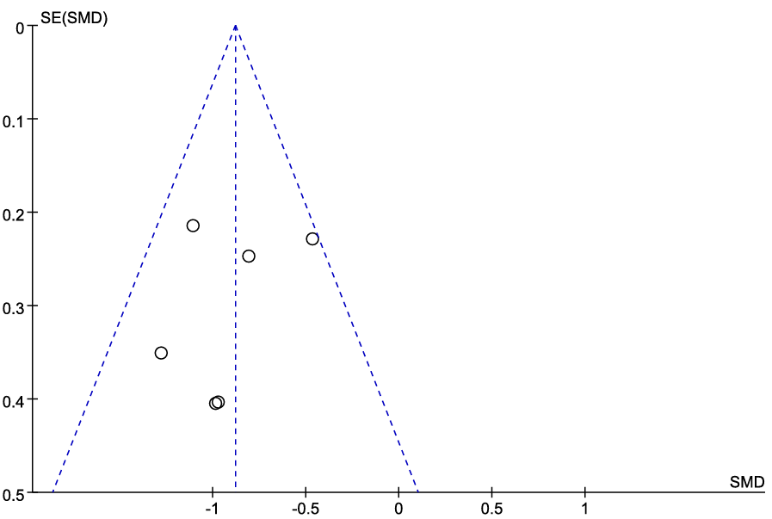
Fig.S3. Funnel plot for publication bias assessment of studies reporting the duration of mechanical ventilation.

