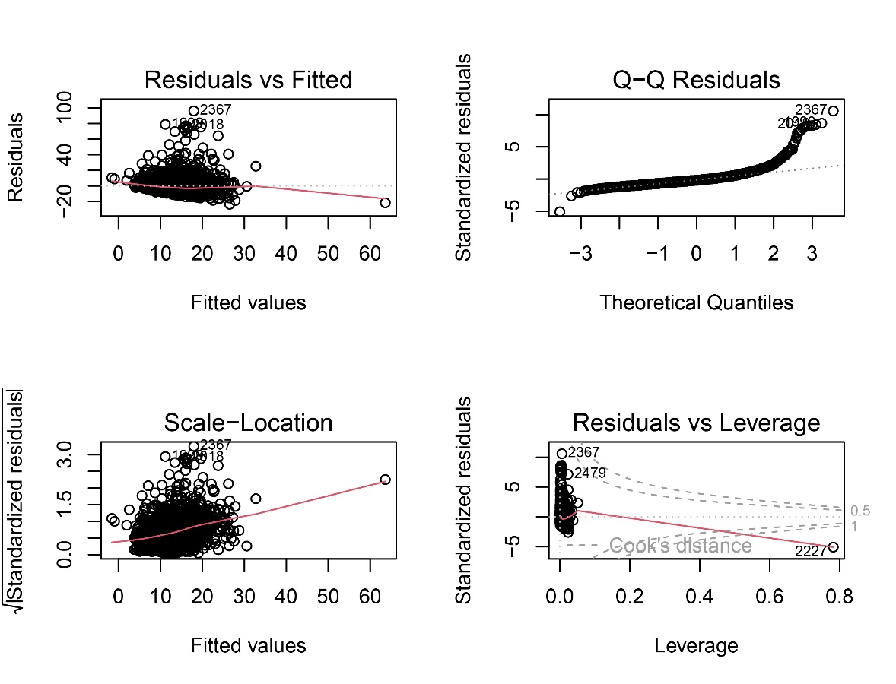
Figure 1. The overall model fit is good, with minor linearity deviations and heteroscedasticity present. The GVIF^(1/(2*Df)) values indicate no multicollinearity issues. Cook’s distance diagnostics suggest the presence of a number of high-leverage influential points, but these do not affect the overall conclusions. The results of the multicollinearity analysis for platelet levels in relation to length of stay (LOS) remain robust.

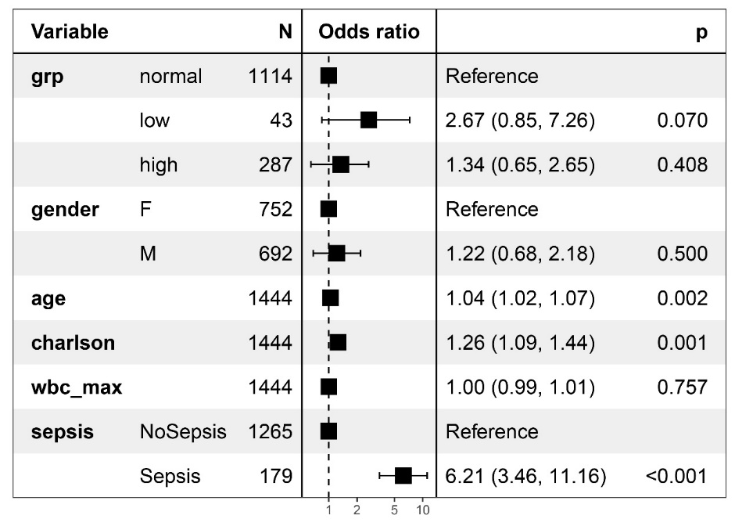
Figure 2. Data from MIMIC-IV is used to validated our results. 1444 first-time admissions with pneumonia as the principal diagnosis (1555 before malignancies and data missing excluded); those with a peak platelet count ≥ 400 ×10⁹/L were classified as thrombocytosis. In this group the sepsis rate was 20.3% and 30-day mortality was 5.17%; thrombocytosis increased the risk of death in overall logistic model.

Table1. Timing of thrombocytosis and thrombocytopenia during hospitalization.
 | Hospital day of 1st increased platelets (n=295) | Number of Cases | Mean days before discharge | Hospital day of 1st decreased platelets (n=281) | Number of Cases | Mean days before discharge
 | 1st | 146 | 14 | 1st | 161 | 14
 | 2nd | 5 | 12 | 2nd | 14 | 17
 | 3rd | 19 | 17 | 3rd | 8 | 15
 | 4th | 15 | 8 | 4th | 8 | 14
 | 5th | 20 | 9 | 5th | 8 | 11
 | 6th | 17 | 6 | 6th | 5 | 19
 | 7th | 10 | 8 | 7th | 6 | 25
 | 8th | 11 | 11 | 8th | 8 | 6
 | 9th | 9 | 8 | 9th | 6 | 8
 | 10th | 8 | 12 | 10th | 2 | 23
 | 11th | 5 | 12 | 11th | 2 | 12
 | 12th | 6 | 22 | 12th | 2 | 14
 | 13th | 4 | 13 | 13th | 1 | 19
 | 14th | 4 | 8 | 14th | 3 | 16
 | 16th | 1 | 3 | 15th | 3 | 16
 | 19th | 1 | 1 | 16th | 4 | 14
 | 20th | 2 | 1 | 17th | 5 | 7
 | 21th | 1 | 11 | 18th | 3 | 13
 | 22th | 2 | 11 | 19th | 1 | 10
 | 24th | 1 | 4 | 20th | 3 | 6
 | 26th | 2 | 25 | 21th | 3 | 8
 | 27th | 1 | 42 | 22th | 3 | 3
 | 28th | 1 | 3 | 23th | 1 | 13
 | 32th | 1 | 1 | 24th | 2 | 15
 | 33th | 2 | 14 | 25th | 2 | 9
 | 44th | 1 | 40 | 26th | 2 | 10
 |  |  |  | 27th | 2 | 19
 |  |  |  | 29th | 2 | 3.5
 |  |  |  | 30th | 1 | 7
 |  |  |  | 32th | 2 | 4
 |  |  |  | 33th | 1 | 22
 |  |  |  | 34th | 1 | 7
 |  |  |  | 36th | 1 | 20
 |  |  |  | 37th | 1 | 1
 |  |  |  | 42th | 1 | 6
 |  |  |  | 48th | 1 | 11
 |  |  |  | 49th | 1 | 4
 |  |  |  | 70th | 1 | 7
Range of Maximum or Minimum Platelet Values (×10⁹/L) |  | 400-1147 |  |  | 1-89

Table 2. Characteristics of pneumonia patients across groups after excluding cancer patients.
 | Thrombocytopenia group  n = 214 | Normal platelet values group  n = 1941 | Thrombocytosis group  n = 267
LOS, days | 17 (10, 30) | 10 (7, 14) | 13 (9, 21)
Mortality | 69 (32.4%) | 64 (3.3%) | 11 (4.1%)
PaO₂, mmHg | 47.6 (35.1, 62.2) | 66.5 (54.7, 77.9) | 65.1 (56.3, 75.2)
CRP, mg/L | 55.2 (13.3, 129.7) | 17.3 (2.8, 61.3) | 55.6 (11.7, 133.7)
PCT, ng/mL | 1.290 (0.293, 6.510) | 0.095 (0.046, 0.289) | 0.197 (0.081, 0.620)

