Table S1 Comparison of participant characteristics: included vs. excluded from analysis (age ≥40 years)
Variables | Excluded participants*  (N=14534) | Included participants  (N=22575) | P Value
Sex |  |  | 0.025
men | 5022 (34.6) | 7545 (33.4)
women | 9512 (65.4) | 15030 (66.6)
Age (years) |  |  | <0.001
40–49 | 2378 (16.4) | 5100 (22.6)
50–59 | 4817 (33.1) | 9887 (43.8)
60–69 | 4412 (30.4) | 5510 (24.4)
≥70 | 2927 (20.1) | 2078 (9.2)
Smokers |  |  | <0.001
Never smoker | 10998 (75.7) | 15861 (70.3)
Former smoker | 811 (5.6) | 2173 (9.6)
Current smoker | 2725 (18.7) | 4541 (20.1)
Region |  |  | <0.001
Longquan | 8576 (59.0) | 9809 (43.5)
Mianzhu | 3002 (20.7) | 5017 (22.2)
Pidu | 2372 (16.3) | 6715 (29.7)
Ganzi | 584 (4.0) | 1034 (4.6)
Note：
* Excluded participants included those who refused, were ineligible, or had spirometry failures or unreliable results.

Table S2 General characteristics of study participants from the four sites
Variables | Mianzhu (N=5017) | Longquan (N=9809) | Pidu (N=6715) | Ganzi (N=1034) | P value
Sex |  |  |  |  | <0.001
men | 1697 (33.8) | 3119 (31.8) | 2425 (36.1) | 304 (29.4)
women | 3320 (66.2) | 6690 (68.2) | 4290 (63.9) | 730 (70.6)
Age (years) |  |  |  |  | <0.001
40–49 | 834 (16.6) | 2786 (28.4) | 1242 (18.5) | 238 (23.0)
50–59 | 1946 (38.8) | 4205 (42.9) | 3250 (48.4) | 486 (47.0)
60–69 | 1532 (30.5) | 2220 (22.6) | 1531 (22.8) | 227 (22.0)
≥70 | 705 (14.1) | 598 (6.1) | 692 (10.3) | 83 (8.0)
Smoking status |  |  |  |  | <0.001
Never-smoker | 3613 (72.0) | 6652 (67.8) | 4812 (71.7) | 768 (74.3)
Former smoker | 589 (11.7) | 883 (9.0) | 570 (8.5) | 131 (12.7)
Current smoker | 815 (16.3) | 2274 (23.2) | 1333 (19.8) | 135 (13.0)
Amount of smoking (pack-years) |  |  |  |  | <0.001
1-9 | 301 (21.4) | 272 (8.6) | 218 (11.5) | 26 (9.8)
10-19 | 345 (24.6) | 345 (10.9) | 309 (16.2) | 32 (12.0)
≥20 | 211 (15.0) | 844 (26.8) | 858 (45.1) | 89 (33.5)
Not available | 547 (39.0) | 1696 (53.7) | 518 (27.2) | 119 (44.7)
Body-mass index (kg/m²) |  |  |  |  | <0.001
＜18.5 (underweight) | 86 (1.7) | 90 (0.9) | 114 (1.7) | 12 (1.2)
18.5-23.9 (normal weight) | 2298 (45.8) | 3849 (39.2) | 2845 (42.4) | 355 (34.3)
24.0-27.9 (overweight) | 1970 (39.3) | 4422 (45.1) | 2816 (41.9) | 445 (43.0)
≥28 (obese) | 515 (10.3) | 1313 (13.4) | 868 (12.9) | 205 (19.9)
Not available | 148 (2.9) | 135 (1.4) | 72 (1.1) | 17 (1.6)
Education level |  |  |  |  | <0.001
Primary school and less | 2262 (45.1) | 1588 (16.2) | 2522 (37.6) | 530 (51.3)
Middle and high school | 2528 (50.4) | 5525 (56.3) | 3962 (59.0) | 425 (41.1)
College and higher | 125 (2.5) | 1504 (15.3) | 188 (2.8) | 68 (6.6)
Not available | 102 (2.0) | 1192 (12.2) | 43 (0.6) | 11 (1.0)
Self-reported diagnosis of hyperglycemia |  |  |  |  | <0.001
Never | 3934 (78.4) | 4992 (50.9) | 6218 (92.6) | 962 (93.0)
Ever | 389 (7.8) | 349 (3.6) | 447 (6.7) | 60 (5.8)
Not available | 694 (13.8) | 4468 (45.5) | 50 (0.7) | 12 (1.2)
Self-reported diagnosis of hypertension |  |  |  |  | <0.001
Never | 3466 (69.1) | 4752 (48.4) | 5499 (81.9) | 810 (78.3)
Ever | 818 (16.3) | 589 (6.0) | 1165 (17.3) | 212 (20.5)
Not available | 733 (14.6) | 4468 (45.6) | 51 (0.8) | 12 (1.2)
Self-reported diagnosis of pulmonary nodule |  |  |  |  | <0.001
Never | 4201 (83.7) | 4927 (50.2) | 6415 (95.6) | 970 (93.8)
Ever | 83 (1.7) | 412 (4.2) | 250 (3.7) | 52 (5.0)
Not available | 733 (14.6) | 4470 (45.6) | 50 (0.7) | 12 (1.2)
Self-reported diagnosis of COPD |  |  |  |  | 0.058
Never | 4298 (85.7) | 4949 (50.4) | 6624 (98.7) | 1022 (98.8)
Ever | 25 (0.5) | 36 (0.4) | 41 (0.6) | 0 (0.0)
Not available | 694 (13.8) | 4824 (49.2) | 50 (0.7) | 12 (1.2)
Spirometry, mean ± SD
FEV₁, L | 2.27 ± 0.58 | 2.41 ± 0.62 | 2.33 ± 0.64 | 2.67 ± 0.68 | <0.001
FVC, L | 2.99 ± 0.72 | 3.14 ± 0.75 | 3.05 ± 0.80 | 3.42 ± 0.85 | <0.001
FEV₁/FVC, % | 0.76 ± 0.09 | 0.77 ± 0.07 | 0.77 ± 0.09 | 0.79 ± 0.06 | <0.001
Abbreviations: SD, standard deviation
Table S3 Prevalence of airflow obstruction (FEV₁/FVC < 0.70) in the general Southwest population aged 40 years or older
Variables | Prevalence (%) in entire population (95% CI) |  |  | Prevalence (%) in never smokers (95% CI)
Variables | Men (N=7545) | Women (N=15030) | Total (N=22575) | Men (N=2603) | Women (N=13242) | Total (N=15845)
All population | 24.6 (23.7–25.6) | 9.6 (9.1–10.1) | 14.6 (14.2–15.1) | 18.9 (17.4–20.4) | 9.5 (9.0–10.0) | 11.0 (10.5–11.5)
P value between groups | <0.001 |  |  | <0.001
Age (years)
40–49 | 9.9 (8.4-11.4) | 4.5 (3.8-5.2) | 6.1 (5.4-6.8) | 9.3 (6.8-11.8) | 4.3 (3.6-5.0) | 5.0 (4.3-5.7)
50–59 | 17.9 (16.5-19.3) | 7.3 (6.7-7.9) | 10.4 (9.8-11.0) | 11.5 (9.5-13.5) | 7.3 (6.7-7.9) | 7.8 (7.2-8.4)
60–69 | 32.8 (30.8-34.8) | 14.2 (13.0-15.4) | 21.4 (20.3-22.5) | 23.1 (20.0-26.2) | 14.3 (13.0-15.6) | 16.0 (14.8-17.2)
≥70 | 47.4 (44.4-50.4) | 27.8 (25.1-30.5) | 37.5 (35.4-39.6) | 39.6 (35.0-44.2) | 26.6 (23.7-29.5) | 30.8 (28.3-33.3)
P value for difference | <0.001 | <0.001 | <0.001 | <0.001 | <0.001 | <0.001
Smoking status
Never smoker | 18.9 (17.4-20.4) | 9.5 (9.0-10.0) | 11.0 (10.5-11.5) | - | - | -
Former smoker | 28.6 (26.2-31.0) | 10.8 (8.6-13.0) | 22.1 (20.4-23.8) | - | - | -
Current smoker | 27.3 (25.8-28.8) | 10.4 (8.5-12.3) | 23.6 (22.4-24.8) | - | - | -
P value for difference | <0.001 | 0.307 | <0.001
Amount of smoking (pack-years)
1-9 | 23.9 (20.6-27.2) | 12.1 (7.1-17.1) | 21.5 (18.7-24.3) | - | - | -
10-19 | 27.6 (24.8-30.4) | 21.4 (11.8-31.0) | 27.2 (24.5-29.9) | - | - | -
≥20 | 29.8 (27.8-31.8) | 25 (10.9-39.1) | 29.7 (27.7-31.7) | - | - | -
P value for difference | 0.014 | 0.065 | <0.001
Body-mass index (kg/m²)
＜18.5 (underweight) | 45.4 (35.5-55.3) | 13.7 (9.0-18.4) | 23.8 (19.0-28.6) | 39.3 (21.2-57.4) | 12.3 (7.4-17.2) | 16.1 (11.0-21.2)
18.5-23.9 (normal weight) | 32.1 (30.4-33.8) | 10.4 (9.7-11.1) | 16.8 (16.0-17.6) | 23.5 (20.7-26.3) | 10.4 (9.6-11.2) | 12.1 (11.3-12.9)
24.0-27.9 (overweight) | 20.2 (18.9-21.5) | 8.7 (8.0-9.4) | 12.9 (12.2-13.6) | 16.5 (14.5-18.5) | 8.6 (7.9-9.3) | 10.2 (9.5-10.9)
≥28 (obese) | 17.9 (15.6-20.2) | 8.9 (7.6-10.2) | 12.1 (10.9-13.3) | 14.9 (11.3-18.5) | 8.4 (7.1-9.7) | 9.6 (8.3-10.9)
P value for difference | <0.001 | 0.001 | <0.001 | <0.001 | 0.004 | <0.001
Education level
Primary school and less | 33.6 (31.6-35.6) | 13.4 (12.4-14.4) | 19.9 (19.0-20.8) | 27.2 (23.9-30.5) | 12.9 (11.9-13.9) | 14.9 (13.9-15.9)
Middle and high school | 22.1 (20.8-23.4) | 8.0 (7.4-8.6) | 12.7 (12.1-13.3) | 16.6 (14.7-18.5) | 8.0 (7.4-8.6) | 9.4 (8.8-10.0)
College and higher | 16.0 (13.5-18.5) | 6.2 (4.8-7.6) | 10.5 (9.1-11.9) | 12.4 (9.1-15.7) | 6.4 (4.9-7.9) | 8.1 (6.7-9.5)
P value for difference | <0.001 | <0.001 | <0.001 | <0.001 | <0.001 | <0.001
Self-reported diagnosis of hyperglycemia
Never | 24.1 (23.0-25.2) | 9.2 (8.7-9.7) | 14.2 (13.7-14.7) | 18.1 (16.3-19.9) | 9.1 (8.5-9.7) | 10.6 (10.0-11.2)
Ever | 23.5 (19.8-27.2) | 11.7 (9.4-14.0) | 16.5 (14.4-18.6) | 19.6 (13.8-25.4) | 10.9 (8.5-13.3) | 12.8 (10.5-15.1)
P value for difference | 0.781 | 0.026 | 0.021 | 0.639 | 0.144 | 0.051
Self-reported diagnosis of hypertension
Never | 23.2 (22.0-24.4) | 9.1 (8.5-9.7) | 13.7 (13.1-14.3) | 17.1 (15.2-19.0) | 9.0 (8.4-9.6) | 10.2 (9.6-10.8)
Ever | 27.3 (24.7-29.9) | 11.4 (9.9-12.9) | 18.0 (16.6-19.4) | 22.5 (18.6-26.4) | 11.2 (9.6-12.8) | 13.9 (12.3-15.5)
P value for difference | 0.004 | 0.002 | <0.001 | 0.009 | 0.007 | <0.001
Self-reported diagnosis of pulmonary nodule
Never | 23.9 (22.8-25.0) | 9.4 (8.9-9.9) | 14.3 (13.8-14.8) | 18.2 (16.5-19.9) | 9.2 (8.6-9.8) | 10.7 (10.1-11.3)
Ever | 26.8 (21.5-32.1) | 9.5 (7.0-12.0) | 15.4 (12.9-17.9) | 19.2 (11.4-27.0) | 10.0 (7.0-13.0) | 11.9 (9.0-14.8)
P value for difference | 0.268 | 0.921 | 0.372 | 0.806 | 0.605 | 0.424
Abbreviations: CI, confidence interval

Table S4 Prevalence of airflow obstruction (FEV₁/FVC < 0.70) across four sites

Sites | Total participants | Number of events | Crude prevalence (95% CI) | P value | Adjusted prevalence (95% CI)* | P value
Mianzhu | 5017 | 881 | 17.6 (16.5–18.6) | <0.001 | 13.9 (13.0–14.9) | <0.001
Pidu | 6715 | 1119 | 16.7 (15.8–17.6) | <0.001 | 14.9 (14.0–15.8) | <0.001
Longquan | 9809 | 1212 | 12.4 (11.7–13.0) | <0.001 | 12.8 (12.1–13.5) | <0.001
Ganzi | 1034 | 87 | 8.4 (6.7–10.1) | <0.001 | 8.0 (6.5–9.9) | <0.001
* Prevalence adjusted for age and sex
Abbreviation: CI, confidence interval

Table S5 Development and validation of the risk prediction model for airflow obstruction (FEV₁/FVC < LLN)

Dataset* | AUC | Accuracy | Sensitivity | Specificity | PPV | NPV
Longquan | 0.642 | 0.677 | 0.509 | 0.70 | 0.189 | 0.912
Mianzhu | 0.725 | 0.608 | 0.756 | 0.579 | 0.261 | 0.924
Pidu | 0.621 | 0.595 | 0.583 | 0.597 | 0.224 | 0.878
Ganzi | 0.648 | 0.619 | 0.561 | 0.626 | 0.140 | 0.929

Notes:
* The data from Longquan were used to develop the risk model while the other three datasets were used for validation. Predictors in the model: sex, age, smoking status, body-mass index, education level, sleep disturbance due to wheezing. Exposure to biomass fuel was not analyzed due to missing data. The threshold of the model was determined by the Youden index in the training set (0.122).
Model performance: Accuracy = (True Positives + True Negatives) / (Total Population), the ratio of correctly predicted participants to the total population. Sensitivity=True Positives / (True Positives + False Negatives), the proportion of actual positives that were correctly identified. Specificity=True Negatives / (True Negatives + False Positives), the proportion of actual negatives that were correctly identified. PPV=True Positives / (True Positives + False Positives), the probability that participants with a positive test truly have the airflow obstruction. NPV=True Negatives / (True Negatives + False Negatives), the probability that participants with a negative test truly do not have the airflow obstruction.
Abbreviations: AUC, area under the curve; PPV, positive predictive value; NPV, negative predictive value

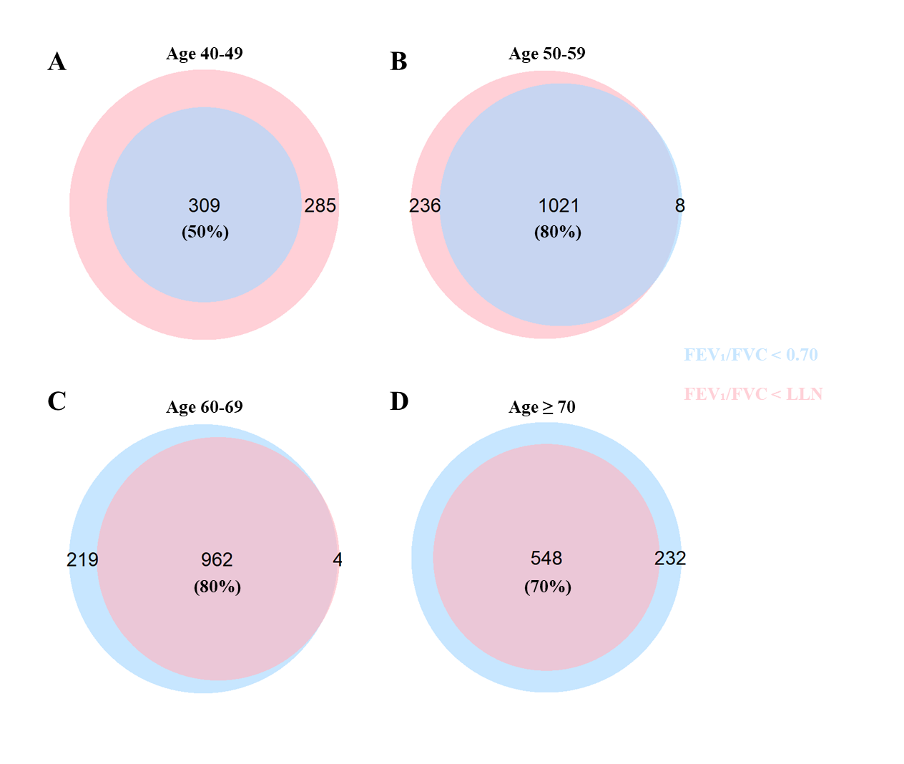
Figure S1 Concordance in airflow obstruction classification between fixed ratio and LLN criteria. (A) 40-49 age group; (B) 50-59 age group; (C) 60-69 age group; (D) ≥70 age group. LLN: lower limit of normal.

Figure S2 Age-specific prevalence of airflow obstruction (FEV₁/FVC < 0.70). (A) Between men and women; (B) Among never-smokers, former smokers and current smokers.

Figure S3 Self-reported diagnosis of COPD and presence of respiratory symptoms among patients with airflow obstruction (FEV₁/FVC < 0.70). (A)Self-reported diagnosis of COPD; (B) Presence of respiratory symptoms (wheezing, breathlessness and/or chest tightness). COPD: chronic obstructive pulmonary disease.

