Supplementary Methods S1: Multidimensional Parameter Optimization Framework for AWRI
To select the optimal age-weighting parameter k in the AWRI formula (AWRI = RDW × (1 + age/k)), we evaluated seven candidate values (k = 25, 50, 75, 100, 125, 150, 200) using a pre-specified multidimensional scoring framework. For each candidate k, an independent AWRI variable was calculated, patients were divided into quartiles based on its distribution, and a Cox proportional hazards regression model was fitted to derive performance metrics. No information was shared across candidate models, ensuring unbiased comparison.
The framework incorporated four evaluation criteria. First, discriminative ability was quantified by the area under the receiver operating characteristic curve (AUC), with 95% confidence intervals computed using the pROC package. Second, effect size was assessed by the hazard ratio comparing the highest quartile (Q4) to the lowest quartile (Q1), reflecting the magnitude of risk stratification achievable with each parameterisation. Third, dose-response trend significance was evaluated by entering AWRI quartiles as a continuous variable (coded 1–4) in a Cox model and extracting the P-value for linear trend, validating the biological plausibility of a monotonic relationship. Fourth, clinical interpretability was scored on a 0–100 scale based on the ease of bedside calculation and communication of the resulting index.
Raw scores on each dimension were standardised to a 0–100 scale using min-max normalisation: Score = (Value − Minimum) / (Maximum − Minimum) × 100. A weighted composite score was then computed as: Composite Score = 0.35 × AUC score + 0.25 × HR score + 0.25 × Trend score + 0.15 × Interpretability score. Weight allocation followed established frameworks: discriminative ability received the highest weight (35%) consistent with its primacy in the TRIPOD+AI reporting guidelines [19–20]; effect size and trend significance each received 25%, reflecting their roles in quantifying clinical benefit magnitude and biological validity respectively, consistent with multi-criteria decision analysis (MCDA) frameworks used in health technology assessment [21–22]; clinical interpretability received 15%, following standard MCDA principles for practical feasibility indicators [23].
A pre-specified decision rule governed parameter selection when composite score differences were small: if two candidate k values yielded scores within 10 points of each other, clinical interpretability served as the tiebreaker. This rule was established and documented prior to examining the full comparison results to prevent post-hoc justification. Per-parameter performance metrics and composite scores are presented in Supplementary Table S2.

Supplementary Methods S2: Exploratory Analysis of the Age-RDW Relationship
To provide an empirical foundation for the linear construction of AWRI, we conducted a systematic exploratory analysis of the relationship between age and RDW prior to index construction. Three complementary analytical approaches were employed.
First, Pearson correlation analysis quantified the linear association between age and RDW and evaluated its statistical significance. Second, LOESS (locally weighted scatterplot smoothing) curves were fitted alongside simple linear regression lines in a scatter plot of age versus RDW, allowing visual comparison of linear and nonlinear patterns across the full age range. Third, generalized additive models (GAM) using thin plate splines—with degrees of freedom automatically selected by generalized cross-validation (GCV) criteria—were compared against simple linear models by evaluating the percentage of deviance explained by each approach.
These analyses revealed a statistically significant but weak positive association (r = 0.0537, P < 0.001), and LOESS smoothing curves showed high consistency with linear regression fitting across the observed age range (Supplementary Figure S2A). Comparative evaluation of GAM versus the linear model showed that GAM improved explained deviance from 0.29% to 0.65%—a 124% relative improvement but an absolute gain of only 0.36 percentage points (Supplementary Figure S2C–D). On parsimony grounds, this negligible absolute improvement did not justify the added complexity of nonlinear adjustment [32–33], supporting adoption of the linear weighted form AWRI = RDW × (1 + age/k) for index construction. Prior to Pearson correlation analysis, normality of both age and RDW was assessed using the Kolmogorov–Smirnov test with Lilliefors correction, given the large sample size (n = 24,709). Both variables satisfied the normality assumption (age: D = 0.032, P = 0.21; RDW: D = 0.028, P = 0.18), confirming the appropriateness of Pearson correlation for quantifying the linear age–RDW association.

Supplementary Methods S3：Machine Learning Feature Engineering and SHAP Interpretability Analysis
S3.1 Feature Engineering: Detailed Protocol
Feature engineering proceeded in two sequential stages designed to minimise multicollinearity while preserving predictive information across physiological domains.
In the first stage, pairwise Pearson correlation coefficients were computed for all 27 continuous clinical variables available at ICU admission. Variable pairs with absolute correlation coefficients exceeding 0.50 were flagged as redundant. Within each redundant pair, the variable with lower ensemble importance (see Stage 2) was removed. This threshold was chosen as a pragmatic balance between eliminating clear redundancy — such as the well-known co-linearity among haemodynamic parameters (SBP, DBP, MAP; r > 0.8) and between haematological indices (haemoglobin and haematocrit) — while retaining variables that carry partially independent prognostic signal. The full correlation matrix prior to filtering is shown in Supplementary Figure S4A.
In the second stage, feature importance was estimated independently using three tree-based models: Random Forest, LightGBM, and XGBoost, each trained on the full training set with their respective default hyperparameters. For each model, variables were ranked by mean decrease in impurity (Random Forest) or gain-based importance (LightGBM, XGBoost). A variable was retained in the final feature set if it ranked among the top 20 features in at least two of the three models. This ensemble-based criterion guards against the known instability of single-model importance rankings, particularly in the presence of correlated features. The final set of 17 variables and their importance ranks across the three models are visualised in Supplementary Figure S4B. All categorical and binary variables (comorbidities, treatment indicators) were included without the correlation filter, as multicollinearity assessment via Pearson correlation is not meaningful for binary variables; their inclusion or exclusion was determined solely by the ensemble importance ranking.
S3.2 SHAP Analysis: Technical Details
SHAP (SHapley Additive exPlanations) values were computed for the trained XGBoost model using the TreeExplainer algorithm, which provides exact Shapley value decomposition for tree-based models without approximation. The TreeExplainer was initialised with the trained XGBoost model and applied independently to the training set (n = 17,296) and the held-out test set (n = 7,413) to confirm that feature importance rankings and dependence patterns were stable across both datasets rather than artefacts of overfitting.
Global feature importance was summarised as the mean absolute SHAP value across all samples for each feature, yielding a ranking that reflects each variable's average contribution magnitude to individual-level mortality risk predictions. This metric is distinct from the hazard ratio derived from Cox regression: whereas the hazard ratio quantifies a variable's average population-level association with mortality after covariate adjustment, the mean absolute SHAP value quantifies how much unique predictive information that variable contributes relative to all other variables simultaneously in a nonlinear model — a question Cox regression is structurally unable to answer.
SHAP dependence plots were constructed for AWRI by plotting each patient's SHAP value against their AWRI value, with a LOESS smoothing curve overlaid to highlight the aggregate nonlinear trend. These plots were generated separately for the training and test sets. The four-stage pattern identified in the dependence plots (negative contributions at AWRI 15–20%, rapid transition at 20–25%, sustained positive contributions at 25–40%, plateau above 40%) was considered robust only because it replicated consistently across both datasets and corresponded closely to the inflection points identified by the independent restricted cubic spline analysis. Analyses were implemented using the shap package (version 0.48.0) in Python 3.11.7. Dependence plots were generated using shap.dependence_plot() with interaction_index set to None to isolate the marginal AWRI effect.
Characteristic | Missing Count | Missing Ratio(%)
Albumin † | 11242 | 45.497592
Oxygenation_Index | 7765 | 31.425796
Avg_paCO2 | 3843 | 15.553037
Avg_PH | 3841 | 15.544943
Bicarbonate | 1906 | 7.713788
Platelets | 1728 | 6.993403
WBC | 1673 | 6.770812
Calcium | 1617 | 6.544174
Hemoglobin | 1521 | 6.155652
Hematocrit | 1511 | 6.115181
Avg_DBP | 1317 | 5.330042
Avg_SBP | 1317 | 5.330042
Avg_MAP | 1315 | 5.321947
BUN | 1107 | 4.480149
eGFR | 1092 | 4.419442
Creatinine | 1088 | 4.403254
Sodium | 1079 | 4.36683
Chloride | 1070 | 4.330406
Potassium | 893 | 3.614068
BMI | 743 | 3.007001
Avg_Temperature | 694 | 2.808693
MCV | 574 | 2.32304
Avg_Resprate | 109 | 0.441135
Avg_SpO2 | 67 | 0.271156
Avg_Heartrate | 41 | 0.165931

Supplementary Table S1.Missing Value Distribution of Clinical Variables in this study.
† Albumin was excluded from all analyses because its missing rate (45.50%) exceeded the pre-specified 40% exclusion threshold.
Complete-data variables: Age, Sex, Race, APACHE IV Score, Acute Physiology Score, RDW, all comorbidity variables (n=17), all treatment intervention variables (n=11), and all outcome variables had no missing values and are not listed above.
For all other variables with missing data, continuous variables were imputed using random forest-based multiple imputation and categorical variables using mode imputation. Imputation quality was validated by kernel density estimation comparing pre- and post-imputation distributions (Supplementary Figure S1).
Abbreviations: Avg, first-day admission average; BMI, body mass index; BUN, blood urea nitrogen; DBP, diastolic blood pressure; eGFR, estimated glomerular filtration rate; MAP, mean arterial pressure; MCV, mean corpuscular volume; paCO₂, arterial carbon dioxide partial pressure; RDW, red cell distribution width; SBP, systolic blood pressure; SpO₂, peripheral oxygen saturation; WBC, white blood cell count.
（A） | （B） | （C） | （D）
（E） | （F） | （G） | （H）
（I） | （J） | （K） | （L）
（M） | （N） | （O） | （P）
（Q） | （R） | （S） | （T）
（U） | （V） | （W） | （X）
Supplementary Figure S1. Multiple Imputation Sensitivity Analysis for Clinical Variables with Missing Values in ICU Patients with Acute Respiratory Failure.
This figure presents a comprehensive sensitivity analysis of the multiple imputation process across 24 clinical variables that contained missing values, displayed as kernel density plots comparing pre-imputation (blue lines) and post-imputation (red lines) distributions.
The density plots demonstrate that the multiple imputation process successfully preserved the original distributional characteristics of each clinical variable. Across all 24 variables shown (A-X), including physiological parameters (oxygenation index, blood pressure measurements, heart rate), laboratory indicators (blood gases, electrolytes, renal function markers), and hematological parameters (blood counts, hemoglobin levels), the pre- and post-imputation curves show remarkable overlap. This near-perfect alignment indicates that the imputation algorithm maintained the underlying statistical properties and biological patterns inherent in the original data.

（A）  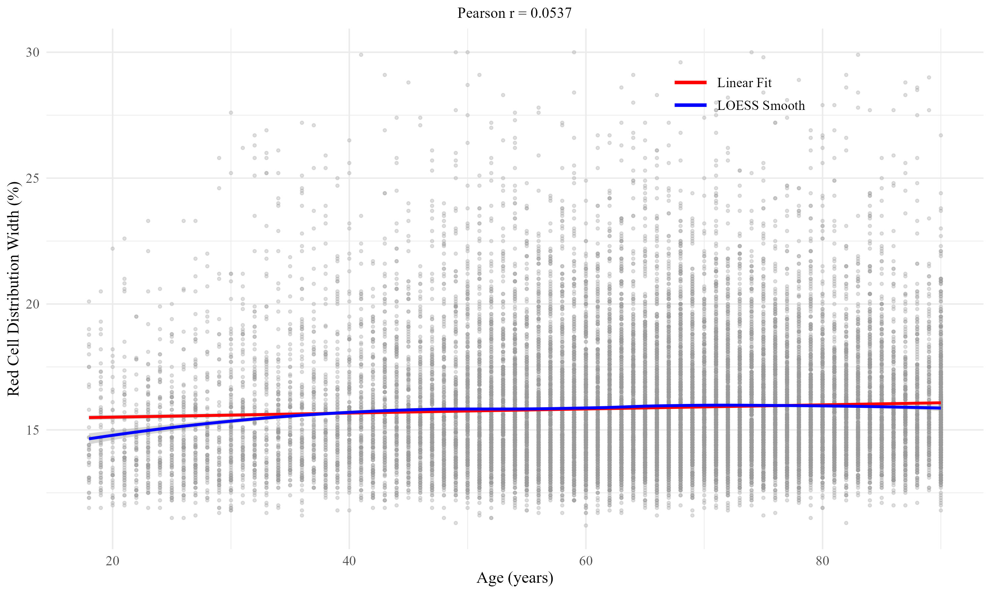 | （B）  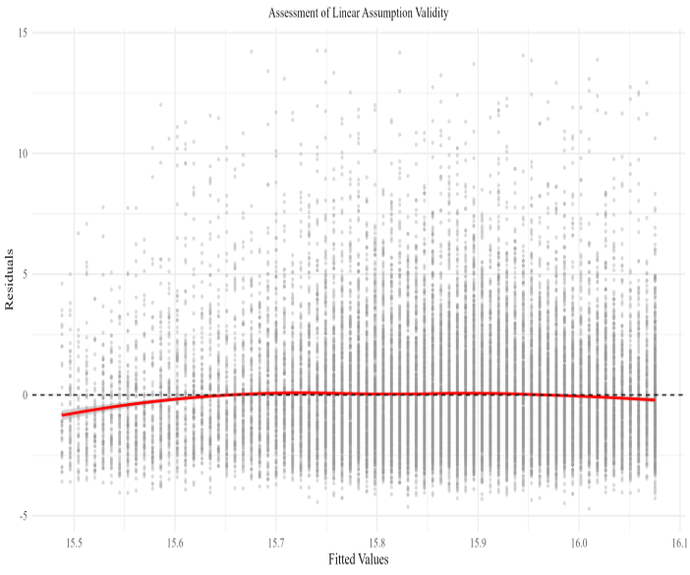 |  | （C）  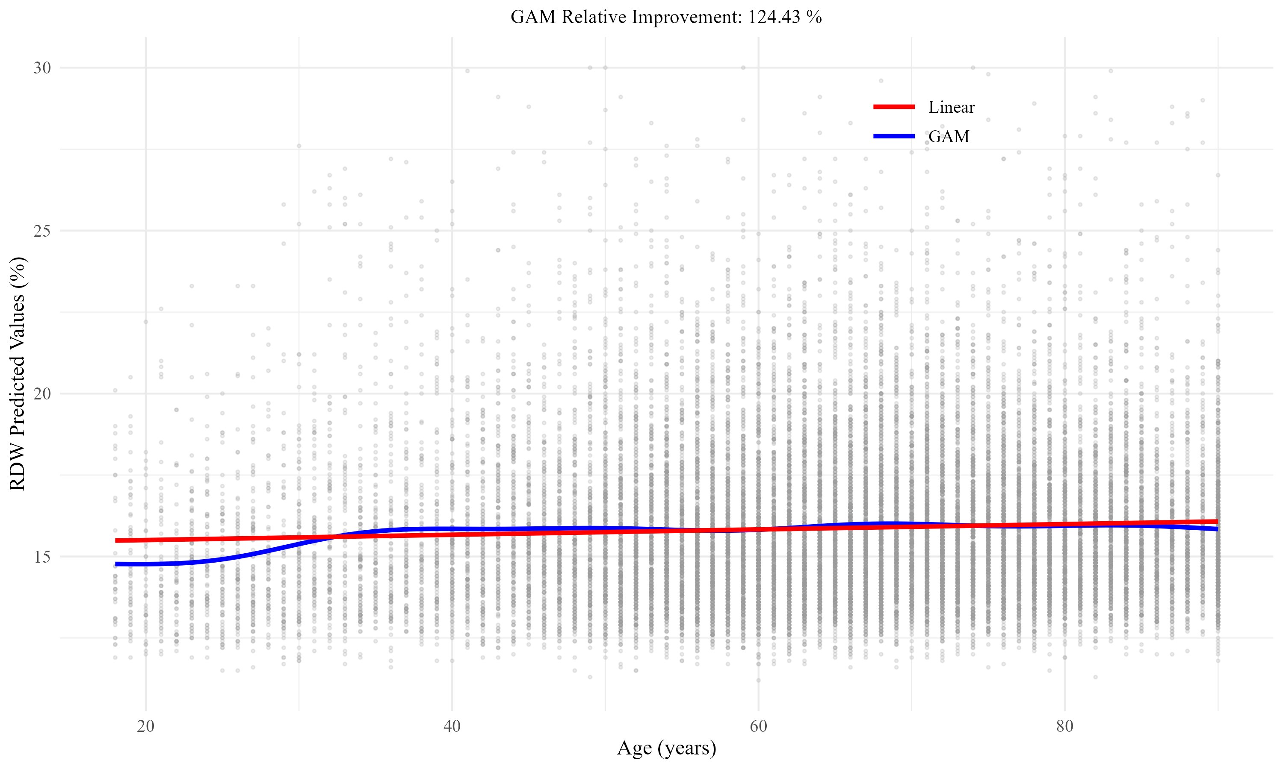
（D）
Parameter |  | Value
Sample Size |  | 24,709
Age, years (Mean ± SD) |  | 64.5 ± 15.7
RDW, % (Mean ± SD) |  | 15.87 ± 2.38
Pearson Correlation Coefficient |  | 0.0537
Correlation p-value |  | <0.001
Linear Model R² |  | 0.002884
GAM Model R² |  | 0.006472
GAM Relative Improvement (%) |  | 124.43
GAM Absolute Improvement (percentage points) |  | 0.36
Supplementary Figure S2.Methodological validation of linear relationship assumptions for age-weighted red cell distribution width index construction.
(A)Foundational correlation analysis between age and red cell distribution width. Scatter plot demonstrates the weak positive correlation (Pearson r = 0.0537, P < 0.001) between patient age and red cell distribution width that provides the theoretical foundation for age adjustment. Individual data points (grey, α = 0.3, n = 24,709) represent critically ill patients with acute respiratory failure. The near-perfect concordance between linear regression (red line) and LOESS smoothing curves (blue line) supports the appropriateness of linear modeling approaches. The weak but statistically significant correlation supports the rationale for linear age adjustment while confirming that age and RDW encode largely independent biological information.
(B) Linear model assumption validation through residual analysis. Diagnostic plot evaluating the validity of linear regression assumptions by examining the distribution of residuals against fitted values from the age-RDW linear model. The random scatter of residuals around zero (black dashed horizontal line) with no systematic patterns indicates satisfaction of key linear model assumptions including homoscedasticity and absence of non-linear relationships. The red LOESS smoothing line remains approximately horizontal across all fitted values, confirming the absence of systematic bias. Successful validation of these assumptions supports the theoretical foundation for implementing simple linear adjustment methods in AWRI construction.
(C) Comparative performance evaluation between linear and generalized additive models. Direct comparison of predictive performance demonstrates near-identical prediction curves between linear regression (red line) and generalized additive modeling (blue line) approaches across the entire age spectrum. Despite a substantial relative improvement of 124.43% in explained deviance for the GAM model, the visual overlay of prediction lines illustrates that this represents minimal absolute improvement (0.36 percentage points). This finding exemplifies the application of Occam's razor principle in statistical modeling, where the simpler linear approach is preferred when complex non-linear methods provide negligible practical benefits [32–33]. The grey background points represent the same patient cohort as in panels A and B, maintaining visual consistency across the analytical sequence.
(D) Statistical Summary of Age-RDW Relationship Analysis and Model Comparison.Abbreviations: RDW, red cell distribution width; GAM, generalized additive model; SD, standard deviation.Statistical significance was set at p < 0.05. The correlation analysis demonstrates a statistically significant but weak association between age and RDW. Model comparison reveals that while GAM shows substantial relative improvement over linear modeling, the absolute improvement remains minimal, supporting the use of simpler linear adjustment methods for AWRI construction.

(A)
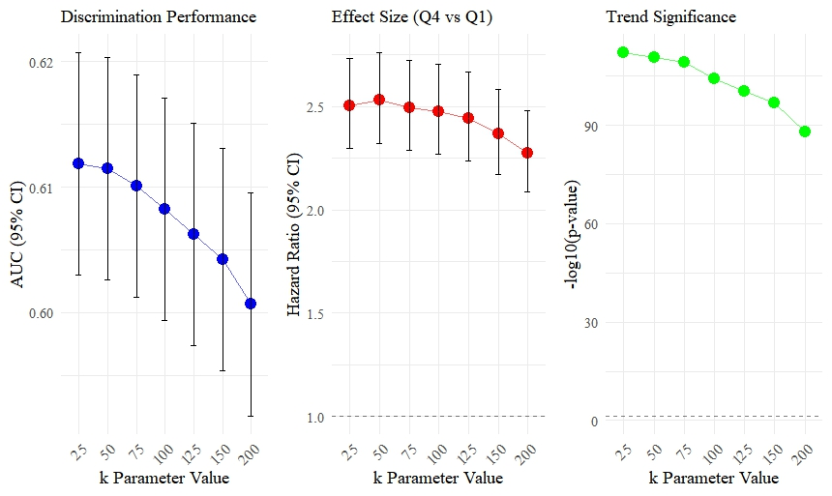

(B)
k Parameter | AUC (95% CI) | HR Q4 vs Q1 (95% CI) | Trend P-value | Composite Score | Selection Status
25 | 0.612 (0.603-0.621) | 2.50 (2.30-2.73) | <0.001 | 66.31 | Candidate
50 | 0.612 (0.603-0.620) | 2.53 (2.32-2.76) | <0.001 | 72.56 | Best Statistical Performance
75 | 0.610 (0.601-0.619) | 2.50 (2.29-2.72) | <0.001 | 63.00 | Candidate
100 | 0.608 (0.599-0.617) | 2.48 (2.27-2.70) | <0.001 | 66.37 | Final Selection
125 | 0.606 (0.597-0.615) | 2.44 (2.24-2.67) | <0.001 | 54.90 | Candidate
150 | 0.604 (0.595-0.613) | 2.37 (2.17-2.59) | <0.001 | 42.34 | Alternative
200 | 0.601 (0.592-0.610) | 2.27 (2.09-2.48) | <0.001 | 28.00 | Not Recommended

(C)
k Parameter | HR Q2 (95% CI) | HR Q3 (95% CI) | HR Q4 (95% CI) | AUC Score | HR Score | Trend Score | Interpretability Score
25 | 1.35 (1.23-1.49) | 1.83 (1.67-2.00) | 2.50 (2.30-2.73) | 100.0 | 89.2 | 0.0 | 60.0
50 | 1.41 (1.28-1.56) | 1.83 (1.67-2.00) | 2.53 (2.32-2.76) | 96.6 | 100.0 | 7.0 | 80.0
75 | 1.40 (1.27-1.54) | 1.88 (1.72-2.06) | 2.50 (2.29-2.72) | 83.8 | 85.8 | 12.9 | 60.0
100 | 1.44 (1.31-1.59) | 1.89 (1.73-2.06) | 2.48 (2.27-2.70) | 67.2 | 78.6 | 32.8 | 100.0
125 | 1.45 (1.32-1.60) | 1.88 (1.72-2.06) | 2.44 (2.24-2.67) | 49.5 | 65.6 | 48.8 | 60.0
150 | 1.39 (1.26-1.53) | 1.83 (1.67-2.01) | 2.37 (2.17-2.59) | 31.8 | 37.2 | 63.6 | 40.0
200 | 1.38 (1.25-1.52) | 1.78 (1.62-1.95) | 2.27 (2.09-2.48) | 0.0 | 0.0 | 100.0 | 20.0

Supplementary Figure S3.AWRI Parameter Optimization: Comprehensive Performance Analysis.
(A) Multi-dimensional Parameter Performance Visualization: Three-panel visualization demonstrating the systematic evaluation of age adjustment intensity parameters (k = 25-200) across key performance metrics. The left panel shows discrimination performance (AUC with 95% confidence intervals), revealing optimal performance at lower k values with gradual decline as k increases. The middle panel displays effect size magnitude (hazard ratios for Q4 vs Q1 comparison with 95% confidence intervals), demonstrating strongest risk stratification at k = 50-75 with progressive attenuation at higher values. The right panel illustrates trend significance (-log10 p-values from dose-response testing), showing consistently strong statistical significance across all parameters with slight decline at extreme values. This comprehensive visualization supports the balanced parameter selection approach by revealing the multi-dimensional trade-offs inherent in age adjustment intensity.
(B) Core Performance Metrics and Selection Decision. (C) Detailed Risk Stratification and Multi-dimensional Scoring.
Legend: AWRI, Age-Weighted Red Cell Distribution Width Index; AUC, area under the receiver operating characteristic curve; HR, hazard ratio; CI, confidence interval; Q2, Q3, Q4, second, third, and fourth quartiles respectively with Q1 as reference. Panel A presents the primary decision matrix for parameter selection, where AWRI = RDW × (1 + age/k) and k represents the age adjustment intensity parameter. Each k value underwent independent model evaluation using Cox proportional hazards regression with quartile-based risk stratification across the complete dataset of 24,709 acute respiratory failure patients. Composite scores were calculated using weighted criteria: discrimination ability (35%), effect size (25%), dose-response relationship (25%), and clinical interpretability (15%). Parameter k=100 was selected as optimal based on balanced performance across all criteria and superior clinical interpretability, representing "10% RDW weight increase per decade of age." Panel B provides detailed risk stratification results and component scores underlying the composite evaluation. All hazard ratios were adjusted for age, gender, comorbidities, and disease severity scores. Performance scores utilized min-max normalization: Score = (Value - Minimum)/(Maximum - Minimum) × 100. Trend P-values derived from Cox regression treating AWRI quartiles as ordinal variables.

Variable | AWRI₅₀ (k = 50) | AWRI₁₀₀ (k = 100)
Parameter optimization metrics
AUC (single-indicator discrimination) | 0.612 | 0.608
Composite optimization score, points | 72.56 (highest) | 66.37
Clinical interpretability score, points | — | 100 (highest)
Model 1 — unadjusted
Q1 (reference) | 1.00 (ref) | 1.00 (ref)
Q2: HR (95% CI) | 1.41 (1.28–1.55) | 1.45 (1.32-1.59)
Q3: HR (95% CI) | 1.85 (1.68–2.02) | 1.75 (1.60-1.92)
Q4: HR (95% CI) | 2.52 (2.31–2.75) | 2.26 (2.08-2.47)
P for trend | <0.001 | <0.001
Model 2 — partially adjustedª
Q1 (reference) | 1.00 (ref) | 1.00 (ref)
Q2: HR (95% CI) | 1.12 (1.01–1.24) | 1.14 (1.03-1.26)
Q3: HR (95% CI) | 1.27 (1.13–1.42) | 1.27 (1.14-1.40)
Q4: HR (95% CI) | 1.59 (1.42–1.79) | 1.49 (1.35-1.65)
P for trend | <0.001 | <0.001
Model 3 — fully adjusted^{b}
Q1 (reference) | 1.00 (ref) | 1.00 (ref)
Q2: HR (95% CI) | 1.09 (0.98–1.21) † | 1.13 (1.02-1.25)
Q3: HR (95% CI) | 1.27 (1.13–1.42) | 1.22 (1.10-1.36)
Q4: HR (95% CI) | 1.51 (1.34–1.71) | 1.42 (1.28-1.59)
P for trend | <0.001 | <0.001

Supplementary Table S2. AWRI parameter optimisation results and sensitivity analysis comparing k = 50 and k = 100.
The table below presents the raw performance metrics and composite scores for each of the seven candidate k values evaluated during AWRI parameter optimisation. For each k, performance was assessed on four dimensions: discriminative ability (AUC for in-hospital mortality), effect size (hazard ratio Q4 vs. Q1 from Cox regression), dose-response trend significance (P-value for quartile trend), and clinical interpretability (0–100 subjective score). Raw values were min-max normalised to a 0–100 scale before weighting. Composite scores were computed as the weighted sum of the four normalised dimension scores (weights: AUC 35%, HR 25%, trend significance 25%, interpretability 15%), as described in Supplementary Methods S1. The pre-specified decision rule stipulated that when two candidates scored within 10 points of each other on the composite scale, clinical interpretability would serve as the tiebreaker. k = 50 achieved the highest composite score (72.56), and k = 100 achieved the second-highest (66.37); because the difference (6.19 points) fell within the pre-specified 10-point margin, k = 100 was selected on the basis of superior clinical interpretability—its formulation as "a 10% increment in RDW weight per decade of age" is substantially more amenable to bedside recall and clinical communication than k = 50.
a Model 2 adjusted for age, sex, race, BMI, heart rate, respiratory rate, systolic and diastolic blood pressure, oxygen saturation, body temperature, and oxygenation index.
b Model 3 further adjusted for comorbidities (myocardial infarction, congestive heart failure, cerebrovascular disease, chronic pulmonary disease, diabetes, renal disease, hypertension, sepsis, and others), laboratory indices (electrolytes, renal function markers, haematological parameters), and treatment variables (mechanical ventilation, vasopressor use, insulin, β-blockers, and others).
† P = 0.118 (not statistically significant at the 0.05 level). All other Q2–Q4 comparisons with Q1 reached P < 0.05. AWRI = RDW × (1 + age/k). AUC values are compared using the DeLong method (P < 0.001).

 | Model 1 | Model 2 | Model 3
AWRI-specific
χ² (df = 3) | 3.248 | 4.027 | 4.297
P-value | 0.355 | 0.259 | 0.231
Global
χ² | 3.248 | 110.475 | 310.597
df | 3 | 13 | 37
P-value | 0.355 | < 0.001 | < 0.001

Supplementary Table S3. Schoenfeld Residuals Test for Proportional Hazards Assumption.
Proportional hazards assumption was assessed using the Schoenfeld residuals test (cox.zph()). AWRI-specific P values were non-significant across all models, confirming that the primary exposure satisfied the assumption throughout the follow-up period. Global violations observed in Models 2 and 3 were attributable to clinical covariates with known time-varying effects (including congestive heart failure, body temperature, vasopressor use, and cerebrovascular disease) rather than to AWRI itself, a pattern expected in large cohort studies (n = 24,709) where the Schoenfeld test has high sensitivity to minor time-dependent covariate effects.

（A）
AWRI  Quartiles | Original Model  HR (95% CI) | Post-Early Death Exclusion HR (95% CI)
Q2 vs Q1 | 1.13 (1.02-1.25) | 1.14 (1.02-1.27)
Q3 vs Q1 | 1.22 (1.10-1.36) | 1.23 (1.10-1.38)
Q4 vs Q1 | 1.42 (1.28-1.59) | 1.42 (1.27-1.60)
（B）
Adjustment Variables | Q4 vs Q1 HR (95% CI) | Attenuation Rate
Base model | 1.424 (1.277-1.586) | -
+ RDW measurement count | 1.419 (1.275-1.580) | 1.2%
+ Average sampling interval | 1.417 (1.271-1.580) | 1.6%
+ Both adjustments | 1.439 (1.292-1.604) | -.3.5%
（C）
Comparison Groups | AUC1 (95% CI) | AUC2 (95% CI) | ΔAUC | Z.value | P.value
AWRI vs Hemoglobin | 0.608 (0.594-0.612) | 0.522 (0.512-0.531) | 0.081 | 15.6 | ＜0.001
AWRI vs Hematocrit | 0.608 (0.594-0.612) | 0.523 (0.513-0.532) | 0.080 | 14.8 | ＜0.001
AWRI vs MCV | 0.608 (0.594-0.612) | 0.514 (0.505-0.524) | 0.089 | 13.0 | ＜0.001
AWRI vs Baseline RDW | 0.608 (0.594-0.612) | 0.572 (0.563-0.581) | 0.031 | 11.6 | ＜0.001

Supplementary Table S4. Sensitivity Analysis of the Association Between Age-Weighted RDW Index and In-Hospital Mortality in ICU Patients with Acute Respiratory Failure.
Abbreviations: AWRI (Age-Weighted RDW Index); HR (Hazard Ratio); CI (Confidence Interval); AUC (Area Under the Curve); RDW (Red Cell Distribution Width); MCV (Mean Corpuscular Volume); Q1-Q4 represent quartiles of AWRI values.
(A) Early Death Exclusion Analysis: Sensitivity analysis excluding patients who died within the first 3 days of ICU admission to address potential reverse causation bias. AWRI quartile cutoffs were recalculated after exclusion. Hazard ratios were calculated using the fully adjusted Cox proportional hazards model (Model 3) with Q1 as the reference group.
(B) Hematological Measurement Adjustment Analysis: Additional sensitivity analysis adjusting for potential measurement bias by including RDW measurement frequency (total number of RDW measurements during ICU stay) and average sampling interval between RDW measurements. The base model represents the fully adjusted model (Model 3) without these additional adjustments. Attenuation rate calculated as: [(Base HR - Adjusted HR) / (Base HR - 1)] × 100%.
(C) Comparative Predictive Performance Analysis: Receiver operating characteristic (ROC) curve analysis comparing the discriminative ability of AWRI versus other hematological parameters for predicting in-hospital mortality. AUC1 represents AWRI performance, AUC2 represents the comparator variable performance. ΔAUC represents the difference in AUC values. P-values were calculated using DeLong's test for comparing correlated ROC curves. All models were adjusted for the same covariates as the fully adjusted model (Model 3)
（A）
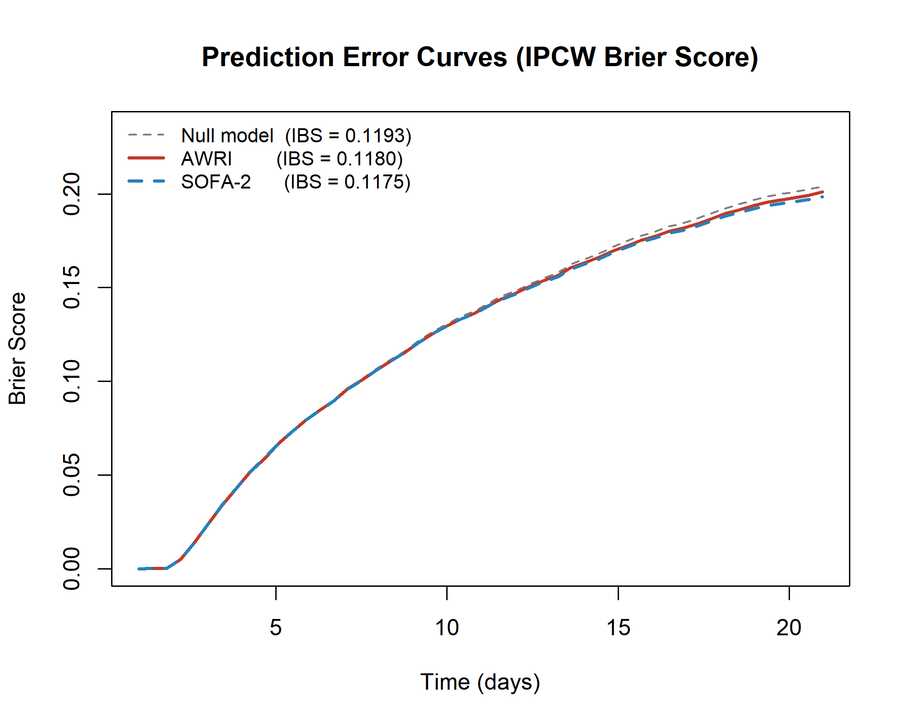
（B）
Time_point | AWRI_AUC | AWRI_95CI | SOFA-2_AUC | SOFA-2_95CI | Delta_AUC | P_value
Day 7 | 0.578 | 0.567–0.592 | 0.562 | 0.549–0.574 | 0.016 | 0.07
Day 14 | 0.588 | 0.577–0.600 | 0.591 | 0.580–0.602 | -0.003 | 0.74
Day 28 | 0.604 | 0.585–0.621 | 0.63 | 0.613–0.646 | -0.026 | 0.05

Supplementary Figure S4.Time-to-event predictive performance comparison between AWRI and SOFA-2.
(A) IPCW-weighted Brier Score curves over time for AWRI (red), SOFA-2 (blue dashed), and the Null/KM reference model (gray dashed). Both scores reduced prediction error modestly relative to the Null model (AWRI IBS = 0.1180; SOFA-2 IBS = 0.1175; Null IBS = 0.1193), with a clinically negligible between-model difference (ΔIBS = 0.0005).
(B) Time-dependent AUC at Day 7, 14, and 28, estimated by IPCW with 95% CIs from 200 bootstrap resamples. AWRI and SOFA-2 showed comparable discrimination throughout: AWRI trended toward superiority at Day 7 (ΔAUC = +0.016, p = 0.07), performance was equivalent at Day 14 (ΔAUC = −0.003, p = 0.74), and SOFA-2 held a marginal advantage at Day 28 (ΔAUC = −0.026, p = 0.05).
Abbreviations: AWRI, Age-Weighted RDW Index; SOFA-2, Sequential Organ Failure Assessment version 2; IBS, Integrated Brier Score; IPCW, Inverse Probability of Censoring Weighting; AUC, Area Under the Curve; KM, Kaplan–Meier.

（A）  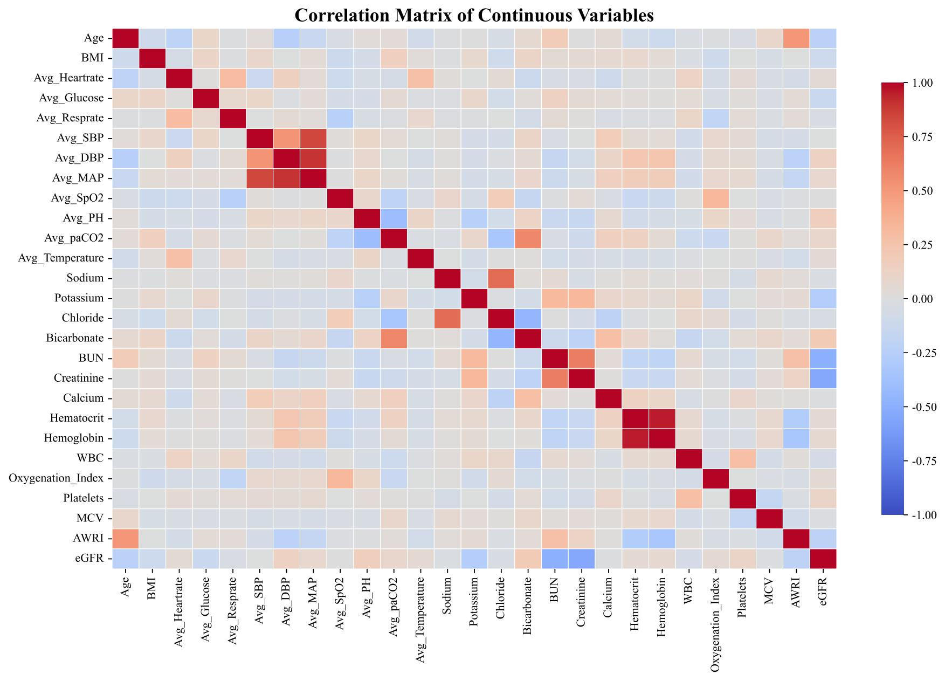 | （B）  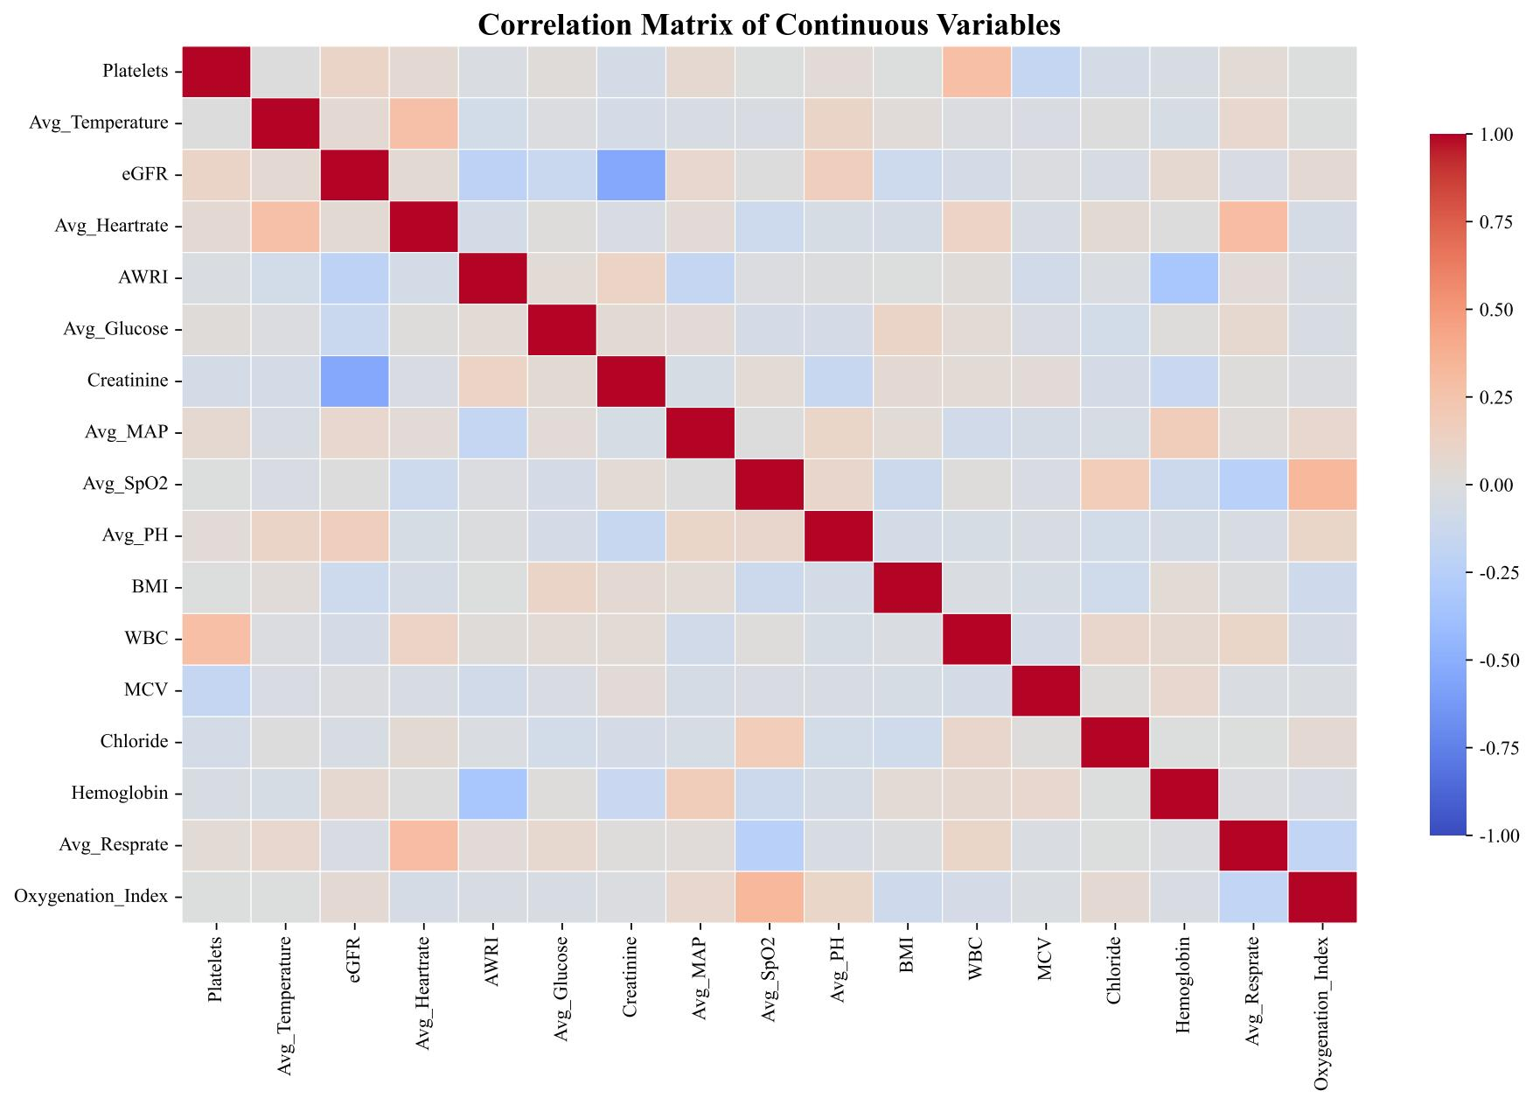

Supplementary Figure S5. Correlation Analysis of Clinical Variables in ICU Patients with Acute Respiratory Failure
(A) Correlation matrix of 27 continuous clinical variables. The heatmap displays Pearson correlation coefficients ranging from -1 (deep blue) to +1 (deep red). Strong correlations were observed between hemodynamic parameters (SBP, DBP, MAP; r > 0.8) and hematological indices (hemoglobin, hematocrit). weak correlations were found between renal function markers and electrolyte indicators.
(B) Correlation matrix of 17 selected clinical variables after feature engineering. Following tree-based feature importance ranking and correlation-based filtering, redundant variables with correlation coefficients > 0.5 were removed to minimize multicollinearity while preserving predictive information across multiple physiological systems.
Abbreviations: SBP (Systolic Blood Pressure); DBP (Diastolic Blood Pressure); MAP (Mean Arterial Pressure). Pearson correlation coefficients were calculated for all continuous variable pairs. Feature selection employed a two-stage approach: first, correlation-based redundancy removal eliminated features with pairwise correlations exceeding 0.5; second, ensemble-based feature ranking using Random Forest, LightGBM, and XGBoost importance scores identified the most predictive variables, with the final feature set representing the union of top-ranked features from all three models.

Model Configuration | No. of Features | AUC (95% CI) | ΔAUC vs Model A | DeLong P-value
Model A: AWRI-included (baseline) | 17 | 0.748 (0.720–0.776) | — | —
Model B: RDW + age replacing AWRI | 18 | 0.737 (0.709–0.765) | −0.011 | 0.032
Model C: AWRI fully removed | 16 | 0.722 (0.694–0.750) | −0.026 | 0.008

Supplementary Table S5. Ablation Analysis of AWRI's Incremental Predictive Contribution in the XGBoost Model.
Model A is the primary XGBoost model containing all 17 selected features including AWRI. Model B replaces AWRI with its constituent components (raw RDW and age), yielding 18 features after re-applying the correlation-based redundancy filter. Model C removes AWRI entirely without substitution, yielding 16 features. All three models were trained using identical XGBoost hyperparameters optimized for Model A on the same training set and evaluated on the same held-out test set. AUC confidence intervals were calculated using 1,000 bootstrap resamples. Between-model AUC differences were assessed using the DeLong method. ΔAUC values are expressed as Model B or C minus Model A (negative values indicate performance reduction relative to baseline).

 | Full Cohort (n = 24,709) |  | OI-Observed Subset (n = 16,944)
AWRI Quartile | HR (95% CI) | P value | HR (95% CI) | P value
Q1 (Reference) | Reference | — | Reference | —
Q2 | 1.13 (1.02–1.25) | 0.02 | 1.10 (0.98–1.24) | 0.12
Q3 | 1.22 (1.10–1.35) | < 0.001 | 1.24 (1.09–1.41) | 0.001
Q4 | 1.41 (1.27–1.57) | < 0.001 | 1.40 (1.23–1.59) | < 0.001

Supplementary Table S6. Sensitivity analysis of the association between AWRI quartiles and in-hospital mortality restricted to patients with directly observed oxygenation index values.
Hazard ratios (HR) and 95% confidence intervals (CI) were derived from the fully adjusted Cox proportional hazards model (Model 3) using identical covariate sets in both analyses. The observed-only subset comprised 16,944 patients whose oxygenation index values were directly measured. Q1 served as the reference category.
Abbreviations: AWRI, Age-Weighted Red Cell Distribution Width Index; CI, confidence interval; HR, hazard ratio; OI, oxygenation index (PaO₂/FiO₂).
Model | Hyperparameter | Candidate values
Logistic Regression | C | 0.1, 1, 10
Logistic Regression | penalty | l2
Logistic Regression | solver | lbfgs, saga
Logistic Regression | class_weight | balanced, None
Random Forest | n_estimators | 50, 100
Random Forest | max_depth | 5, 10, 15
Random Forest | min_samples_split | 5, 10, 20
Random Forest | min_samples_leaf | 2, 5, 10
Random Forest | max_features | sqrt, 0.5
Random Forest | class_weight | balanced, balanced_subsample, None
XGBoost | learning_rate | 0.01, 0.1, 0.3
XGBoost | max_depth | 3, 5, 7
XGBoost | n_estimators | 100, 200
XGBoost | scale_pos_weight | 1, 5, 10
LightGBM | learning_rate | 0.01, 0.1, 0.3
LightGBM | num_leaves | 10, 31, 50, 100
LightGBM | n_estimators | 100, 150
LightGBM | boosting_type | gbdt, dart
LightGBM | class_weight | balanced, None
Gaussian Naive Bayes | var_smoothing | 1×10⁻¹², 1×10⁻¹¹, …, 1×10⁻³ (log-spaced, 10 values)
Gaussian Naive Bayes | priors | None, [0.80, 0.20], [0.75, 0.25], [0.70, 0.30]

Supplementary Table S7. Candidate hyperparameter search spaces for the five machine learning models.
All models were optimised using grid search over the candidate ranges listed below. Model selection within each fold was based on AUC on the held-out validation set. Random seed was fixed at 42 throughout to ensure full reproducibility. AUC, area under the receiver operating characteristic curve. All hyperparameter searches were conducted using scikit-learn 1.2.2 (Python 3.11.7) with GridSearchCV and 5-fold stratified cross-validation.

Section / Topic | Item | Checklist Item | Location in Manuscript | Reported
TITLE AND ABSTRACT
Title | 1 | Identify the study as developing and/or validating a prediction model, specifying the predicted outcome (in-hospital mortality) and target population (ICU patients with ARF). | Title page | Yes
Abstract | 2a | Structured summary including design, setting, sample size, predictors, outcome, statistical methods, results, and conclusions. | Abstract (all sections) | Yes
Abstract (AI) | 2b | Model type stated in abstract ("five machine learning algorithms with SHAP-based interpretability"); specific algorithm names and software versions specified in main-text Methods. | Abstract — Methods; Methods: Statistical Software | Yes
INTRODUCTION
Background & objectives | 3a | Medical context (prognostic prediction in ARF), existing RDW evidence, and rationale for age-weighting (age-related hematopoietic changes; limitations of conventional RDW) described. | Introduction, paragraphs 1–5 | Yes
Background & objectives | 3b | Three objectives stated: (1) Cox regression validation of AWRI; (2) RCS nonlinear characterisation; (3) ML/SHAP importance quantification. | Introduction, final paragraph | Yes
METHODS
Source of data | 4a | Study design (retrospective cohort) and data source (eICU Collaborative Research Database, 2014–2015, 208 US hospitals) described. | Methods: Study Design and Data Sources | Yes
Source of data | 4b | Setting (multi-centre US ICUs, 2014–2015) described; temporal and geographic generalisability limitations acknowledged. | Methods: Study Design; Limitations | Yes
Participants | 5a | Observational retrospective cohort; sequential eligibility screening with documented exclusion steps; flow diagram provided. | Methods: Study Population; Figure 1 | Yes
Participants | 5b | Inclusion (age ≥18, ARF diagnosis, ICU stay >48 h, RDW within 24 h) and exclusion criteria (haematologic malignancy, transfusion history) fully specified. | Methods: Study Population | Yes
Outcome | 6a | Primary outcome (all-cause in-hospital mortality) defined with time origin (ICU admission), event endpoint (in-hospital death), and censoring (discharge alive). | Methods: Descriptive Analysis and Survival Analysis | Yes
Outcome | 6b | Outcome extracted from electronic database (not subject to observer bias); RDW measured within 24 h of admission, preceding outcome ascertainment. | Methods: Study Design; Inclusion Criteria | Yes
Predictors | 7a | AWRI defined as RDW × (1 + age/100); all 17 ML predictors measured at ICU admission or within 24 h. Full variable list in Supplementary Figure S4B. | Methods: Variable Collection; AWRI Construction; Suppl. Fig. S4B | Yes
Predictors (AI) | 7b | Two-stage feature engineering: (1) pairwise correlation filtering (r > 0.50); (2) ensemble importance ranking across RF, LightGBM, and XGBoost yielding 17 final features. | Methods: ML Modelling; Supplementary Methods S3 | Yes
Sample size | 8 | No formal sample size calculation; all eligible patients included (n = 24,709), consistent with secondary database analysis. | Methods: Study Population; Results: Study Population | Yes
Missing data | 9 | Variables >40% missing excluded (albumin, 45.5%); continuous variables imputed by random forest-based multiple imputation; categorical variables by mode imputation. KDE validation performed. | Methods: Clinical Data Collection; Suppl. Table S1; Suppl. Fig. S1 | Yes
Analysis: predictors | 10a | AWRI as quartiles in Cox models; continuous in ML models. Nonlinear patterns explored via RCS (4 knots: 5th, 35th, 65th, 95th percentiles). | Methods: Cox Regression; Non-linear Relationship Exploration | Yes
Analysis: model building | 10b | Three progressively adjusted Cox models; five ML algorithms; 70:30 stratified split; 5-fold CV hyperparameter optimisation (search spaces in Suppl. Table S7); class weight balancing. | Methods: Cox Regression; ML Modelling; Suppl. Table S7 | Yes
Analysis: algorithm (AI) | 10b-AI | Algorithms and versions specified: scikit-learn 1.2.2 (Logistic Regression, Random Forest, Gaussian Naive Bayes), XGBoost, LightGBM; shap v0.48.0; R survival package. | Methods: ML Modelling; Statistical Software | Yes
Analysis: performance measures | 10c | Discrimination metrics specified: AUC (primary), sensitivity, specificity, precision, F1-score, C-statistic; DeLong test for AUC comparison; bootstrap CIs (n = 1,000). | Methods: Cox Regression; ML Modelling | Yes
Analysis: overfitting (AI) | 10c-AI | Overfitting assessed via 5-fold CV, training-to-test AUC gap for all five models, and SHAP importance stability across training and held-out test sets. | Methods: ML Modelling; Results: ML Model Performance | Yes
Analysis: interpretability (AI) | 10d | SHAP via TreeExplainer (exact Shapley decomposition); global importance as mean |SHAP|; dependence plots for nonlinear AWRI patterns; replicated on training and test sets. | Methods: ML Modelling; Supplementary Methods S3 | Yes
Development vs. validation | 11 | Development only; internal validation via 70:30 stratified split (training n = 17,296; test n = 7,413). No external validation; acknowledged as limitation. | Methods: ML Modelling; Limitations | Yes
RESULTS
Participants | 12 | Participant counts at each exclusion step with reasons; final cohort n = 24,709; in-hospital mortality 18.8% (4,658 events); flow diagram provided. | Results: Study Population; Figure 1 | Yes
Participant characteristics | 13a | Baseline characteristics by AWRI quartile (Q1–Q4): demographics, physiological parameters, comorbidities, laboratory indices, treatment interventions, and outcomes. | Results: AWRI Risk Stratification; Table 1 | Yes
Participant characteristics | 13b | Between-quartile comparisons reported (Kruskal-Wallis; chi-square); all P-values, medians, and IQRs in Table 1. | Table 1; Results: AWRI Risk Stratification | Yes
Model performance | 14a | AUC with 95% CI for all five ML models and APACHE IV (training and test sets); sensitivity, specificity, precision, F1 in Figure 5. Adjusted HRs with 95% CI for three Cox models in Table 2. | Results: ML Model Performance; Table 2; Figure 5 | Yes
Model performance (AI): interpretability | 14b | SHAP importance rankings (training/test; Figure 6A–B); SHAP dependence plots showing four-stage AWRI pattern (Figure 6E–F); ablation analysis: Model A (AUC 0.748), B (0.737), C (0.722) in Suppl. Table S5. | Results: ML Model Performance; Figure 6; Suppl. Table S5 | Yes
Other analyses | 15 | Subgroup analyses (age, sex, sepsis, ICU LOS, ventilation) with interaction testing; RCS threshold analysis (AWRI ≤16.3%: HR 0.453; ≥27%: HR 1.31); sensitivity analyses (early death exclusion, measurement bias, hematologic index comparison). | Results: Subgroup Effects; Non-linear Analysis; Figures 3–4; Suppl. Tables S4, S6 | Yes
DISCUSSION
Limitations | 16 | Limitations: retrospective design; single eICU database; US cohort 2014–2015; albumin excluded (45.5% missing); moderate standalone AUC (0.608); no external validation; calibration not assessed. | Limitations section | Yes
Interpretation | 17 | AWRI independently predicts in-hospital mortality; four-stage nonlinear pattern confirmed by RCS and SHAP; highest SHAP importance among 17 variables; XGBoost outperforms APACHE IV (AUC 0.748 vs 0.670, P<0.001). | Discussion (all paragraphs) | Yes
Implications | 18 | Clinical utility at two levels: composite ML model (AUC 0.748) and individual bedside biomarker (AUC 0.608). Threshold structure (≤16.3%, 16.3–27%, 27–40%, >40%) requires prospective validation before clinical adoption. | Discussion; Conclusion | Yes
OTHER INFORMATION
Funding | 19 | Funding sources (Guangdong grants 2022A1515140033 and B2025307) and funder non-involvement in study conduct stated. | Funding section | Yes
Supplementary information | 20 | Supplementary Methods S1–S3, Tables S1–S7, and Figures S1–S4 provided. eICU data and code available from corresponding authors on request. | Data Availability; Supplementary files | Yes

Supplementary Table S8. TRIPOD+AI Checklist.
Status: Yes = fully reported; Partial = partially reported (see note in Checklist Item cell); N/A = not applicable.
Abbreviations: ARF, acute respiratory failure; AWRI, Age-Weighted RDW Index; AUC, area under the ROC curve; CI, confidence interval; CV, cross-validation; ICU, intensive care unit; KDE, kernel density estimation; LOS, length of stay; ML, machine learning; RCS, restricted cubic spline; RDW, red cell distribution width; RF, random forest; SHAP, SHapley Additive exPlanations.

