Supplementary Figure 1 Flow chart of variable screening

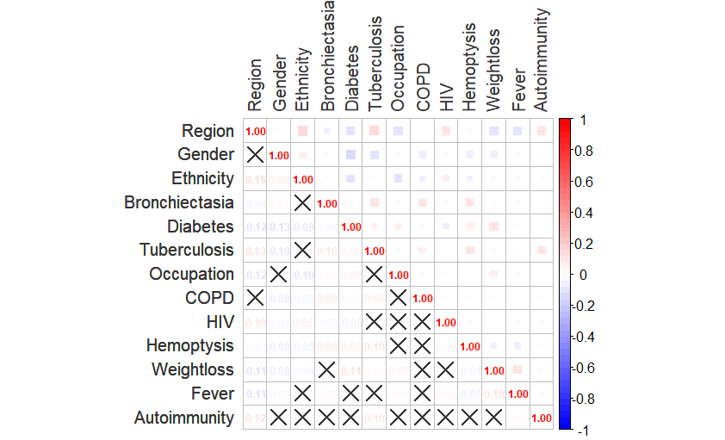
Supplementary Figure 2. Heat map of variable correlation

A
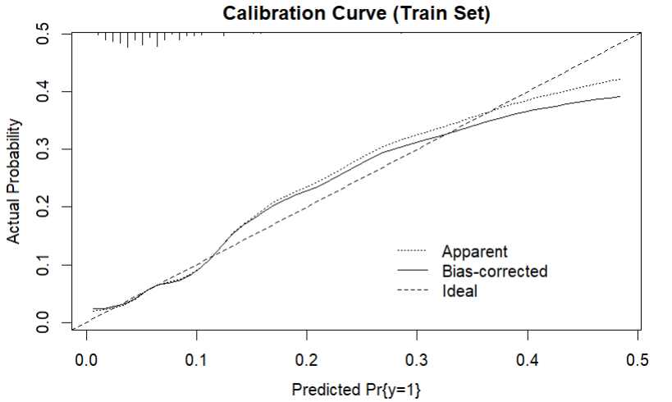
B
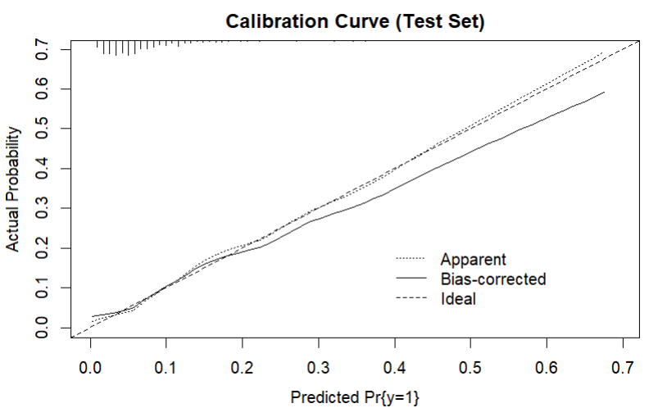
Supplementary Figure 3. Calibration curve of the logistic regression model: A training set, B test set
Supplementary Figure 4. Diagnostic algorithm for NTM-PD based on the 2007 ATS/IDSA guidelines with proposed integration of the machine learning model

Supplementary Table 1 . Hyperparameters of the LightGBM model
Parameter | Value | Description
objective | binary | Binary classification
boosting_type | gbdt | Gradient boosting decision tree
num_leaves | 70 | Maximum leaves per tree
learning_rate | 0.1498 | Shrinkage rate
n_estimators | 233 | Number of boosting iterations
max_depth | -1 | No depth limit
feature_fraction | 0.996 | Feature sampling ratio
reg_alpha | 3.72 | L1 regularization
reg_lambda | 4.79 | L2 regularization
scale_pos_weight | 13.67 | Imbalance weight (negative/positive)
metric | auc | Evaluation metric
seed | 42 | Random seed
Note: Hyperparameters were tuned using 5‑fold cross‑validation on the training set. Abbreviations: AUC, area under the curve; gbdt, gradient boosting decision tree.

