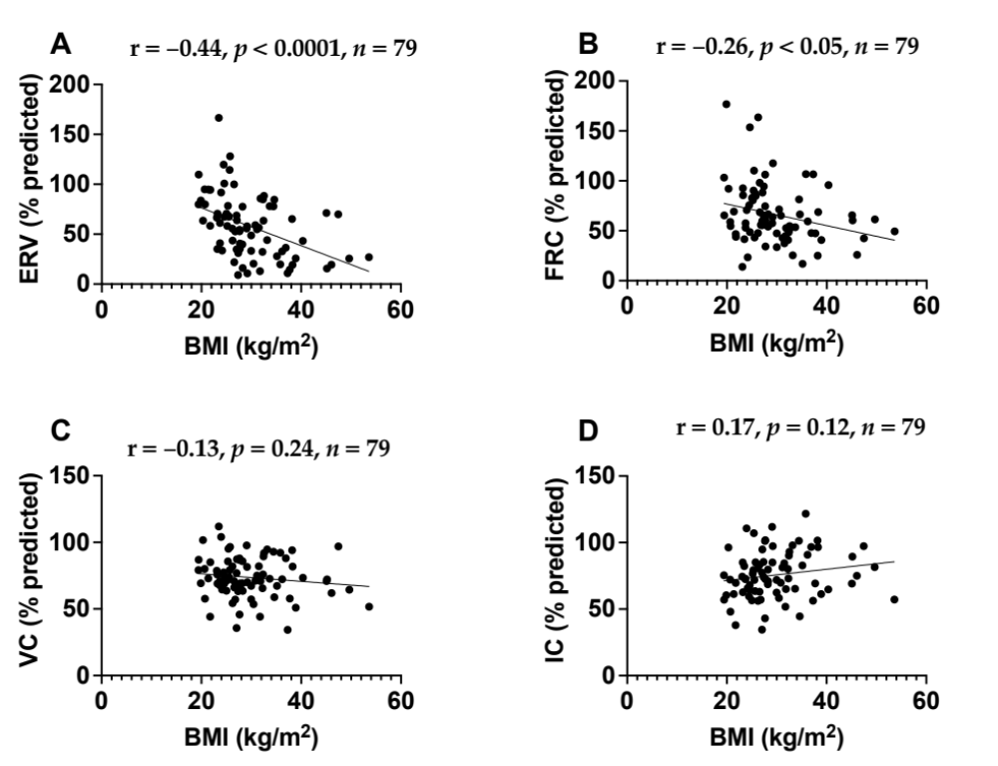
Supplementary Figure S1: The correlation between BMI kg/m² with ERV (% predicted) (A), FRC (% predicted) (B), IC (% predicted) (C), and VC (% predicted) (D) among individuals with shortness of breath. Pearson correlation analyses showed a significant negative correlation between BMI and ERV (% predicted) (r = −0.44, p < 0.0001) and FRC (% predicted) (r = −0.26, p < 0.05). No significant correlations were observed between BMI and VC or IC.

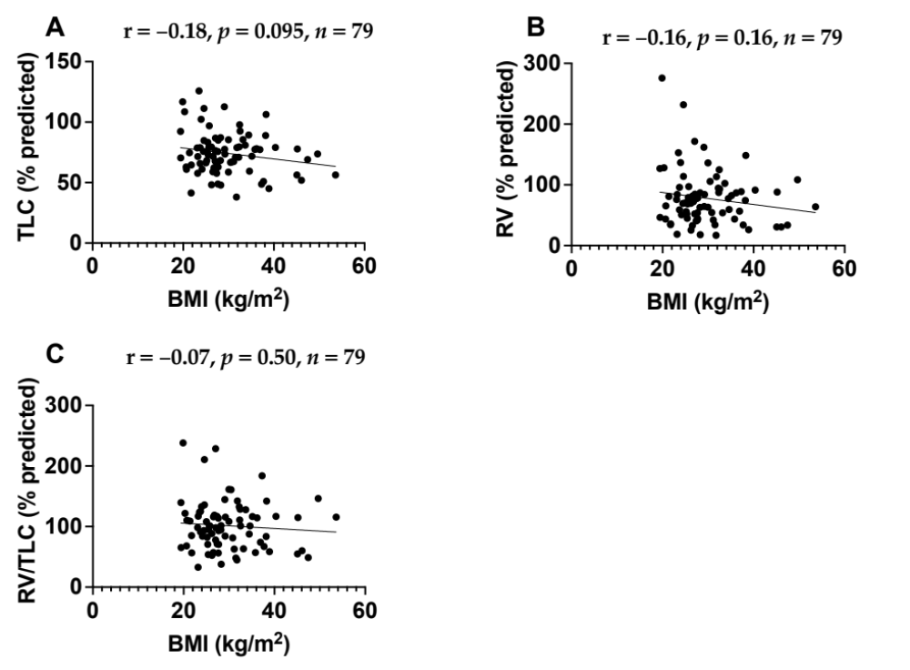
Supplementary Figure S2: The correlation between BMI kg/m² with TLC % predicted) (A), RV% predicted) (B), and RV/TLC (% predicted) (C) among individuals with shortness of breath. BMI was not significantly correlated with TLC, RV, or RV/TLC (% predicted).
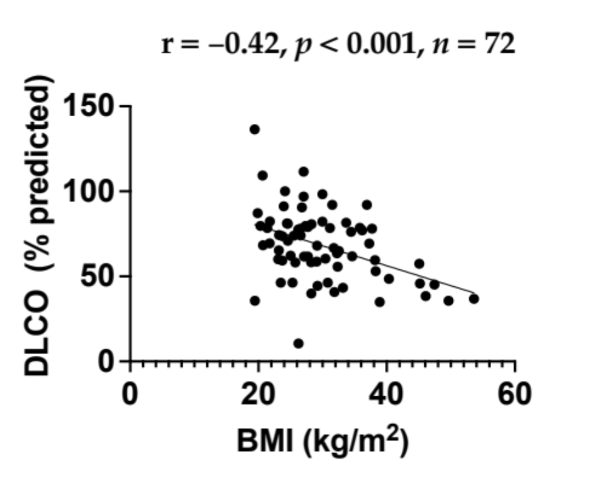

Supplementary Figure S3: The correlation between BMI kg/m² with diffusing capacity of the lungs for carbon monoxide (DLCO % predicted) among individuals with shortness of breath. A significant negative correlation was also observed between BMI and DLCO (% predicted) (r = −0.42, p < 0.001).

