Supplementary Materials
Method 1. Search strategy
Method 2. Inclusion and exclusion criteria
Method 3. Data extraction
Method 4. Quality assessment
Method 5. Model building
Method 6. Model assessment
Method 7. Model NONMEM codes
Method 8. The method of subgroup analysis

Table S1. The list of included studies
Table S2. Basic information of the included studies
Table S3. The results of the literature assessment
Table S4. Covariate selection process for FVC%
Table S5. Estimated parameters of the model

Figure S1. Characteristics of literature data
Figure S2. The summary of literature assessment
Figure S3. Covariate selection for the placebo response model of All-cause mortality
Figure S4. The goodness-of-fit plots of the placebo response model of All-cause mortality
Figure S5. Covariate selection for the placebo response model of FVC%
Figure S6. The goodness-of-fit plots of the placebo response model of FVC%
Figure S7. Covariate selection for the placebo response model of FVCmL
Figure S8. The goodness-of-fit plots of the placebo response model of FVCmL
Figure S9. Covariate selection for the placebo response model of DLCO%
Figure S10. The goodness-of-fit plots of the placebo response model of DLCO%
Figure S11. Covariate selection for the placebo response model of 6MWD
Figure S12. The goodness-of-fit plots of the placebo response model of 6MWD
Method 1. Search strategy
A comprehensive search was conducted in the databases of PubMed, Embase, and Cochrane Library. The search covered the period from the inception of each database up to November 12, 2024. The specific search strategy was as follows:
Database | NO. | Query | Results | Date
PubMed | #1 | "idiopathic pulmonary fibrosis"[All Fields] OR "ipf"[All Fields] | 16200 | 2024.11.12
 | #2 | #1 Filters: Clinical Trial | 509 | 2024.11.12
 | #3 | #2 Filters: English | 489 | 2024.11.12
Embase | #1 | 'idiopathic pulmonary fibrosis'/exp OR 'idiopathic pulmonary fibrosis' OR ipf | 46023 | 2024.11.12
 | #2 | #1 AND ([Controlled Clinical Trial]/lim OR [Randomized Controlled Trial]/lim) | 1167 | 2024.11.12
Cochrane Library | #1 | ("idiopathic pulmonary fibrosis")ti,ab,kw OR ("ipf")ti,ab,kw | 1972 | 2024.11.12
 | #2 | #1 Filters: Trials | 1940 | 2024.11.12
 | #3 | #2 Filters: English | 1911 | 2024.11.12

Method 2. Inclusion and exclusion criteria
Inclusion criteria were as follows: 1) Study type: placebo-controlled randomized trials; 2) Study subjects: adult patients diagnosed with IPF and no other significant health conditions; 3) Intervention: pharmacological treatment; 4) Outcome measures: at least one of the following outcomes reported: FVC, DLCO, 6MWD, or all-cause mortality.
Exclusion criteria included: 1) Conference abstracts, which are typically not peer-reviewed and lack comprehensive information; 2) Case studies, which do not provide sufficient statistical power or generalizability; 3) Non-original data publications, such as meta-analyses and reviews, to prevent data duplication; 4) Studies with a sample size smaller than 10, as small sample sizes can lead to significant sampling errors.

Method 3. Data extraction
WPS Excel software was employed as the database entry template to extract the following information from the literature meeting the inclusion and exclusion criteria: (1) Bibliographic characteristics (title, authors, year of publication, country, trial registration number, etc.); (2) Trial design (grouping of trials, intervention treatments, dosing regimens, sample size, duration of treatment, etc.); (3) Characteristics of subjects (age, weight, percentage of males, ethnicity, percentage of smokers, duration of disease, baseline values of each efficacy indicator, etc.); (4) Clinical outcomes (all-cause mortality, FVC, DLCO, 6MWD at each visit time point).
Data extraction was independently conducted by two researchers. In cases of disagreement, a third researcher was involved in the discussion to determine the resolution approach. If outcome data in the publications were presented in graphical form, the Engauge Digitizer software (version 11.3) was used for data extraction, and the average of the two values was taken as the final result. If the discrepancy in data extraction between the two researchers exceeded 2%, the data were re-extracted.
Method 4. Quality assessment
The quality of the included literature was assessed using the Cochrane Risk of Bias Tool 2.0. The assessment items included the randomization process, deviations from intended interventions, missing outcome data, measurement of the outcome, and selection of reported results. Each item was rated on a scale of 'Yes', 'Probably yes', 'No information', 'Probably no', and 'No'. Two researchers independently extracted and assessed all of this information, resolving any discrepancies through consultation with a third researcher.
Method 5. Model establishment
This study aimed to establish time-effect models for all-cause mortality, FVC%, FVC mL, 6MWD, and DLCO% in patients with idiopathic pulmonary fibrosis following placebo intervention. A survival model will be used to analyze all-cause mortality. This model is linked to the hazard function h(t), which represents the instantaneous risk of death at time t. Equation 1 describes the relationship between the survival function and the hazard function:
Survival model $S(t)=exp\left(−\int_{0}^{t}{h\left(t\right)dt}\right)$ (1)
In Equation 1, $\int_{0}^{t}{h\left(t\right)dt}$ represents the cumulative hazard from time 0 to time t, and $S(t)$ represents the survival probability at time t. Through this formula, the hazard function can be transformed into the survival function.
This study will examine four different hazard function models (Equations 2-5):
Constant: $h\left(t\right)=λ$ (2)
Gompert: $h\left(t\right)=λ∙exp\left(β∙t \right)$ (3)
Weibull: $h\left(t\right)=λ∙exp\left(β∙\ln\left(t\right) \right)$ (4)
Lognormal: $h\left(t\right)=\frac{{\left(σt\sqrt{2π}\right)}^{−1}e^{\left(− \frac{1}{2}z^{2}\right)}}{1−∅\left(z\right)}$ $, Z=\frac{\ln\left(t\right)−μ}{σ}$ (5)
In Equations 2-4, the hazard functions are defined by the parameters λ and β, which represent the hazard rate of death at time 0 and the rate of change in the hazard rate of death over time, respectively. In Equation 5, the hazard function is defined by the parameters μ and σ, which represent the median and standard deviation of the log-normal distribution, respectively.
Exploratory data analysis revealed that the changes from baseline in FVC% and FVC mL gradually increased over time and appeared to reach a plateau. This characteristic can be described using an exponential model (Equation 6):
$E=−E_{max}×\left(1−e^{−k×time}\right)$ (6)
In Equation 6, E represents the efficacy of the placebo group in terms of FVC% and FVCmL at time time, E_{max} represents the maximum effect achievable by the placebo, time represents the observation time in months, k is the rate parameter for the onset of the placebo effect. When the time time=0.693/k, the placebo effect E=0.5 E_{max}, which is the time required to achieve half of the maximum response of the placebo.
The 6MWD and DLCO% showed a trend of linear increase over time, which can be described using a linear model (Equation 7):
$E=−B0×time+B1$ (7)
In Equation 7, E represents the efficacy of the placebo group on 6MWD and DLCO% at time point, B0 represents the slope, B1 represents the intercept, and time is the observation time in months.
To describe the difference between the observed values and those predicted by the model, intertrial and residual variation need to be incorporated into the model. Intertrial variation will examine additive (Equation 8) or exponential (Equation 9) models, and residual variation will examine additive (Equation 10), proportional (equation 11), and proportional additive (Equation 12) models. According to the objective function value (OFV) estimated by NONMEM software, the relative standard error (RSE) of the estimated model parameters and the goodness-of-fit (GOF) plot, the better model was selected.
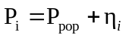 (8)
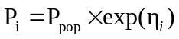 (9)
${ Obs}_{i,j}={Pred}_{i,j}+w_{i,j}×{ε1}_{i,j}$ (10)
${ Obs}_{i,j}={Pred}_{i,j}×(1+w_{i,j}×{ε2}_{i,j})$ (11)
${ Obs}_{i,j}={Pred}_{i,j}×(1+w_{i,j}×{ε2}_{i,j})+w_{i,j}×{ε1}_{i,j}$ (12)
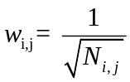 (13)
In Equations 8-9, P_{i}, P_{pop} and η_{i} represent the individual trial values, the population typical values and the intertrial variation of the model parameters, respectively. ηi fits the normal distribution with mean 0 and variance ω_{i}². In Equations 10-12, Obs_{i,j} represents the efficacy observation for the i-th trial at the j-th observation time point, while Predi,j represents the predicted value for the i-th trial at the j-th observation time point. Ɛ1_{i,j} is the additive residual variation at the j-th observation time point of the i-th trial group, and Ɛ2_{i,j} is the proportional residual variation at the j-th observation time point of the i-th trial group, which fit a normal distribution with mean 0 and variance σ₁² and σ₂², respectively. In Equation 13, w_{i,j} is the correction factors of the residuals, which is corrected by the inverse of the open root of the sample size, that is, the larger the sample size, the smaller the variation of the residuals.
The influencing factors of model parameters were analyzed by constructing a covariate model. The factors investigated included: baseline value, age, proportion of males, proportion of smokers, proportion of Caucasians, whether receiving background treatment, disease duration, and sample size. A covariate was excluded if it had a missing rate of 30% or more. Multiple imputation was used to handle missing data if the missing rate was less than 30%. In this process, we will put model parameters and missing covariates together, choose Predictive Mean Matching (PMM) as the main imputation algorithm, and perform six rounds of imputation. To obtain the final data analysis results, we will combine the calculation results of these six imputations.
For the model of all-cause mortality, covariates would be incorporated into the baseline hazard function in the following manner:
$h(t){_}_{Final}=h(t){_}_{Base}∙e^{(α_{1}∙x_{1}+α_{2}∙x_{2}+⋯+α_{n}∙x_{n})}$ (14)
In Equation 14, $h(t){_}_{Base}$represents the base hazard function and $e^{(α_{1}∙x_{1}+α_{2}∙x_{2}+⋯+α_{n}∙x_{n})}$ represents the effect of covariates on the risk of death, where x₁, x₂, …, x_{n} represents 1-n covariates that have an effect on the risk of death, and their effect coefficients on the risk of death are α₁, α₂, …, α_{n}.
For the other four models, continuous variables are introduced as in Equations (15-16), and dichotomous variables are introduced as in Equation (17) :
$P_{i}=P_{typical}+\left({COV}_{i}−{COV}_{median}\right)∗θ_{cov}$ (15)
$P_{i}=P_{typical}∗{\left({COV}_{i}/{COV}_{median}\right)}^{θ_{cov}}$ (16)
$P_{i}=P_{typical}+{COV}_{i}∗θ_{cov}$ (17)
In Equations 15-17, P_{i} represents the individual value of the model parameter in the i-th trial, COV_{media}n is the median of the covariate in the dataset, P_{typical} represents the typical value of the model parameter when the categorical covariate equals 0 or the continuous covariate equals COV_{median}, COV_{i} represents the covariate value in the i-th trial, and θ_{cov} is the correction coefficient of the covariates for the model parameters.
The correlation between each covariate and the individual parameter values obtained through Bayesian feedback was first calculated, and the covariates that had a significant influence (p<0.05) on the individual parameter values were initially screened in a stepwise manner based on changes in the objective function value (OFV) between the hierarchical models. A reduction in the OFV of more than 6.63 points (χ², p<0.05, df=1) was used as the criterion in the forward inclusion step, and an increase in the OFV of more than 6.63 (χ², p<0.01, df=1) was considered statistically significant in the backward elimination step.

Method 6. Model evaluation
After the final model is constructed, its performance needs to be evaluated. First, goodness-of-fit (GOF) plots will be used to assess the model fit, including the following four scatter plots: observed values (OBS) vs population predictions (PRED), observed values (OBS) vs individual predictions (IPRED), conditional weighted residuals (CWRES) vs population predictions (PRED), and conditional weighted residuals (CWRES) vs time. Second, visual predictive checks (VPC) will be used to validate the model's predictive ability. Based on the final model parameters, 1000 Monte Carlo simulations will be conducted to obtain the 95% confidence interval (CI) of the predicted effects in the placebo group. This confidence interval will be compared with the actual observed values to evaluate the model's predictive performance. Finally, the robustness of the model will be assessed by conducting 1000 nonparametric bootstrap simulations. The parameter estimates and their distribution ranges obtained from the bootstrap method will be compared with the parameter estimates of the final model to validate the model's robustness.

Method 7. Model NONMEM Codes
NONMEM codes of all-cause mortality model

$PROBLEM placebo effect
$DATA all-cause mortality.csv IGNORE=C
$INPUT ID Time DV MDV Size

$SUBROUTINE ADVAN6 TOL=4
$MODEL COMP=(HZLAST)

$PK
SIGM=THETA(1)*EXP(ETA(1))
MU=THETA(2)*EXP(ETA(2))

$DES
DEL= 1E-12
TIM=T+DEL
LNT = LOG(TIM)
X1 =(LNT-MU)/SIGM
PDF= EXP(-1/2*(X1**2))/SQRT(2*3.14159265)
DADT(1)=1/(TIM*SIGM)*PDF/(1-PHI(X1))

$ERROR
CUMEVT=A(1)
EFT=1-EXP(-CUMEVT)
IPRED=EFT
W=SQRT((IPRED+0.001)*(1-IPRED+0.001)/Size)
Y=EFT+W*ERR(1)

$THETA (0,5) ;SIGM
$THETA (3,7) ;MU

$OMEGA 0.09
$OMEGA 0,Fixed

$SIGMA 1

$ESTIMATION METHOD=1 INTER MAXEVAL=9990 PRINT=10 NOHABORT NOTHETABOUNDTEST NOOMEGABOUNDTEST NOSIGMABOUNDTEST POSTHOC
$COVARIANCE
$TABLE ID Time DV MDV Size Y SIGM MU ETA(1) ETA(2) CUMEVT CWRES IPRED
NOPRINT ONEHEADER FILE=Edata.txt

NONMEM codes of FVC% model

$PROBLEM placebo effect
$DATA FVC%.csv IGNORE=C
$INPUT ID Time DV MDV Size Baseline
$PRED

TVEM=THETA(1)*(Baseline/73.1)**THETA(3)
TVk=THETA(2)

EM=TVEM*EXP(ETA(1))
k=TVk*EXP(ETA(2))

EFT=-EM*(1-EXP(-k*Time))

W=1/SQRT(Size)
IPRED=EFT
Y=EFT+ERR(1)*W

$THETA (0,15);EM
$THETA 0.0452,Fixed;k
$THETA (0,1);Baseline on EM

$OMEGA 0.09
$OMEGA 0,Fixed

$SIGMA 1

$ESTIMATION METHOD=1 INTER MAXEVAL=9990 PRINT=10 POSTHOC
$COVARIANCE
$TABLE ID Time DV MDV EM k Size Baseline Y CWRES IPRED
NOPRINT ONEHEADER FILE=Edata.txt

NONMEM codes of FVCmL model

$PROBLEM placebo effect
$DATA FVCmL.csv IGNORE=C
$INPUT ID Time DV MDV Size Baseline
$PRED

TVEM=THETA(1)*(Baseline/2768)**THETA(3)
TVk=THETA(2)

EM=TVEM*EXP(ETA(1))
k=TVk*EXP(ETA(2))

EFT=-EM*(1-EXP(-k*Time))

IPRED=EFT
W=1/SQRT(Size)
Y=EFT*(1+W*ERR(1))

$THETA (0,400);EM
$THETA 0.0697,Fixed; k
$THETA (0,3);Baseline on EM

$OMEGA 0.09
$OMEGA 0,Fixed

$SIGMA 0.09

$ESTIMATION METHOD=1 INTER MAXEVAL=9990 PRINT=10 POSTHOC
$COVARIANCE
$TABLE ID Time DV Y IPRED MDV Size Baseline CWRES k EM
NOPRINT ONEHEADER FILE=Edata.txt

NONMEM codes of 6MWD model

$PROBLEM placebo effect
$DATA 6MWD.csv IGNORE=C
$INPUT ID Time DV MDV Size
$PRED

TVB0=THETA(1)
B0=TVB0+ETA(1)

EFT=-B0*Time

IPRED=EFT
W=1/SQRT(Size)
Y=EFT+W*ERR(1)

$THETA (0,3);B0

$OMEGA 1

$SIGMA 1

$ESTIMATION METHOD=1 INTER MAXEVAL=9990 PRINT=10 POSTHOC
$COVARIANCE
$TABLE ID Time DV MDV Size B0 Y IPRED CWRES
NOPRINT ONEHEADER FILE=Edata.txt

NONMEM codes of DLCO% model

$PROBLEM placebo effect
$DATA DLCO%.csv IGNORE=C
$INPUT ID Time DV MDV Size
$PRED

TVB0=THETA(1)
B0=TVB0+ETA(1)

EFT=-B0*Time

IPRED=EFT
W=1/SQRT(Size)
Y=EFT*(1+W*ERR(2))+W*ERR(1)

$THETA (0,0.5);B0

$OMEGA 1

$SIGMA 0.09
$SIGMA 1

$ESTIMATION METHOD=1 INTER MAXEVAL=9990 PRINT=10 POSTHOC ;estimation method
$COVARIANCE
$TABLE ID Time DV MDV Size B0 Y IPRED CWRES
NOPRINT ONEHEADER FILE=Edata.txt

Method 8. The method of subgroup analysis
Based on the established final model, Bayesian feedback was employed to estimate the structure model parameter values for each study along with their standard errors. When a structure model parameter was significantly affected by a covariate, it was necessary to adjust the parameter through the inverse operation of the covariate model to ensure that the impact of heterogeneity in covariate levels was accounted for. The adjusted structure model parameters for each study were then pooled and analyzed according to subgroup classifications using a random-effects model from a single-arm meta-analysis, yielding the distribution of structure model parameters across different subgroups, including point estimates and their 95% CI. Subsequently, parameters were randomly sampled from the distribution of structure model parameters in each subgroup, and the response or dropout rate at various time points were calculated. This process was repeated 10,000 times to obtain the median response or dropout rate for each subgroup at different time points, along with their 95% CI.

Table S1. The list of included studies
ID | First Author | Publication Year | Article Title
1 | Ganesh Raghu | 2004 | A placebo-controlled trial of interferon gamma-1b in patients with idiopathic pulmonary fibrosis
2 | Talmadge E King Jr | 2008 | BUILD-1: a randomized placebo-controlled trial of bosentan in idiopathic pulmonary fibrosis
3 | Ganesh Raghu | 2008 | Treatment of idiopathic pulmonary fibrosis with etanercept: an exploratory, placebo-controlled trial
4 | Talmadge E King Jr | 2009 | Effect of interferon gamma-1b on survival in patients with idiopathic pulmonary fibrosis (INSPIRE): a multicentre, randomised, placebo-controlled trial
5 | David A Zisman | 2010 | A controlled trial of sildenafil in advanced idiopathic pulmonary fibrosis
6 | Craig E Daniels | 2010 | Imatinib treatment for idiopathic pulmonary fibrosis: Randomized placebo-controlled trial results
7 | Robert M Jackson | 2010 | Sildenafil therapy and exercise tolerance in idiopathic pulmonary fibrosis
8 | Talmadge E King Jr | 2011 | BUILD-3: a randomized, controlled trial of bosentan in idiopathic pulmonary fibrosis
9 | Paul W Noble | 2011 | Pirfenidone in patients with idiopathic pulmonary fibrosis (CAPACITY): two randomised trials
10 | Luca Richeldi | 2011 | Efficacy of a tyrosine kinase inhibitor in idiopathic pulmonary fibrosis
11 | Imre Noth | 2012 | A placebo-controlled randomized trial of warfarin in idiopathic pulmonary fibrosis
12 | Ganesh Raghu | 2013 | Macitentan for the treatment of idiopathic pulmonary fibrosis: the randomised controlled MUSIC trial
13 | Ganesh Raghu | 2013 | Treatment of idiopathic pulmonary fibrosis with ambrisentan: a parallel, randomized trial
14 | Talmadge E King Jr | 2014 | A phase 3 trial of pirfenidone in patients with idiopathic pulmonary fibrosis
15 | Luca Richeldi | 2014 | Efficacy and safety of nintedanib in idiopathic pulmonary fibrosis
16 | Fernando J Martinez | 2014 | Randomized trial of acetylcysteine in idiopathic pulmonary fibrosis
17 | Ganesh Raghu | 2017 | Efficacy of simtuzumab versus placebo in patients with idiopathic pulmonary fibrosis: a randomised, double-blind, controlled, phase 2 trial
18 | Scott M Palmer | 2018 | Randomized, Double-Blind, Placebo-Controlled, Phase 2 Trial of BMS-986020, a Lysophosphatidic Acid Receptor Antagonist for the Treatment of Idiopathic Pulmonary Fibrosis
19 | Joseph M Parker | 2018 | A Phase 2 Randomized Controlled Study of Tralokinumab in Subjects with Idiopathic Pulmonary Fibrosis
20 | Ganesh Raghu | 2018 | Effect of Recombinant Human Pentraxin 2 vs Placebo on Change in Forced Vital Capacity in Patients With Idiopathic Pulmonary Fibrosis: A Randomized Clinical Trial
21 | Ganesh Raghu | 2018 | SAR156597 in idiopathic pulmonary fibrosis: a phase 2 placebo-controlled study (DRI11772)
22 | Andrew M Wilson | 2020 | Effect of Co-trimoxazole (Trimethoprim-Sulfamethoxazole) vs Placebo on Death, Lung Transplant, or Hospital Admission in Patients With Moderate and Severe Idiopathic Pulmonary Fibrosis: The EME-TIPAC Randomized Clinical Trial
23 | Luca Richeldi | 2020 | Pamrevlumab, an anti-connective tissue growth factor therapy, for idiopathic pulmonary fibrosis (PRAISE): a phase 2, randomised, double-blind, placebo-controlled trial
24 | Toby M Maher | 2021 | Phase 2 trial to assess lebrikizumab in patients with idiopathic pulmonary fibrosis
25 | Luca Richeldi | 2022 | Trial of a Preferential Phosphodiesterase 4B Inhibitor for Idiopathic Pulmonary Fibrosis
26 | Ganesh Raghu | 2022 | A Phase IIb Randomized Clinical Study of an Anti-αvβ6 Monoclonal Antibody in Idiopathic Pulmonary Fibrosis
27 | Irina R Strambu | 2023 | GLPG1205 for idiopathic pulmonary fibrosis: a phase 2 randomised placebo-controlled trial
28 | Toby M Maher | 2023 | Ziritaxestat, a Novel Autotaxin Inhibitor, and Lung Function in Idiopathic Pulmonary Fibrosis: The ISABELA 1 and 2 Randomized Clinical Trials
29 | Lisa Lancaster | 2024 | Bexotegrast in Patients with Idiopathic Pulmonary Fibrosis: The INTEGRIS-IPF Clinical Trial
30 | Waldo L L D Mattos | 2024 | Phase 2, Double-Blind, Placebo-controlled Trial of a c-Jun N-Terminal Kinase Inhibitor in Idiopathic Pulmonary Fibrosis
31 | Ganesh Raghu | 2024 | Pamrevlumab for Idiopathic Pulmonary Fibrosis: The ZEPHYRUS-1 Randomized Clinical Trial
32 | Luca Richeldi | 2024 | Zinpentraxin Alfa for Idiopathic Pulmonary Fibrosis: The Randomized Phase III STARSCAPE Trial

Table S2. Basic information of the included studies
Author,Year | Sample  size | Duration  (week) | Mean Age  (year) | Male  (%) | 6MWD  Baseline (m) | FVC  Baseline (%) | DLCO  Baseline (%) | FVC  Baseline (mL) | Background Treatment
Raghu,2004 | 168 | 48 | 63.4 | 66 | NA | 64.1 | 36.8 | NA | Y
King,2008 | 83 | 48 | 65.1 | 75.9 | 372 | 69.5 | 41.4 | NA | Y
Raghu,2008 | 41 | 48 | 65.1 | 58.5 | 396.8 | 63.3 | 36.9 | NA | N
King,2009 | 275 | 77 | 65.9 | 68 | 392.8 | 73.1 | 47.3 | NA | Y
Zisman,2010 | 91 | 12 | 68.2 | 82.4 | 267.7 | 58.7 | 26.7 | 2420 | Y
Daniels,2010 | 60 | 96 | 67.8 | 64 | 379 | 65.6 | 39.3 | 2540 | N
Jackson,2010 | 15 | 24 | 71 | 80 | 358.8 | 62.7 | 43.5 | NA | Y
King,2011 | 209 | 48 | 63.2 | 63.6 | NA | 73.1 | 47.9 | 2660 | Y
Paul,2011* | 174 | 72 | 66.3 | 73.6 | 410 | 76.2 | 46.1 | NA | Y
Paul,2011* | 173 | 72 | 67 | 71.7 | 399.1 | 73.1 | 47.4 | NA | Y
Richeldi,2011 | 85 | 52 | 64.8 | 74.1 | NA | 81.7 | NA | 2800 | Y
Noth,2012 | 73 | 48 | 66.7 | 79 | 280.2 | 58.7 | 34.6 | 2400 | Y
Raghu,2013 | 59 | 48 | 64.5 | 62.7 | NA | 74.8 | 45.6 | 2740 | Y
Raghu,2013 | 163 | 48 | 66.1 | 68.1 | 420.5 | 69.9 | 45.6 | NA | N
King,2014 | 277 | 52 | 67.8 | 76.9 | 420.7 | 68.6 | 44.2 | NA | Y
Richeldi,2014* | 204 | 52 | 66.9 | 79.9 | NA | 80.5 | 47.5 | 2845 | Y
Richeldi,2014* | 219 | 52 | 67.1 | 78.1 | NA | 78.1 | 46.4 | 2619 | Y
Martinez,2014 | 131 | 60 | 67.2 | 74.8 | 375 | 73.4 | 46 | 2900 | N
Raghu,2017 | 272 | 130 | 68.5 | 82.7 | 395 | 62.3 | 37.9 | 2400 | Y
Palmer,2018 | 47 | 26 | 69.3 | 70.2 | NA | 69 | 45 | 2460 | N
Parker,2018 | 57 | 72 | 67.5 | 78.9 | 391 | 70.3 | 47 | 2660 | N
Raghu,2018 | 39 | 28 | 67.6 | 74 | 457.7 | 67.4 | 43.2 | 2763 | Y
Raghu,2018 | 110 | 52 | 69 | 80 | NA | 71.5 | 51.6 | 2700 | Y
Wilson,2020 | 172 | 48 | 70.7 | 91.3 | NA | 55.2 | 44.5 | 2300 | Y
Richeldi,2020 | 53 | 48 | 68.4 | 81.1 | NA | 73.1 | 53.8 | 2900 | N
Maher,2021 | 76 | 52 | 69 | 82.9 | 455.5 | 72.8 | 40.9 | NA | N
Richeldi,2022 | 25 | 12 | 71.8 | 68 | NA | 82.1 | 48.3 | 2865 | N
Raghu,2022 | 52 | 52 | 68.5 | 76.9 | 458.4 | 76.1 | 52.6 | 2883 | Y
Strambu,2023 | 23 | 30 | 68.3 | 73.9 | 391.8 | 75.8 | 46.2 | 2817.1 | Y
Maher,2023* | 174 | 52 | 70.6 | 83.9 | 400.8 | 79.7 | 53.1 | 2943.3 | Y
Maher,2023* | 258 | 52 | 70.6 | 81 | 400.4 | 77.6 | 57.1 | 2749.5 | Y
Lancaster,2024 | 31 | 12 | 72.1 | 87.1 | NA | 78.1 | 50.1 | 3083.6 | Y
Mattos,2024 | 36 | 24 | 71.6 | 83.3 | 410.4 | 77.9 | 50.6 | 2841 | Y
Raghu,2024 | 175 | 48 | 70.8 | 72 | NA | 71.8 | 50 | 2416 | Y
Richeldi,2024 | 330 | 52 | 70.5 | 79.1 | 401.4 | 77.1 | 51.7 | 2804.3 | Y
6MWD, 6-Minute Walk Distance; FVC, Forced Vital Capacity; DLCO, Diffusing Capacity of the Lung for Carbon Monoxide;
NA: No relevant data were reported; Y: Background therapy; N: No background therapy.
* Different trial groups in the same article
Table S3. The results of the literature assessment
Study | Randomization process | Deviations from intended interventions | Missing outcome data | Measurement of the outcome | Selection of the reported result | Overall Bias
Ganesh Raghu 2004 | Low | Low | Low | Low | Low | Low
Talmadge E King Jr 2008 | Low | Some concerns | Low | Low | Low | Some concerns
Ganesh Raghu 2008 | Low | Low | Some concerns | Low | Some concerns | Some concerns
Talmadge E King Jr 2009 | Low | Low | Low | Low | Low | Low
David A Zisman 2010 | Low | Low | Low | Low | Low | Low
Craig E Daniels 2010 | Low | Low | Some concerns | Low | High | High
Robert M Jackson 2010 | Low | Low | Low | Low | Low | Low
Talmadge E King Jr 2011 | Low | Low | Low | Low | Some concerns | Some concerns
Paul W Noble 2011 | Low | Low | Low | Low | Low | Low
Luca Richeldi 2011 | Low | Low | Low | Low | Low | Low
Imre Noth 2012 | Low | Low | Low | Low | Low | Low
Ganesh Raghu 2013 | Low | Low | Some concerns | Low | High | High
Ganesh Raghu 2013 | Low | Some concerns | Low | Low | Low | Some concerns
Talmadge E King Jr 2014 | Low | Low | Low | Low | Low | Low
Luca Richeldi 2014 | Low | Low | Low | Low | Low | Low
Fernando J Martinez 2014 | Low | Low | Low | Some concerns | Some concerns | Some concerns
Ganesh Raghu 2017 | Low | Low | Low | Low | Some concerns | Some concerns
Scott M Palmer 2018 | Low | Some concerns | Low | Low | High | High
Joseph M Parker 2018 | Low | Some concerns | Some concerns | Low | High | High
Ganesh Raghu 2018 | Low | Low | Low | Low | Low | Low
Ganesh Raghu 2018 | Low | Some concerns | Low | Low | Low | Some concerns
Andrew M Wilson 2020 | Low | Low | Low | Low | Some concerns | Some concerns
Luca Richeldi 2020 | Low | Low | Low | Low | Low | Low
Toby M Maher 2021 | Low | Low | Low | Low | Some concerns | Some concerns
Luca Richeldi 2022 | Low | Low | Low | Low | Low | Low
Ganesh Raghu 2022 | Low | Some concerns | Some concerns | Low | Low | Some concerns
Irina R Strambu 2023 | Low | Some concerns | Some concerns | Low | Low | Some concerns
Toby M Maher 2023 | Low | Low | High | Low | Some concerns | High
Lisa Lancaster 2024 | Low | Low | Low | Low | Low | Low
Waldo L L D Mattos 2024 | Low | Some concerns | Low | Low | Low | Some concerns
Ganesh Raghu 2024 | Low | Low | Low | Low | Low | Low
Luca Richeldi 2024 | Low | Some concerns | Low | Some concerns | High | High

Table S4. Covariate selection process for FVC%.
Model No | Covariate | Model form |  | OFV | ΔOFV
Base model |  |  |  | 84.066
First round of forward introduction
1 | Base model + Baseline on E_{max} |  | (Baseline-73.1)*θ | 74.241 | -9.825
2 | Base model + Baseline on E_{max} |  | EXP((Baseline-73.1)*θ) | 76.481 | -7.585
3 | Base model + Baseline on E_{max} |  | (Baseline/73.1)^θ | 75.563 | -8.503
4 | Base model + Male on E_{max} |  | (Male-79)*θ | 77.562 | -6.504
5 | Base model + Male on E_{max} |  | EXP((Male-79)*θ) | 79.432 | -4.634
6 | Base model + Male on E_{max} |  | (Male/79)^θ | 80.172 | -3.894
Second round of forward introduction
7 | Model 3 + Male on E_{max} |  | (Baseline/73.1) ^θ₁ +(Male-79)*θ₂ | 69.461 | -6.102
8 | Model 3 + Male on E_{max} |  | (Baseline/73.1)^θ₁ *EXP((Male-79)*θ₂) | 70.002 | -5.561
9 | Model 3 + Male on E_{max} |  | (Baseline/73.1) ^θ₁ *(Male/79) ^{θ2} | 70.374 | -5.189
First round of backward elimination
10 | Model 8 - Male on E_{max} |  | (Baseline/73.1) ^θ | 75.563 | 5.561

Table S5. Estimated parameters of the final model

Estimated parameters for the placebo response model of all-cause mortality
 | Final model |  | Bootstrap(911*/1000)
 | Estimate | RSE(%) | median(95%CI)
θ_{SIGM} | 1.84 | 25.3 | 1.89（1.34-2.94）
θ_{MU} | 5.45 | 13.3 | 5.5（4.7-7.0）
η_{SIGM} | 0.274 | 22.5 | 0.269（0.185-0.428）
ε | 0.207 | 39.8 | 0.208（0.053-0.319）
RSE, relative standard error; CI, confidence interval; SIGM, Scale parameter; MU, Position parameter; θ, fixed effect parameter; η, inter-trial variability; ε, residual error.
* Number of successful model minimizations during the Bootstrapping process

Estimated parameters for the placebo response model of FVC% and FVCmL
 | FVC% |  | FVCmL
 | Final model | Bootstrap(1000*/1000) | Final model | Bootstrap(1000*/1000)
 | Estimate(RSE%) | median(95%CI) | Estimate(RSE%) | median(95%CI)
θ_{Emax} | 13.2（6.5） | 13.2（11.9-14.8） | 332（7.4） | 344（298-498）
θ_{K} | 0.0452（Fixed） | - | 0.0697（Fixed） | -
θ_{Baseline on Emax} | 2.09（34.9） | 2.03（0.247-3.14） | 2.64（41.3） | 2.64（0.026-5.97）
η_{Emax} | 0.292（16.9） | 0.274（0.182-0.352） | 0.277（16.9） | 0.274（0.152-0.411）
ε | 6.701（11.4） | 6.686（5.392-7.938） | 2.775（9.6） | 2.751（2.229-3.179）
FVC, Forced Vital Capacity; RSE, relative standard error; CI, confidence interval; Emax, theoretical maximal efficacy; k, rate of onset; θ, fixed effect parameter; η, inter-trial variability; ε, residual error.
* Number of successful model minimizations during the Bootstrapping process

Estimated parameters for the placebo response model of 6MWD and DLCO%
 | 6MWD |  | DLCO%
 | Final model | Bootstrap(1000*/1000) | Final model | Bootstrap(999*/1000)
 | Estimate(RSE%) | median(95%CI) | Estimate(RSE%) | median(95%CI)
θ_{B0} | 2.39（15.0） | 2.39（1.75-2.97） | 0.403（10.9） | 0.406（0.336-0.475）
η_{B0} | 1.487（17.6） | 1.439（0.958-1.911） | 0.181（18.8） | 0.172（0.086-0.233）
ε₁ | 53.198（12.7） | 53.01（40-63.408） | 3.886（25.6） | 3.701（0.003-5.282）
ε₂ | - | - | 1.643（10.2） | 1.643（0.965-2.185）
6MWD, 6-Minute Walk Distance; DLCO, Diffusing Capacity of the Lung for Carbon Monoxide; RSE, relative standard error; CI, confidence interval; B₀, slope; θ, fixed effect parameter; η, inter-trial variability; ε, residual error.
* Number of successful model minimizations during the Bootstrapping process

Figure S1. Characteristics of the included literature data

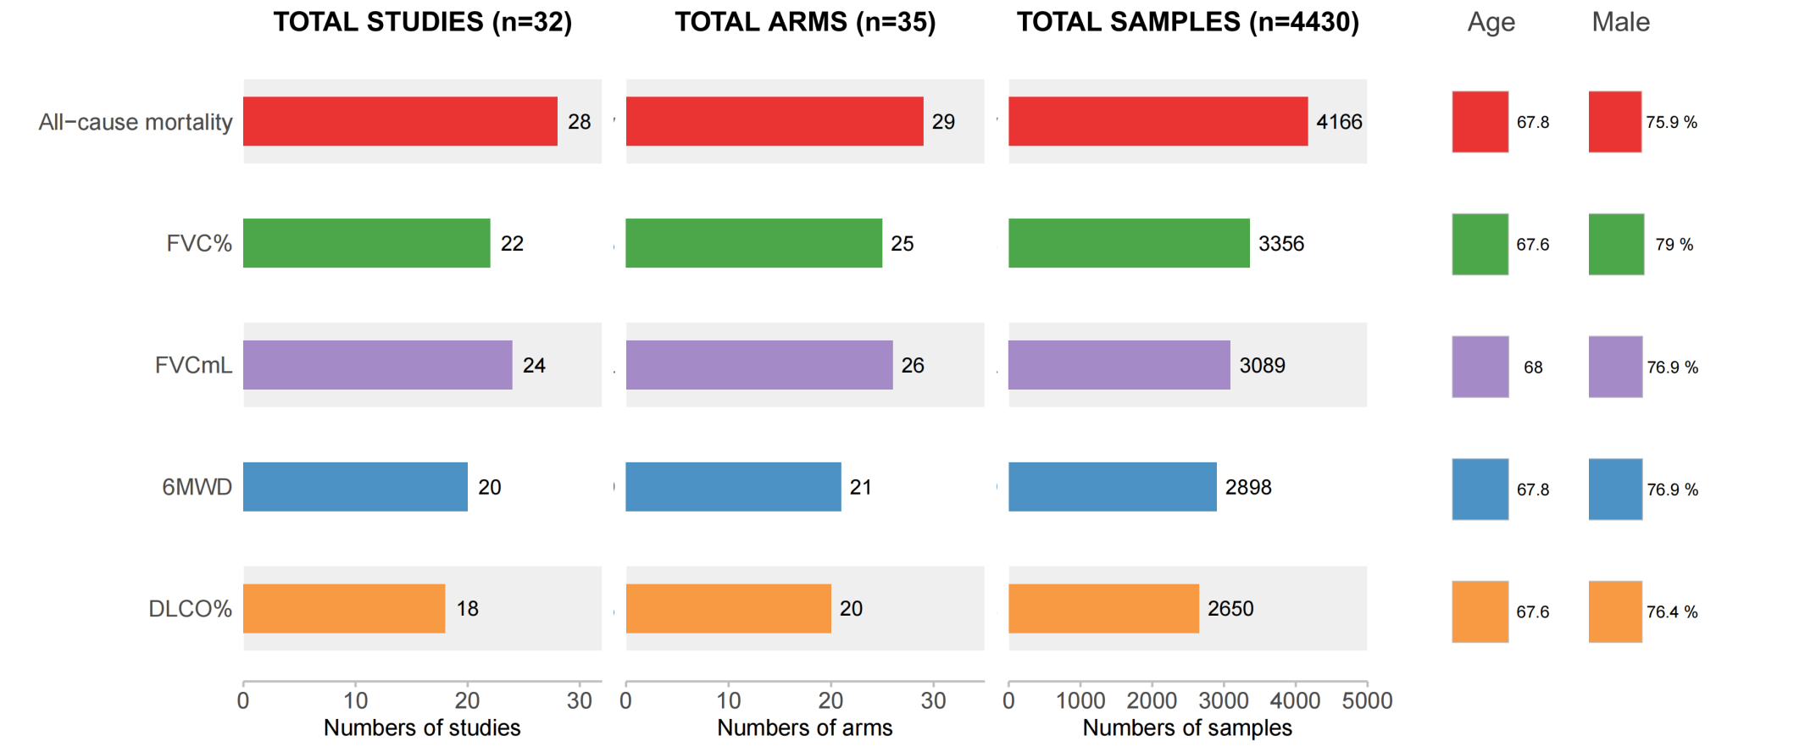

FVC, Forced Vital Capacity; 6MWD, 6-Minute Walk Distance; DLCO, Diffusing Capacity of the Lung for Carbon Monoxide; Age: median age of participants.; Male: median percentage of male participants.
Figure S2. The summary of literature assessment

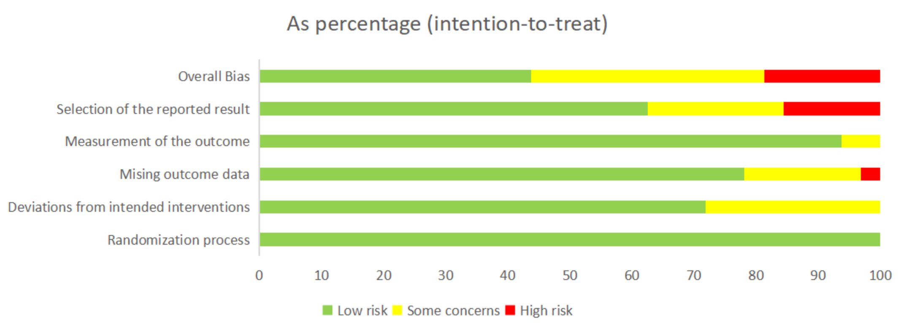

Figure S3. Covariate selection for the placebo response model of all-cause mortality

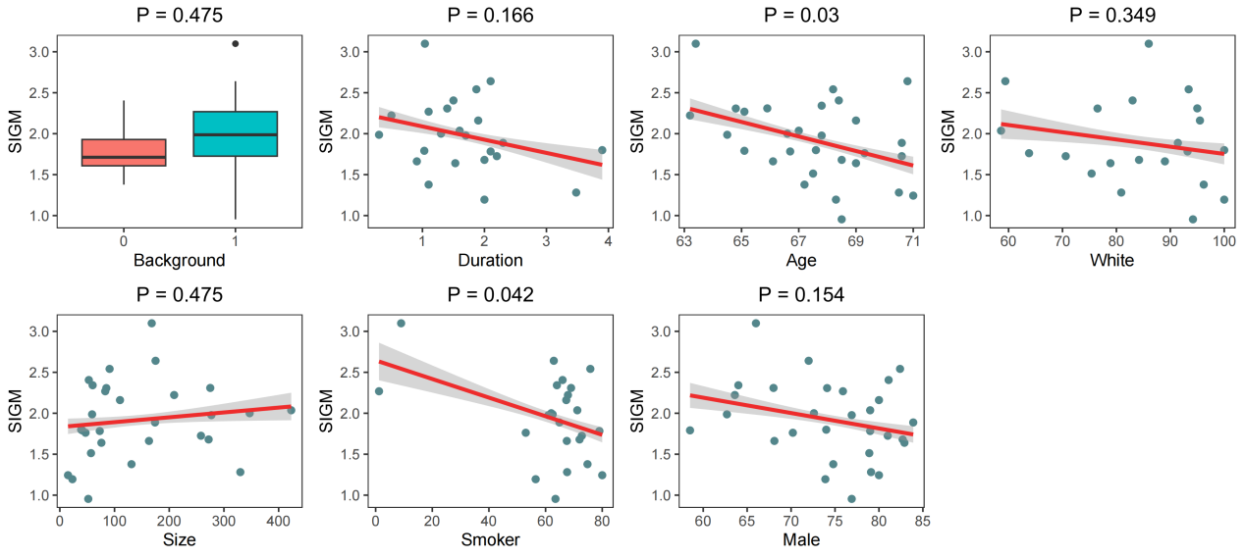

The correlation between continuous variables and model parameter SIGM was assessed using Pearson correlation analysis, while the association between categorical variables and model parameter SIGM was evaluated using the t-test. A p-value of less than 0.05 was considered indicative of a statistically significant correlation.
Background: Whether the patient received background therapy, in the sub-graph of Background, 0 represents the patient did not receive background therapy, 1 represents the patient received background therapy; Duration: Duration time since diagnosis; Smoker: Proportion of smokers; Male: Proportion of males; White: Proportion of whites

Figure S4. The goodness-of-fit plots of the placebo response model of all-cause mortality

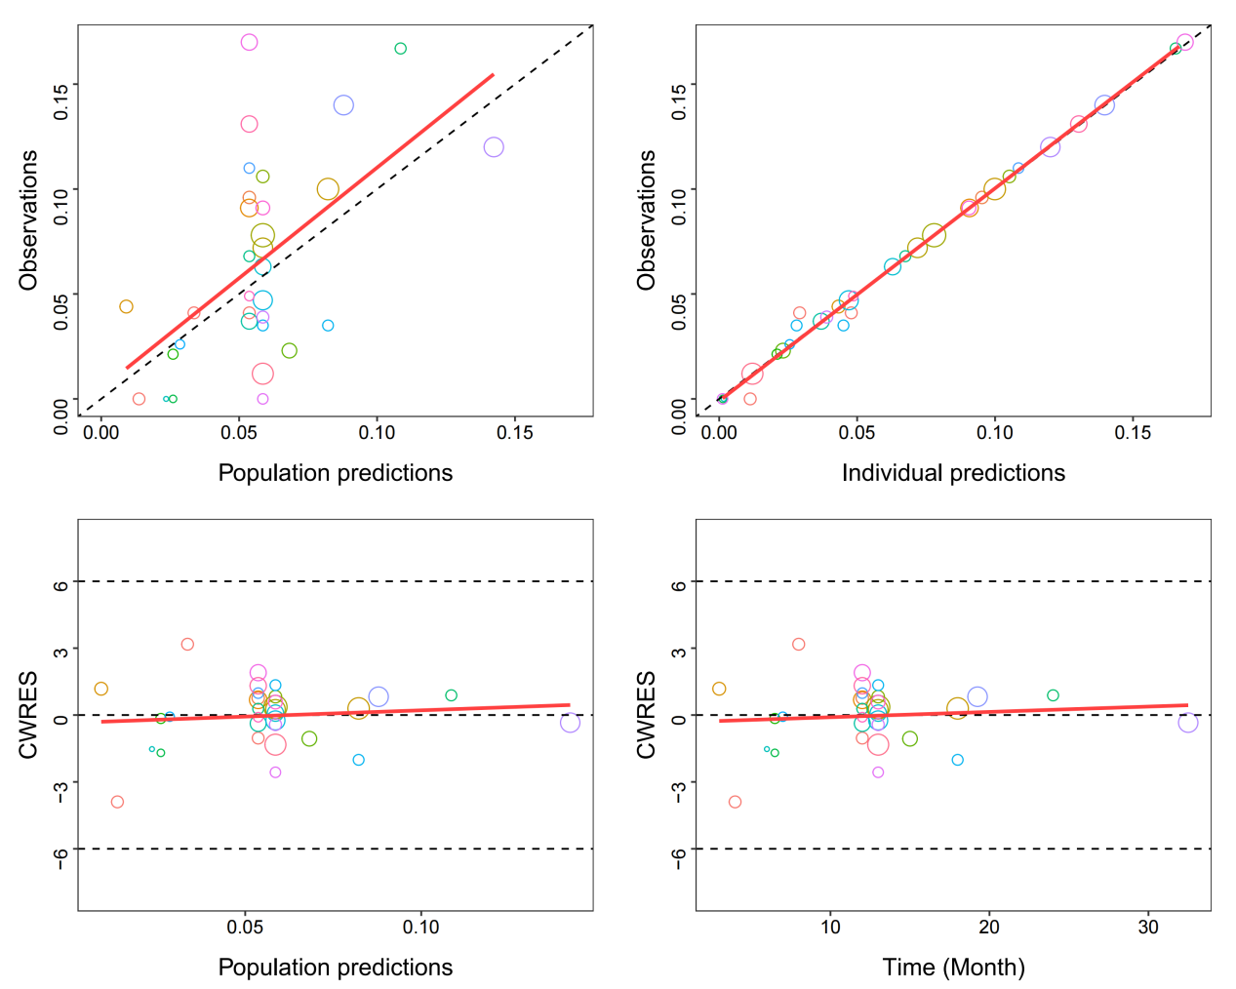

The top-left graph displays the population predicted (PRED) values against the observed values (OBS), while the top-right graph shows the individual predicted (IPRED) values against OBS. The bottom-left graph presents the conditional weighted residuals (CWRES) against PRED, and the bottom-right graph shows CWRES against time. The top-left and top-right graphs have dashed and solid lines that represent the diagonal and fitting lines, respectively, while the bottom-left and bottom-right graphs have dashed and solid lines that represent the 0 and ±6 lines and fitting lines, respectively. Points of the same color represent data from the same group. The size of the point is related to the sample size.
Figure S5. Covariate selection for the placebo response model of FVC%

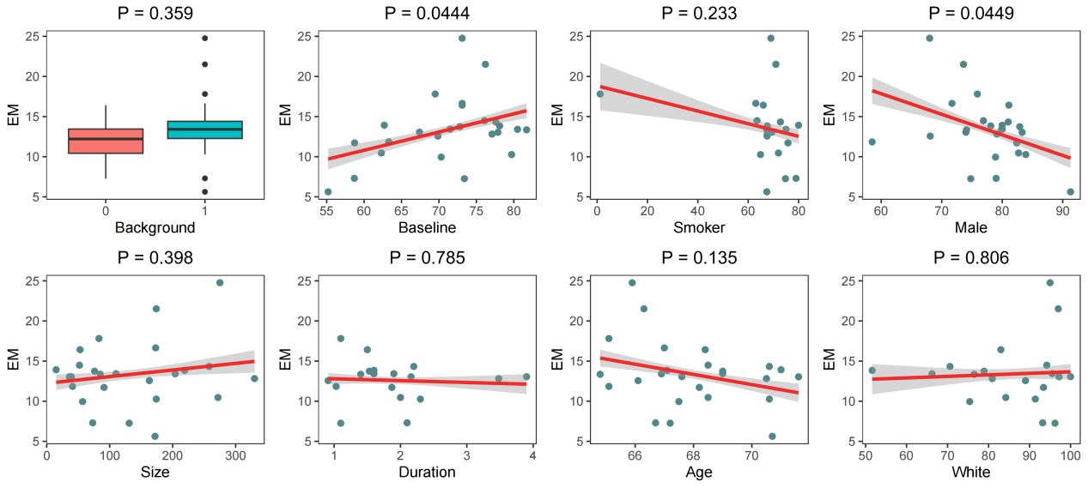

The correlation between continuous variables and model parameter E_{max} was assessed using Pearson correlation analysis, while the association between categorical variables and model parameter E_{max} was evaluated using the t-test. A p-value of less than 0.05 was considered indicative of a statistically significant correlation.
EM: E_{max}, maximal placebo response; Background: Whether the patient received background therapy, in the sub-graph of Background, 0 represents the patient did not receive background therapy, 1 represents the patient received background therapy; Duration: Duration time since diagnosis; Smoker: Proportion of smokers; Male: Proportion of males; White: Proportion of whites.
Figure S6. The goodness-of-fit plots of the placebo response model of FVC%

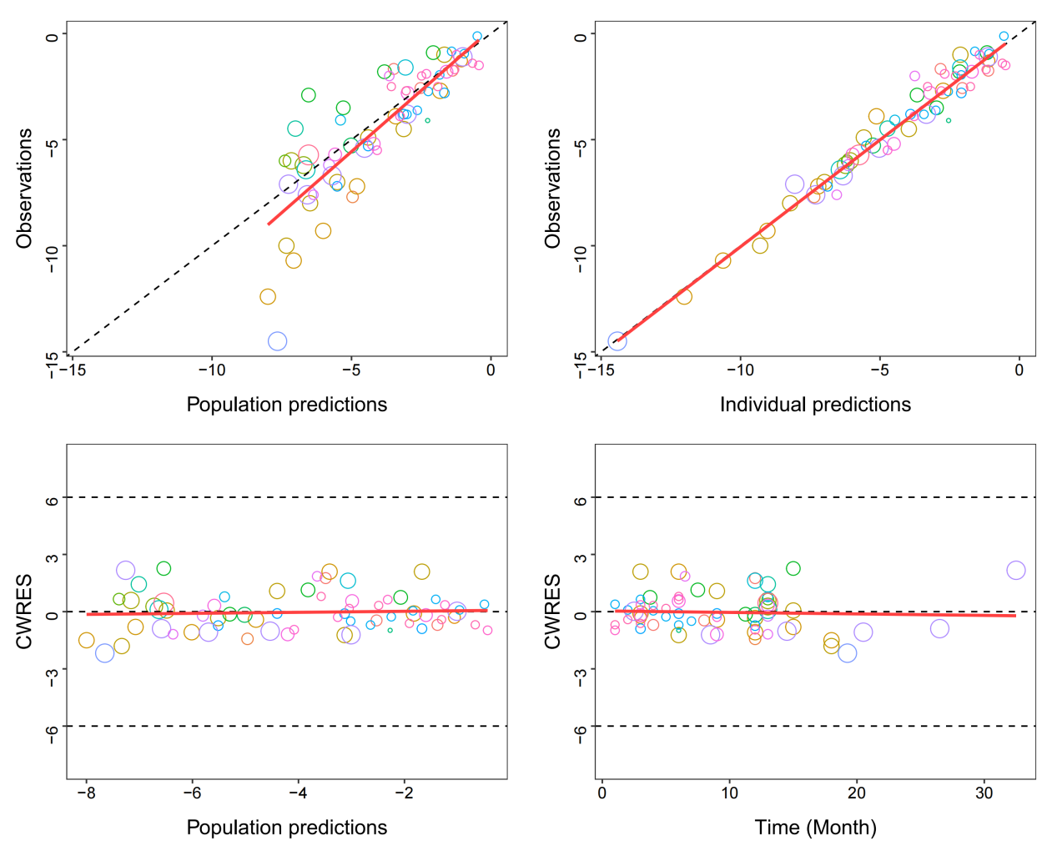

The top-left graph displays the population predicted (PRED) values against the observed values (OBS), while the top-right graph shows the individual predicted (IPRED) values against OBS. The bottom-left graph presents the conditional weighted residuals (CWRES) against PRED, and the bottom-right graph shows CWRES against time. The top-left and top-right graphs have dashed and solid lines that represent the diagonal and fitting lines, respectively, while the bottom-left and bottom-right graphs have dashed and solid lines that represent the 0 and ±6 lines and fitting lines, respectively. Points of the same color represent data from the same group. The size of the point is related to the sample size.
Figure S7. Covariate selection for the placebo response model of FVCmL

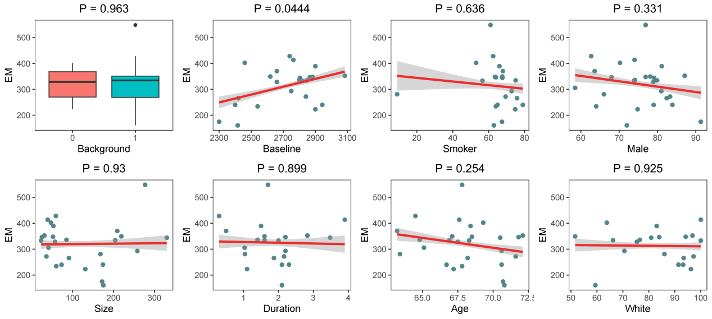
The correlation between continuous variables and model parameter E_{max} was assessed using Pearson correlation analysis, while the association between categorical variables and model parameter E_{max} was evaluated using the t-test. A p-value of less than 0.05 was considered indicative of a statistically significant correlation.
EM: E_{max}, maximal placebo response; Background: Whether the patient received background therapy, in the sub-graph of Background, 0 represents the patient did not receive background therapy, 1 represents the patient received background therapy; Duration: Duration time since diagnosis; Smoker: Proportion of smokers; Male: Proportion of males; White: Proportion of whites.
Figure S8. The goodness-of-fit plots of the placebo response model of FVCmL.

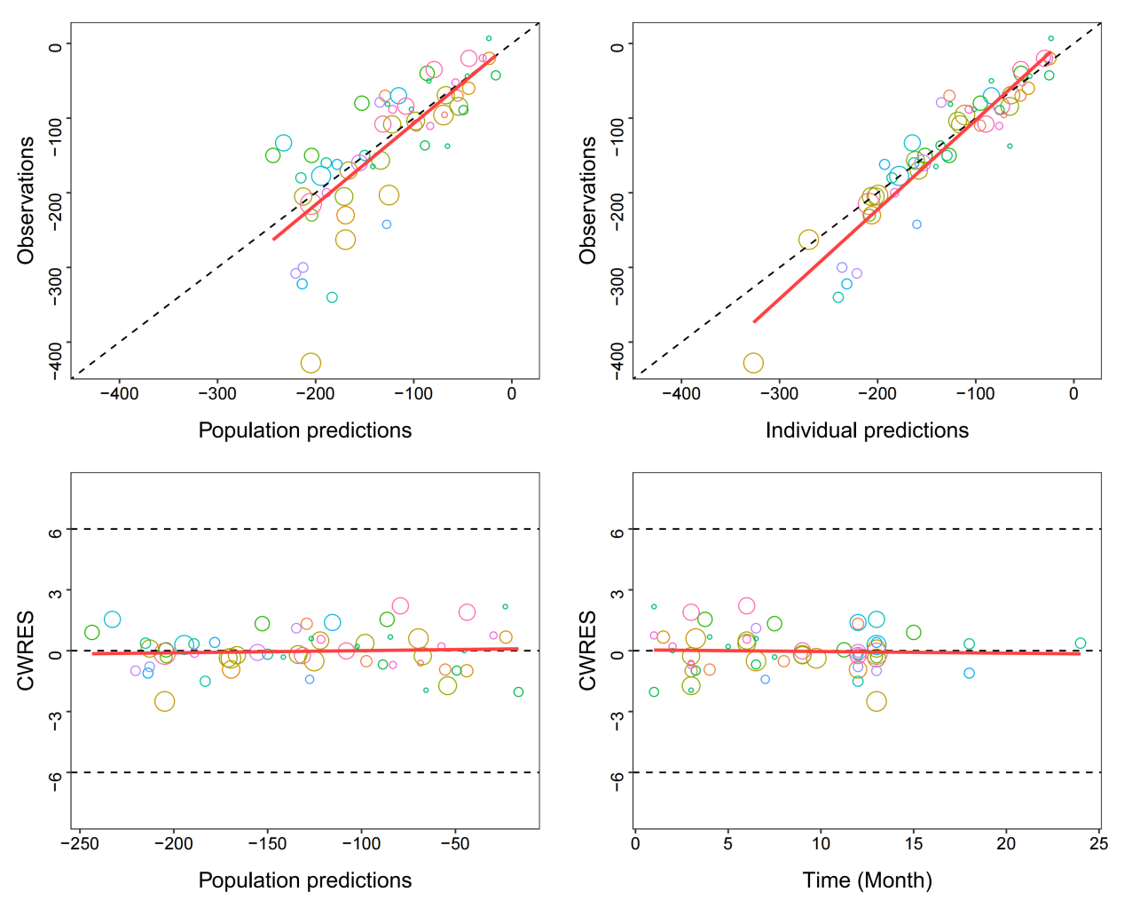

The top-left graph displays the population predicted (PRED) values against the observed values (OBS), while the top-right graph shows the individual predicted (IPRED) values against OBS. The bottom-left graph presents the conditional weighted residuals (CWRES) against PRED, and the bottom-right graph shows CWRES against time. The top-left and top-right graphs have dashed and solid lines that represent the diagonal and fitting lines, respectively, while the bottom-left and bottom-right graphs have dashed and solid lines that represent the 0 and ±6 lines and fitting lines, respectively. The colors of the points indicate the test groups. The size of the point is related to the sample size.
Figure S9. Covariate selection for the placebo response model of DLCO%.

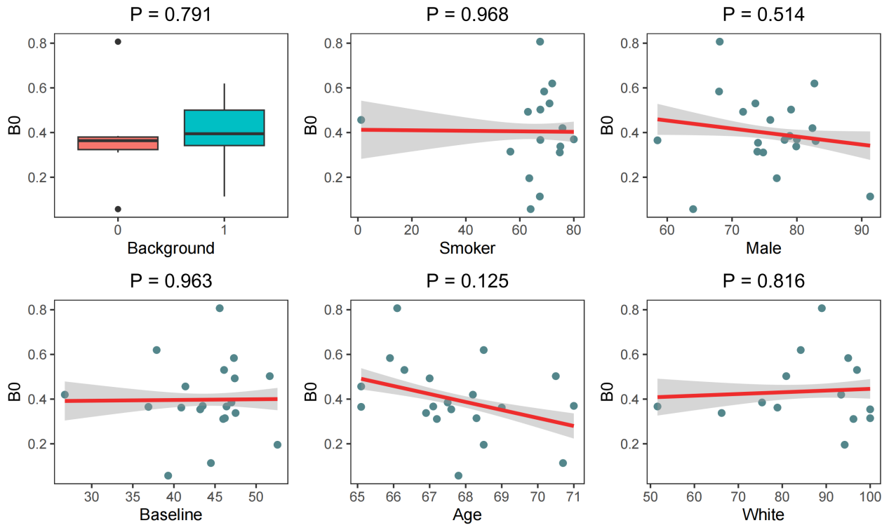

The correlation between continuous variables and model parameter B₀ was assessed using Pearson correlation analysis, while the association between categorical variables and model parameter B₀ was evaluated using the t-test. A p-value of less than 0.05 was considered indicative of a statistically significant correlation.
B₀: slope parameter; Background: Whether the patient received background therapy, in the sub-graph of Background, 0 represents the patient did not receive background therapy, 1 represents the patient received background therapy; Smoker: Proportion of smokers; Male: Proportion of males; White: Proportion of whites.

Figure S10. The goodness-of-fit plots of the placebo response model of DLCO%

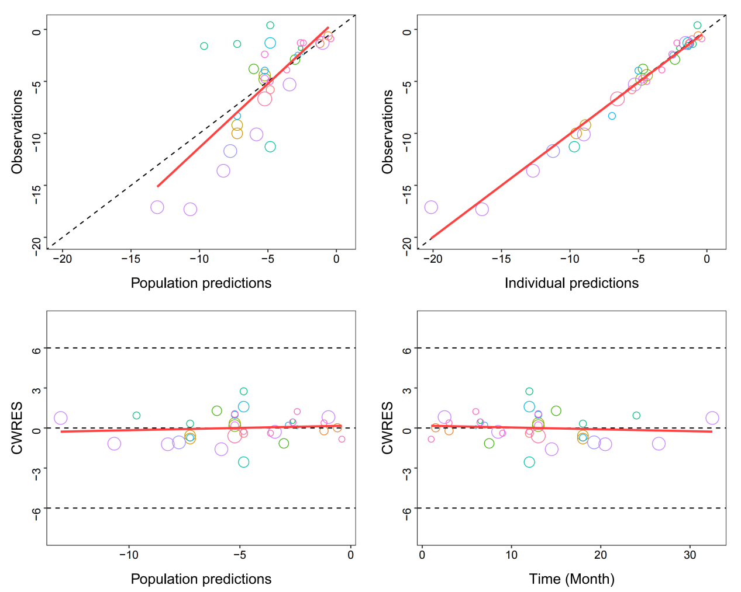

The top-left graph displays the population predicted (PRED) values against the observed values (OBS), while the top-right graph shows the individual predicted (IPRED) values against OBS. The bottom-left graph presents the conditional weighted residuals (CWRES) against PRED, and the bottom-right graph shows CWRES against time. The top-left and top-right graphs have dashed and solid lines that represent the diagonal and fitting lines, respectively, while the bottom-left and bottom-right graphs have dashed and solid lines that represent the 0 and ±6 lines and fitting lines, respectively. The colors of the points indicate the test groups. The size of the point is related to the sample size.
Figure S11. Covariate selection for the placebo response model of 6MWD

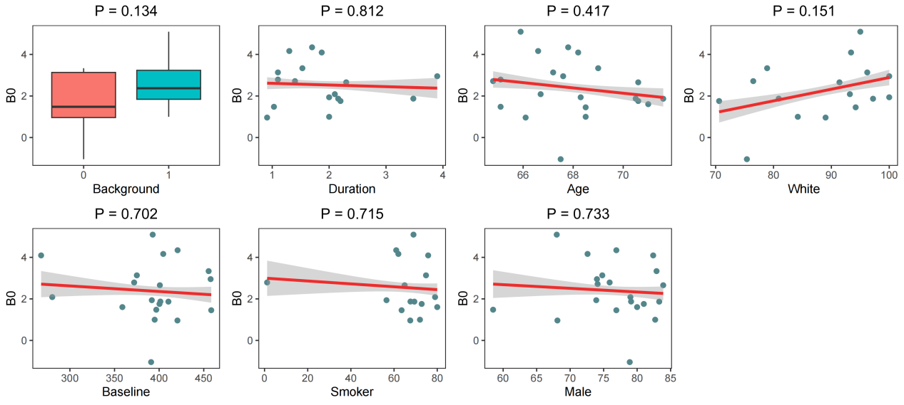

The correlation between continuous variables and model parameter B₀ was assessed using Pearson correlation analysis, while the association between categorical variables and model parameter B₀ was evaluated using the t-test. A p-value of less than 0.05 was considered indicative of a statistically significant correlation.
B₀: slope parameter; Background: Whether the patient received background therapy, in the sub-graph of Background, 0 represents the patient did not receive background therapy, 1 represents the patient received background therapy; Duration: Duration time since diagnosis; Smoker: Proportion of smokers; Male: Proportion of males; White: Proportion of whites.

Figure S12. The goodness-of-fit plots of the placebo response model of 6MWD

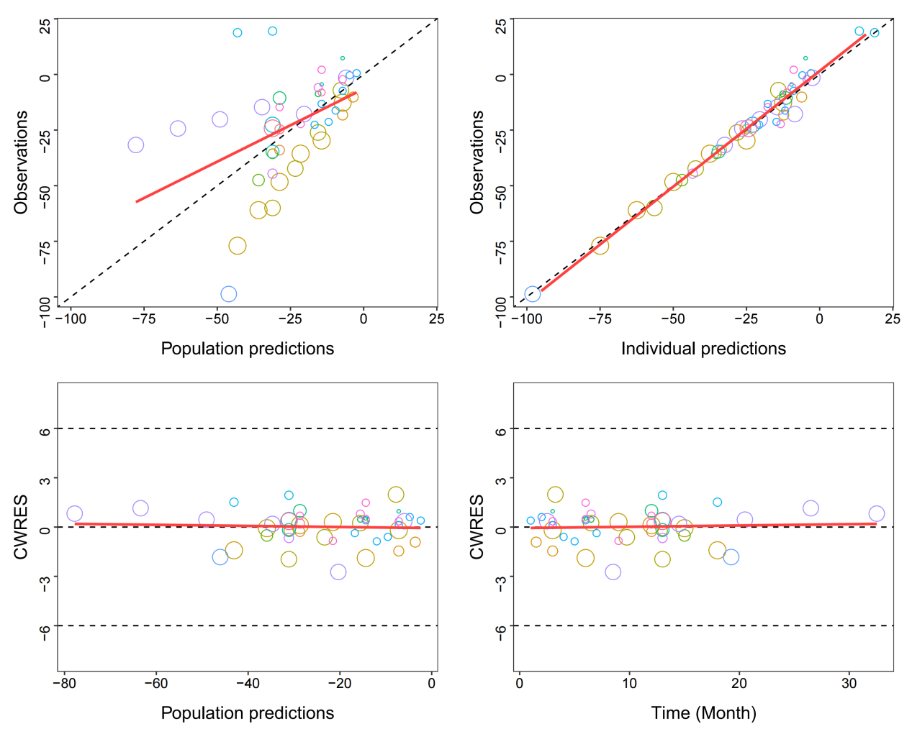

The top-left graph displays the population predicted (PRED) values against the observed values (OBS), while the top-right graph shows the individual predicted (IPRED) values against OBS. The bottom-left graph presents the conditional weighted residuals (CWRES) against PRED, and the bottom-right graph shows CWRES against time. The top-left and top-right graphs have dashed and solid lines that represent the diagonal and fitting lines, respectively, while the bottom-left and bottom-right graphs have dashed and solid lines that represent the 0 and ±6 lines and fitting lines, respectively. The colors of the points indicate the test groups. The size of the point is related to the sample size.

