Table S1. Pulmonary function test results
Parameter | Predicted value | Measured value | % predicted
FVC (L) | 5.46 | 4.75 | 87.0
FEV1 (L) | 4.51 | 3.63 | 80.6
FEV1/FVC (%) | 76.54 | 76.54 | —
DLCO (mmol/min/kPa) | 12.35 | 9.54 | 77.3
DLCO/VA (mmol/min/kPa/L) | 1.60 | 1.58 | 98.7

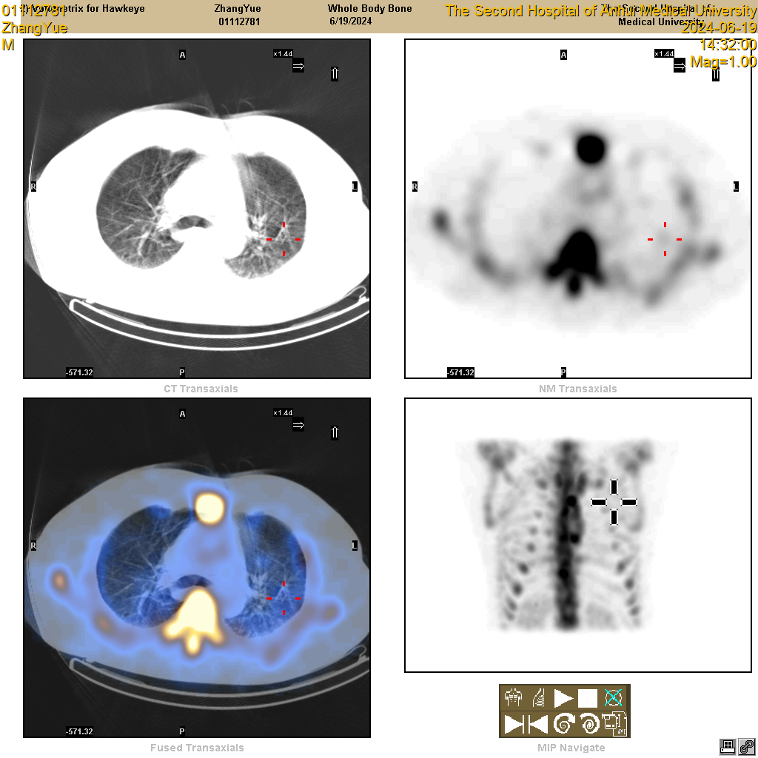
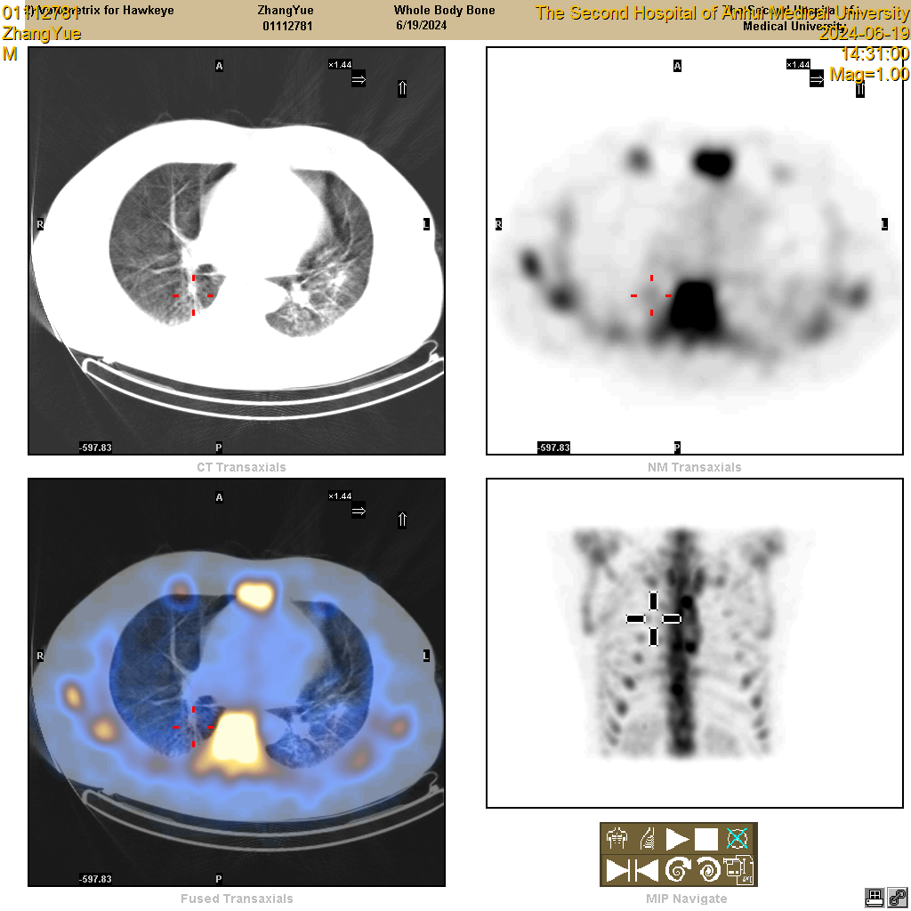
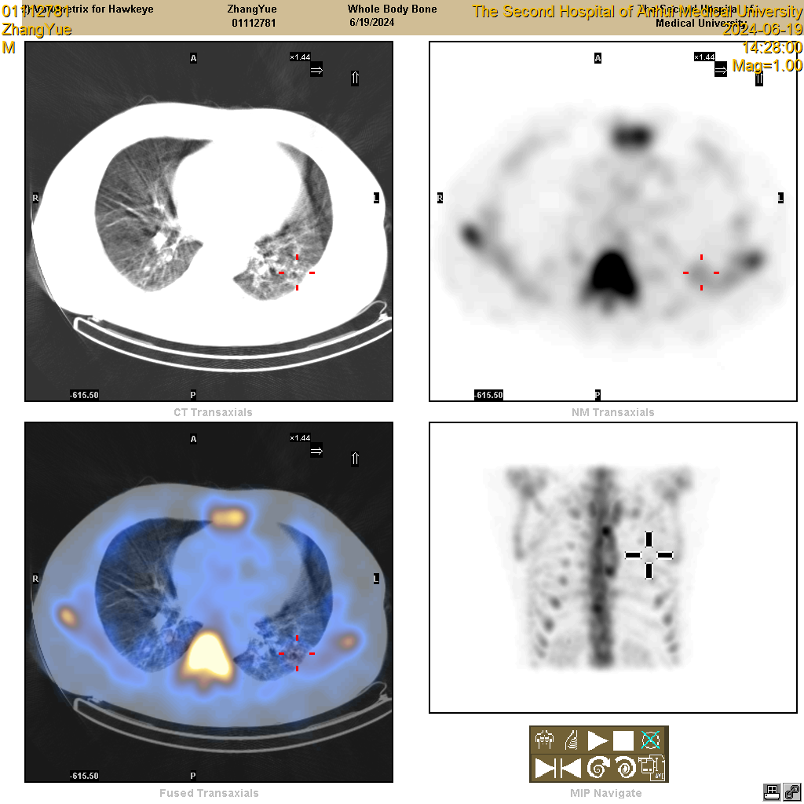
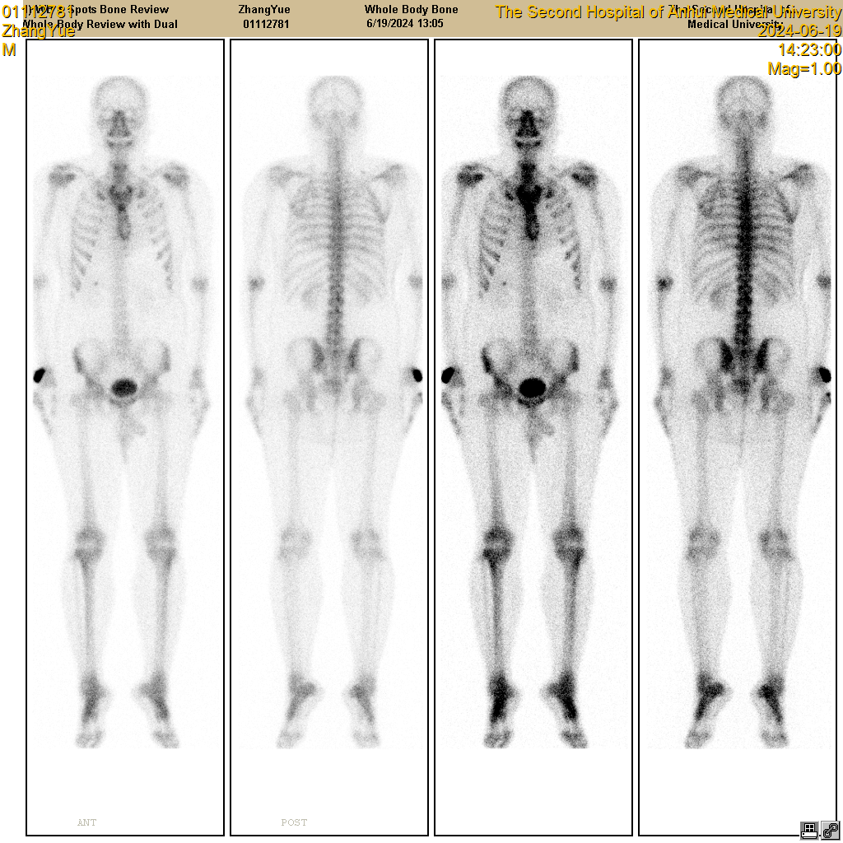
A
B
Figure S1. Bone scintigraphy and SPECT/CT fusion imaging of pulmonary ossification lesions in idiopathic diffuse pulmonary ossification.
(A) Whole-body bone scintigraphy showed abnormal tracer uptake in the bilateral lung fields, indicating increased osteoblastic activity.
(B) SPECT/CT fusion images demonstrated the spatial correspondence between radiotracer accumulation and CT-visible pulmonary calcified lesions.

