Supplementary material
Figure S1. Observed CAR values in the CAR-rising phenotype.
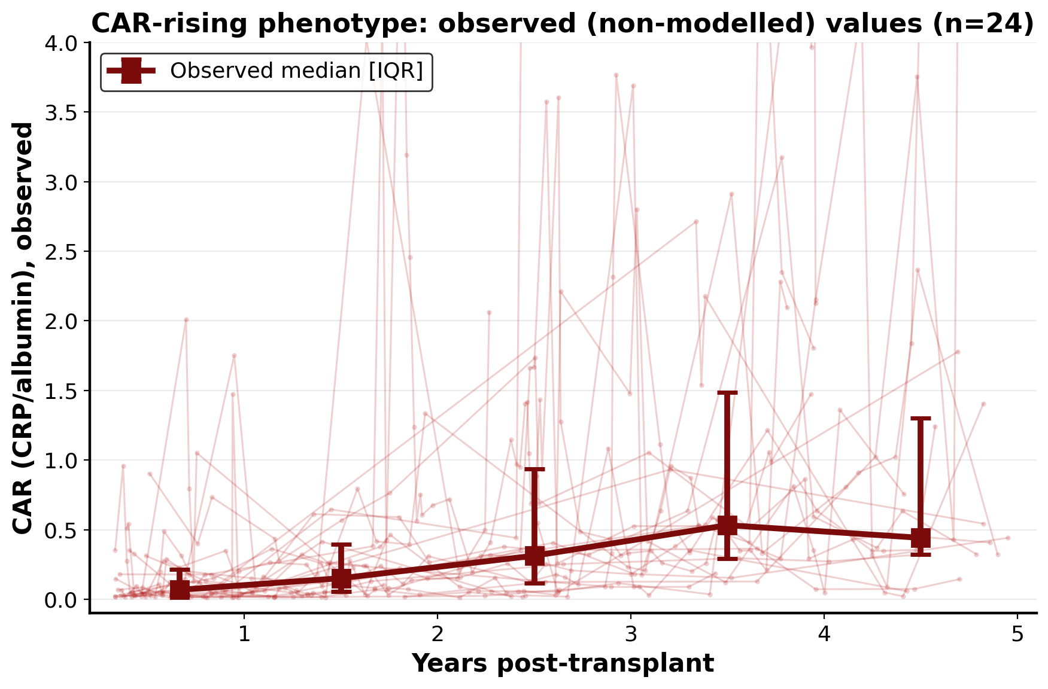
Faint red lines show individual patient CAR measurements; the heavy line shows the observed median with interquartile range within yearly intervals. The monotonic rise across years confirms that the late escalation is present in the raw measurements and is not an artefact of the modelled quadratic time term. CAR = CRP-to-albumin ratio.
Supplementary Table S1. Comparison of included (analytic cohort) and excluded patients.
Characteristic | Included (n=104) | Excluded (n=34) | p
Age at LTx, years | 58.6 [53.7–62.5] | 58.0 [49.9–62.9] | 0.29
Male sex, n (%) | 64 (62) | 22 (65) | 0.84
IPF, n (%) | 31 (30) | 16 (47) | 0.09
BMI, kg/m² | 24.9 [22.3–27.1] | 24.1 [21.0–27.2] | 0.44
LAS at listing | 42.2 [36.8–53.9] | 45.4 [40.3–57.5] | 0.28
FVC, % predicted | 67.0 [49.4–80.3] | 68.2 [48.6–75.5] | 0.68
Baseline CAR | 1.2 [0.4–2.2] | 0.5 [0.2–1.4] | 0.002
Deceased (any follow-up), n (%) | 50 (48) | 16 (47) | 1.00
Follow-up, days | 2053 [1383–3225] | 273 [93–514] | <0.001
Values are median [IQR] for continuous variables and n (%) for categorical variables. P-values from the Mann–Whitney U test (continuous) or Fisher's exact test (categorical). LAS, Lung Allocation Score; CAR, CRP-to-albumin ratio; FVC, forced vital capacity; BMI, body mass index.

