Supplementary Appendix

Database | Search Strategy | Records Retrieved (n)
PubMed/MEDLINE | ("High-Flow Nasal Cannula" OR "HFNC" OR "high flow nasal cannula" OR "nasal high flow" OR "high flow nasal oxygen" OR "high flow nasal oxygen therapy" OR "nasal highflow") AND ("Respiratory Failure" OR "Respiratory Insufficiency"[Mesh] OR "acute hypoxemic respiratory failure" OR "acute respiratory failure" OR "hypoxemic respiratory failure") | 1573
Embase | ("High-Flow Nasal Cannula" OR "HFNC" OR "high flow nasal cannula" OR "nasal high flow" OR "high flow nasal oxygen" OR "high flow nasal oxygen therapy" OR "nasal highflow") AND ("Respiratory Failure" OR "Respiratory Insufficiency" OR "acute hypoxemic respiratory failure" OR "acute respiratory failure" OR "hypoxemic respiratory failure") (restricted to randomized controlled trials) | 529
Scopus | ("High-Flow Nasal Cannula" OR "HFNC" OR "high flow nasal cannula" OR "nasal high flow" OR "high flow nasal oxygen" OR "high flow nasal oxygen therapy" OR "nasal highflow") AND ("Respiratory Failure" OR "Respiratory Insufficiency" OR "acute hypoxemic respiratory failure" OR "acute respiratory failure" OR "hypoxemic respiratory failure") | 2424
Cochrane Library (CENTRAL) | ("High-Flow Nasal Cannula" OR "HFNC" OR "high flow nasal cannula" OR "nasal high flow" OR "high flow nasal oxygen" OR "high flow nasal oxygen therapy" OR "nasal highflow") AND ("Respiratory Failure" OR "Respiratory Insufficiency" OR "acute hypoxemic respiratory failure" OR "acute respiratory failure" OR "hypoxemic respiratory failure") | 817
ClinicalTrials.gov | ("High-Flow Nasal Cannula" OR "HFNC" OR "high flow nasal cannula" OR "nasal high flow" OR "high flow nasal oxygen" OR "high flow nasal oxygen therapy" OR "nasal highflow") AND ("Respiratory Failure" OR "Respiratory Insufficiency" OR "acute hypoxemic respiratory failure" OR "acute respiratory failure" OR "hypoxemic respiratory failure") | 200
Supplementary Table S1. Detailed electronic search strategies
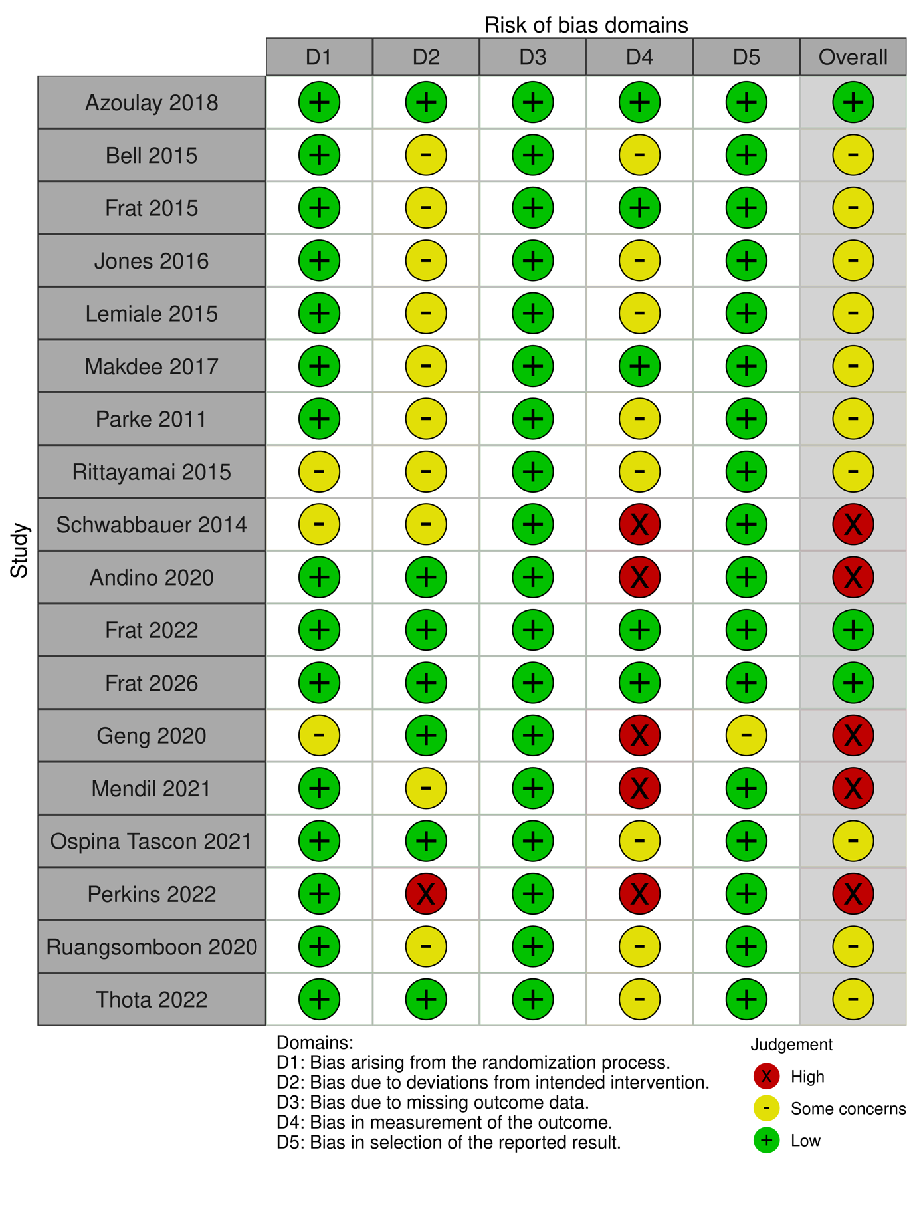Supplementary Figure S1. Risk of bias traffic-light plot generated using the Cochrane Risk of Bias 2 (RoB 2) tool showing domain-level risk of bias assessments for each included randomized controlled trial.
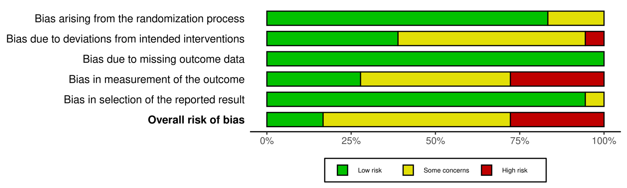Supplementary Figure S2. Risk of bias summary plot showing the proportion of studies judged as low risk, some concerns, or high risk across each RoB 2 domain.

Outcome | Sample Size | Effect Estimate | Quality Assessment | Inconsistency | Indirectness | Imprecision | Publication Bias | Overall Quality
Cardiac arrest | 943 | RR: 0.65 [0.31, 1.40] | Not Serious | Not Serious | Not Serious | Serious³ | N/A | Moderate
Cardiac dysrhythmia | 439 | RR: 0.94 [0.23, 3.87] | Not Serious | Not Serious | Not Serious | Serious³ | N/A | Moderate
Hospital length of stay (days) | 3416 | MD: -0.65 [-1.23, -0.07] | Serious¹ | Not Serious | Not Serious | Not Serious | N/A | Moderate
ICU-Mortality | 2551 | RR: 0.96 [0.84, 1.11] | Not Serious | Not Serious | Not Serious | Not Serious | N/A | High
Length of ICU stay (days) | 3275 | MD: -0.91 [-0.75, 2.56] | Not Serious | Serious² | Not Serious | Serious³ | N/A | Low
Mortality (HR) | 1889 | HR: -.75 [0.54, 1.05] | Not Serious | Serious² | Not Serious | Serious⁴ | N/A | Low
Mortality | 3814 | RR: 0.97 [0.82, 1.13] | Not Serious | Not Serious | Not Serious | Not Serious | Serious⁵ | Moderate
Need for intubation or invasive mechanical ventilation | 4043 | RR: 0.87 [0.79, 0.97] | Not Serious | Not Serious | Not Serious | Not Serious | Serious⁵ | Moderate
Patient reported comfort | 2167 | MD: 0.10 [-0.41, 0.60] | Serious¹ | Serious² | Not Serious | Not Serious | Serious⁵ | Very Low
Patient reported dyspnea | 2104 | MD: 0.01 [-0.38, 0.39] | Not Serious | Serious² | Not Serious | Not Serious | N/A | Moderate
Pneumothorax | 1453 | RR: 2.49 [0.79, 7.90] | Not Serious | N/A | Not Serious | Serious³ | N/A | Moderate
Septic Shock | 1350 | RR: 0.77 [0.57, 1.03] | Not Serious | Not Serious | Not Serious | Serious⁴ | N/A | Moderate
Treatment failure or need for escalation | 4099 | RR: 0.87 [0.75, 1.02] | Serious¹ | Serious² | Not Serious | Not Serious | Serious⁵ | Very Low
Ventilator-free days at day 28 | 1509 | MD: 1.19 [-1.48, 3.87] | Not Serious | Serious² | Not Serious | Serious³ | N/A | Low

- High risk studies had a greater percentage of effect.
- Downgraded for inconsistency: significant heterogeneity (I² > 50%) observed across studies.
- Downgraded 1 level for wide confidence intervals.
- Downgraded 1 level for a small number of events.
- Downgraded for asymmetry in the funnel plot.

Table S2: GRADE Summary of Findings; GRADE Assessment of Main Outcomes

Publication Bias Plots:
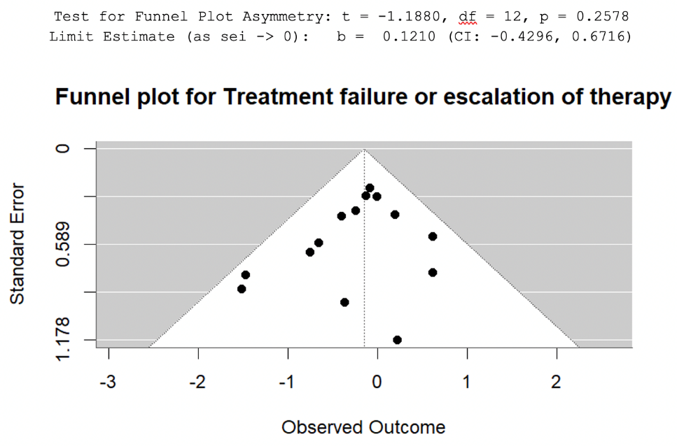
Supplementary Figure S3. Funnel plot for treatment failure or escalation of therapy.

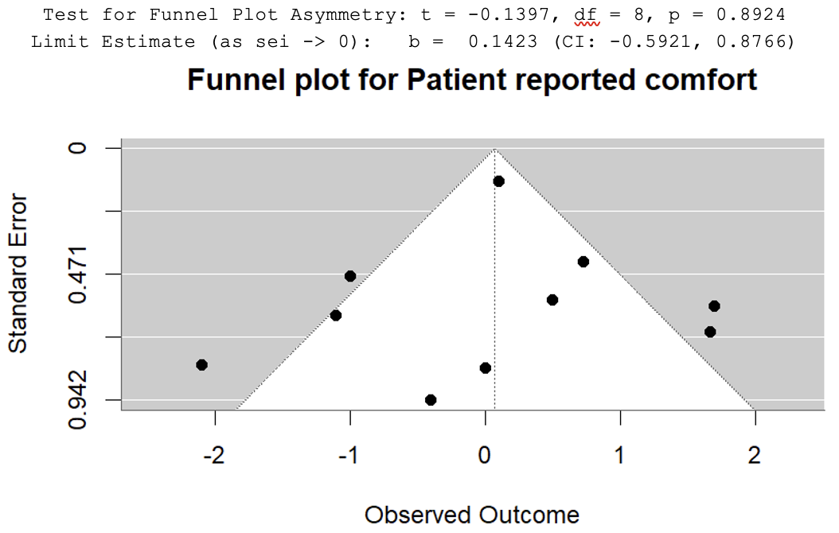
Supplementary Figure S4. Funnel plot for patient-reported comfort.
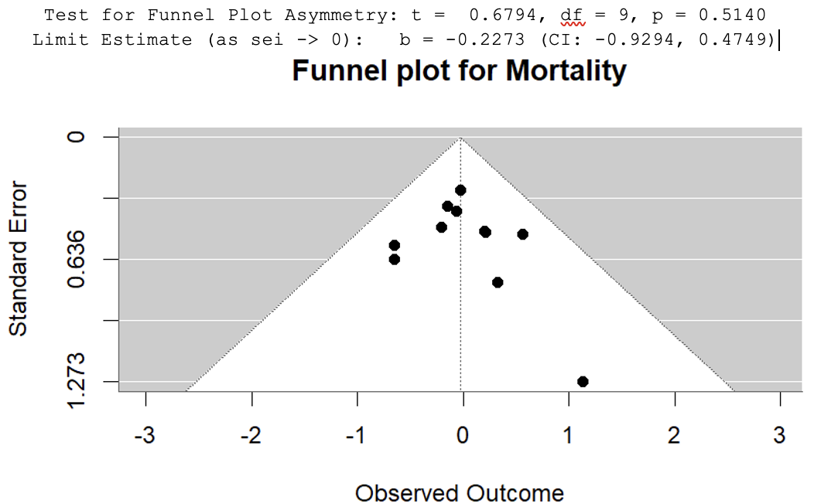
Supplementary Figure S5. Funnel plot for all-cause mortality.

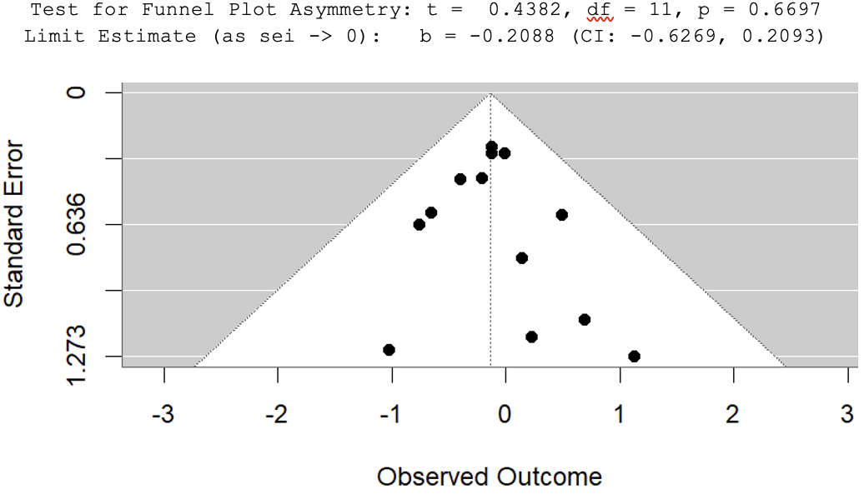
Supplementary Figure S6. Funnel plot for need for endotracheal intubation or invasive mechanical ventilation.

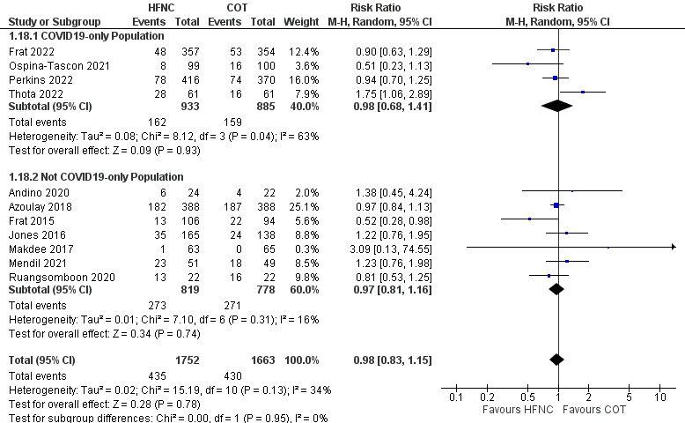Supplementary Figure S7. Subgroup analysis of mortality according to COVID-19 status.
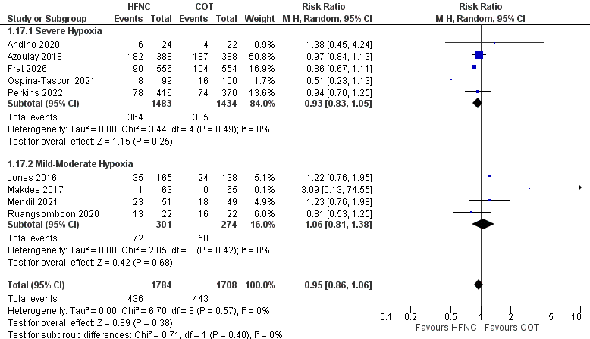Supplementary Figure S8. Subgroup analysis of mortality according to severity of hypoxemia.
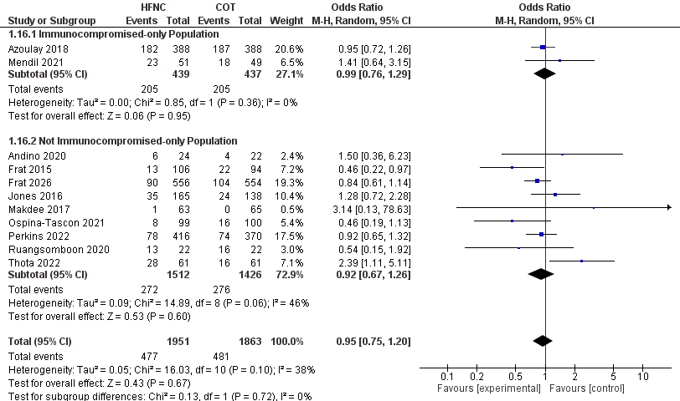Supplementary Figure S9. Subgroup analysis of mortality according to immune status.
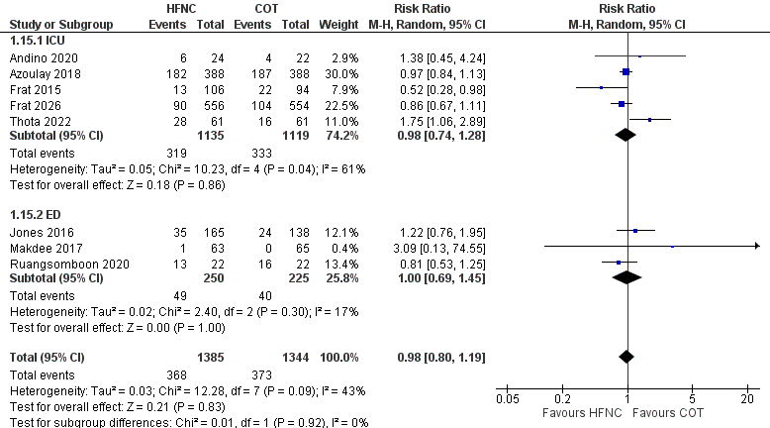Supplementary Figure S10. Subgroup analysis of mortality according to location of administration.

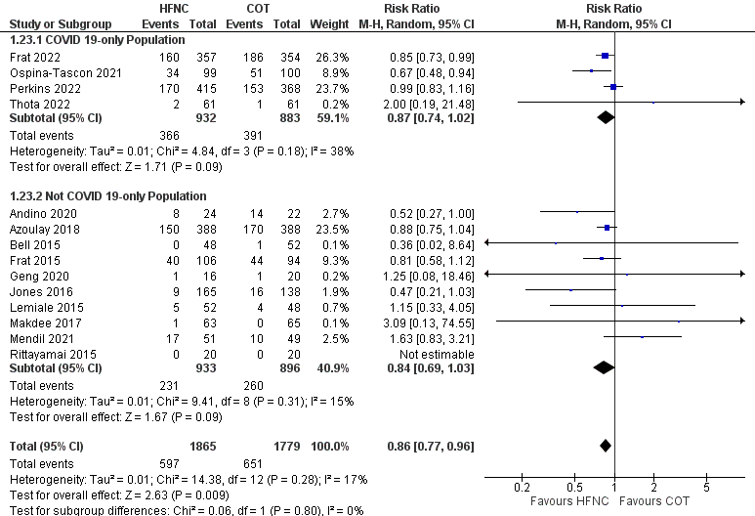Supplementary Figure S11. Subgroup analysis of intubation or invasive mechanical ventilation according to COVID-19 status.
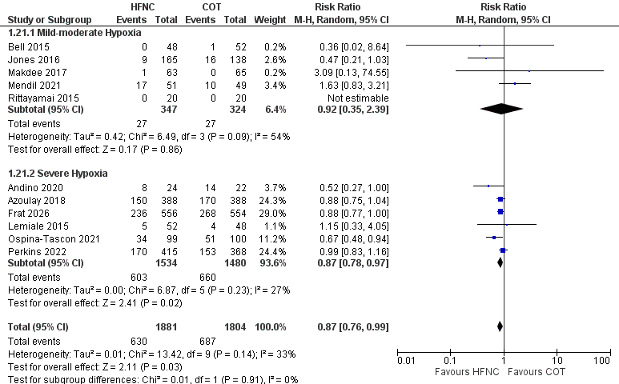Supplementary Figure S12. Subgroup analysis of intubation or invasive mechanical ventilation according to severity of hypoxemia.
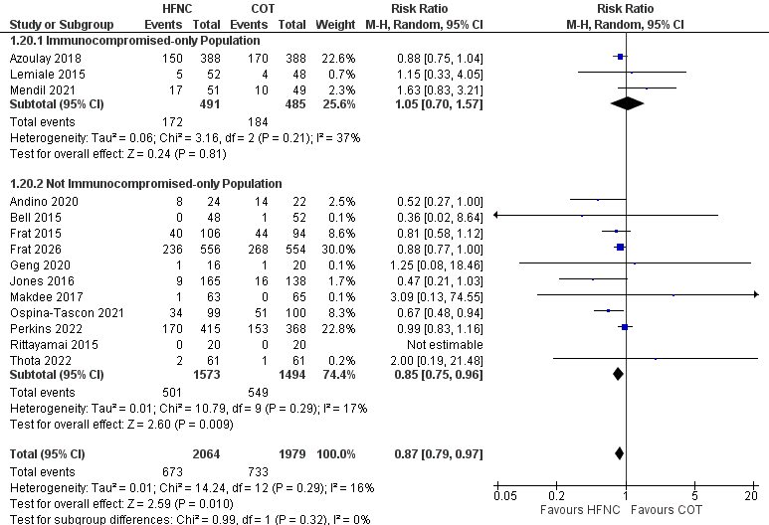Supplementary Figure S13. Subgroup analysis of intubation or invasive mechanical ventilation according to immune status.
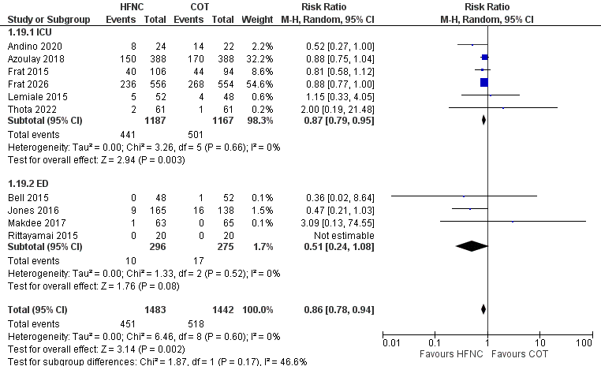Supplementary Figure S14. Subgroup analysis of intubation or invasive mechanical ventilation according location of administration.
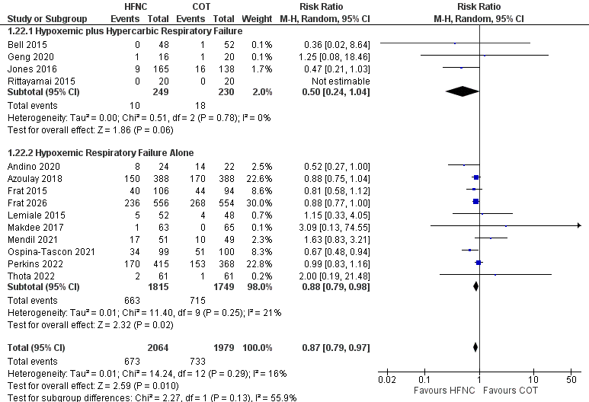Supplementary Figure S15. Subgroup analysis of intubation or invasive mechanical ventilation according to respiratory failure phenotype.
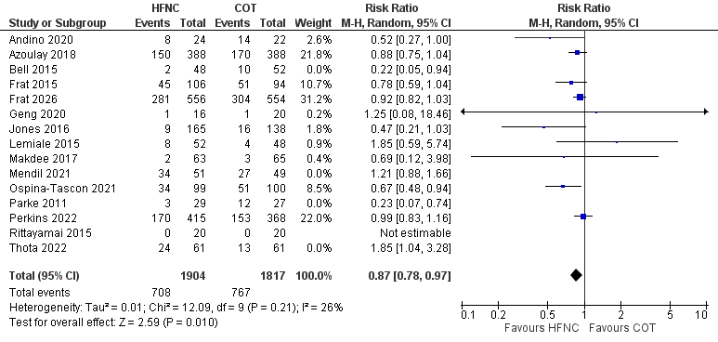Supplementary Figure S16. Leave-one-out sensitivity analysis for treatment failure or escalation of therapy.
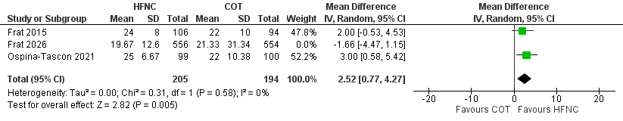Supplementary Figure S17. Leave-one-out sensitivity analysis for ventilator-free days at day 28.
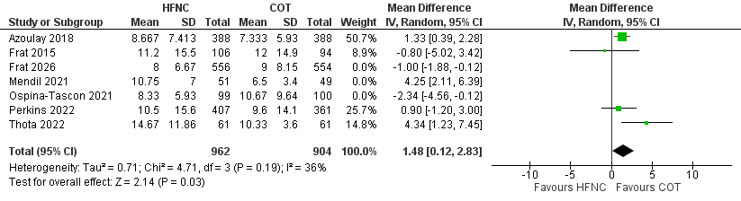Supplementary Figure S18. Leave-one-out sensitivity analysis for ICU length of stay.

Trial Sequential Analysis Plots:
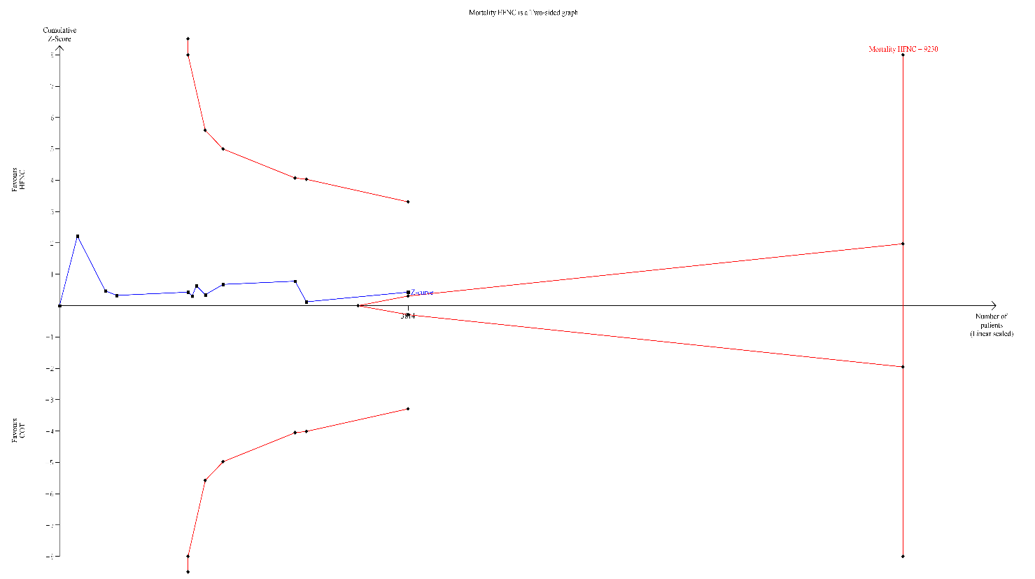
Supplementary Figure S19: Trail Sequential Analysis Plot of Mortality
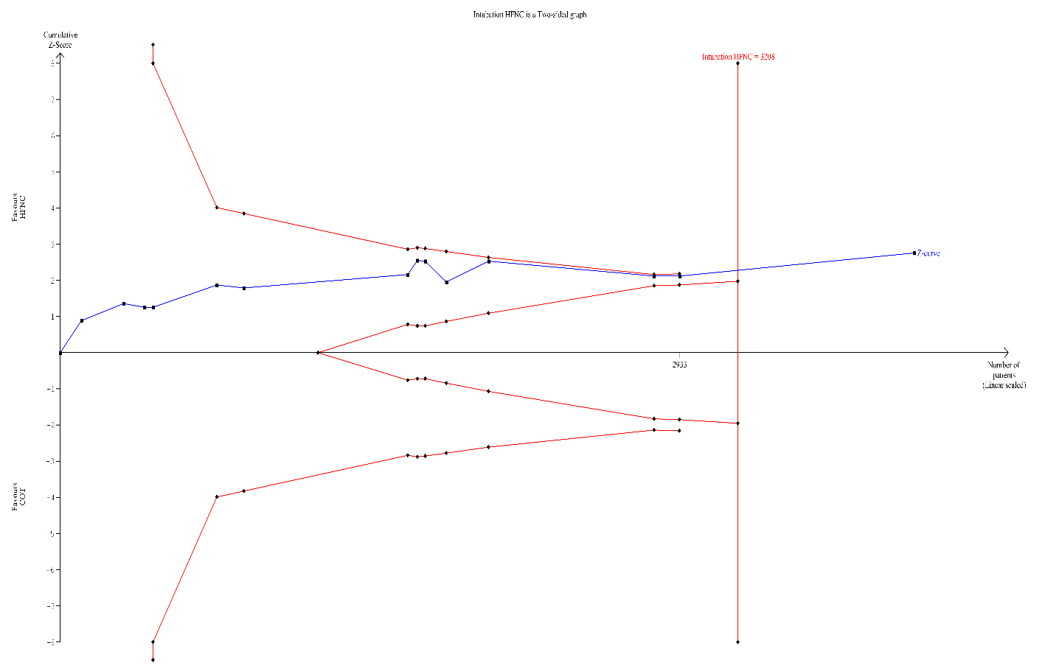
Supplementary Figure S20: Trail Sequential Analysis Plot of Need for Intubation or Invasive Mechanical Ventilation

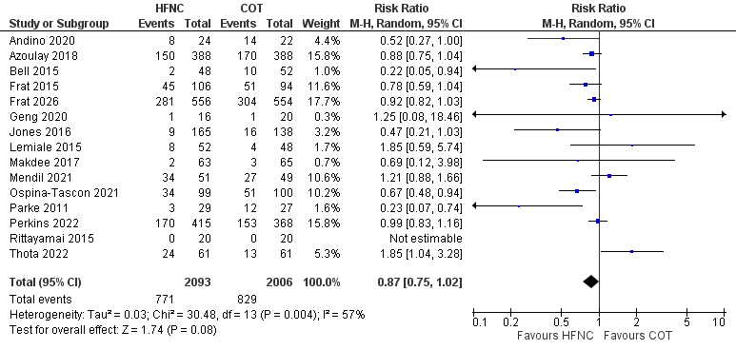
Supplementary Figure S21. Forest plot comparing treatment failure or escalation of respiratory support between high-flow nasal cannula and conventional oxygen therapy.

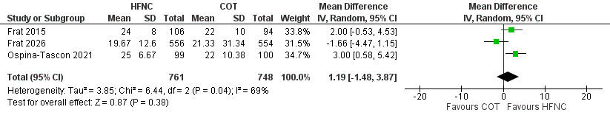
Supplementary Figure S22. Forest plot comparing ventilator-free days at day 28 between high-flow nasal cannula and conventional oxygen therapy.

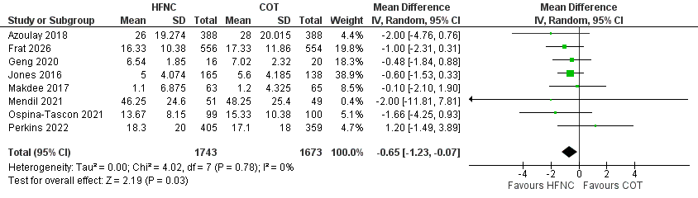
Supplementary Figure S23. Forest plot comparing hospital length of stay between high-flow nasal cannula and conventional oxygen therapy.

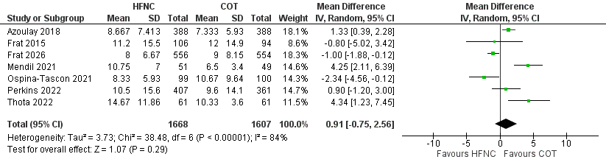
Supplementary Figure S24. Forest plot comparing intensive care unit length of stay between high-flow nasal cannula and conventional oxygen therapy.

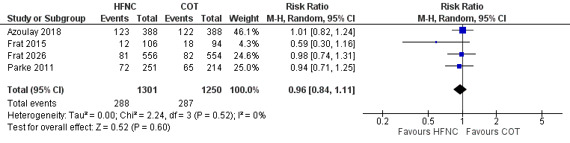
Supplementary Figure S25. Forest plot comparing intensive care unit mortality between high-flow nasal cannula and conventional oxygen therapy.

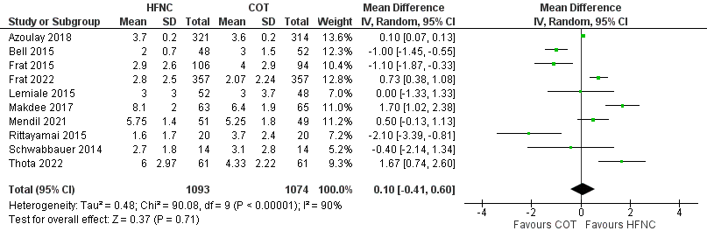
Supplementary Figure S26. Forest plot comparing patient-reported comfort between high-flow nasal cannula and conventional oxygen therapy.

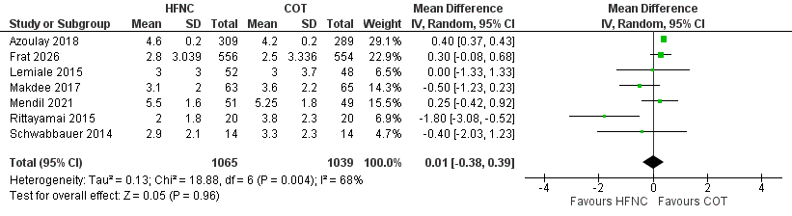
Supplementary Figure S27. Forest plot comparing patient-reported dyspnea between high-flow nasal cannula and conventional oxygen therapy.

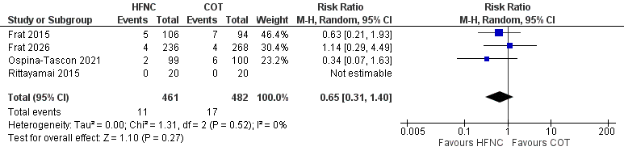
Supplementary Figure S28. Forest plot comparing incidence of cardiac arrest between high-flow nasal cannula and conventional oxygen therapy.

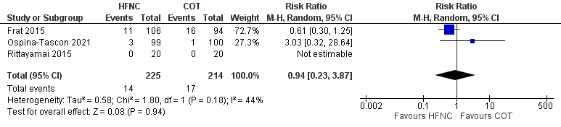
Supplementary Figure S29. Forest plot comparing incidence of cardiac dysrhythmia between high-flow nasal cannula and conventional oxygen therapy.

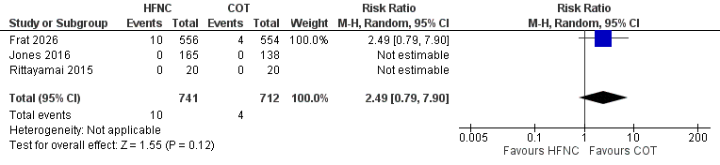
Supplementary Figure S30. Forest plot comparing incidence of pneumothorax between high-flow nasal cannula and conventional oxygen therapy.

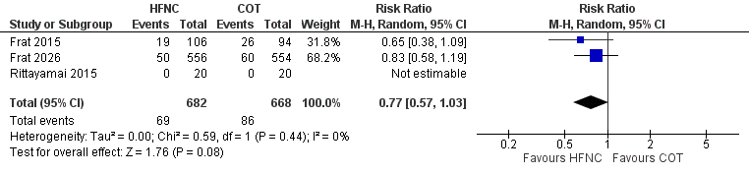
Supplementary Figure S31. Forest plot comparing incidence of septic shock between high-flow nasal cannula and conventional oxygen therapy.

