a)  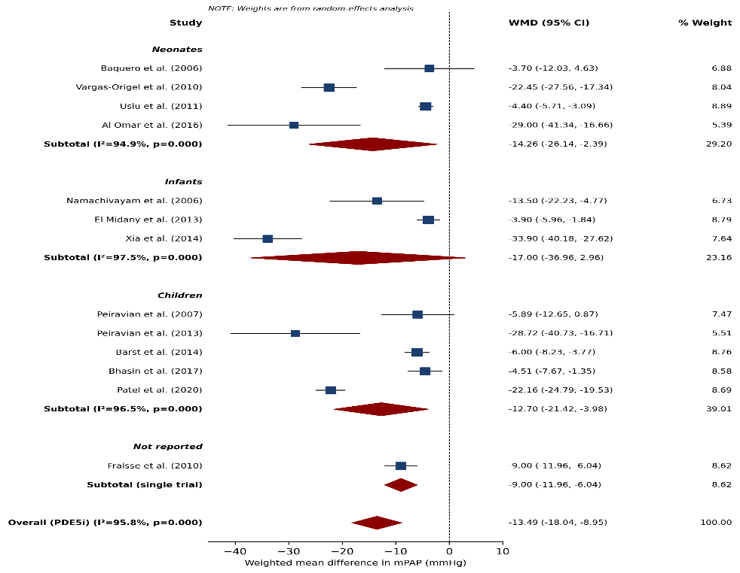 | b)  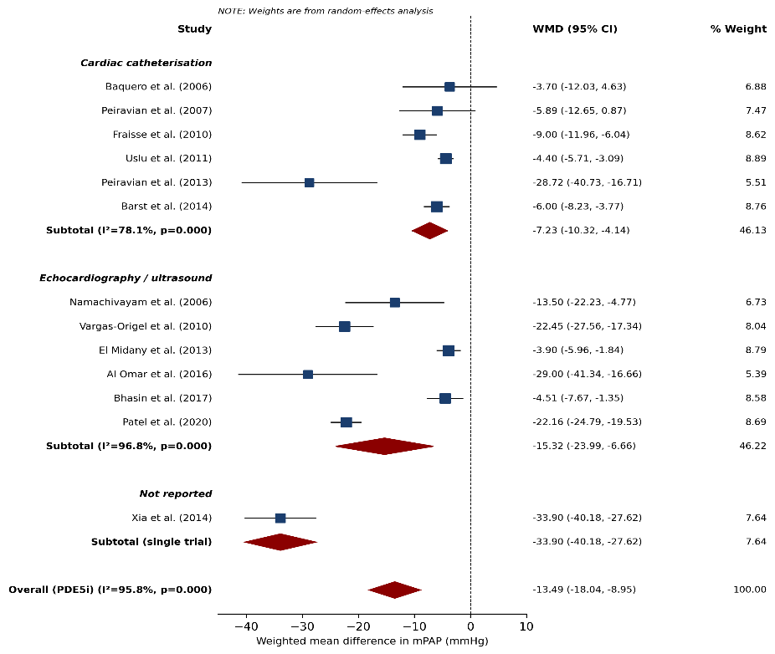
c)
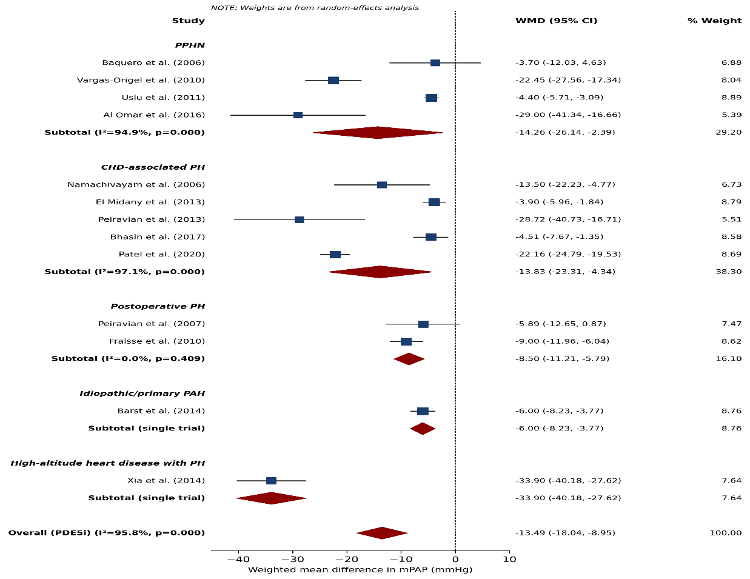
Supplementary Fig. 1 Subgroup analyses of mean pulmonary artery pressure. a PDE5 inhibitor trials stratified by age group. b PDE5 inhibitor trials stratified by measurement modality. c PDE5 inhibitor trials stratified by primary diagnosis. d PDE5 inhibitor and endothelin receptor antagonist trials stratified by population (neonatal PPHN versus non-neonatal paediatric). e Sensitivity analysis restricted to trials measuring pulmonary pressure by cardiac catheterisation

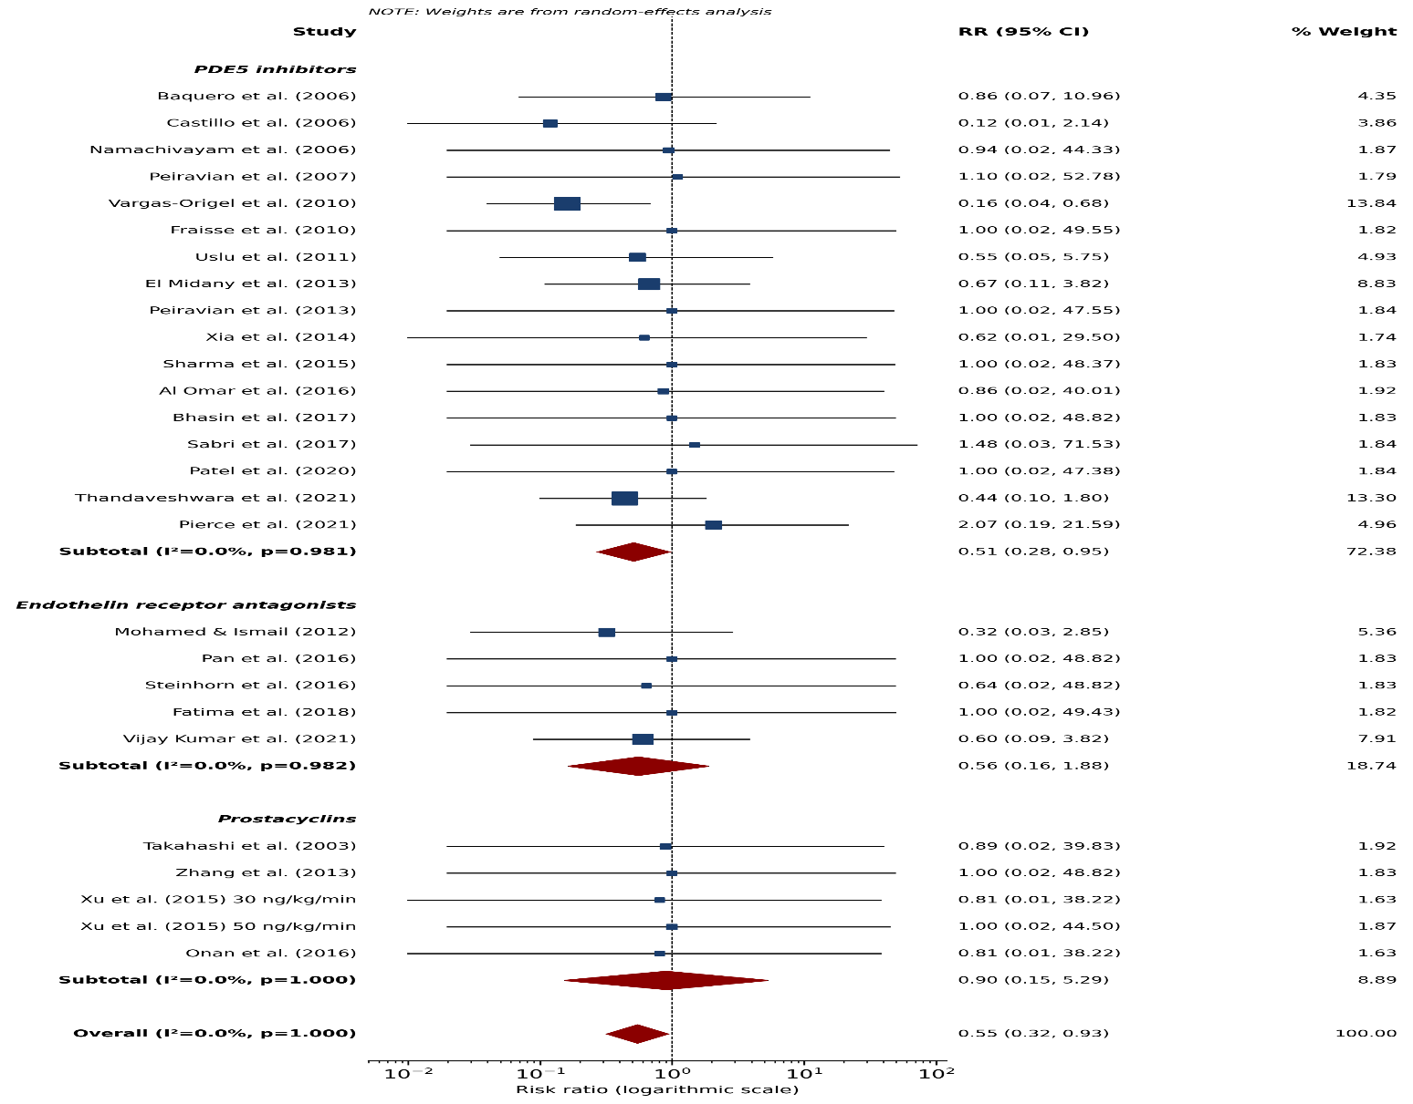
Supplementary Fig. 2 Forest plot of all-cause mortality by drug class. Risk ratios were pooled using a DerSimonian–Laird random-effects model on the logarithmic scale

- mPAP  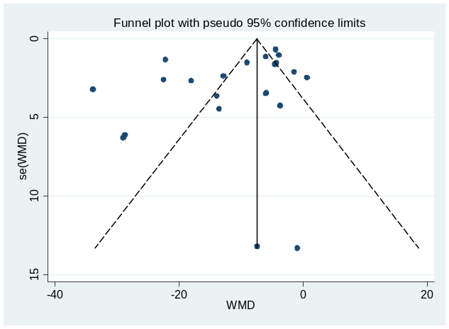 | - sPAP  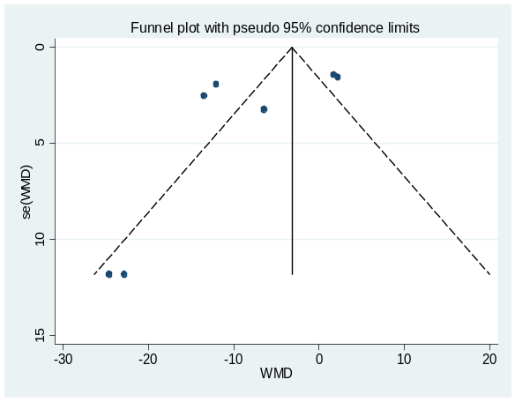
- OI  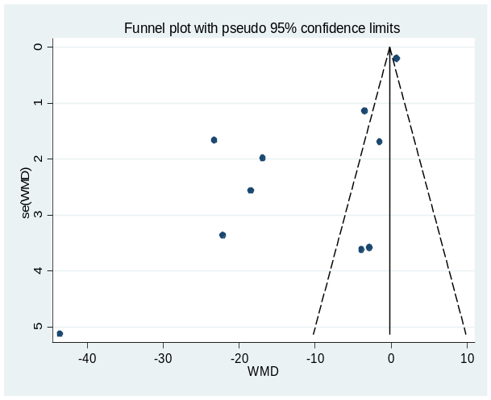 | - SpO2  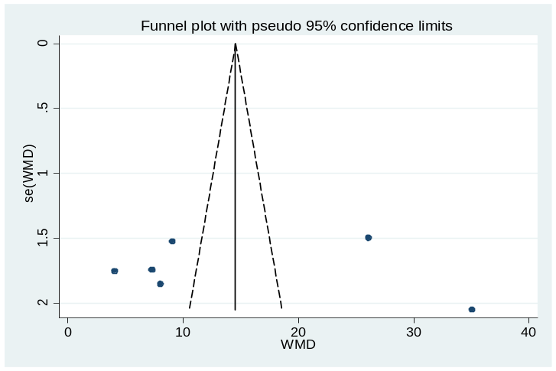
e) PaO2  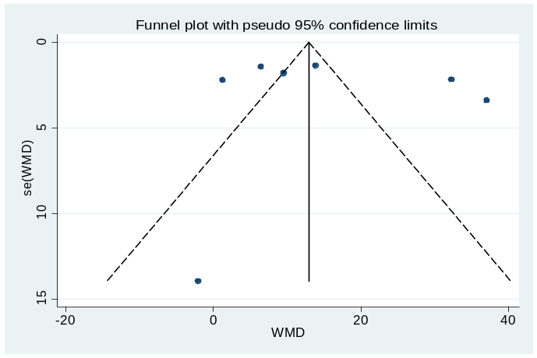 | f)PA/AO  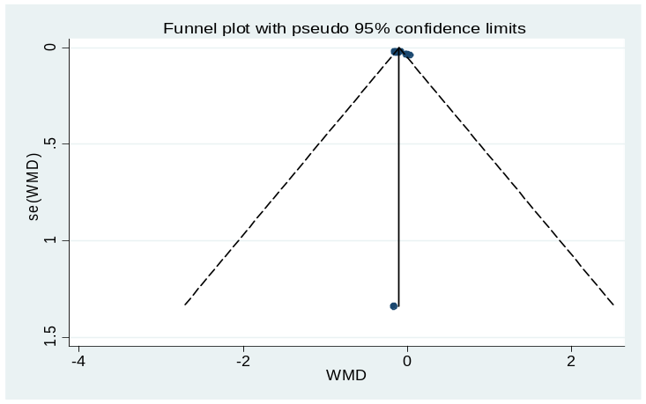
g)mortality  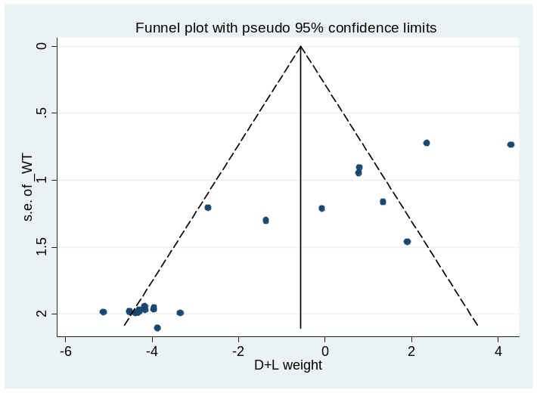 | h) ventilation time  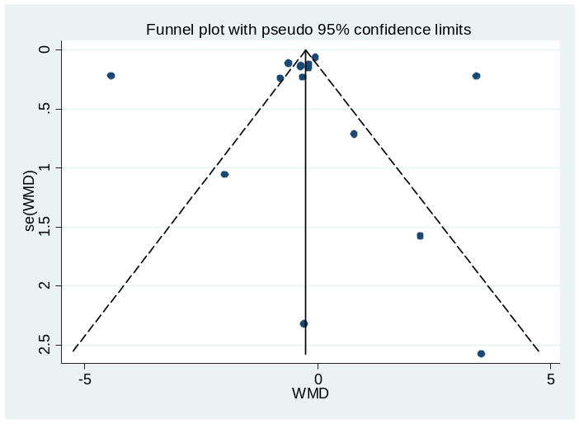
- ICU stay  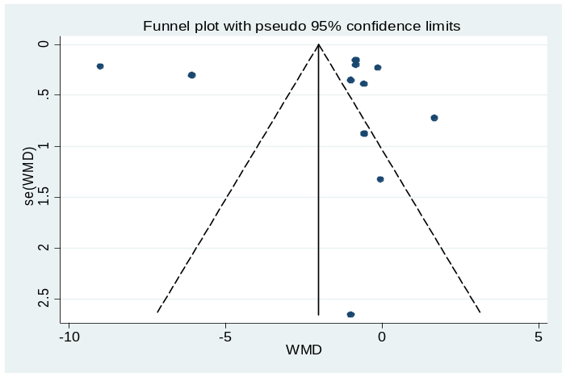 | j) hospital stay  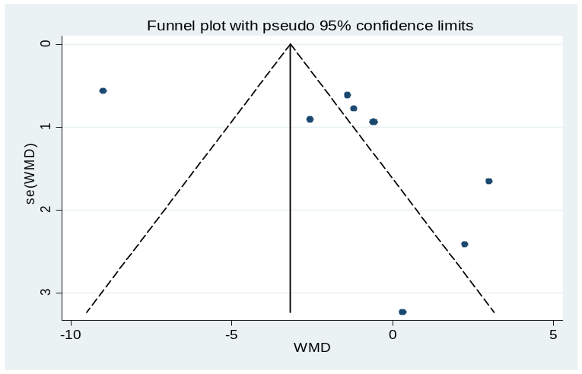
Supplementary Fig. 3 Funnel plots with pseudo 95% confidence limits for each outcome. a Mean pulmonary artery pressure. b Systolic pulmonary artery pressure. c Oxygenation index. d Oxygen saturation. e Partial pressure of oxygen. f Pulmonary artery to aorta ratio. g Mortality. h Duration of mechanical ventilation. i Intensive care unit length of stay. j Hospital length of stay

