Supplementary Materials

Supplementary Figure S1. Genotyping verification and peripheral blood cell profile analysis of myeloid cell-specific Egr1 cKO mice.
Legend:
(A) PCR genotyping results of wild-type C57BL/6J mice, Egr1^{flox/flox} mice and Egr1
cKO (Lyz2-Cre⁺/ Egr1^{flox/flox}) mice. Marker: DNA marker; Lane 1: WT mouse (single band); Lanes 2–10: Egr1^{flox/flox} mice (single band); Lanes 11–20: Egr1 cKO mice (two specific bands); Lane 21: negative control (no amplified band). (B–D) Comparison of peripheral blood cell counts between Egr1 cKO mice and wild-type C57BL/6J control mice (n = 5 per group). (B) Total white blood cell (WBC) count (K/μL); (C) red blood cell (RBC) count (M/μL); (D) platelet count (K/μL). Data are presented as mean ± SD. Statistical analysis was performed using an unpaired t-test (ns, not significant, p > 0.05).

Peripheral Blood Cell Profile Analysis of Egr1 cKO Mice
To exclude potential baseline hematopoietic abnormalities that might affect the interpretation of the S. aureus pneumonia model, peripheral blood samples were collected from 6–7-week-old male Egr1 cKO mice and age-matched wild-type C57BL/6J control mice (n = 5 per group). Automated hematology analysis was performed to determine total WBC, RBC, and platelet counts. No significant differences were observed in these parameters between Egr1 cKO mice and WT control mice (all p > 0.05). These results indicate that myeloid-specific deletion of Egr1 does not cause overt abnormalities in peripheral blood cell composition under basal conditions, suggesting that the phenotypic differences observed in the subsequent S. aureus pneumonia experiments are unlikely to be attributable to gross baseline hematologic abnormalities.

Supplementary Figure S2. Flow cytometric gating strategy for the identification of pulmonary neutrophils.
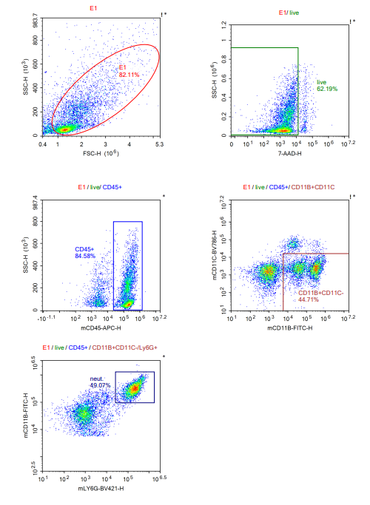
Legend: The complete gating strategy is shown using a representative uninfected (PBS) control sample. Neutrophils were identified according to the following hierarchy: Live cells → CD45⁺ leukocytes → CD11b⁺CD11c⁻ myeloid cells → Ly6G⁺ cells (neutrophils).

Flow Cytometric Gating Strategy for Neutrophil Analysis
To quantify pulmonary neutrophil infiltration in Egr1 cKO and control mice, single-cell suspensions were prepared from infected lung tissues and analyzed by flow cytometry. Supplementary Figure S2 shows the complete gating strategy using a representative uninfected (PBS) control sample. Neutrophils were identified according to the hierarchy Live → CD45⁺ → CD11b⁺CD11c⁻ → Ly6G⁺ (neutrophils).

Supplementary Source Data

Original numerical flow-cytometry data underlying Figures 8 and 9 are provided as a separate Excel file (Supplementary_Source_Data_Flow_Cytometry.xlsx).

Supplementary Table S1. Basic information and quality metrics of RNA-seq data.

The detailed RNA-seq quality metrics for all samples are provided in a separate supplementary file.

