Thoracic Electrical Impedance Tomography in China: A Nationwide Survey of Clinical Implementation, Practice Variation, and Barriers
Yuxian Wang ^{1#}, Shimin Zhang^{1#}, Xu Wang^{2#}, Zhanqi Zhao^{3,4,5*}, Kai Liu¹*, Ming Zhong^{1,6}*
#Yu-xian Wang, Shimin Zhang and Xu Wang contributed equally to this study.

Table S1.Comparison of Demographic and Institutional Characteristics Between Respiratory Therapists and Physicians
Questions | RT(N=151) | Physicians(n=59) | p
Age, yr | 31.10±6.30 | 37.97±8.06 | <0.001
Gender  Male  Female | 70(46.4)  81(53.6) | 39(66.1)  20(33.9) | 0.014
The highest degree of education  Associate degree  Bachelor’s degree  Master’s degree  Doctor’s degree | 10(6.6)  107(70.9)  30(19.9)  4(2.7) | 0(0)  7(11.9)  34(57.6)  18(30.5) | <0.001
Job ranking  Level I  Level II  Level III | 83(55.0)  58(38.4)  10(6.6) | 13(22.0)  19(32.2)  27(45.7) | <0.001
Years of working, yr  0-5  6-10  11-15  >15 | 65(43.1)  44(29.1)  23(15.2)  19(12.6) | 10(16.9)  20(33.9)  10(16.9)  19(32.2) | <0.001
Location of hospital  Eastern China  Western China  Central China  Northeast China | 106(70.2)  28(18.5)  15(9.9)  2(1.3) | 35(59.3)  11(18.6)  10(16.9)  3(5.1) | 0.170
Hospital-level  Tertiary  Secondary | 139(92.1)  12(8.0) | 58(98.3)  1(1.7) | 0.117
Department  GICU  PCCM  SICU  EICU  MICU  PICU  Others | 73(48.3)  27(17.9)  15(9.9)  15(9.9)  6(4.0)  4(2.7)  11(7.3) | 44(74.6)  9(15.3)  3(5.1)  2(3.4)  1(1.7)  0(0)  0(0) | 0.018
Number of beds in your department/unit | 30.27±21.83 | 29.76±18.80 | 0.761
Abbreviations: GICU, general intensive care unit; PCCM, pulmonary and critical care medicine; SICU, surgical intensive care unit; EICU, emergency intensive care unit; MICU, medical intensive care unit; PICU, pediatric intensive care unit; EIT, electric impedance tomography.

Table S2. Subgroup Analysis of EIT Operational Protocols: Physicians versus Respiratory Therapists
Questions | RT(n=151) | Physicians(n=59) | P
Estimating thoracic circumference to determine electrode belt size  Always  Often  Sometimes  Rarely  Never | 82(54.3)  49(32.5)  15(9.9)  5(3.3)  0(0) | 17(28.8)  24(40.7)  15(25.4)  2(3.4)  1(1.7) | <0.001
Preparing the skin/electrode belt with alcohol or saline prior to application  Always  Often  Sometimes  Rarely  Never | 145(96.0)  15(9.9)  7(4.6)  0(0)  4(2.7) | 18(30.5)  16(27.1)  4(6.8)  1(1.7)  0(0) | <0.001
PEEP increment/decrement step size during titration  1 cmH2O  2 cmH2O  3 cmH2O  5 cmH2O | 1(0.7)  120(79.5)  9(6.0)  22(14.6) | 1(1.7)  32(54.2)  16(27.1)  9(15.3) | <0.001
What quality control measures do you use  Verify correct electrode belt positioning  Check contact quality for all electrodes  Exclude artifacts caused by patient movement  Perform signal calibration/correction  Others | 145(96.0)  142(94.0)  128(84.8)  146(96.7)  2(1.3) | 55(93.2)  56(94.9)  46(78.0)  43(72.9)  2(3.4) | 0.619  0.999  0.331  <0.001  0.314
What EIT parameters or images do you utilize in decision-making  Regional ventilation distribution  Change in end-expiratory lung volume (EELV)  Global inhomogeneity index  Ventilation and perfusion (V/Q) distribution maps  Regional delay index  Dead space and shunt fraction | 149(98.7)  125(82.8)  104(68.9)  120(79.5)  90(59.6)  94(62.3) | 57(96.6)  39(66.1)  42(71.2)  42(71.2)  37(62.7)  34(57.6) | 0.314  0.015  0.873  0.270  0.797  0.645
What else data do you routinely document except EIT data  Patient position  Basic vital signs  Respiratory support mode and settings/parameters  Electrode belt position  Arterial blood gas (ABG) results  Hemodynamic data  Therapeutic interventions administered  Others | 102(67.6)  124(82.1)  146(96.7)  85(56.3)  102(67.6)  17(11.3)  58(38.4)  4(2.7) | 42(71.2)  50(84.7)  56(94.9)  34(57.6)  43(72.9)  39(66.1)  33(55.9)  0(0) | 0.730  0.802  0.839  0.984  0.558  <0.001  0.032  0.579

Table S3. Detailed Practice Patterns, Technical Specifications, and Perceived Needs for EIT Clinical Application: A Subgroup Analysis
Questions | RT(n=151) | Physicians(n=59) | p
Number of EIT machines in your department  0  1  2  3  4  ≥5 | 6(4.0)  98(64.9)  36(23.8)  4(2.7)  5(3.3)  2(1.3) | 1(1.7)  32(54.2)  18(30.5)  3(5.1)  2(3.4)  3(5.1) | 0.364
EIT device manufacturer in your department  Dräger  Invision  Sealand Technology  Amoul  Midas-med  Others | 118(78.2)  42(27.8)  5(3.3)  7(4.6)  0(0)  10(6.6) | 37(62.7)  18(30.5)  15(25.4)  1(1.7)  4(6.8)  0(0) | 0.035  0.827  <0.001  0.447  0.006  0.066
EIT experience, yr  1-2  3-4  5-6  7-8  9-10 | 80(53.0)  35(23.2)  30(19.9)  3(2.0)  3(2.0) | 40(67.8)  7(11.8)  9(15.2)  0(0)  3(5.1) | 0.115
How did you acquire training in EIT  By the manufacturer  In-house departmental training  By professional societies  Online courses/ webinars  Self-directed learning  Others | 110(72.9)  84(55.6)  71(47.0)  63(41.7)  77(51.0)  5(3.3) | 44(74.6)  32(54.2)  25(42.4)  20(33.9)  26(44.1)  0(0) | 0.935  0.978  0.650  0.376  0.454  0.325
Rate your knowledge of EIT from 1 to 10  1-2  3-4  5-6  7-8  9-10 | 10(6.6)  21(13.9)  71(47.0)  39(25.8)  10(6.6) | 6(10.2)  8(13.4)  25(42.3)  14(23.6)  6(10.2) | 0.794
How frequently do you use EIT in your clinical practice  Rarely (less than once a month)  Occasionally (several times a month)  Regularly (several times a week)  Daily (several times a day) | 20(13.3)  65(43.1)  54(35.8)  12(8.0) | 5(8.5)  25(42.4)  24(40.7)  5(8.5) | 0.776
Indicate the clinical scenarios where you utilize EIT  Identification of pulmonary ventilation/perfusion abnormalities  Continuous, individualized monitoring and guidance of ventilation strategies  Guidance for selecting and optimizing respiratory support modalities  Assessment of the clinical effects of other respiratory therapies  others | 139(92.1)  146(96.7)  116(76.8)  64(42.4)  4(2.7) | 49(83.1)  53(89.8)  28(47.5)  30(50.8)  0(0) | 0.096  0.097  <0.001  0.340  0.579
Have you performed any EIT research  Yes  No | 72(47.7)  79(52.3) | 34(57.6)  25(42.4) | 0.221
Sampling frequency during EIT monitoring  Not applicable  >50Hz  50Hz  20-50Hz  20Hz  <20Hz | 28(18.5)  29(19.2)  29(19.2)  48(31.8)  9(6.0)  2(1.3) | 19(32.2)  9(15.3)  11(18.6)  21(35.6)  3(5.1)  2(3.4) | 0.546
Duration maintained at each PEEP level  120s  30s  60s  20s  10s  Others | 56(37.1)  34(22.5)  22(14.6)  9(6.0)  4(2.7)  26(17.2) | 16(27.1)  12(20.3)  14(23.7)  3(5.1)  5(8.5)  9(15.3) | 0.227
Do you use EIT to monitor pulmonary perfusion  Yes  No | 98(64.9)  53(35.1) | 31(52.5)  28(47.5) | 0.115
Concentration of hypertonic saline solution used  3%  5%  10%  20%  Others | N=98  5(5.1)  17(17.4)  71(72.5)  2(2.0)  3(3.1) | N=31  3(9.7)  0(0)  27(87.1)  1(3.2)  0(0) | 0.094
Injection volume per bolus, ml  20  15  10  5  Others | 13(13.3)  2(2.0)  71(72.5)  5(5.1)  7(7.1) | 4(12.9)  2(6.5)  22(71.0)  2(6.5)  1(3.2) | 0.708
Which phase of the respiratory cycle do you choose  End-expiration  End-inspiration  Both | 52(53.1)  17(17.4)  29(29.6) | 15(48.4)  6(19.4)  10(32.3) | 0.901
How to determine the position of electrode belt  Anatomical landmarks  Intercostal space counting  Initial positioning followed by adjustment based on real-time ventilation distribution  Cross-reference with medical imaging (CT/X-ray/ultrasound)  Others | 138(91.4)  56(37.1)  59(39.1)  18(11.9)  1(0.7) | 50(84.7)  18(30.5)  23(39.0)  6(10.2)  0(0) | 0.245  0.462  0.999  0.907  0.999
Support resources your department provide  Backup electrode belts or main cables  Standardized operating procedures  Standardized training materials | 110(72.9)  77(51.0)  56(37.1) | 43(72.9)  40(67.8)  30(50.8) | 0.999  0.040  0.096
What potential reasons do you consider for not using EIT  Lack of assisting staff  Time-consuming procedure  Lack of personal proficiency/experience  No billing code  EIT monitoring results are unneeded  Frequent malfunction of electrode belts or main cables  Others | 90(59.6)  81(53.6)  34(22.5)  42(27.8)  44(29.1)  32(21.2)  11(7.3) | 28(47.5)  24(40.7)  17(28.8)  21(35.6)  9(15.2)  8(13.6)  4(6.8) | 0.150  0.125  0.437  0.348  0.057  0.284  0.999
Which of the following support do you need most  More opportunities for clinical practice  Standardized training courses  Standardized operating procedures and guidelines  Guidance and communication with experts  Sharing of typical clinical cases  Others | 100(66.2)  113(74.8)  121(80.1)  110(72.9)  110(72.8)  4(2.7) | 46(78.0)  48(81.4)  47(79.7)  47(79.7)  39(66.1)  1(1.7) | 0.135  0.411  0.999  0.398  0.424  0.999
What is the perceived level of departmental support for EIT  Highly supportive and regularly utilized  Fairly recognized but infrequently used  Neutral  Skeptical about its clinical value | 78(51.7)  60(39.7)  10(6.6)  3(2.0) | 22(37.3)  32(54.2)  4(6.8)  1(1.7) | 0.273
Most improvement for broader clinical adoption of EIT  Standardized operating procedures  Standardized guidelines for result interpretation  Reimbursement policies and standardized reporting  Equipment maintenance and troubleshooting support  Professional training systems  Multicenter clinical research data/evidence  Others | 120(79.5)  134(88.7)  113(74.8)  79(52.3)  112(74.2)  77(51.0)  2(1.3) | 53(89.8)  50(84.7)  44(74.6)  27(45.8)  41(69.5)  35(59.3)  1(1.7) | 0.116  0.577  0.999  0.484  0.608  0.351  0.999

Abbreviations: CT, computed tomography; EIT, electrical impedance tomography; Hz, hertz; ml, milliliters; PEEP, positive end-expiratory pressure; RT, respiratory therapist; s, seconds; SOPs, standardized operating procedures.

Figure S1
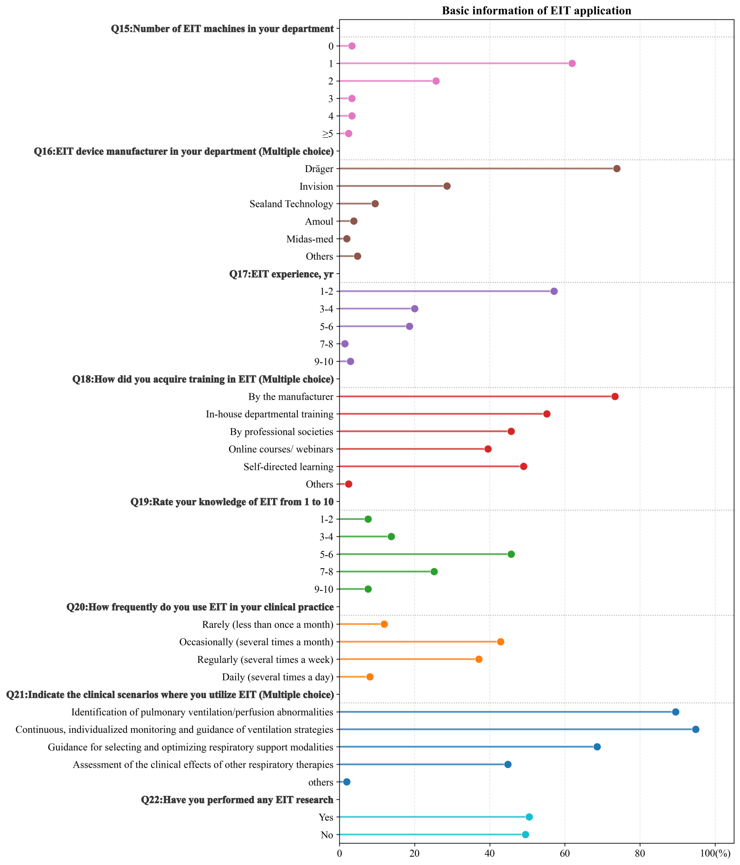
Figure S1. Basic information on the clinical application of Electrical Impedance Tomography (EIT). The lollipop chart summarizes the survey responses (N=210) regarding the infrastructure and utilization of EIT. Data are presented as the percentage of respondents for each category.

