Supplementary file:
2009 and 2013 Thai Cohort Study low back pain questions

2009
In the past 4 weeks, have you had pain in your lower back? (in the area shown on the diagram)  Yes  No  If yes, was this pain bad enough to limit your usual activities or change your daily routine for more than one day?  Yes  No | 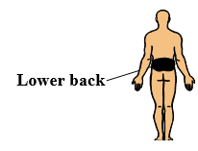
2013
In the past 4 weeks, have you had pain in your lower back? (in the area shown on the diagram)
Yes
No
If yes, was this pain bad enough to limit your usual activities or change your daily routine for more than one day?
Yes
No

