Adachi et al
Additional File 1: Design of FREEDOM and the Extension study. Q6M once every 6 months, SC subcutaneous
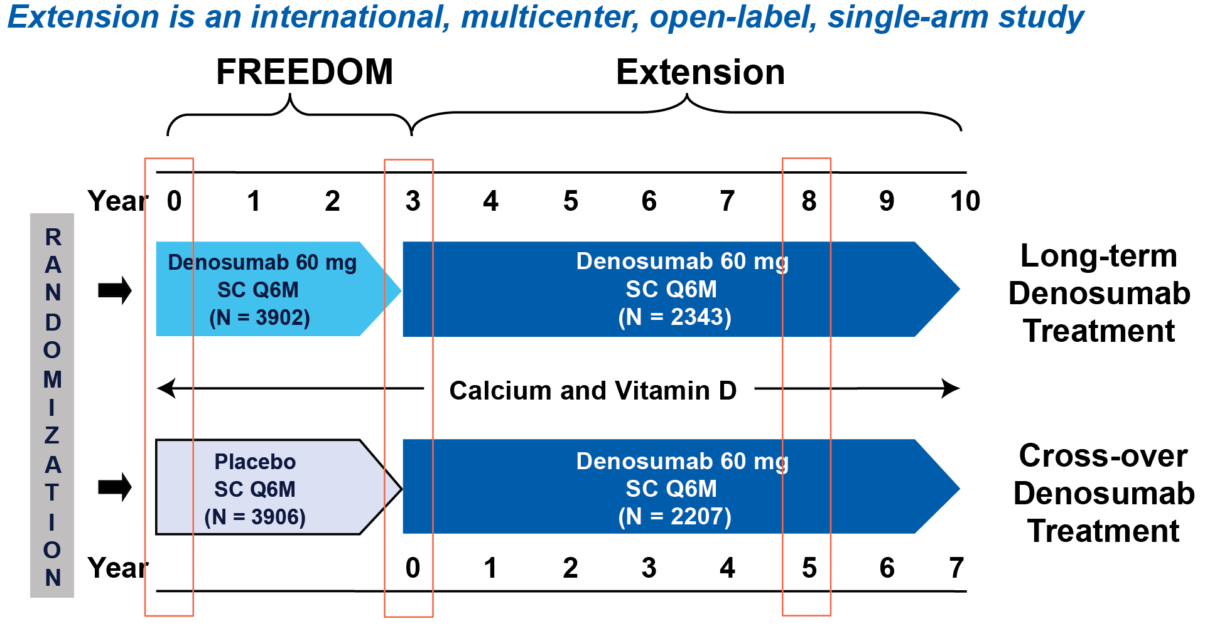

Reference
Papapoulos S, Chapurlat R, Libanati C, Brandi ML, Brown JP, Czerwinski E, et al. Five years of denosumab exposure in women with postmenopausal osteoporosis: results from the first two years of the FREEDOM extension. J Bone Miner Res. 2012;27(3):694-701.

