Additional file 3. Annotated forest plots for nonsignificant meta-analyses
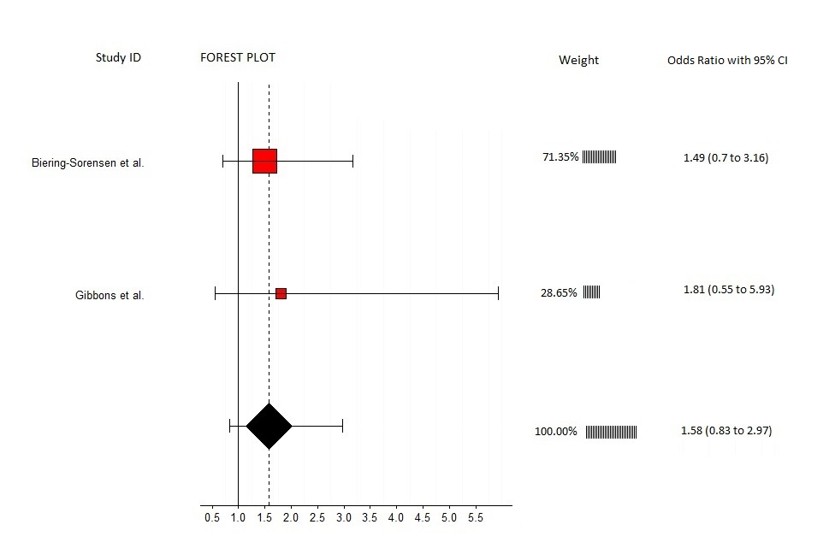
Fully annotated forest plot for back muscle strength and LBP
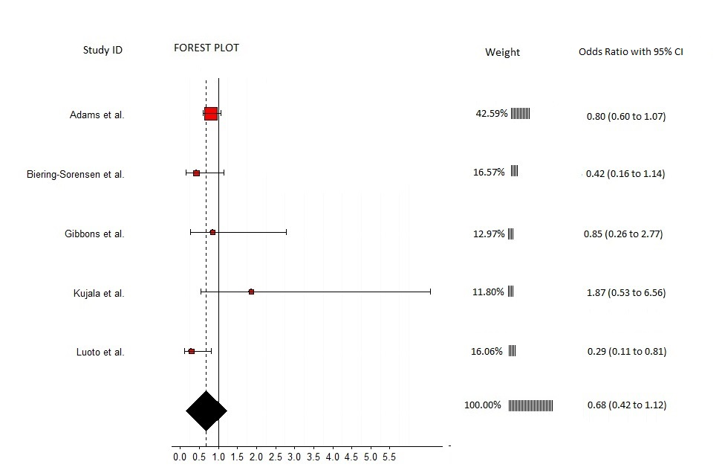
Fully annotated forest plot for back muscle endurance and LBP
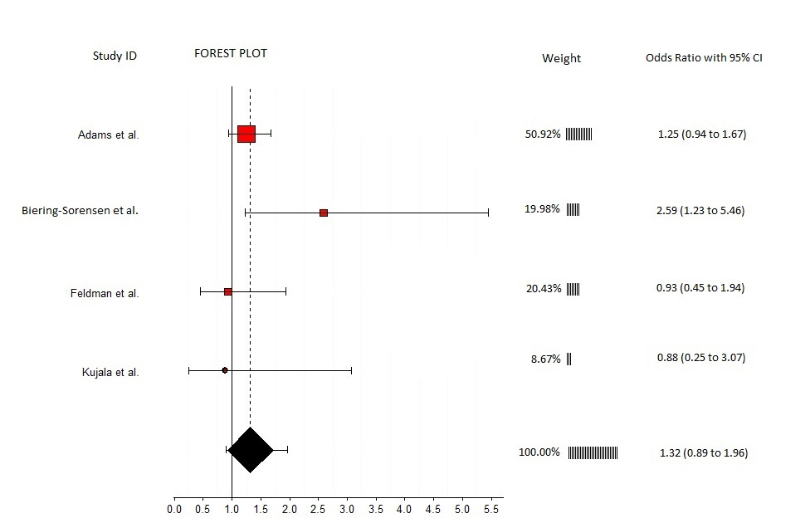
Fully annotated forest plot for lumbar flexion range of motion and LBP
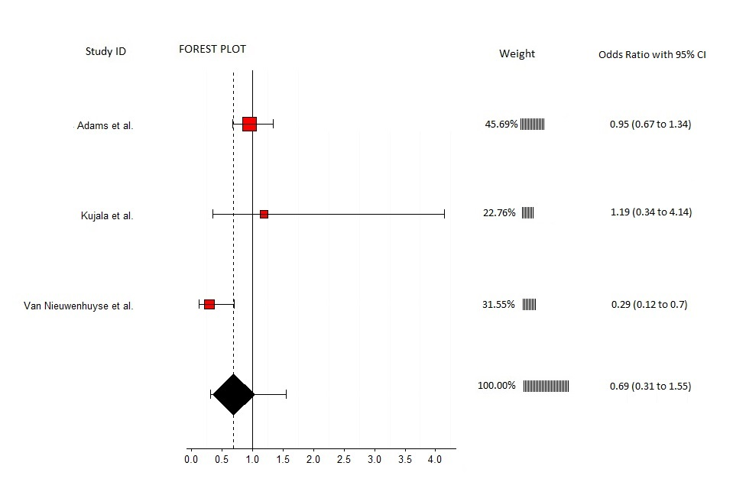
Fully annotated forest plot for lumbar extension range of motion and LBP
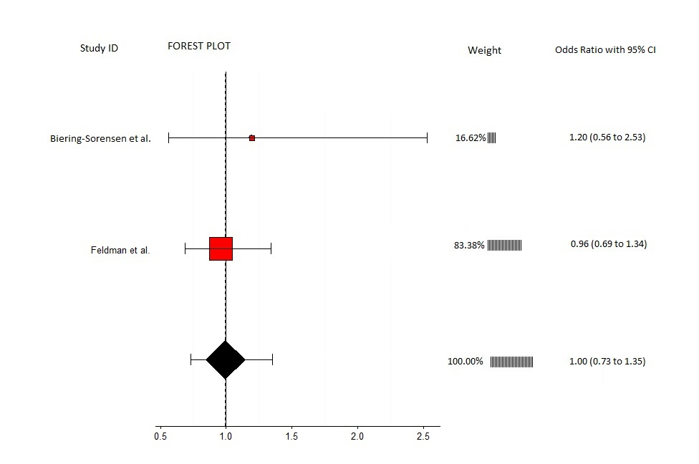
Fully annotated forest plot for isometric abdominal strength and LBP
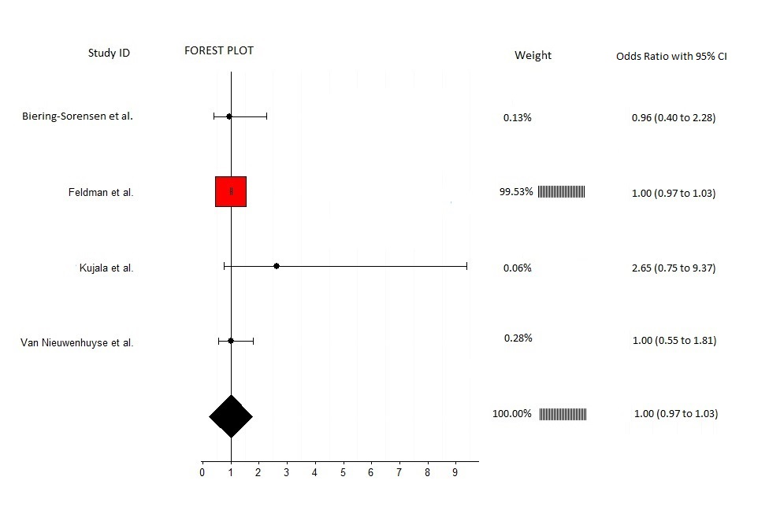
Fully annotated forest plot for fingertip to floor distance and LBP

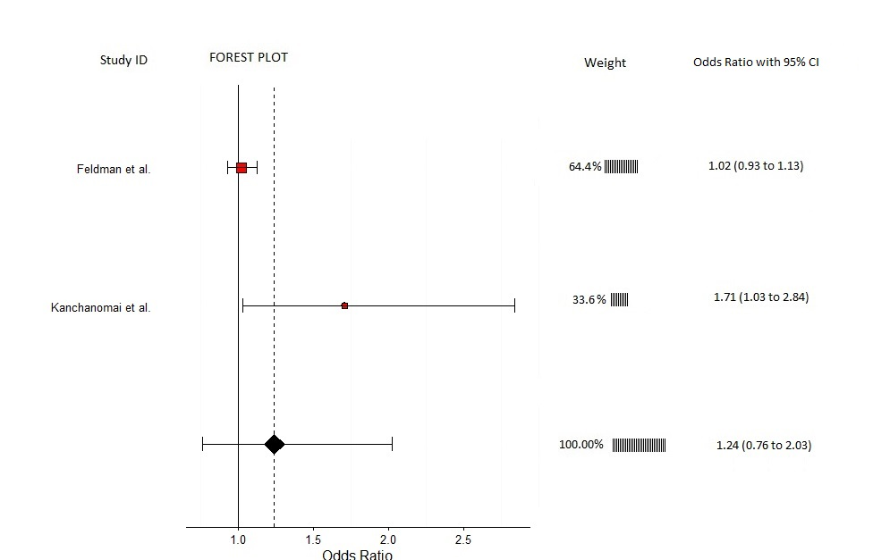
Fully annotated forest plot for quadriceps flexibility and LBP

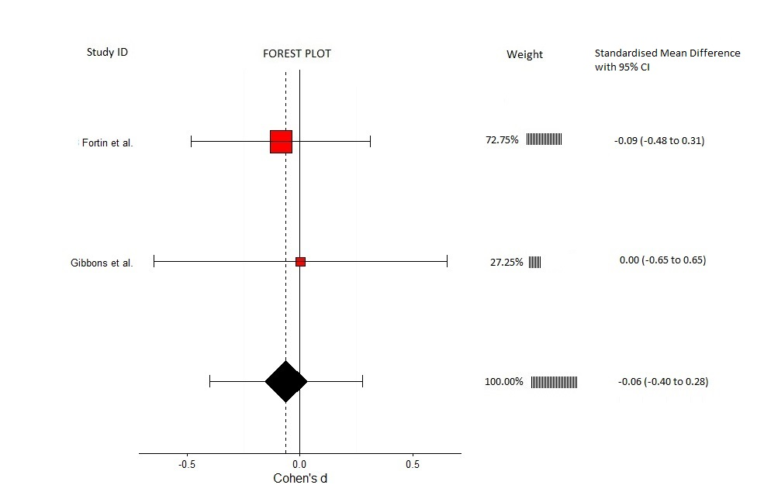
Fully annotated forest plot for erector spinae cross sectional area and LBP
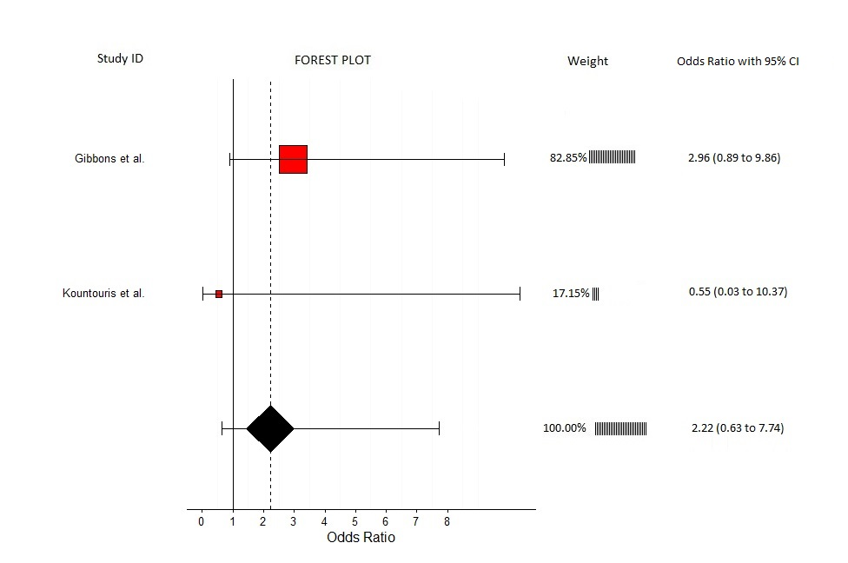
Fully annotated forest plot for quadratus lumborum cross sectional area and LBP

