MAIN MODULE

I have read the study information and the information about the confidentiality of  the data and I accept that the data will be used as indicated in the information  of the study. | Yes
GENERAL QUESTIONS

1.- Sex?
(PG.1)
Male
Female

2.- How old are you?
(PG.2)
Less than 20 years
20-29 years
30-39 years
40-49 years
50 years or more than 50 years

3.- What is your birthplace?
(PG.3)
City:
Country:

4.- What is the highest academic degree achieved?
Normal Teacher
University Technician (Middle / Higher)
Bachelor's degree (University)
Postgraduate Diploma / Master's / Doctorate

Other:

5.- What type of teacher are you?
Primary
Secondary
Primary and secondary
Manager

Other:

6.- Choose the alternative that best reflects your situation regarding the type of educational establishment where you teach (Check all that apply):
Public Establishment
Private Establishment
Establishment of “agreement”

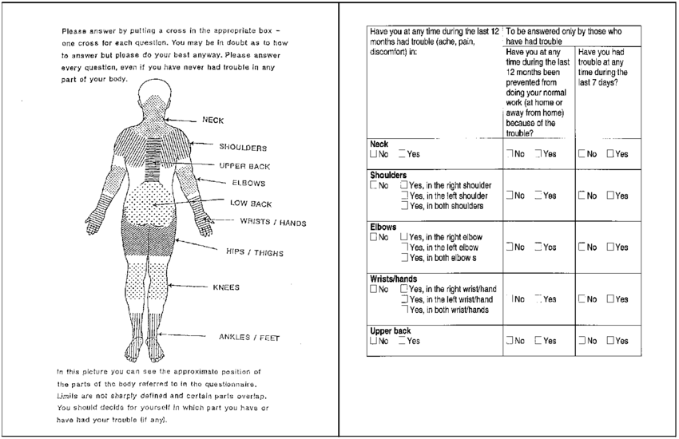

Module: Musculoskeletal Disorders
 | Have you felt discomfort during the last 12 MONTHS (pain, discomfort / discomfort, numbness) in:  (MM.6) |  |  |  |  | If "Yes": Have you had any discomfort during the last 7 days?  (MM.7) |  |  |  |  | Have you at any time during the last 12 MONTHS been prevented from doing your job?  (MM.8)
 | NO | YES | YES, Left | YES, Right | YES, Both | NO | YES | YES, Left | YES, Right | YES, Both | NO | YES
- Neck
- Shoulders
- Wrists/Hands
- Upper back
- Low back
- One or both hips, legs
- One or both knees
- One or both ankles, feet

We appreciate your collaboration!

