Below are screenshots of the different procedures used in the Sham Physical Therapy Arm of the TeMPO Trial.
Therapist Guided Hip Internal/External Rotation
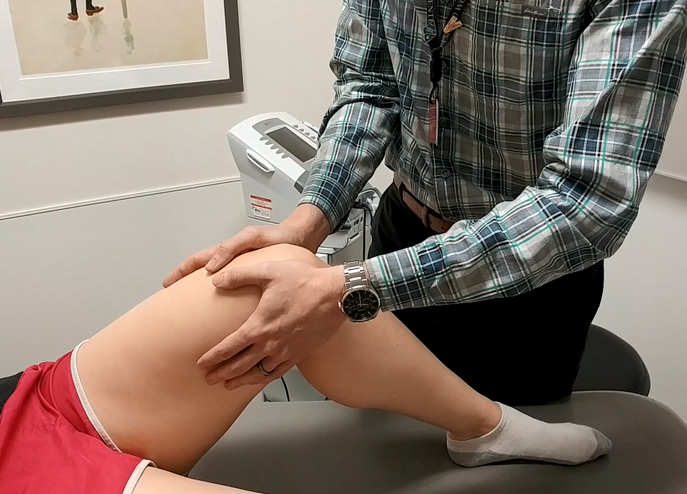
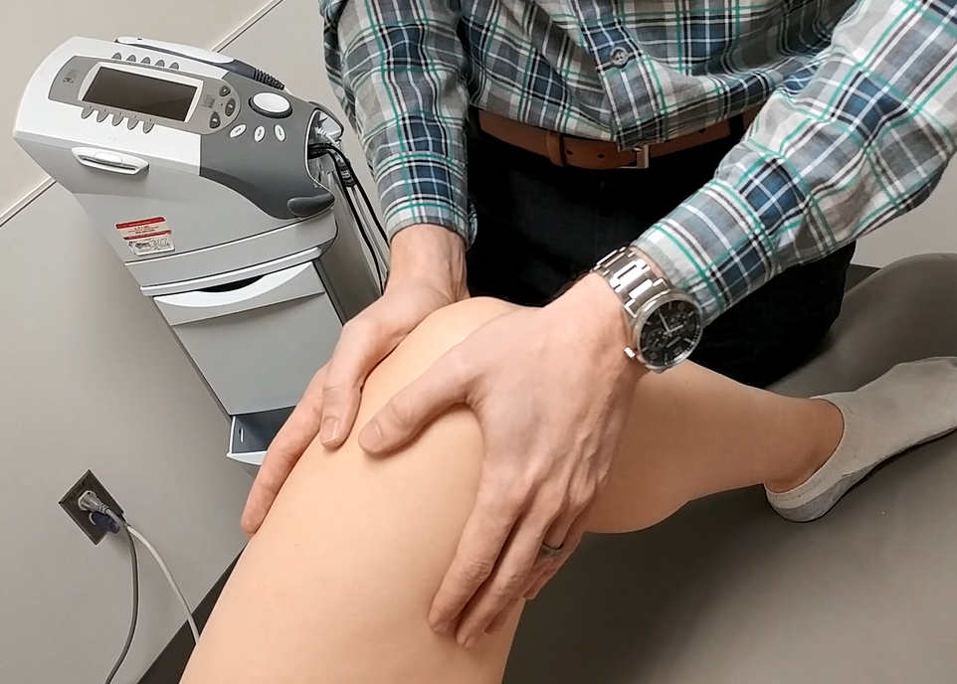

Ankle Plantar/Dorsi Flexion and Inversion/Eversion
