Additional file 1
Interviewer-administered questionnaire

Please fill in by asking patient or his well-known family.
Please check those that apply
- Basic information

- What is the reason for coming to this facility? (Multiple answers allowed).
_ Having some complaint
_ No complaint
_ I am in a nursing facility for elderly.

- What is the chief complaint? (Multiple answers allowed).
_Lumbar back pain
_Knee pain
_Numbness on the lower extremities
_Pain of the lower extremity on areas other than the knee
_Abnormal posture
_Abnormal gait
_Trauma
_Others

- Diagnosis of current chief complaint. (Multiple answers allowed).
_Osteoarthritis of the knee
_Osteoarthritis of the hip
_Rheumatoid arthritis
_Other joint disease
_Lumbar back pain
_Spondylosis
_Myelopathy
_Hip fracture
_Fracture of the lower extremities
_ Fracture of the upper extremities
_ Fracture of the spine
_Osteoporosis
_Others

- Treatment for current chief complaint. (Multiple answers allowed).
_None
_Physiotherapy
_Prosthesis
_Patient education
_Oral medicine
_Injection or block
_Exercise

- Comorbidity other than musculoskeletal disease. (Multiple answers allowed).
_Hypertension
_Diabetes mellitus
_Disorder of lipid metabolism
_Bronchial asthma
_Chronic respiratory insufficiency
_Renal dysfunction
_Malignant tumor
_Sequelae aftereffect of stroke
_Neuromuscular disease
_Collagen disease
_Cataracts
_Others

- Medicine currently prescribed
_Antihypertensive agent
_Hypoglycemic agent (including insulin)
_Medicine for disorder of lipid metabolism
_NSAIDs
_Medicine for osteoporosis
_Steroids
_Hypnotic drug
_Antidepressant drug
_Others

- Past disease which symptom was stabilized. (Multiple answers allowed).
_Stroke
_Cardiovascular disease
_Respiratory disease
_Malignant tumor
_Gastrointestinal disease
_Renal disease
_Fracture of the upper extremities
_Fracture of the spine
_Fracture of the lower extremities
_Arthritis
_Urologic disease
_Trauma of musculoskeletal organ
_Others

II. Living environment / Past history

- What was your job in which engaged for longest period? (Please choose one).
_Self-owned business (Sales)
_Self-owned business (Productive industry)
_Self-owned business (Service)
_Managerial position of company
_Public officer
_Agriculture and forestry
_Fishing industry
_Transport
_Factory production
_Full-time homemaker
_Unemployed
_Others

- Which was your age of last education background?
_15-17 years old
_18-19 years old
_20-21 years old
_22-23 years old
_More than 23 years old

- How many family members do you have living together with you?
_None
_1
_2
_3
_More than 3

- Who are the family members living together with you? (Multiple answers allowed).
_Parent
_Brothers or sisters
_Spouse
_Children
_Other relatives
_Others

- What type of residence do you live in?
_One story house
_Multiple storied house
_Apartments house with elevator
_Apartment house without elevator
_Others

- Do you have certification of elderly person's Long-Time Care insurance in Japan?
_Not applied for
_Not applicable
_Unknown
_Needed Support level 1
_Needed Support level 2
_Needed Long-Term Care level 1
_Needed Long-Term Care level 2
_Needed Long-Term Care level 3
_Needed Long-Term Care level 4
_Needed Long-Term Care level 5

- Were you certified as a specific elderly people of Japanese health care system?
_No
_Yes
_I don’t know

- Have you ever suffered fracture?
_No
_Yes
_Upper extremity
_Rib
_Spine
_Pelvis
_Proximal femur
_Other lower extremity

- Have you ever fallen and been injured?
_I never fallen
_I have fallen, but no injury
_I have dropped and suffered injury other than fracture
_I have fallen and suffered fracture

- Did your health condition change after falling?
_I have never fallen
_I have fallen, but no change of health condition
_ I have fallen and had change of health condition
_Walking disability
_Lumbar back pain
_Aggravation of lumbar back pain
_Lower extremity pain
_Aggravation of lower extremity pain
_Apprehension for falling
_Restriction of going out
_Others

- Do you use any walking aid? Choose most frequently used one.
_Don’t use
_Use
_Wheel chair
_Walker
_Crutch
_T-shaped Cane
_Long leg prosthesis
_Short leg prosthesis
_Supporter on the knee
_Supporter or prosthesis for the ankle
_Others
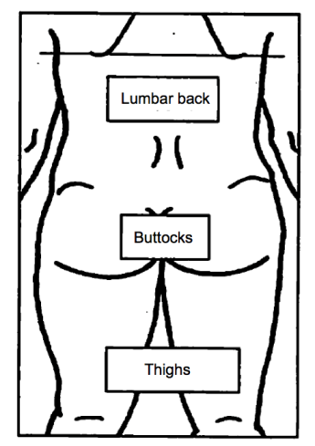
Pain areas
Referring right figure, check the pain site. (spontaneous pain, pain with motion, tenderness).

 | Right | Left
Lumbar back
Buttocks
thighs

If the participant has the knee pain, please check. (spontaneous pain, pain with motion, tenderness).
 | Right | Left
Knee pain

