Additional file 9: Analysis of heterogeneity (ANOHE).

Direct comparisons
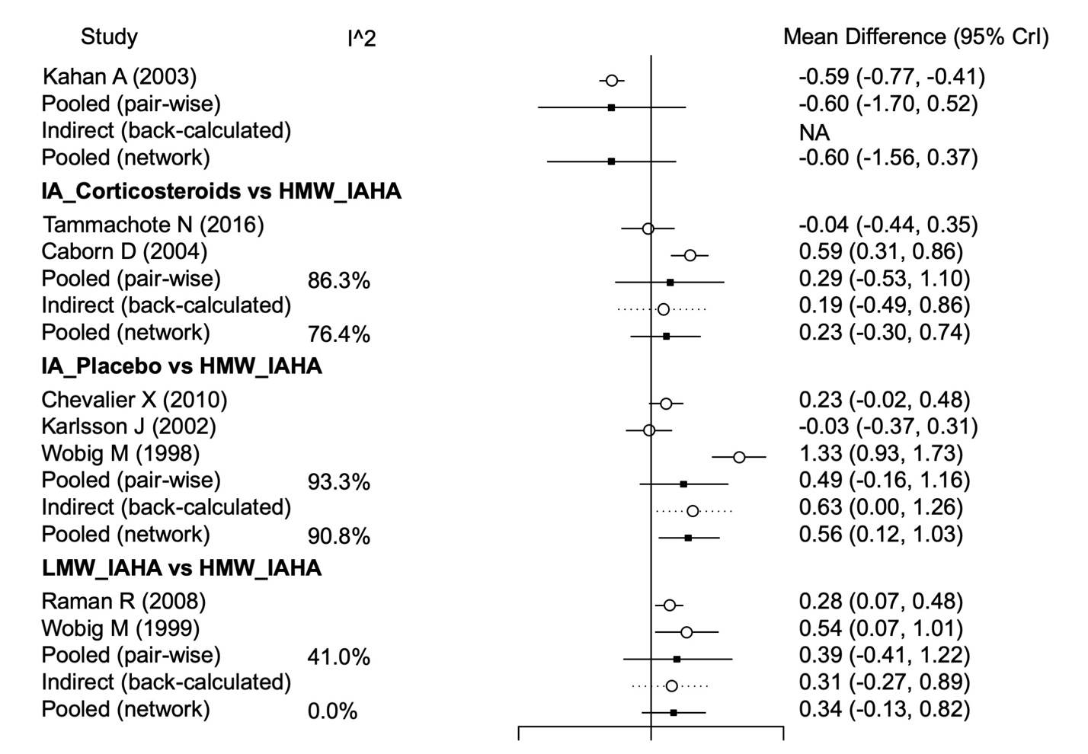
*Crl = credible interval; HMW = high molecular weight; IA = intraarticular; IAHA = intraarticular hyaluronic acid; LMW = low molecular weight.

Indirect comparisons

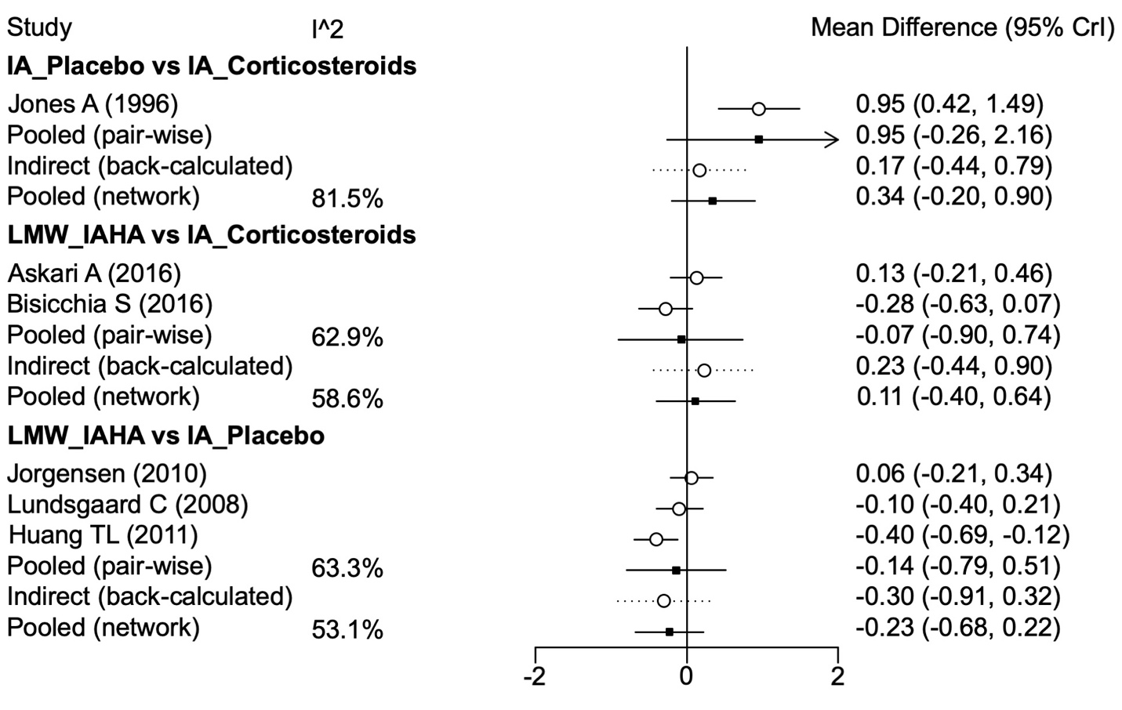
*Crl = credible interval; HMW = high molecular weight; IA = intraarticular; IAHA = intraarticular hyaluronic acid; LMW = low molecular weight.

