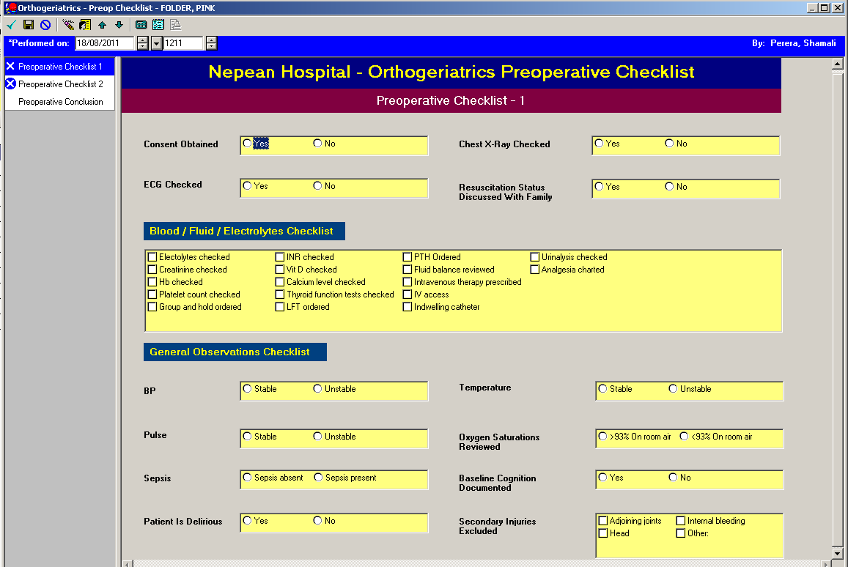
Pre-operative Checklist (Section 1)
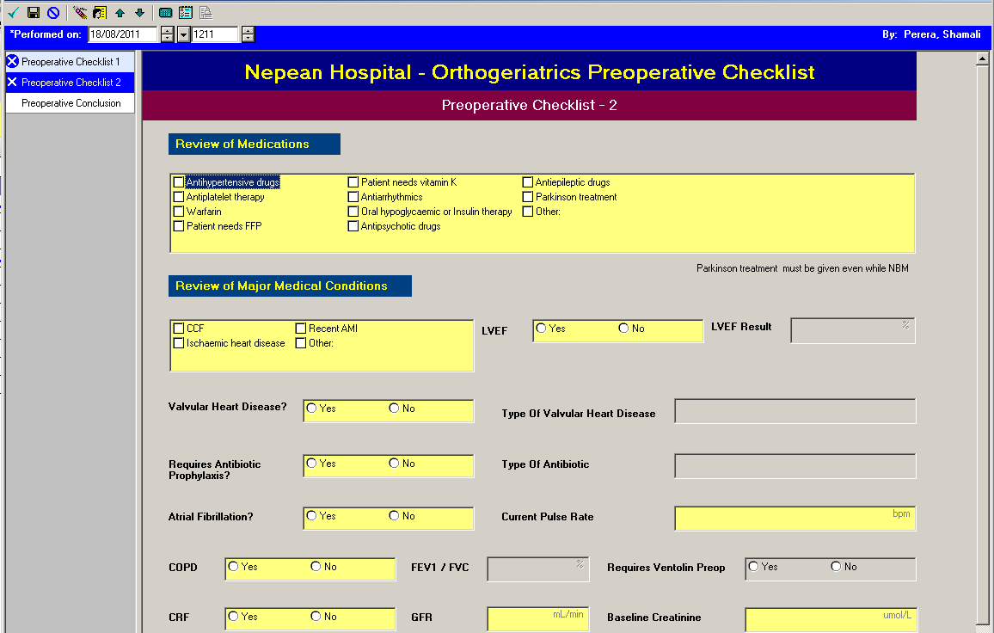
Pre-operative Checklist (Section 2)
- Yellow indicates required/mandatory fields
- The Powerform cannot be signed off until data is entered
Greyed out fields are activated when “Yes” is selected in the previous box

Pre-operative Checklist (Section 3)
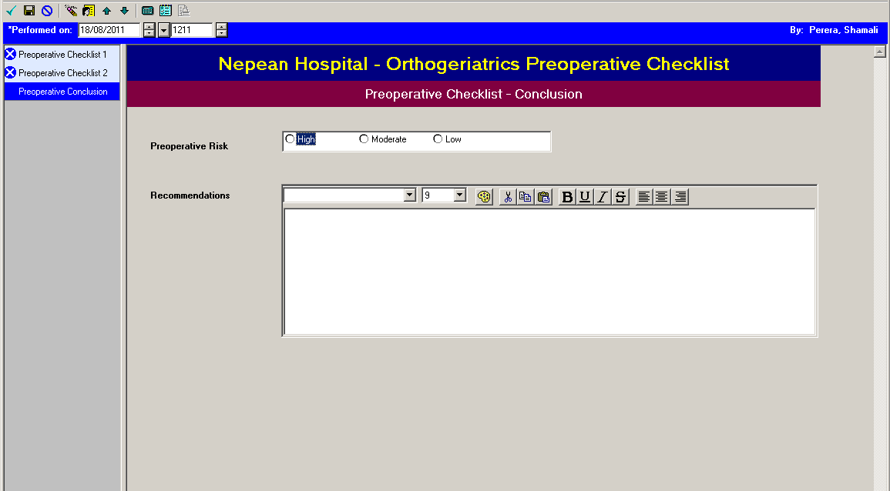

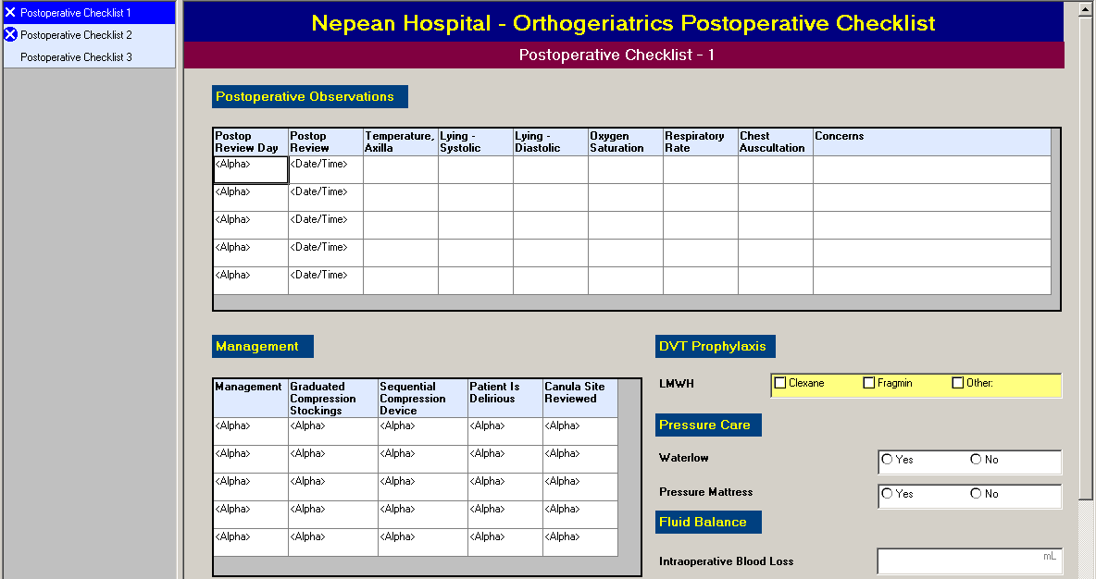

Post-operative Checklist (Section 1)
Post-operative Checklist (Section 2)
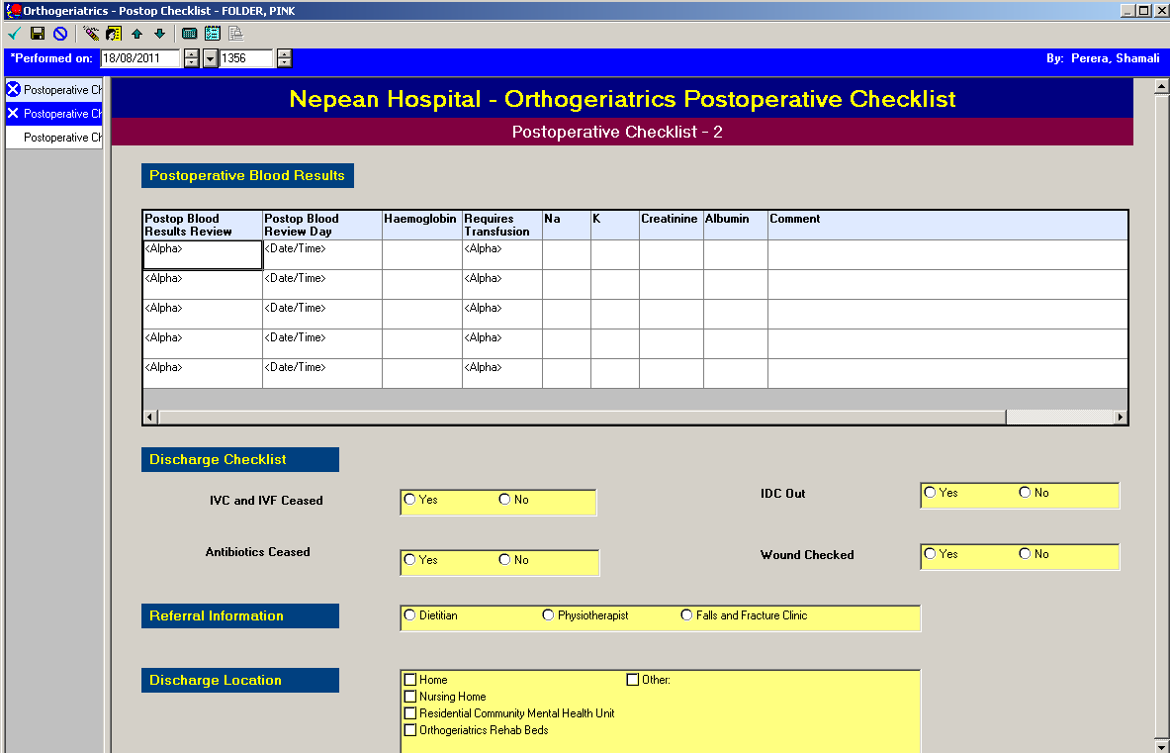

Post-operative Checklist (Section 3)


