Additional file 1
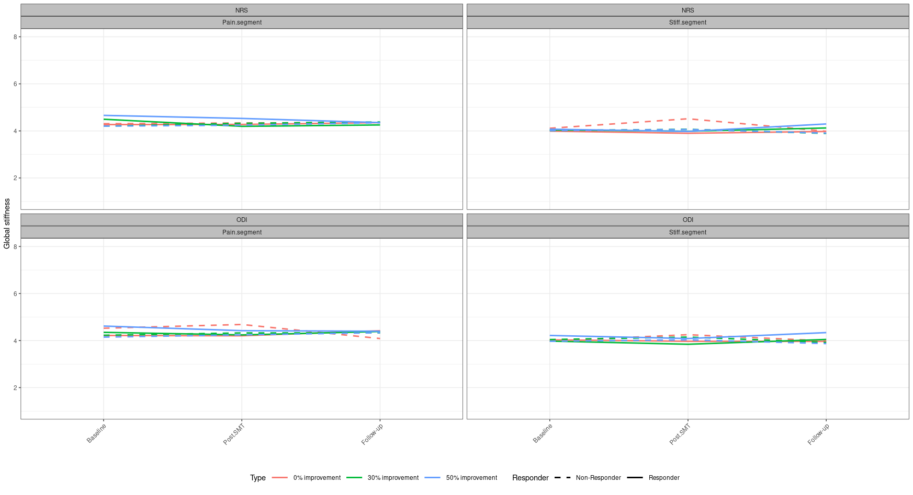
Group mean differences in global stiffness for 50, 30 and 0% improvement in disability and patient reported low back pain. Estimates are presented as mean values for each time-point and within group significance level (p<0.05) - presented as: * = Significant changes in responders from baseline to post-SMT. ** = Significant changes in responders from baseline to follow-up. # = Significant changes in non-responders from baseline to post-SMT. ## = Significant changes in non-responders from baseline to follow-up. SMT = Spinal manipulative therapy

Group mean differences in heat pain threshold for 50, 30 and 0% improvement in disability and patient reported low back pain. Estimates are presented as mean values for each time-point and within group significance level (p<0.05) - presented as: * = Significant changes in responders from baseline to post-SMT. ** = Significant changes in responders from baseline to follow-up. # = Significant changes in non-responders from baseline to post-SMT. ## = Significant changes in non-responders from baseline to follow-up. SMT = Spinal manipulative therapy
