Additional file 2
The segmental changes in pressure pain threshold, heat pain threshold, and global stiffness presented for 0% improvement in disability. Estimates are presented as mean and 95% confidence intervals for each time-point. Segments are divided into the segment targeted, the adjacent segments to the targeted segment and all other segments. SMT = spinal manipulative therapy
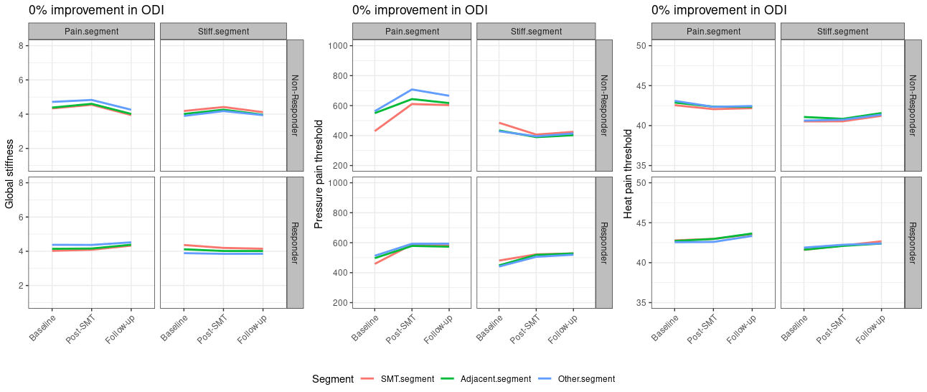
The segmental changes in pressure pain threshold, heat pain threshold, and global stiffness presented for 50% improvement in disability. Estimates are presented as mean and 95% confidence intervals for each time-point. Segments are divided into the segment targeted, the adjacent segments to the targeted segment and all other segments. SMT = spinal manipulative therapy
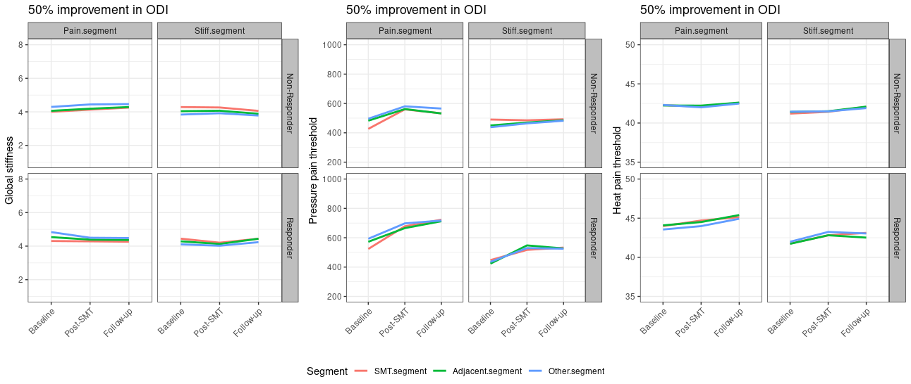

The segmental changes in pressure pain threshold, heat pain threshold, and global stiffness presented for 0% improvement in patient reported low back pain. Estimates are presented as mean and 95% confidence intervals for each time-point. Segments are divided into the segment targeted, the adjacent segments to the targeted segment and all other segments. SMT = spinal manipulative therapy
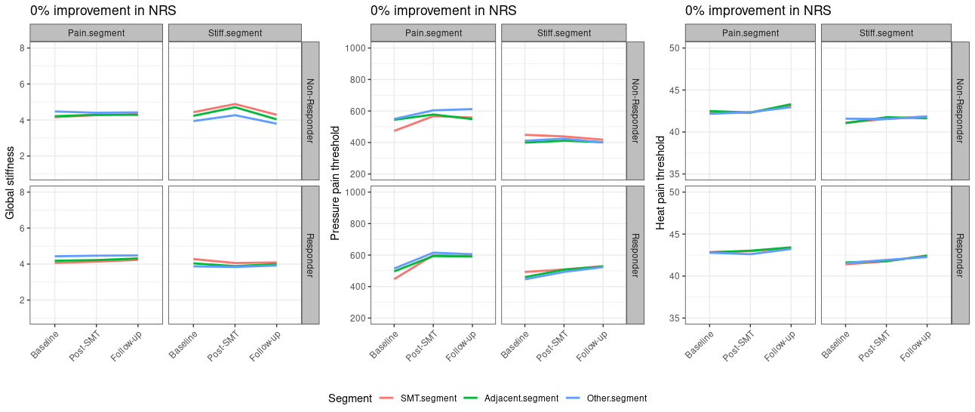

The segmental changes in pressure pain threshold, heat pain threshold, and global stiffness presented for 30% improvement in patient reported low back pain. Estimates are presented as mean and 95% confidence intervals for each time-point. Segments are divided into the segment targeted, the adjacent segments to the targeted segment and all other segments. SMT = spinal manipulative therapy
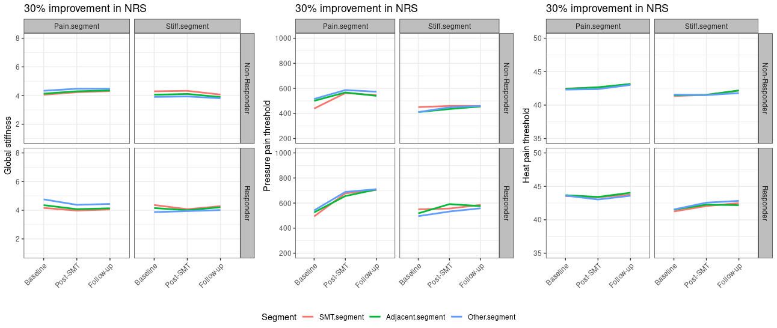

The segmental changes in pressure pain threshold, heat pain threshold, and global stiffness presented for 50% improvement in patient reported low back pain. Estimates are presented as mean and 95% confidence intervals for each time-point. Segments are divided into the segment targeted, the adjacent segments to the targeted segment and all other segments. SMT = spinal manipulative therapy
