Appendix 1: Clinical characteristics at baseline by treatment arms. Data are m, number of trials, and n, number of participants.

Characteristics |  | Controlª |  |  | Intervention^{b} |  |  | All
 |  | No. of trials m=14 |  | No. of participants n=3573 | No. of trials m=19 | No. of participants n=5755 |  | No. of trials m=19 | No. of participants n=9328
Physical disability
CPG-DS (0 to 100; 100=worst)ª
 | No. of trials, m: no. of participants, n | 4 |  | 1439 | 4 | 1889 |  | 4 | 3328
 | Mean (SD) | 51.35 |  | (21.46) | 49.26 | (22.35) |  | 50.16 | (21.99)
FFbHR (0 to 100; 100=best)
 | No. of trials, m: no. of participants, n | 3 |  | 2249 | 3 | 1927 |  | 3 | 4176
 | Mean (SD) | 57.06 |  | (20.37) | 58.33 | (20.63) |  | 57.64 | (20.5)
ODI (0 to 100; 100=worst)
 | No. of trials, m: no. of participants, n | 1 |  | 80 | 1 | 159 |  | 1 | 239
 | Mean (SD) | 31.36 |  | (14.24) | 33.72 | (15.40) |  | 32.93 | (15.03)
PDI (0 to 70; 70=worst)
 | No. of trials, m: no. of participants, n | 1 |  | 152 | 1 | 146 |  | 1 | 298
 | Mean (SD) | 31.23 |  | (12.26) | 28.92 | (11.12) |  | 30.10 | (11.75)
PSFS (0 to 10; 10=best)
 | No. of trials, m: no. of participants, n | 2 |  | 188 | 3 | 479 |  | 3 | 667
 | Mean (SD) | 3.97 |  | (1.84) | 3.71 | (1.73) |  | 3.79 | (1.76)
RMDQ (0 to 24; 24=worst)
 | No. of trials, m: no. of participants, n | 9 |  | 1150 | 14 | 3560 |  | 14 | 4710
 | Mean (SD) | 9.03 |  | (5.04) | 10.19 | (5.08) |  | 9.91 | (5.09)
Troublesomeness
 | No. of trials, m | 3 |  |  | 4 |  |  | 4
 | Not at all troublesome (%) | 4 |  | (0.66) | 7 | (0.43) |  | 11 | (0.49)
 | Slightly troublesome (%) | 51 |  | (8.44) | 158 | (9.65) |  | 209 | (9.32)
 | Moderately troublesome (%) | 284 |  | (47.02) | 724 | (44.20) |  | 1008 | (44.96)
 | Very troublesome (%) | 211 |  | (34.93) | 578 | (35.29) |  | 789 | (35.19)
 | Extremely troublesome (%) | 54 |  | (8.94) | 171 | (10.44) |  | 225 | (10.04)
Pain
CPG-PS (0 to 100; 100=worst)^{c}
 | No. of trials, m: no. of participants, n | 4 |  | 1441 | 4 | 1898 |  | 5 | 3339
 | Mean (SD) | 63.98 |  | (16.52) | 61.66 | (17.83) |  | 62.66 | (17.31)
Average pain today (0 to 100; 100=worst)
 | No. of trials, m: no. of participants, n | 2 |  | 171 | 4 | 971 |  | 4 | 1142
 | Mean (SD) | 59.37 |  | (20.92) | 55.02 | (23.15) |  | 55.67 | (22.87)
Average pain over the past 1 week (0 to 100; 100=worst)
 | No. of trials, m: no. of participants, n | 2 |  | 84 | 4 | 797 |  | 4 | 881
 | Mean (SD) | 52.69 |  | (18.23) | 63.25 | (21.51) |  | 62.24 | (21.44)
Average pain over the past 2 weeks (0 to 100; 100=worst)
 | No. of trials, m: no. of participants, n | 0 |  | 0 | 1 | 286 |  | 1 | 286
 | Mean (SD) | - |  | - | 58.02 | (19.42) |  | 58.02 | (19.42)
Average pain over the past 4 weeks (0 to 100; 100=worst)
 | No. of trials, m: no. of participants, n | 1 |  | 24 | 1 | 24 |  | 1 | 48
 | Mean (SD) | 62.58 |  | (19.72) | 56.17 | (27.67) |  | 59.38 | (23.99)
Worst pain today (0 to 100; 100=worst)
 | No. of trials, m: no. of participants, n | 1 |  | 51 | 1 | 172 |  | 1 | 223
 | Mean (SD) | 82.16 |  | (17.47) | 81.43 | (18.06) |  | 81.60 | (17.89)
Worst pain over the past 2 weeks (0 to 100; 100=worst)
 | No. of trials, m: no. of participants, n | 0 |  | 0 | 1 | 286 |  | 1 | 286
 | Mean (SD) | - |  | - | 74.74 | (19.59) |  | 74.74 | (19.59)
Worst pain over the past 4 weeks (0 to 100; 100=worst)
 | No. of trials, m: no. of participants, n | 1 |  | 24 | 1 | 24 |  | 1 | 48
 | Mean (SD) | 73.79 |  | (20.04) | 76.42 | (22.69) |  | 75.10 | (21.22)
Quality of life
SF-12/36 PCS (0 to 100; 100=best)
 | No. of trials, m: no. of participants, n | 6 |  | 2722 | 9 | 3973 |  | 9 | 6695
 | Mean (SD) | 35.72 |  | (8.58) | 36.51 | (8.07) |  | 36.19 | (8.29)
SF-12/36 MCS (0 to 100; 100=best)
 | No. of trials, m: no. of participants, n | 6 | 2722 |  | 9 |  | 3973 | 9 | 6695
 | Mean (SD) | 46.01 | (11.82) |  | 44.67 |  | (11.92) | 45.22 | (11.90)
Health utility
EQ-5D-3L (-0.11 to 1;1=best)
 | No. of trials, m: no. of participants, n | 5 | 724 |  | 7 |  | 2356 | 7 | 3080
 | Mean (SD) | 0.59 | (0.26) |  | 0.59 |  | (0.27) | 0.59 | (0.27)
Depression
DASS-DE (0 to 42; 42=worst)
 | No. of trials, m: no. of participants, n | 1 | 68 |  | 1 |  | 190 | 1 | 258
 | Mean (SD) | 7.06 | (7.61) |  | 7.24 |  | (8.07) | 7.19 | (7.94)
DRAM
 | No. of trials, m | 2 |  |  | 2 |  |  | 2
 | Type N (%) | 184 | (44.88) |  | 373 |  | (36.89) | 557 | (39.2)
 | Type R (%) | 158 | (38.54) |  | 414 |  | (40.95) | 572 | (40.25)
 | Type DD (%) | 49 | (11.95) |  | 142 |  | (14.05) | 191 | (13.44)
 | Type DS (%) | 19 | (4.63) |  | 82 |  | (8.11) | 101 | (7.11)
HADS-DE (0 to 21; 21=worst)
 | No. of trials, m: no. of participants, n | 1 | 231 |  | 1 |  | 464 | 1 | 695
 | Mean (SD) | 5.54 | (3.60) |  | 6.04 |  | (3.81) | 5.87 | (3.75)
MZDI (0 to 69; 69=worst)
 | No. of trials, m: no. of participants, n | 2 | 411 |  | 3 |  | 1313 | 3 | 1724
 | Mean (SD) | 19.77 | (10.75) |  | 21.46 |  | (10.66) | 21.06 | (10.70)
Anxiety
DASS-AN (0 to 42; 42=worst)
 | No. of trials, m: no. of participants, n | 1 | 68 |  | 1 |  | 190 | 1 | 258
 | Mean (SD) | 5.35 | (6.92) |  | 5.41 |  | (7.23) | 5.40 | (7.14)
HADS-AN (0 to 21; 21=worst)
 | No. of trials, m: no. of participants, n | 1 | 230 |  | 1 |  | 458 | 1 | 688
 | Mean (SD) | 7.49 | (4.43) |  | 8.22 |  | (4.30) | 7.98 | (4.35)
Fear avoidance
ALBPSQ-FA (0 to 30; 30=worst)
 | No. of trials, m: no. of participants, n | 1 | 33 |  | 2 |  | 274 | 2 | 307
 | Mean (SD) | 18.42 | (5.90) |  | 18.20 |  | (6.47) | 18.22 | (6.40)
FABQ-PC (0 to 24; 24=worst)
 | No. of trials, m: no. of participants, n | 5 | 1522 |  | 5 |  | 1960 | 5 | 3482
 | Mean (SD) | 16.49 | (5.48) |  | 15.33 |  | (5.65) | 15.84 | (5.61)
TSK (16 to 68; 68=worst)
 | No. of trials, m: no. of participants, n | 4 | 353 |  | 5 |  | 949 | 5 | 1302
 | Mean (SD) | 39.40 | (8.51) |  | 41.31 |  | (7.91) | 40.79 | (8.12)
Catastrophising
CSQ-CAT (0 to 36; 36=worst)
 | No. of trials, m: no. of participants, n | 0 | 0 |  | 2 |  | 561 | 2 | 561
 | Mean (SD) | - | - |  | 9.19 |  | (7.16) | 9.19 | (7.16)
PRSS-CAT (0 to 45; 45=worst)
 | No. of trials, m: no. of participants, n | 2 | 188 |  | 2 |  | 309 | 2 | 497
 | Mean (SD) | 17.23 | (8.53) |  | 17.21 |  | (8.92) | 17.22 | (8.77)
Coping
CSQ-CSS (0 to 36; 36=best)
 | No. of trials, m: no. of participants, n | 0 | 0 |  | 1 |  | 394 | 1 | 394
 | Mean (SD) | - | - |  | 25.23 |  | (6.43) | 25.23 | (6.43)
PRSS-CSS (0 to 45; 45=best)
 | No. of trials, m: no. of participants, n | 2 | 188 |  | 2 |  | 309 | 2 | 497
 | Mean (SD) | 31.97 | (6.85) |  | 30.61 |  | (7.29) | 31.13 | (7.15)
PSEQ (0 to 60; 60=best)
 | No. of trials, m: no. of participants, n | 2 | 290 |  | 4 |  | 1049 | 4 | 1339
 | Mean (SD) | 41.74 | (12.76) |  | 40.10 |  | (12.93) | 40.46 | (12.90)
Somatic perception
MSPQ (0 to 39; 39=worst)
 | No. of trials, m: no. of participants, n | 2 | 411 |  | 3 |  | 1403 | 3 | 1814
 | Mean (SD) | 6.14 | (5.34) |  | 6.55 |  | (5.31) | 6.45 | (5.32)
Sensory index
McGill-SE (0 to 33; 33=worst)
 | No. of trials, m: no. of participants, n | 0 | 0 |  | 1 |  | 355 | 1 | 355
 | Mean (SD) | - | - |  | 14.24 |  | (6.22) | 14.24 | (6.22)
SES-SE (10 to 40; 40=worst)
 | No. of trials, m: no. of participants, n | 1 | 152 |  | 1 |  | 146 | 1 | 298
 | Mean (SD) | 49.45 | (9.84) |  | 49.70 |  | (9.05) | 49.57 | (9.45)
Affective index
McGill-AF (0 to 12; 12=worst)
 | No. of trials, m: no. of participants, n | 0 | 0 |  | 1 |  | 379 | 1 | 379
 | Mean (SD) | - | - |  | 4.23 |  | (3.33) | 4.23 | (3.33)
SES-AF (14 to 56; 56=worst)
 | No. of trials, m: no. of participants, n | 1 | 152 |  | 1 |  | 146 | 1 | 298
 | Mean (SD) | 50.43 | (8.78) |  | 50.19 |  | (8.38) | 50.31 | (8.57)
a Control arm includes best usual care and sham treatments. Four trials did not have control arm.
b Intervention arm includes active physical, passive physical, psychological and combination.
c Two trials with 4 weeks recall period and three trials with 3 months recall period.
Abbreviations: BMI, body mass index; CPG-DS, chronic pain grade disability score; FFbHR, Hannover functional ability questionnaire for measuring back-pain related functional limitations; ODI, Oswestry disability index; PDI, pain disability index; PSFS, patient specific functional scale; RMDQ, Roland Morris disability questionnaire; CPG-PS, chronic pain grade pain intensity score; PCS, physical component scale of SF-12/36; MCS, mental component scale of SF-12/36; DASS, depression anxiety stress scales; DRAM, distress and risk assessment method; Type N, normal; Type R, at risk; Type DD, distressed-depressive; Type DS, distressed-somatic; HADS, hospital anxiety and depression scale; MZDI, modified Zung depression index; ALBPSQ, acute low back pain screening questionnaire; FABQ, fear-avoidance beliefs questionnaire; TSK, Tampa scale for kinesiophobia; CSQ, coping strategy questionnaire; PRSS, pain related self-statement; PSEQ, pain self-efficacy questionnaire; MSPQ, modified somatic perception questionnaire; SES, pain experience scale (Schmerzempfindungsskala).

Adapted with permission from: Patel S, Hee SW, Mistry D, Jordan J, Brown S, Dritsaki M, Ellard DR, Friede T, Lamb SE, Lord J, Madan J, Morris T, Stallard N, Tysall C, Willis A, Underwood M, the Repository G. Programme Grants for Applied Research. Identifying back pain subgroups: developing and applying approaches using individual patient data collected within clinical trials. Southampton (UK): NIHR Journals Library
Appendix 2: Summary of the number of trials (m), number of participants (n) and covariates used to identify subgroup in overall comparison for each short-term outcome with recursive partitioning (RP) and adaptive refinement by directed peeling (ARDP) methods.

 | RP |  |  | ARDP
Outcomes | m | n* | Covariates | m | n* | Covariates
Pain | 2[17,19] | 1377 | Age, sex, anxiety, fear avoidance, MCS, PCS, pain, RMDQ | 3[17,18,  19] | 2534 | Age, pain, PCS, MCS
EQ-5D | 2[17,19] | 1339 | Age, sex, anxiety, fear avoidance, MCS, PCS, pain, RMDQ | 2[17,19] | 1365 | RMDQ, pain, PCS, MCS
FFbHR | 3[16,18,21] | 3718 | Age, sex, PCS, FFbHR, MCS | 3[16,18,21] | 3718 | Age, FFbHR, PCS, MCS
MCS of SF-12/36 | 3[16,18,21] | 3630 | Age, sex, FFbHR, MCS, PCS | 3[16,18,21] | 3630 | Age, FFbHR, PCS, MCS
PCS of SF-12/36 | 6[16,17,18,19,21,24] | 5208 | Age, sex, MCS, PCS | 6[16,17,18,19,21,24] | 5208 | Age, PCS, MCS
RMDQ | 7[17,19,23,25,26,28,29] | 2564 | Age, sex, fear avoidance, RMDQ | 8[17,19,23,25,26,28,29,34] | 2675 | Age, RMDQ
QALY | 4[17,19,29,31] | 1514 | Age, RMDQ
FFbHR, Hannover functional ability questionnaire for measuring back-pain related functional limitations; RMDQ, Roland Morris disability questionnaire; PCS, physical component scale of SF-12/36; MCS, mental component scale of SF-12/36; QALY, quality-adjusted life-years.
*Figures vary as RP includes more variables and if the additional variables have missing values then these are dropped, hence why lower figures are observed for RP compared to ARDP.

Appendix 3: Summary of the number of trials (m), number of participants (n) and covariates used to identify subgroup for different pairwise comparisons for each short-term outcome with recursive partitioning (RP) and adaptive refinement by directed peeling (ARDP) methods.
 |  | RP |  |  | ARDP
Pairwise comparison | Outcomes | m | n* | Covariates | m | n* | Covariates
Active physical vs. non-active usual care | RMDQ | 2[17,29] | 576 | Fear avoidance,  age, sex, RMDQ,  pain, EQ-5D, anxiety | 2[17,29] | 622 | Age, RMDQ
Active physical vs. non-active usual care | QALY | 2[17,31] | 496 | Age, RMDQ
Passive physical vs. non-active usual care | FFbHR | 3[16,18,21] | 3272 | Age, PCS, FFbHR, sex, MCS | 3[16,18,21] | 3272 | Age, FFbHR, PCS, MCS
Passive physical vs. non-active usual care | PCS | 5[16,17,18,21,24] | 3879 | Age, sex, MCS, PCS | 5[16,17,18,21,24] | 3879 | Age, PCS, MCS
Passive physical vs. non-active usual care | MCS | 5[16,17,18,21,24] | 3879 | Age, sex, MCS, PCS | 5[16,17,18,21,24] | 3879 | Age, PCS, MCS
Passive physical vs. non-active usual care | QALY | 3[17,18,24] | 1209 | Age, PCS
Psychological vs. non-active usual care | RMDQ | 3[19,26,28] | 928 | Fear avoidance, age, sex, RMDQ, pain | 3[19,26,28] | 957 | Age, RMDQ
Sham control vs. non-active usual care | FFbHR | 2[18,21] | 881 | Age, sex, MCS, PCS | 2[18,21] | 881 | Age, FFbHR, PCS, MCS
Sham control vs. non-active usual care | PCS | 2[18,21] | 879 | Age, sex, MCS, PCS | 2[18,21] | 879 | Age, PCS, MCS
Sham control vs. non-active usual care | MCS | 2[18,210 | 879 | Age, sex, MCS, PCS | 2[18,210 | 879 | Age, PCS, MCS

FFbHR, Hannover functional ability questionnaire for measuring back-pain related functional limitations; RMDQ, Roland Morris disability questionnaire; PCS, physical component scale of SF-12/36; MCS, mental component scale of SF-12/36; QALY, quality-adjusted life-years.
*Figures vary as RP includes more variables and if the additional variables have missing values then these are dropped, hence why lower figures are observed for RP compared to ARDP.

Appendix 4: Subgroups identified by the recursive partitioning (RP) method for the passive physical vs non-active usual care comparison
Subgroups | n | Treatment effect (95% confidence interval, CI) | Interaction effect | Unadjusted p-value
Outcome: short-term FFbHR
Overall treatment effect (95% CI): 9.95 (8.80, 11.11)
Candidate 1
FFbHR ≤ 54.2 | 1,424 | 12.9 (10.81, 14.91) | 5.45 | <0.001
FFbHR > 54.2 | 1,848 | 7.4 (6.23, 8.59)
Candidate 2
FFbHR ≤ 54.2 AND Age ≤ 57 | 731 | 15.9 (12.80, 18.92) | 6.63 | 0.002
FFbHR ≤ 54.2 AND Age > 57 | 693 | 9.2 (6.64, 11.82)
Candidate 3
FFbHR ≤ 54.2 AND Age ≤ 53 | 571 | 16.7 (13.16, 20.18) | 6.85 | 0.001
FFbHR ≤ 54.2 AND Age > 53 | 853 | 9.8 (7.43, 12.22)
Candidate 4
FFbHR ≤ 41.7 | 792 | 15.0 (12.06, 18.01) | 6.71 | <0.001
FFbHR > 41.7 | 2,480 | 8.3 (7.19, 9.45)
Outcome: short-term MCS
Overall treatment effect (95% CI): 2.96 (2.31, 3.61)
Candidate 1
MCS ≤ 54.3 | 2,714 | 3.8 (2.97, 4.55) | 2.82 | <0.001
MCS > 54.3 | 1,165 | 0.9 (0.10, 1.76)
Candidate 2
MCS ≤ 54.3 AND PCS ≤ 43.9 | 2,171 | 4.3 (3.39, 5.15) | 2.43 | 0.019
MCS ≤ 54.3 AND PCS > 43.9 | 543 | 1.9 (0.11, 3.59)
Candidate 3
MCS ≤ 51.3 | 2,327 | 3.8 (2.96, 4.70) | 2.57 | <0.001
MCS > 51.3 | 1,552 | 1.3 (0.52, 1.99)
Outcome: short-term PCS
Overall treatment effect (95% CI): 4.10 (3.56, 4.63)
Candidate 1
PCS ≤ 43.6 | 3,103 | 4.4 (3.78, 4.99) | 1.61 | 0.013
PCS > 43.6 | 776 | 2.8 (1.87, 3.67)
Candidate 2
PCS ≤ 43.6 AND Age ≤ 44 | 942 | 5.4 (4.21, 6.49) | 1.45 | 0.040
PCS ≤ 43.6 AND Age > 44 | 2,161 | 3.9 (3.20, 4.60)
Candidate 3
PCS ≤ 37.8 | 2,326 | 4.6 (3.90, 5.32) | 1.23 | 0.025
PCS > 37.8 | 1,553 | 3.4 (2.66, 4.09)
Candidate 4
PCS ≤ 37.8 AND Age ≤ 62 | 1,682 | 5.1 (4.21, 5.94) | 1.97 | 0.016
PCS ≤ 37.8 AND Age > 62 | 644 | 3.1 (1.94, 4.28)
Candidate 5
PCS ≤ 37.8 AND MCS > 44.0 | 1,396 | 5.5 (4.55, 6.41) | 1.80 | 0.011
PCS ≤ 37.8 AND MCS ≤ 44.0 | 930 | 3.7 (2.64, 4.71)
Candidate 6
PCS ≤ 37.8 AND MCS > 51.8 | 932 | 5.8 (4.63, 6.91) | 1.78 | 0.012
PCS ≤ 37.8 AND MCS ≤ 51.8 | 1,394 | 4.0 (3.11, 4.87)
Candidate 7
PCS ≤ 37.8 AND MCS > 51.8 AND Sex = Female | 520 | 6.6 (5.12, 8.16) | 1.73 | 0.167
PCS ≤ 37.8 AND MCS > 51.8 AND Sex = Male | 412 | 4.9 (3.17, 6.65)
Candidate 8
PCS ≤ 40.3 | 2,715 | 4.5 (3.85, 5.16) | 1.61 | 0.006
PCS > 40.3 | 1,164 | 2.9 (2.11, 3.68)
Candidate 9
PCS ≤ 40.3 AND MCS > 51.5 | 1,086 | 5.4 (4.37, 6.48) | 1.38 | 0.042
PCS ≤ 40.3 AND MCS ≤ 51.5 | 1,629 | 4.1 (3.24, 4.85)
Note: The first row of each candidate subgroup is the selected subgroup with enhanced treatment effect.
FFbHR, Hannover functional ability questionnaire for measuring back-pain related functional limitations; RMDQ, Roland Morris disability questionnaire; PCS, physical component scale of SF-12/36; MCS, mental component scale of SF-12/36.
Reproduced with permission from: Patel S, Hee SW, Mistry D, Jordan J, Brown S, Dritsaki M, Ellard DR, Friede T, Lamb SE, Lord J, Madan J, Morris T, Stallard N, Tysall C, Willis A, Underwood M, the Repository G. Programme Grants for Applied Research. Identifying back pain subgroups: developing and applying approaches using individual patient data collected within clinical trials. Southampton (UK): NIHR Journals Library
Appendix 5: Subgroups identified by the recursive partitioning (RP) method for the psychological vs non-active usual care comparison
Subgroups | n | Treatment effect (95% confidence interval, CI) | Interaction effect | Unadjusted p-value
Outcome: short-term RMDQ
Overall treatment effect (95% CI): 1.40 (0.89, 1.91)
Candidate 1
RMDQ > 4 | 697 | 1.7 (1.12, 2.31) | 1.07 | 0.038
RMDQ ≤ 4 | 231 | 0.7 (-0.11, 1.40)
Note: The first row of each candidate subgroup is the selected subgroup with enhanced treatment effect.
RMDQ, Roland Morris disability questionnaire.
Reproduced with permission from: Patel S, Hee SW, Mistry D, Jordan J, Brown S, Dritsaki M, Ellard DR, Friede T, Lamb SE, Lord J, Madan J, Morris T, Stallard N, Tysall C, Willis A, Underwood M, the Repository G. Programme Grants for Applied Research. Identifying back pain subgroups: developing and applying approaches using individual patient data collected within clinical trials. Southampton (UK): NIHR Journals Library
Appendix 6: Subgroups identified by the recursive partitioning (RP) method for the sham vs non-active usual care comparison
Subgroups | n | Treatment effect (95% confidence interval, CI) | Interaction effect | Unadjusted p-value
Outcome: short-term MCS
Overall treatment effect (95% CI): 2.59 (1.13, 4.04)
Candidate 1
Age ≤ 65 | 705 | 3.4 (1.80, 5.04) | 4.32 | 0.019
Age > 65 | 174 | -0.9 (-4.16, 2.35)
Candidate 2
PCS ≤ 42.0 | 791 | 3.1 (1.55, 4.65) | 4.99 | 0.043
PCS > 42.0 | 88 | -1.9 (-6.07, 2.28)
Note: The first row of each candidate subgroup is the selected subgroup with enhanced treatment effect.
PCS, physical component scale of SF-12/36; MCS, mental component scale of SF-12/36.

Reproduced with permission from: Patel S, Hee SW, Mistry D, Jordan J, Brown S, Dritsaki M, Ellard DR, Friede T, Lamb SE, Lord J, Madan J, Morris T, Stallard N, Tysall C, Willis A, Underwood M, the Repository G. Programme Grants for Applied Research. Identifying back pain subgroups: developing and applying approaches using individual patient data collected within clinical trials. Southampton (UK): NIHR Journals Library

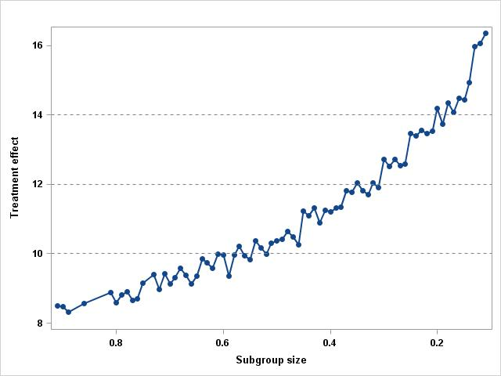  (a) m = 3; n = 3718 | 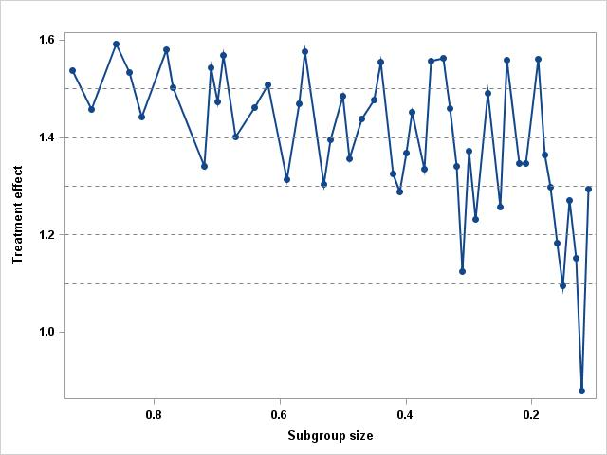  (b) m = 8; n = 2675 | 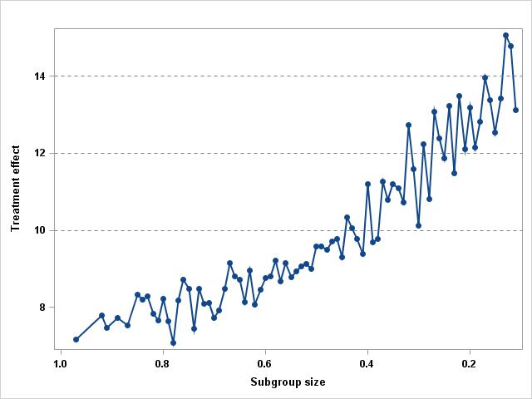  (c) m = 3; n = 2534
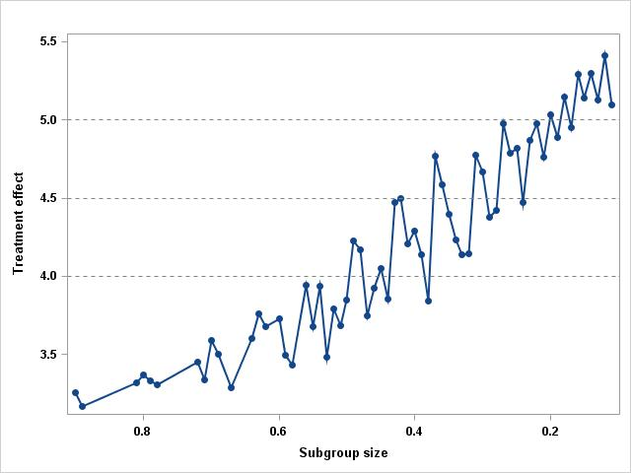  (d) m = 6; n = 5208 | 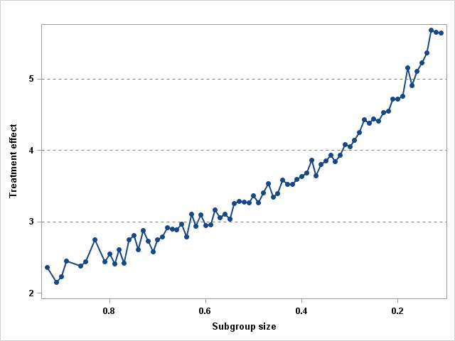  (e) m = 3; n = 3630 | 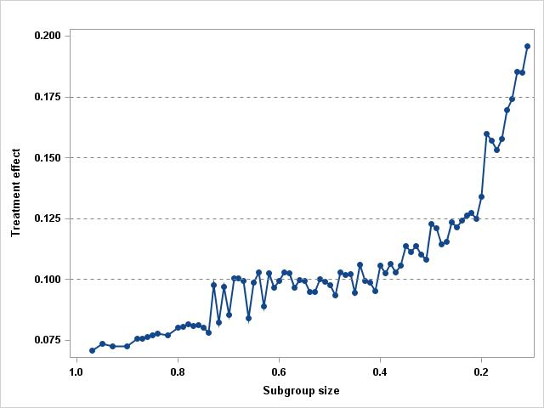  (f) m = 2; n = 1365
Appendix 7: Trajectory plot for the treatment effect against the size of the constructed region for short-term (a) Hannover functional ability questionnaire for measuring back-pain related functional limitations, FFbHR, (b) Roland Morris disability questionnaire, RMDQ, (c) Pain, (d) physical component scale of SF-12/36, (e) mental component scale of SF-12/36, and (f) EQ-5D. The number of trials, m, and number of patients, n, in each of the subgroup identification analyses.

Adapted with permission from: Patel S, Hee SW, Mistry D, Jordan J, Brown S, Dritsaki M, Ellard DR, Friede T, Lamb SE, Lord J, Madan J, Morris T, Stallard N, Tysall C, Willis A, Underwood M, the Repository G. Programme Grants for Applied Research. Identifying back pain subgroups: developing and applying approaches using individual patient data collected within clinical trials. Southampton (UK): NIHR Journals Library

Appendix 8: Thresholds for selected sizes of the subgroup for the short-term SF-12/36 MCS as seen in Appendix 7, figure (e).

Subgroup size | Age (>) | PCS (<) | MCS (<) | FFbHR (<) | Treatment effect
0.108 | 16 | 28.84 | 50.61 | 100.00 | 5.98
0.207 | 31 | 43.62 | 50.61 | 45.83 | 4.72
0.301 | 54 | 43.62 | 56.82 | 75.00 | 4.05
0.401 | 45 | 67.75 | 60.35 | 62.50 | 3.64
0.505 | 31 | 38.01 | 60.35 | 75.00 | 3.37
0.604 | 45 | 67.75 | 60.35 | 100.00 | 2.94
0.701 | 16 | 47.59 | 60.35 | 75.00 | 2.75
0.807 | 16 | 47.59 | 60.35 | 100.00 | 2.55
0.907 | 16 | 47.59 | 72.11 | 100.00 | 2.23
FFbHR, Hannover functional ability questionnaire for measuring back-pain related functional limitations; PCS, physical component scale of SF-12/36; and MCS, mental component scale of SF-12/36.
Adapted with permission from: Patel S, Hee SW, Mistry D, Jordan J, Brown S, Dritsaki M, Ellard DR, Friede T, Lamb SE, Lord J, Madan J, Morris T, Stallard N, Tysall C, Willis A, Underwood M, the Repository G. Programme Grants for Applied Research. Identifying back pain subgroups: developing and applying approaches using individual patient data collected within clinical trials. Southampton (UK): NIHR Journals Library
Appendix 9: Thresholds for selected sizes of the subgroup for the short-term EQ-5D as seen in Appendix 7, figure (f).

Subgroup size | PCS (<) | MCS (<) | Pain (>) | RMDQ (>) | Treatment effect
0.101 | 35.66 | 60.35 | 0.00 | 14 | 0.21
0.190 | 31.34 | 72.11 | 0.00 | 6 | 0.16
0.210 | 33.62 | 56.82 | 0.00 | 6 | 0.13
0.303 | 40.45 | 47.17 | 0.00 | 6 | 0.12
0.407 | 67.75 | 72.11 | 57.00 | 0 | 0.11
0.505 | 40.45 | 72.11 | 30.00 | 6 | 0.10
0.593 | 47.59 | 56.82 | 0.00 | 6 | 0.10
0.610 | 67.75 | 56.82 | 20.00 | 6 | 0.10
0.704 | 47.59 | 60.35 | 20.00 | 5 | 0.09
0.803 | 47.59 | 60.35 | 0.00 | 0 | 0.08
0.909 | 67.75 | 60.35 | 0.00 | 0 | 0.07
RMDQ, Roland Morris disability questionnaire; PCS, physical component scale of SF-12/36; MCS, mental component scale of SF-12/36.
Adapted with permission from: Patel S, Hee SW, Mistry D, Jordan J, Brown S, Dritsaki M, Ellard DR, Friede T, Lamb SE, Lord J, Madan J, Morris T, Stallard N, Tysall C, Willis A, Underwood M, the Repository G. Programme Grants for Applied Research. Identifying back pain subgroups: developing and applying approaches using individual patient data collected within clinical trials. Southampton (UK): NIHR Journals Library

