Introduction to the supra-/infra- pectineal plates
The plates are made of pure titanium (TA3) and is fitted to the pelvic brim. The supra-pectineal plate is a 2.8mm thick 9-hole plate (Fig.1A). Holes 1, 2, 8 and 9 are 3.5mm ordinary round holes, and 3.5mm screws can be placed. Holes 3 and 7 are oval sliding holes, and screw insertion point can be adjusted intraoperatively to place 3.5mm infra-acetabular screw and posterior column screw, respectively. Holes 4~6 are small round holes, corresponding to the joint surface area. In order to avoid the screw penetrating into the joint, no screw should be placed. The infra-pectineal plate is a 2.8mm thick 8-hole arc plate (Fig.1B). Holes 1~3, 7 and 9 are 3.5mm ordinary round holes that allows 3.5mm screws to be inserted. Holes 4 and 8 are oval sliding holes which allows 3.5mm screws to be inserted, or used as the joint holes of pubo-ischiatic plate and ilio-ischiatic plate respectively. Holes 5 and 6 are small round holes, corresponding to the joint surface, and screws are not inserted.
Therefore, the supra-/infra- pectineal plates are suitable for acetabular anterior column and quadrilateral plate fractures, and can be easily inserted with the pelvic rim exposed (Fig.1C).
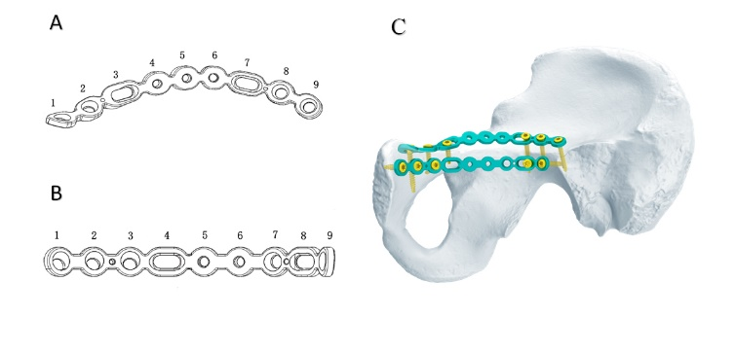
Fig. 1 Schematic diagram of the two kinds of anatomical plates. A The supra-pectineal plate is a 9-hole plate fitted to the bone surface of the anterior column. B The supra-pectineal plate is a 8-hole placed below the iliopectineal line to resist medial displacement of the quadrilateral plate. C The plates are fit to the irregular pelvic brim.

