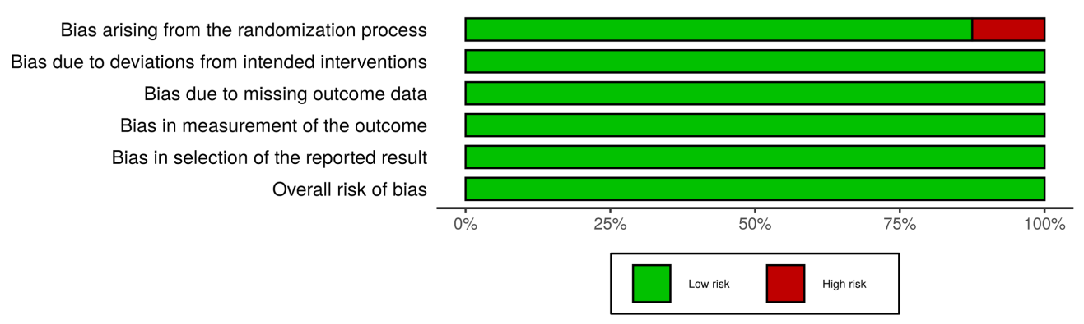
Additional File 4: Summary of Risk of Bias in Included Studies

