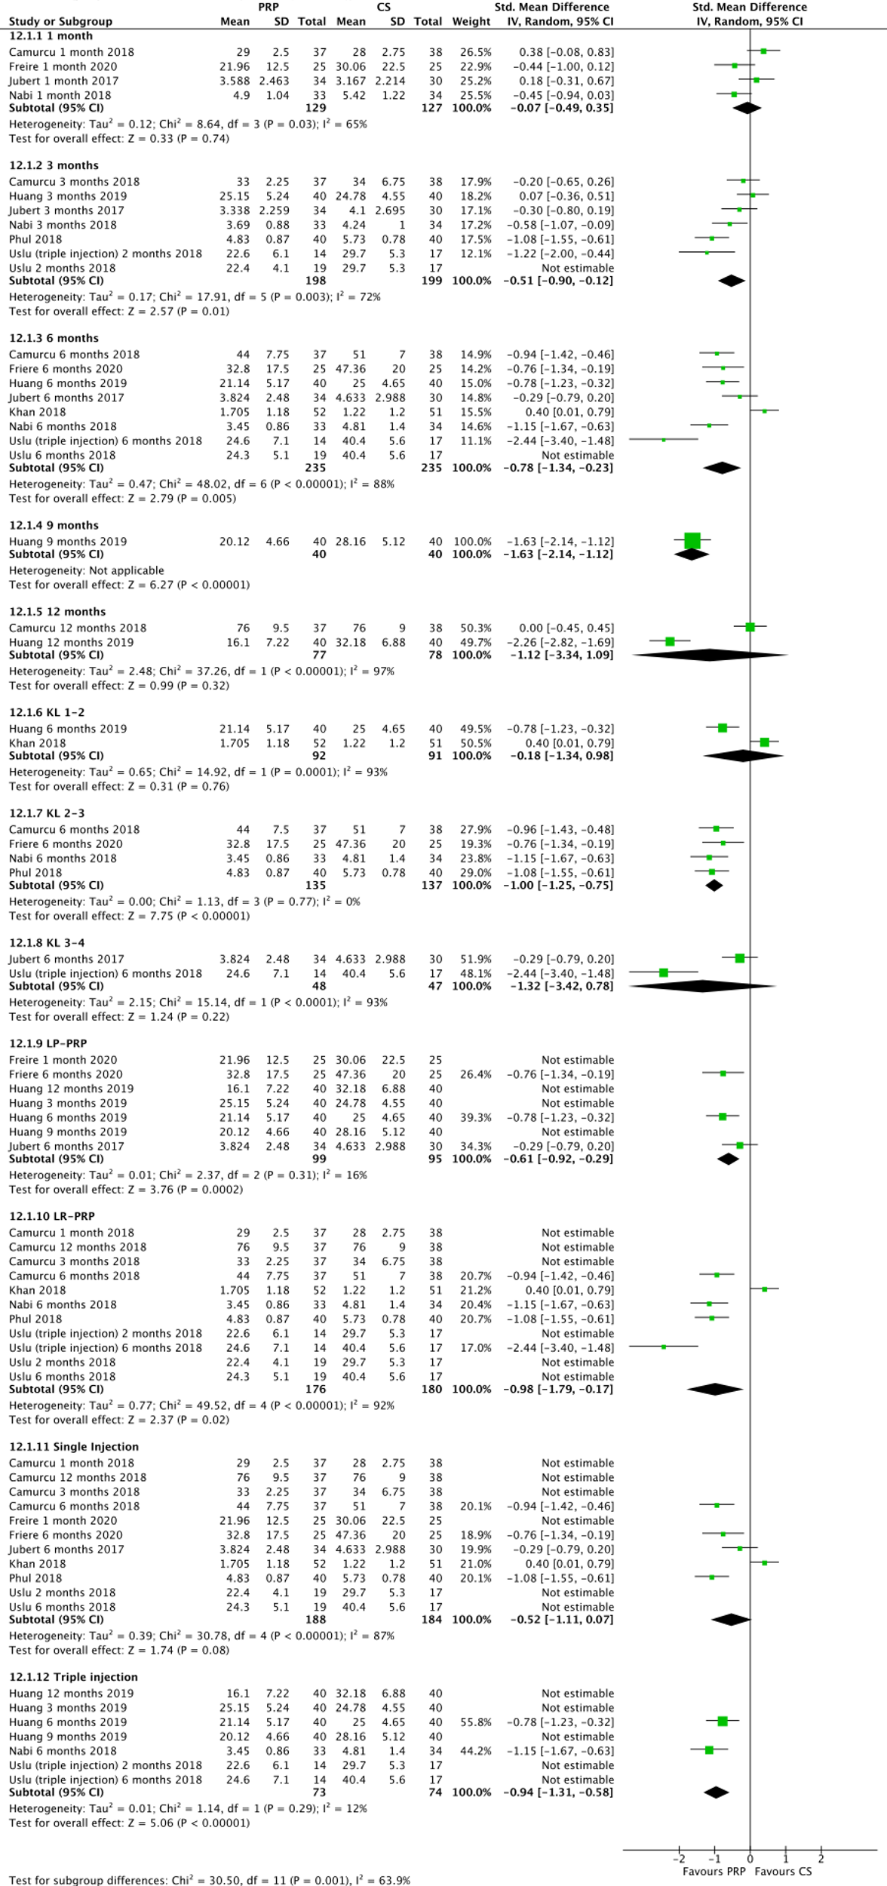
Additional File 6: Forest plot of Main Analyses Performed (SMD)

