Additional file 10. Forest plots for meta-analysis and post-hoc sensitivity analysis concerning cervicogenic headache and asymptomatic individuals comparison. Studies were excluded from post-hoc sensitivity analysis due to moderate/high risk of bias (Quality Index <75%)

- Cervical ROM
A.1. Meta-analysis
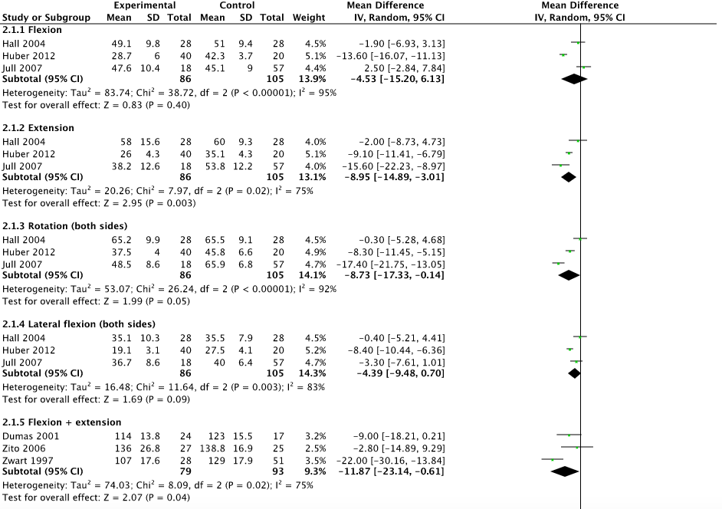
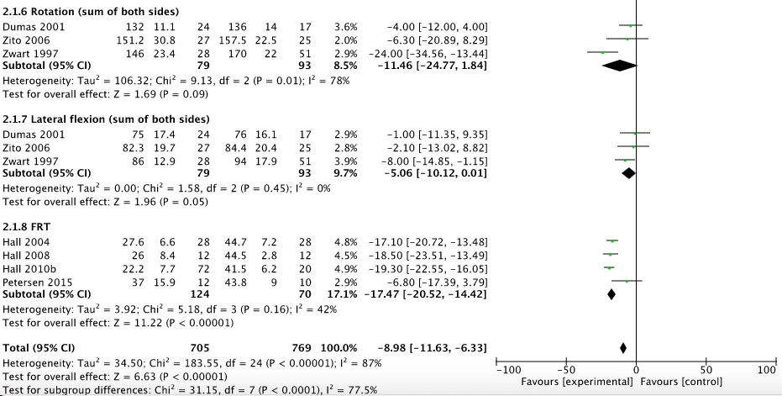

A.2. Post-hoc sensitivity analysis
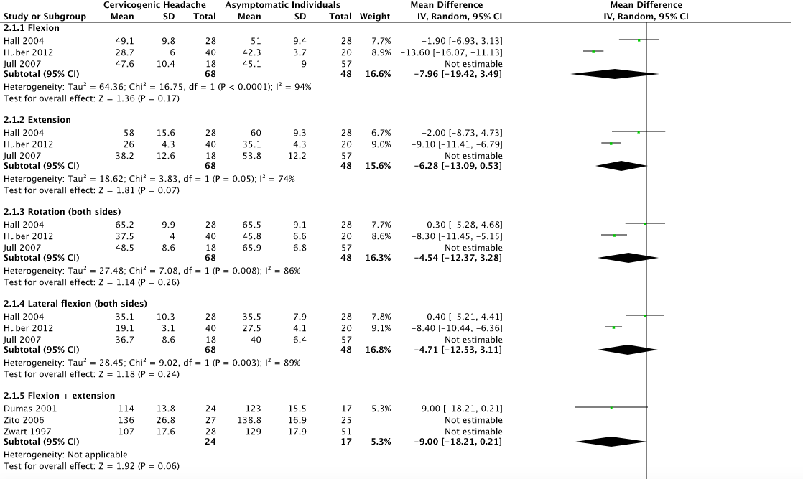
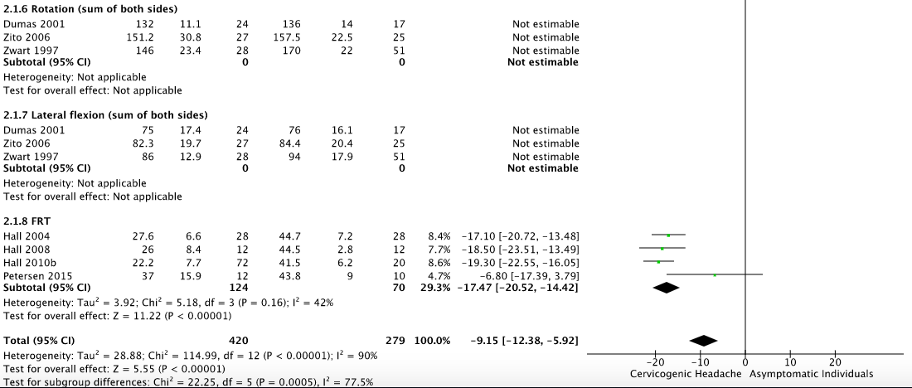

- Neck strength
B.1. Meta-analysis
