Supplementary material

Fig. A Search strategy for each database

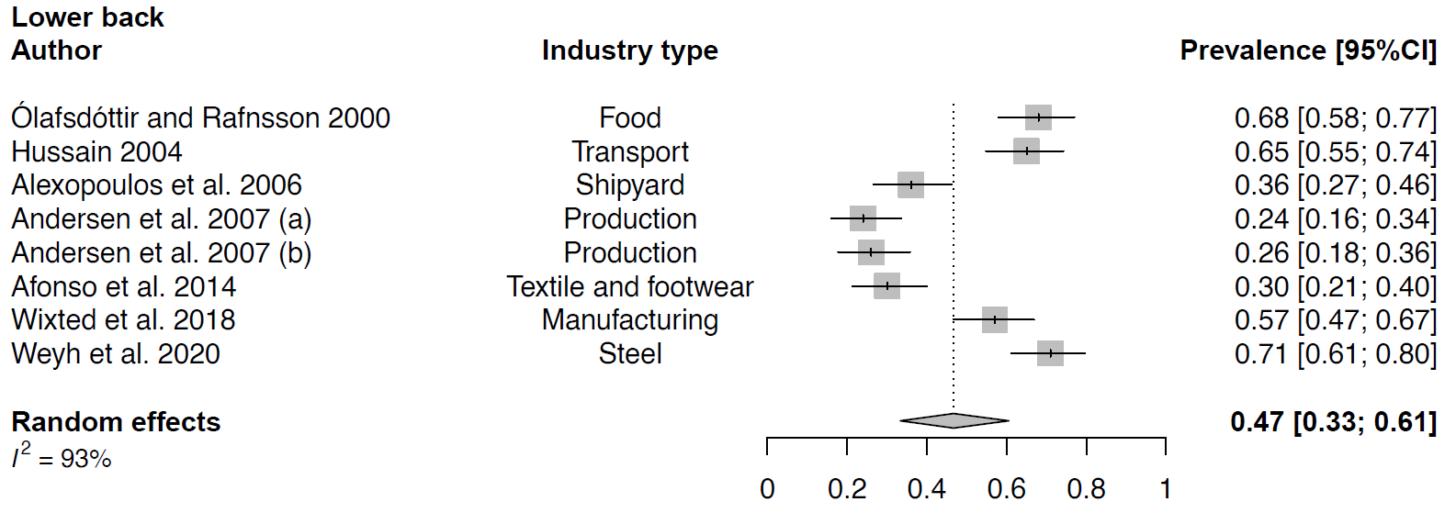
Fig. B Meta-analytic overview of prevalence of lower back WMSDs. (a) = baseline; (b) = 24-month follow-up.


Fig. C Meta-analytic overview of prevalence of upper back WMSDs.

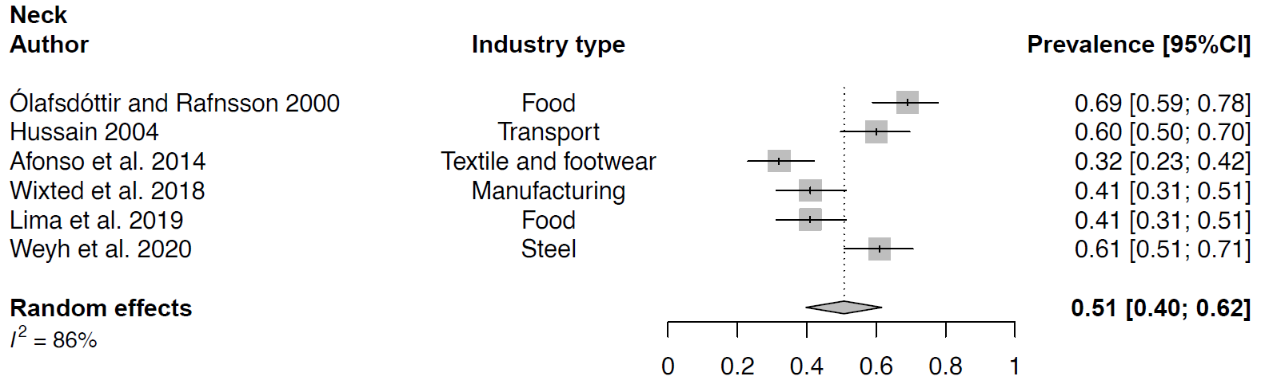
Fig. D Meta-analytic overview of prevalence of neck WMSDs.

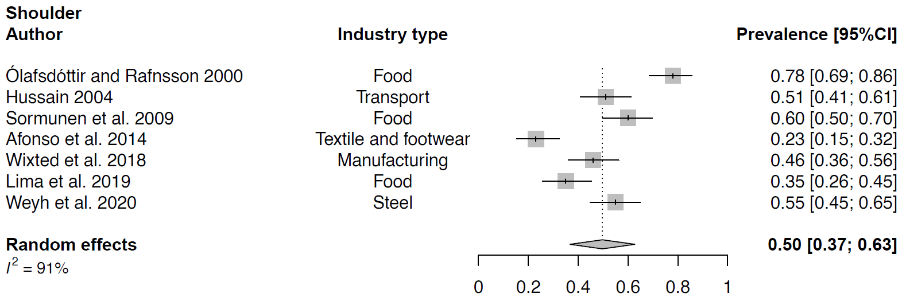
Fig. E Meta-analytic overview of prevalence of shoulder WMSDs.

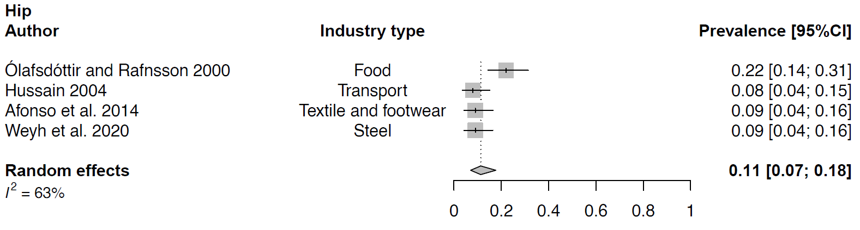
Fig. F Meta-analytic overview of prevalence of hip WMSDs.

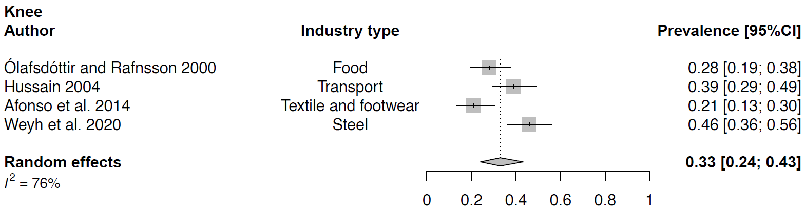
Fig. G Meta-analytic overview of prevalence of knee WMSDs.

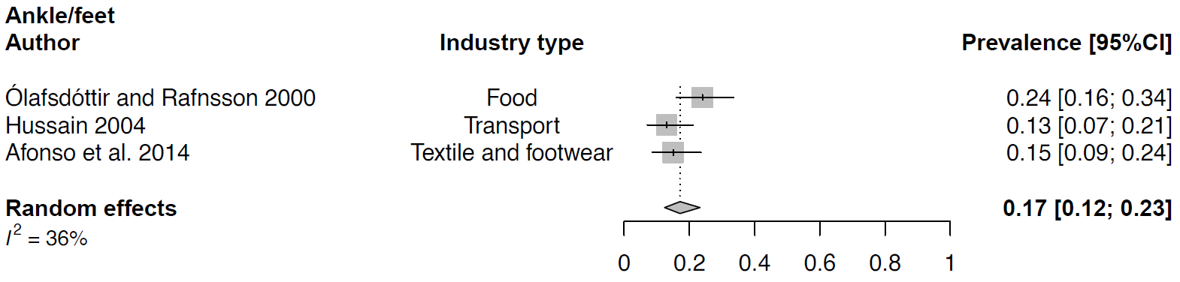

Fig. H Meta-analytic overview of prevalence of ankle/feet WMSDs.

