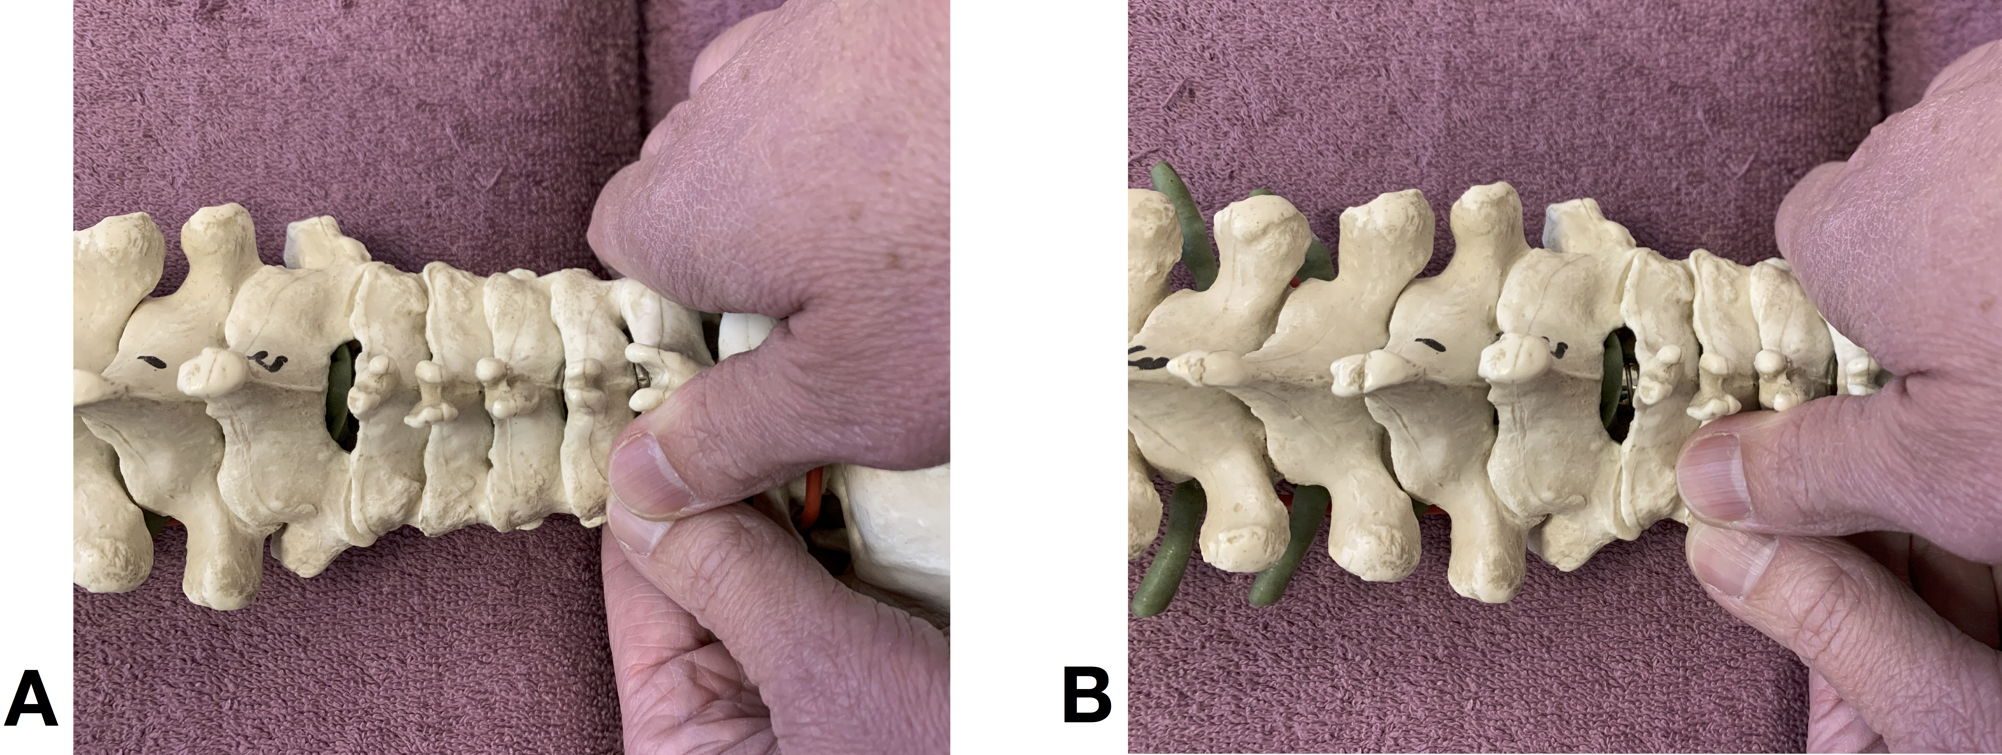
Fig 3. Examples of PAIVM’s (Passive Accessory Intervertebral Movement’s). Right unilateral on C₂ (A) and C₆ (B) with hand placement (“patient” in prone with the “head” on the right side of each picture). The assessor applied his thumb directed posterior-anterior force to the articular pillars from the upper cervical region C₀₋₁, C₁₋₂ and C₂₋₃ to the lower region C₆₋₇ on each side.

