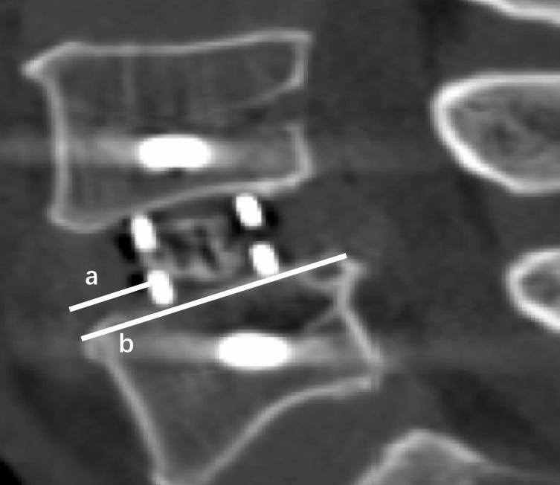

Supplement figure 1.The measurement of cage position. The cage position is calculated as a/b*100%. a, the distance between the anterior metal marker and the leading edge of the caudal endplate. b, the length of caudal endplate

