Supplement

eTable 1 Baseline Characteristics of the Patients by Admission Blood Glucose (Quartile-based four-category) (mmol/L) before PSM.

Characteristics | Total patients  (n = 600) | Blood glucose Quartile(mmol/L) |  |  |  | P for Trend†
Characteristics | Total patients  (n = 600) | 0.00-5.30  (n = 143) | 5.30–6.00  (n = 180) | 6.00-6.95  (n = 127) | > 6.95  (n = 150) | P for Trend†
Demographic
Male gender (n, %) | 246(41.0) | 68(47.6) | 83(46.1) | 46(36.0) | 49(32.7) | 0.019
Age, ×year [median (IQR)] | 72.0(14.0) | 68.00(15.0) | 70.5(17.8) | 75.00(16.00) | 75.00(12.00) | <0.001
Smoking (n, %) | 75(12.5) | 19(13.3) | 30(16.7) | 20(15.7) | 23(15.3) | 0.867
Hypertension (n, %) | 252(42.0) | 46(32.2) | 70(38.9) | 49(38.6) | 87(58.0) | <0.001
Diabetes (n, %) | 112(18.7) | 3(2.1) | 14(7.8) | 13(10.2) | 68(54.7) | <0.001
Cardiovascular disease (n, %) | 84(14.0) | 18(12.6) | 22(11.7) | 15(11.8) | 29(19.3) | 0.283
Stroke (n, %) | 119(19.8) | 26(18.2) | 35(19.4) | 17(13.4) | 41(27.3) | 0.031
Fracture type
Femoral neck fracture (n, %) | 369(61.5) | 103(72.0) | 112(62.2) | 71(55.9) | 83(55.30) | 0.026
Intertrochanteric fracture (n, %) | 177(29.5) | 26(18.2) | 53(29.4) | 43(33.9) | 55(36.7)
Subtrochanteric fracture (n, %) | 54(9.0) | 14(9.8) | 15(8.3) | 13(10.2) | 12(8.00)
ASA
Ⅲ-Ⅳ (n, %) | 293(48.8) | 59(41.3) | 84 (46.7) | 70(55.1) | 80(53.3) | 0.077
Ⅰ-Ⅱ (n, %) | 307(52.0) | 84(58.7) | 96(53.3) | 57(44.9) | 70(46.7)
Operation surgery
Intraoperative time, ×hour [median (IQR)] | 1.5(0.9) | 1.5(0.8) | 1.5(0.8) | 1.5(1.8) | 1.5(0.8) | 0.334
Intraoperative blood loss, ×ml [median (IQR)] | 180.0(158.8) | 200.0(150.0) | 150.0(135.0) | 180.0(200.0) | 170.0(131.5) | 0.578
Bedridden time, ×day [median (IQR)] | 5.0(3.0) | 5.0(3.0) | 6.0(4.0) | 5.00(3.0) | 5.5(3.3) | 0.306
Laboratory findings
ALB, ×g/dL [median (IQR)] | 39.0(5.0) | 39.0(6.0) | 39.0(3.3) | 39.00(5.00) | 38.0(6.0) | 0.031
HGB level, ×g/L [median (IQR)] | 123.0(26.0) | 123.0(27.0) | 125.0(22.0) | 123.0(25.0) | 122.5(29.0) | 0.951
RBC level, ×10^9/L [median (IQR)] | 4.0(1.0) | 4.05(1.0) | 4.1(0.7) | 4.1(0.9) | 4.0(1.0) | 0.871
WBC count, ×10^9/L [median (IQR)] | 8.2(3.3) | 7.7(3.6) | 8.0(2.9) | 8.5(3.5) | 8.8(3.6) | 0.469
D-Dimer，×mg/L [median (IQR)] | 3.4(5.0) | 3.0(4.3) | 3.5(5.0) | 3.7(8.0) | 3.6(4.9) | 0.141
Cr, × μmol /L [median (IQR)] | 60.0(24.8) | 63.0(23.0) | 59.5(24.0) | 58.0(24.0) | 61.5(29.3) | 0.098

† P values for linear trend for continuous variables are from a generalized linear model, and categorical variables are from an ordinal or logistic regression
eTable 2 Comparison of the Incidence of Pneumonia before PSM based on Glucose Level (≥6.10 mmol/L vs <6.10 mmol/L)

Pneumonia | No. (%) |  | p-value*
Pneumonia | Blood glucose<6.10 mmol/L  (n=323) | Blood glucose≥6.10 mmol/L  (n=277) | p-value*
Yes | 21(6.5) | 55(19.8) | <0.001
No | 302(93.5) | 222(80.2) | <0.001

*p-value is from Chi-Squared Test to indicate significant differentiation (P<0.05 indicates significant differentiation)

eTable 3 Univariate and Multivariate Regression Analyses of Risk Factors for POP

Variables | Univariate |  |  | Multivariate
Variables | OR | 95%CI | P-value | OR | 95%CI | P-value
Demographic
Male gender (n, %) | 0.873 | 0.532-1.431 | 0.590
Age (years, mean ± SD) | 1.072 | 1.042-1.102 | <0.001 | 1.046 | 1.010-1.083 | 0.012
Smoking (n, %) | 1.372 | 0.702-2.682 | 0.355
Hypertension (n, %) | 1.208 | 0.745-1.958 | 0.444
Diabetes (n, %) | 2.287 | 1.339-3.905 | 0.002 | 1.994 | 1.048-3.793 | 0.035
Cardiovascular disease (n, %) | 1.727 | 0.974-3.283 | 0.061 | 1.301 | 0.645-2.625 | 0.462
Stroke (n, %) | 0.993 | 0.543-1.817 | 0.982
Fracture type | 0.795 | 0.561-1.127 | 0.198
ASA | 2.224 | 1.343-3.681 | 0.002 | 1.361 | 0.752-2.464 | 0.309
Operation surgery
Intraoperative time (hour, mean ± SD) | 1.528 | 1.178-1.981 | 0.001 | 1.364 | 0.967-1.924 | 0.077
Intraoperative blood loss (ml, mean ± SD) | 1.001 | 1.000-1.003 | 0.015 | 1.001 | 0.999-1.002 | 0.490
Bedridden time (day, mean ± SD) | 1.12 | 1.053-1.191 | <0.001 | 1.077 | 1.000-1.161 | 0.050
Laboratory indicators
ALB, g/Dl | 0.875 | 0.828-0.923 | <0.001 | 0.839 | 0.784-0.897 | <0.001
HGB level (g/L, mean ± SD) | 0.981 | 0.969-0.993 | 0.002 | 1.011 | 0.986-1.036 | 0.406
RBC level (n*109/L, mean ± SD) | 0.506 | 0.347-0.737 | <0.001 | 0.877 | 0.418-1.842 | 0.729
WBC count (n*109/L, mean ± SD) | 1.017 | 0.994-1.041 | 0.147
D-Dimer (ng/ml, mean ± SD) | 1.027 | 0.991-1.064 | 0.142
Cr (μmol /L, mean ± SD) | 1.00 | 0.996-1.004 | 0.898
Glu (≥6.10 mmol/) | 3.563 | 2.093-6.064 | <0.001 | 2.644 | 1.420-4.925 | 0.002
Note: Data are presented as mean ± standard deviation or number (%)
Abbreviations: SMD, standardized mean difference, Used to evaluate the balance before and after PSM, ≥ 0.5 indicates imbalance; PSM: propensity score matching; IQR: Interquartile Range; ASA: the American Society of Anesthesiologists Physical Status Classification System; ALB（g/Dl）， albumin; HGB, hemoglobin; RBC, red blood cell; WBC: White blood cell; Cr, Creatinine

eTable 4 Patient Characteristics Before and After PSM by Glucose Level (Q1 [0.00-5.30] vs. Q2[5.30-6.00] mmol/L).
Variables | Before PSM |  |  | After PSM
Variables | Q1 [0.00-5.30] (n=143) | Q2[5.30-6.00]  (n=180) | SMD | Q1 [0.00-5.30] (n=139) | Q2[5.30-6.00] (n=139) | SMD
Demographic
Male gender (n, %) | 68(47.6) | 83(46.1) | 0.029 | 66(47.5) | 65(46.8) | 0.014
Age, ×year [median (IQR)] | 68.0(15.0) | 70.5(17.8) | 0.243 | 68.0(14.0) | 69.0(16.0) | 0.032
Smoking (n, %) | 19(13.3) | 30(16.7) | 0.049 | 18(12.9) | 23(16.5) | 0.101
Hypertension (n, %) | 46(32.2) | 70(38.9) | 0.140 | 46(33.1) | 52(37.4) | 0.090
Diabetes (n, %) | 2(1.4) | 14(7.8) | 0.308 | 2(1.4) | 2(1.4) | <0.001
Cardiovascular disease (n, %) | 18(12.60) | 22(11.7) | 0.011 | 18(12.9) | 16(11.5) | 0.044
Stroke (n, %) | 26(18.2) | 35(19.4) | 0.032 | 26(18.7) | 24(17.3) | 0.037
Fracture type
Femoral neck fracture (n, %) | 103(72.0) | 112(62.2) | 0.128 | 101(72.7) | 86(61.9) | 0.145
Intertrochanteric fracture (n, %) | 26(18.2) | 53(29.4) |  | 25(18.0) | 42(30.2)
Subtrochanteric fracture (n, %) | 14(9.8) | 15(8.3) |  | 13(9.4) | 11(7.9)
ASA
Ⅲ-Ⅳ (n, %) | 59(41.3) | 84 (46.7) | 0.109 | 59(42.4) | 59(42.4) | <0.001
Ⅰ-Ⅱ (n, %) | 84(58.7) | 96(53.3) |  | 80(57.6) | 80(57.6)
Operation surgery
Intraoperative time, ×hour [median (IQR)] | 1.5(0.8) | 1.5(0.8) | 0.077 | 1.5(0.8) | 1.50(0.8) | 0.100
Intraoperative blood loss, ×ml [median (IQR)] | 200.0(150.0) | 150.0(135.0) | 0.017 | 200.0(150.0) | 150.0(145.0) | 0.056
Bedridden time, ×day [median (IQR)] | 5.00(3.0) | 6.00(4.0) | 0.096 | 5.0(4.0) | 5.0(3.0) | 0.025
Laboratory findings
ALB, ×g/Dl [median (IQR)] | 39.0(6.0) | 39.0(3.3) | 0.061 | 39.0(7.0) | 39.0(5.0) | 0.029
HGB level, ×g/L [median (IQR)] | 123.0(27.0) | 125.0(22.0) | 0.034 | 125.0(27.0) | 126.0(23.0) | 0.074
RBC level, ×10^9/L [median (IQR)] | 4.1(1.0) | 4.1(0.7) | 0.059 | 4.1(1.0) | 4.1(0.8) | 0.097
WBC count, ×10^9/L [median (IQR)] | 7.7(3.6) | 8.0(2.9) | 0.052 | 7.7(3.6) | 8.0(2.8) | 0.079
D-Dimer，×mg/L [median (IQR)] | 3.0(4.3) | 3.5(5.0) | 0.072 | 3.0(4.3) | 3.5(5.2) | 0.108
Cr, × μmol/L [median (IQR)] | 63.0 (23.0) | 59.5(24.0) | 0.227 | 64.0(24.0) | 58.0(21.0) | 0.271
Note: Data are presented as mean ± standard deviation or number (%)
Abbreviations: SMD, standardized mean difference, used to evaluate the balance before and after PSM, ≥ 0.5 indicates imbalance; PSM: propensity score matching; IQR: Interquartile Range; ASA: the American Society of Anesthesiologists Physical Status Classification System; ALB (g/Dl), albumin; HGB, hemoglobin; RBC, red blood cell; WBC: White blood cell; Cr, Creatinine

eTable 5 Patient Characteristics Before and After PSM by Glucose Level (Q1 [0.00-5.30] vs. Q3[6.00-6.95] mmol/L).

Variables | Before PSM |  |  | After PSM
Variables | Q1 [0.00-5.30]  (n=143) | Q3[6.00-6.95]  (n=180) | SMD | Q1 [0.00-5.30]  (n=106) | Q3[6.00-6.95]  (n=105) | SMD
Demographic
Male gender (n, %) | 68(47.6) | 46(36.2) | 0.230 | 46(43.4) | 42(40.0) | 0.069
Age, ×year [median (IQR)] | 68.0(15.0) | 75.0(16.0) | 0.356 | 72.5(13.0) | 74.0(15.0) | 0.034
Smoking (n, %) | 19(13.3) | 14(11.0) | 0.069 | 16(15.1) | 12(11.4) | 0.108
Hypertension (n, %) | 46(32.2) | 49(38.6) | 0.134 | 39(36.8) | 35(33.3) | 0.072
Diabetes (n, %) | 2(1.4) | 14(11.0) | 0.405 | 2(1.9) | 2(1.9) | 0.001
Cardiovascular disease (n, %) | 18(12.60) | 15(11.8) | 0.024 | 15(14.2) | 10(9.5) | 0.143
Stroke (n, %) | 26(18.2) | 17(13.4) | 0.131 | 23(21.7) | 14(13.3) | 0.220
Fracture type
Femoral neck fracture (n, %) | 103(72.0) | 71(55.9) | 0.248 | 73(68.9) | 61(58.1) | 0.205
Intertrochanteric fracture (n, %) | 26(18.2) | 43(33.9) |  | 24(12.6) | 32(30.5)
Subtrochanteric fracture (n, %) | 14(9.8) | 13(10.2) |  | 9(8.5) | 12(11.4)
ASA
Ⅲ-Ⅳ (n, %) | 59(41.3) | 70(55.1) | 0.279 | 50(47.2) | 57(54.3) | 0.142
Ⅰ-Ⅱ (n, %) | 84(58.7) | 57(44.9) |  | 56(52.8) | 48(45.7)
Operation surgery
Intraoperative time, ×hour [median (IQR)] | 1.5(0.8) | 1.5(1.1) | 0.191 | 1.4(0.8) | 1.6(1.1) | 0.229
Intraoperative blood loss, ×ml [median (IQR)] | 200.0(150.0) | 180.0(200.0) | 0.074 | 200.0(200.0) | 170.0(200.0) | 0.001
Bedridden time, ×day [median (IQR)] | 5.0(3.0) | 6.0(4.0) | 0.048 | 5.0(4.3) | 5.0(3.5) | 0.011
Laboratory findings
ALB, ×g/dL [median (IQR)] | 39.0(6.0) | 39.0(5.0) | 0.207 | 38.0(6.0) | 39.0(5.0) | 0.041
HGB level, ×g/L [median (IQR)] | 123.0(27.0) | 123.0(25.0) | <0.001 | 121.0(27.3) | 124.0(23.5) | 0.135
RBC level, ×10^9/L [median (IQR)] | 4.1(1.0) | 4.1(0.9) | 0.037 | 4.0(10.9) | 4.1(0.8) | 0.222
WBC count, ×10^9/L [median (IQR)] | 7.7(3.6) | 8.5(3.5) | 0.077 | 7.4(3.7) | 8.6(3.3) | 0.056
D-Dimer, ×mg/L [median (IQR)] | 3.0(4.3) | 3.7(8.0) | 0.265 | 3.0(4.3) | 4.2(8.3) | 0.310
Cr, × μmol/L [median (IQR)] | 63.0 (23.0) | 58.0(24.0) | 0.244 | 62.5(25.5) | 59.0(26.5) | 0.232
Note: Data are presented as mean ± standard deviation or number (%)
Abbreviations: SMD, standardized mean difference, used to evaluate the balance before and after PSM, ≥ 0.5 indicates imbalance; PSM: propensity score matching; IQR: Interquartile Range; ASA: the American Society of Anesthesiologists Physical Status Classification System; ALB (g/Dl), albumin; HGB, hemoglobin; RBC, red blood cell; WBC: White blood cell; Cr, Creatinine

eTable 6 Patient Characteristics Before and After PSM by Glucose Level (Q1 [0.00-5.30] vs. Q4[≥6.95] mmol/L).
Variables | Before PSM |  |  | After PSM
Variables | Q1 [0.00-5.30]  (n=143) | Q4[≥6.95]  (n=150) | SMD | Q1 [0.00-5.30]  (n=66) | Q4[≥6.95]  (n=66) | SMD
Demographic
Male gender (n, %) | 68(47.6) | 49(32.7) | 0.306 | 31(47.0) | 26(49.4) | 0.152
Age, ×year [median (IQR)] | 68.0(15.0) | 75(16.0) | 0.491 | 68.0(15.0) | 75.0(16.0) | 0.025
Smoking (n, %) | 19(13.3) | 15(10.0) | 0.102 | 6(9.1) | 8(12.1) | 0.098
Hypertension (n, %) | 46(32.2) | 87(58.0) | 0.536 | 26(39.4) | 38(57.6) | 0.367
Diabetes (n, %) | 2(1.4) | 82(54.7) | 1.468 | 2(3.0) | 2(3.0) | <0.001
Cardiovascular disease (n, %) | 18(12.6) | 29(19.3) | 0.184 | 6(9.1) | 11(16.7) | 0.226
Stroke (n, %) | 26(18.2) | 41(27.3) | 0.219 | 13(19.7) | 16(24.2) | 0.109
Fracture type
Femoral neck fracture (n, %) | 103(72.0) | 83(55.3) | 0.229 | 47(71.2) | 31(47.0) | 0.407
Intertrochanteric fracture (n, %) | 26(18.2) | 55(36.7) |  | 13(19.7) | 27(40.9)
Subtrochanteric fracture (n, %) | 14(9.8) | 12(8.0) |  | 6(9.1) | 8(12.1)
ASA
Ⅲ-Ⅳ (n, %) | 59(41.3) | 80(53.3) | 0.243 | 31(47.0) | 38(57.6) | 0.212
Ⅰ-Ⅱ (n, %) | 84(58.7) | 70(46.7) |  | 35(53.0) | 28(42.4)
Operation surgery
Intraoperative time, hour [median (IQR)] | 1.5(0.9) | 1.5(1.1) | 0.171 | 1.5(0.9) | 1.5(1.1) | 0.259
Intraoperative blood loss, ×ml [median (IQR)] | 200.0(150.0) | 180.00(200.0) | 0.116 | 200.0(150.0) | 180.0(200.0) | 0.031
Bedridden time, ×day [median (IQR)] | 5.00(3.0) | 6.00(4.0) | 0.097 | 5.0(3.0) | 6.0(4.0) | 0.059
Laboratory findings
ALB, ×g/dL [median (IQR)] | 39.00(6.0) | 39.00(5.0) | 0.365 | 39.0(6.0) | 39.0(5.0) | 0.068
HGB level, ×g/L [median (IQR)] | 123.0(27.0) | 123.0(25.0) | 0.032 | 123.0(27.0) | 123.0(25.0) | 0.216
RBC level, ×10^9/L [median (IQR)] | 4.1(1.0) | 4.1(0.9) | 0.073 | 4.1(1.0) | 4.1(0.9) | 0.289
WBC count, ×10^9/L [median (IQR)] | 7.7(3.6) | 8.5(3.5) | 0.190 | 7.7(3.6) | 8.5(3.5) | 0.036
D-Dimer, ×mg/L [median (IQR)] | 3.0(4.3) | 3.7(8.0) | 0.175 | 3.0(4.3) | 3.7(8.0) | 0.478
Cr, ×μmol/L [median (IQR)] | 63.0 (23.0) | 58.0(24.0) | 0.021 | 63.0(23.0) | 58.0(24.0) | 0.104
Note: Data are presented as mean ± standard deviation or number (%)
Abbreviations: SMD, standardized mean difference, Used to evaluate the balance before and after PSM, ≥ 0.5 indicates imbalance; PSM: propensity score matching; IQR: Interquartile Range; ASA: the American Society of Anesthesiologists Physical Status Classification System; ALB (g/Dl), albumin; HGB, hemoglobin; RBC, red blood cell; WBC: White blood cell; Cr, Creatinine
eFigure 1: The Proportion of Patients with Diabetes and the Specific Usage of Anti-DM Interventions
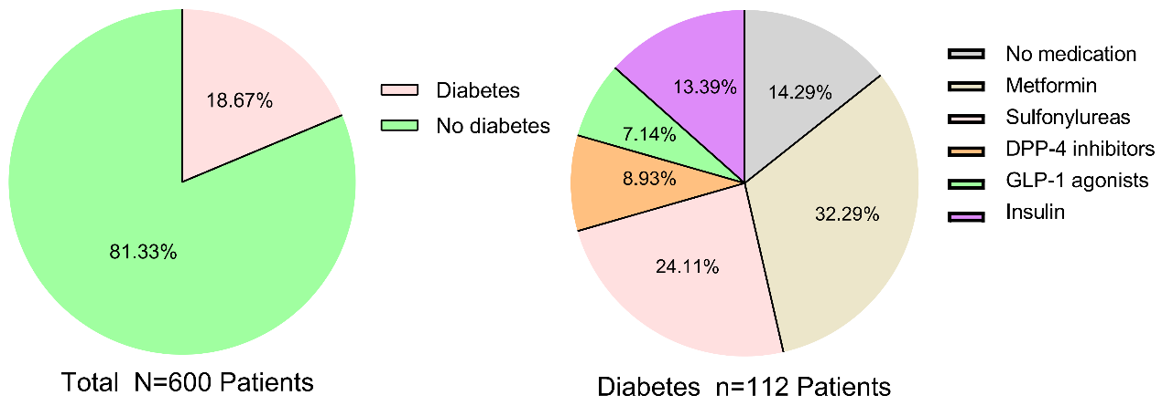

eFigure 2:Flow Chart of Diabetes Diagnosis
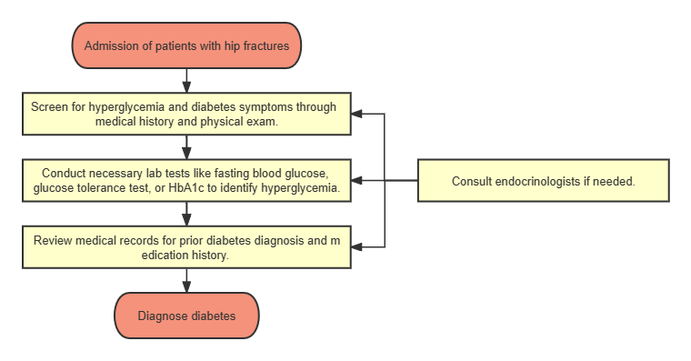
eFigure 3: The Specific Process of Perioperative Glucose Management 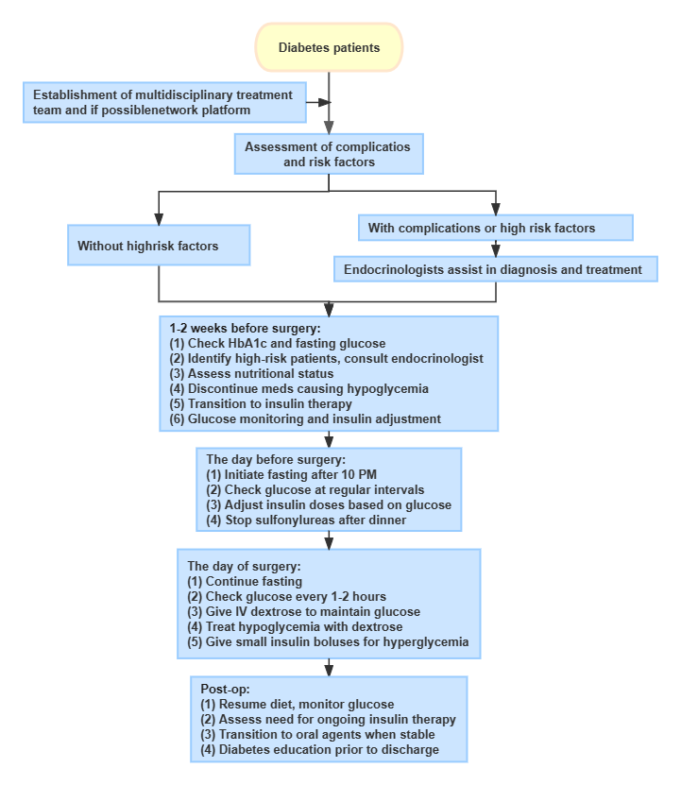

eFigure 4: The Multivariate ROC Analysis of Risk Factors for POP
