Additional file 5

Meta-analyses based on data from the included SRs (MAs) for each exercise type

Forest plots for the effect sizes of specific exercise types for pain intensity, disability and for short-term and intermediate/long-term. The plot depicts model fit, individual study and pooled effect size estimates (standardized mean differences and corresponding 95% confidence intervals), separated for the different comparators (non-exercise controls and exercise controls). The size of the boxes corresponds to the respective studies’ (inverse variance) weighting. SMD: standardized mean difference; CI: confidence interval. SMDs were calculated when at least two SRs provided data.

5.1 MCE: Outcome pain-intensity: MCE compared to non-exercise controls, short-term

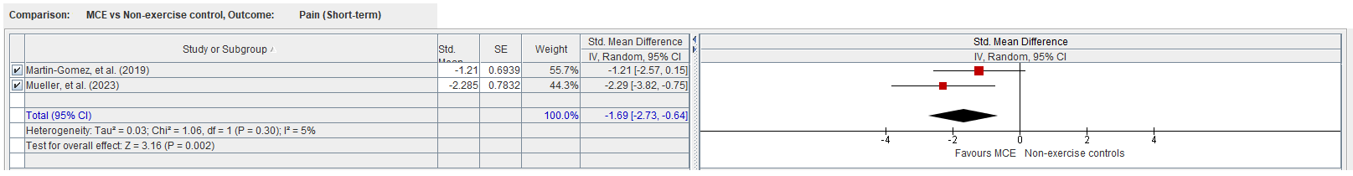

5.2 MCE: Outcome pain-intensity: MCE compared to exercise controls, short-term

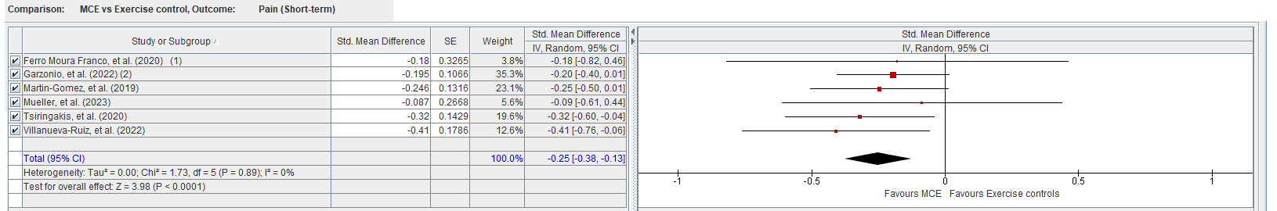

5.3 MCE: Outcome disability: MCE compared to non-exercise controls, short-term

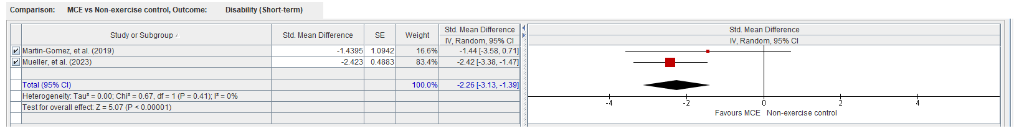

5.4 MCE: Outcome disability: MCE compared to exercise controls, short-term

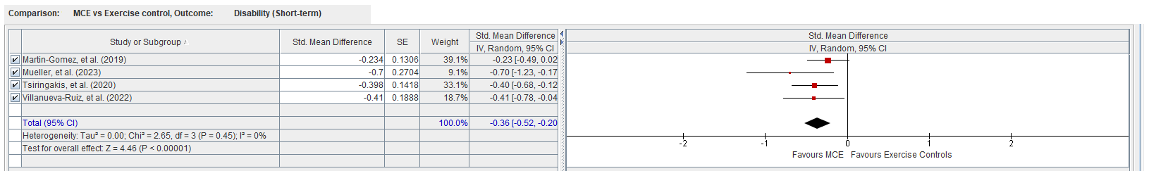

5.5 Resistance training: Outcome pain-intensity: Resistance exercises compared to non-exercise controls, short-term

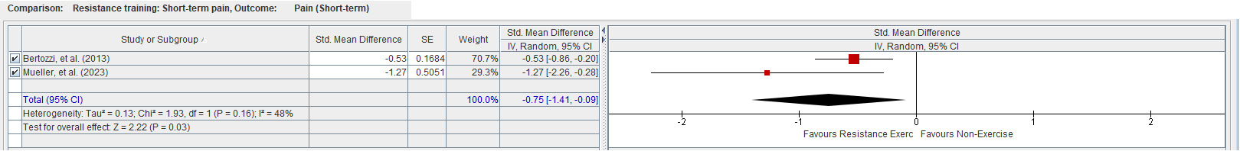

5.6 Resistance training: Outcome pain-intensity: Resistance exercises compared to non-exercise controls, intermediate/long-term

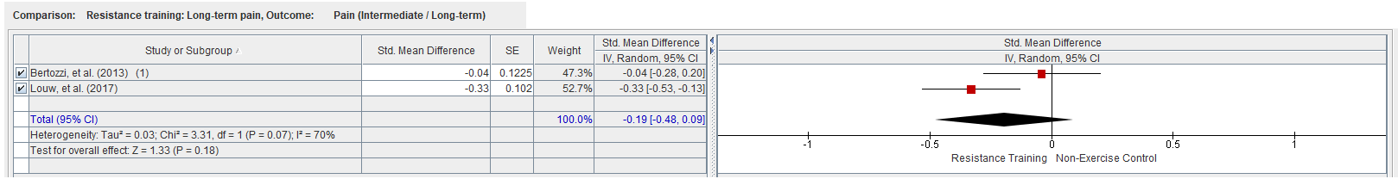

5.7 Resistance training: Outcome pain-intensity: Resistance exercises compared to Exercise controls, short-term

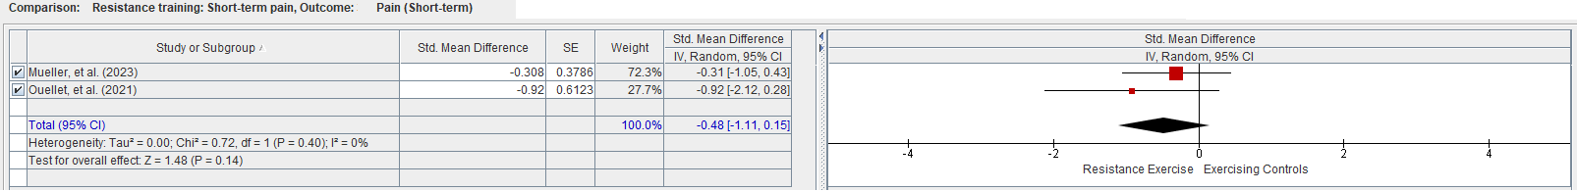

5.8 Resistance training: Outcome disability: Resistance exercises compared to non-exercise controls, short-term

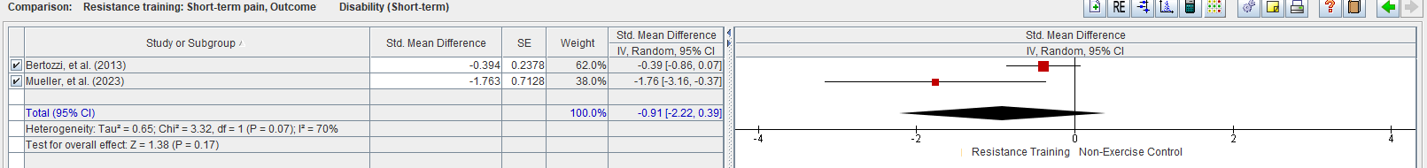

5.9 Resistance training: Outcome disability compared to non-exercise controls, intermediate/long-term

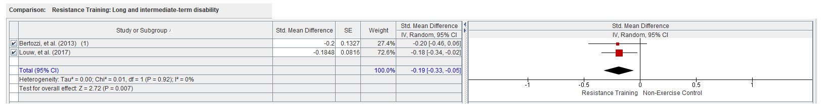

5.10 TCE: Outcome pain-intensity: TCE compared to non-exercise controls, short-term

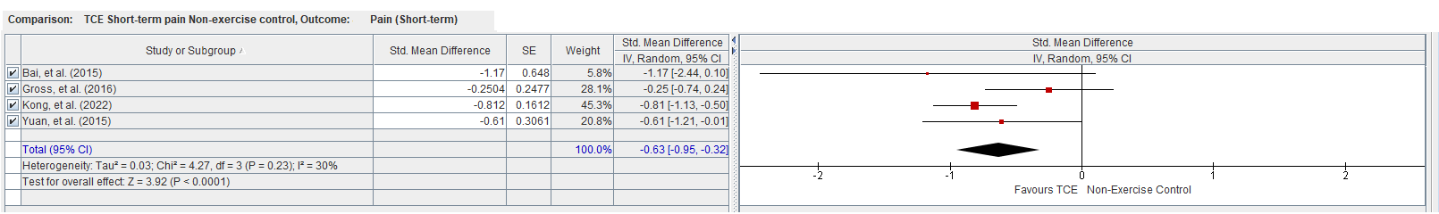

5.11 TCE: Outcome pain-intensity: TCE compared to non-exercise controls, intermediate/long-term

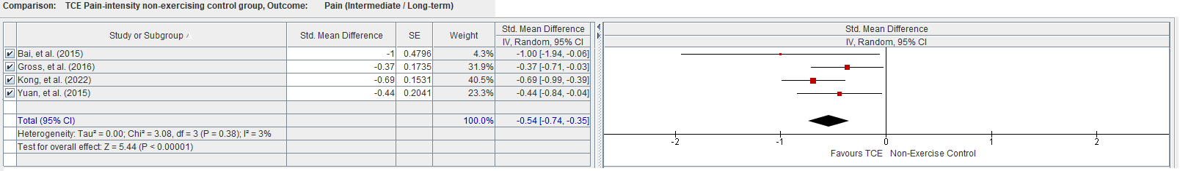

5.12 TCE: Outcome pain-intensity: TCE compared to exercise controls, short-term

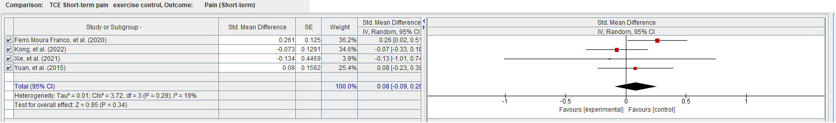

5.13 TCE: Outcome disability: TCE compared to non-exercise controls, short-term

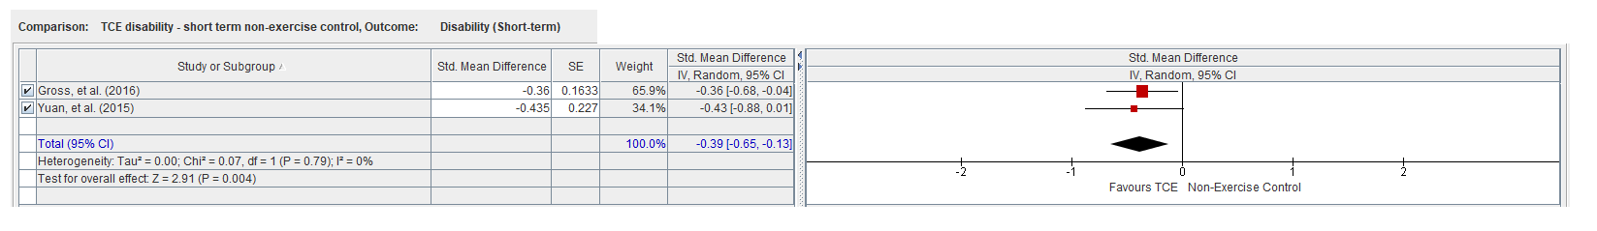

5.14 TCE: Outcome disability: TCE compared to non-exercise controls, intermediate/long-term

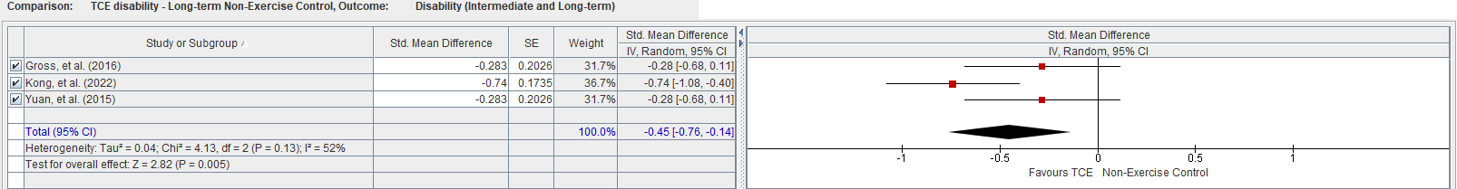

5.15 TCE: Outcome disability: TCE compared to exercise controls, short-term

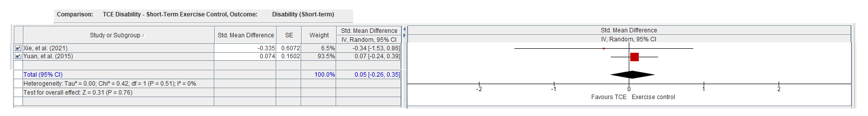

5.16 Yoga: Outcome pain-intensity: Yoga compared to non-exercise controls, short-term

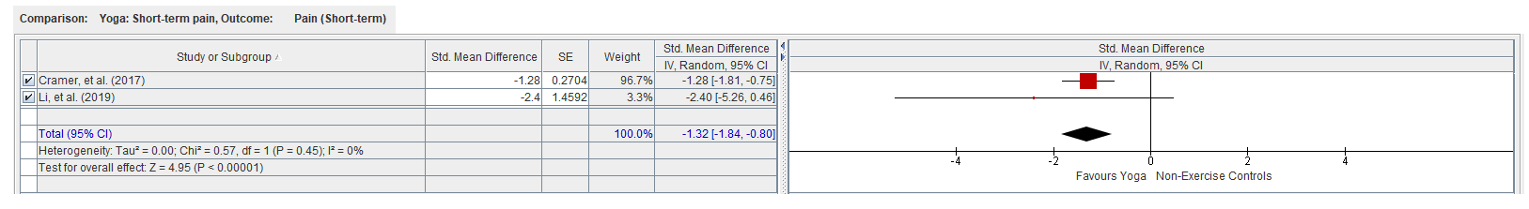

5.17 Yoga: Outcome disability: Yoga compared to non-exercise controls, short-term

