Funnel plot for multifidus stiffness
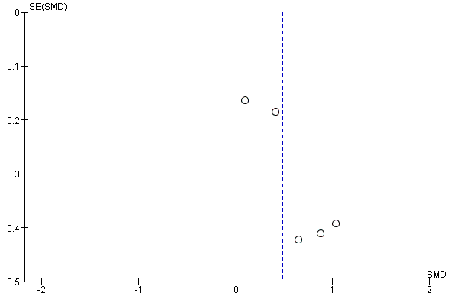
Funnel plot for erector spinae stiffness
