The images of exercise protocol for SET and IET groups according to the explanations given in table 1.

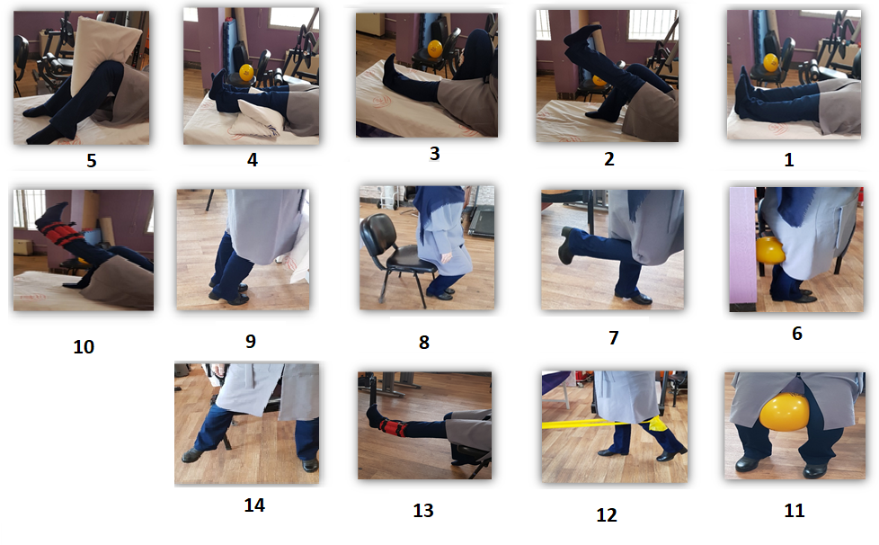 the exercise protocol for SET and IET groups

