degree | G | loglik | conv | npm | AIC | BIC | SABIC | entropy | Class membership (%) | Mean posterior probabilities (%) | prob>0.7
linear | 1 | -156050 | 1 | 3 | 312106 | 312125.4 | 312115.9 | 1 | 1 | 1 | 1
 | 2 | -151473.1 | 1 | 6 | 302958.1 | 302996.9 | 302977.8 | 0.8356791 | 67.41/32.59 | 96.09/93.35 | 95.36/91.50
 | 3 | -150174.6 | 1 | 9 | 300367.2 | 300425.4 | 300396.8 | 0.7914583 | 46.57/39.93/13.51 | 91.5/87.84/91.91 | 89.15/82.58/89.36
 | 4 | -149772.5 | 1 | 12 | 299568.9 | 299646.5 | 299608.4 | 0.7550028 | 34.56/39.38/20.52/5.54 | 87.95/85.45/82.14/91.52 | 84.71/79.20/73.81/89.31
 | 5 | -149622.6 | 1 | 15 | 299275.2 | 299372.1 | 299324.4 | 0.7256586 | 26.55/36.19/24.41/10.86/1.99 | 83.2/77.76/80.29/84.99/89.73 | 75.56/67.64/71.17/80.93/86.17
quadratic | 1 | -156048.2 | 1 | 4 | 312104.4 | 312130.3 | 312117.6 | 1 | 1 | 1 | 1
 | 2 | -151469.3 | 1 | 8 | 302954.5 | 303006.2 | 302980.8 | 0.8357363 | 67.41/32.59 | 96.11/93.34 | 95.20/91.50
 | 3 | -150167.8 | 1 | 12 | 300359.7 | 300437.2 | 300399.1 | 0.7916015 | 46.63/39.91/13.46 | 91.49/87.85/92.01 | 89.26/82.52/89.48
 | 4 | -149764.8 | 1 | 16 | 299561.7 | 299665 | 299614.2 | 0.7547639 | 34.56/39.4/20.5/5.54 | 87.96/82.05/85.48/91.7 | 84.59/74.25/79.28/89.31
 | 5 | -149639.4 | 1 | 20 | 299318.9 | 299448.1 | 299384.6 | 0.7309295 | 32.97/39.19/11.03/10.84/5.96 | 87.13/80.84/75.97/70.4/90.7 | 82.56/73.68/62.45/49.12/86.88
cubic | 1 | -156043.6 | 1 | 5 | 312097.2 | 312129.5 | 312113.6 | 1 | 1 | 1 | 1
 | 2 | -151461.9 | 1 | 10 | 302943.8 | 303008.5 | 302976.7 | 0.8359211 | 67.45/32.55 | 96.07/93.41 | 95.30/91.69
 | 3 | -150156.5 | 1 | 15 | 300343 | 300439.9 | 300392.3 | 0.792595 | 46.82/39.89/13.3 | 91.54/87.86/92.23 | 89.16/82.41/90.30
 | 4 | -149752.3 | 1 | 20 | 299544.6 | 299673.8 | 299610.2 | 0.7550165 | 34.52/20.63/39.34/5.52 | 88.01/85.36/82.09/92.09 | 84.69/79.10/74.48/90.04
 | 5 | -149621 | 1 | 25 | 299292 | 299453.5 | 299374.1 | 0.7302506 | 32.76/11.18/10.93/39.12/6 | 87.03/75.09/71.35/80.72/91.31 | 82.39/60.68/50.48/72.99/87.68

Supplementary Table 1: Fit statistics of latent class mixed model for all participants:
G: number of latent classes; loglik: log-likelihood of the model; conv status of convergence: =1 if the convergence criteria were satisfied, =2 if the maximum number of iterations was reached; AIC: Akaike information criterion; BIC: Bayesian information criterion; SABIC: sample size adjusted Bayesian information criterion; prob: table of posterior classification and posterior individual class-membership probabilities.
degree | G | loglik | conv | npm | AIC | BIC | SABIC | entropy | Class membership (%) | Mean posterior probabilities (%) | prob>0.7
linear | 1 | -43826.24 | 1 | 3 | 87658.49 | 87674.36 | 87664.83 | 1 | 1 | 1 | 1
 | 2 | -42558.03 | 1 | 6 | 85128.05 | 85159.8 | 85140.74 | 0.8206739 | 69.28/30.72 | 95.57/92.57 | 94.30/89.80
 | 3 | -42230.51 | 1 | 9 | 84479.01 | 84526.64 | 84498.05 | 0.7508723 | 43.19/41.49/15.33 | 89.54/85.27/91.21 | 86.75/78.82/87.11
 | 4 | -42104.64 | 1 | 12 | 84233.28 | 84296.78 | 84258.66 | 0.7498526 | 37.06/40.53/18.26/4.16 | 87.49/81.61/86.36/88.76 | 83.64/72.10/80.60/85.25
 | 5 | -42063.22 | 1 | 15 | 84156.45 | 84235.82 | 84188.17 | 0.7304344 | 35.9/10.42/8.99/40.46/4.22 | 87.42/73.58/74.04/79.79/87.97 | 84.25/55.56/56.82/68.18/82.26
quadratic | 1 | -43825.66 | 1 | 4 | 87659.32 | 87680.49 | 87667.78 | 1 | 1 | 1 | 1
 | 2 | -42556.69 | 1 | 8 | 85129.39 | 85171.72 | 85146.31 | 0.8214352 | 69.35/30.65 | 95.58/92.6 | 94.40/90.22
 | 3 | -42228.79 | 1 | 12 | 84481.57 | 84545.07 | 84506.95 | 0.7511463 | 43.6/41.21/15.19 | 89.28/85.46/91.45 | 86.09/79.17/86.10
 | 4 | -42098.23 | 1 | 16 | 84228.46 | 84313.13 | 84262.3 | 0.7501546 | 36.99/18.19/40.67/4.16 | 87.59/86.58/81.55/89.2 | 84.53/81.65/72.19/85.25
 | 5 | -42056.34 | 1 | 20 | 84152.68 | 84258.51 | 84194.98 | 0.733837 | 36.24/10.08/40.46/8.72/4.5 | 87.43/75.37/80.17/73.12/85.01 | 83.83/58.78/68.52/53.91/77.27
cubic | 1 | -43825.55 | 1 | 5 | 87661.1 | 87687.55 | 87671.67 | 1 | 1 | 1 | 1
 | 2 | -42556.03 | 1 | 10 | 85132.06 | 85184.98 | 85153.21 | 0.821599 | 69.35/30.65 | 95.65/92.49 | 94.40/89.78
 | 3 | -42226.99 | 1 | 15 | 84483.98 | 84563.36 | 84515.71 | 0.7507741 | 43.46/41.14/15.4 | 89.31/85.52/91.08 | 85.89/79.97/86.28
 | 4 | -42095.23 | 1 | 20 | 84230.46 | 84336.29 | 84272.76 | 0.7501803 | 36.99/18.46/40.33/4.22 | 87.52/86.04/81.83/89.5 | 83.98/80.07/72.97/82.26
 | 5 | -10000000 | 4 | 25 | 2000000050 | 2000000182 | 2000000103 | 1 | 0/0/0/0/0 | NaN/NaN/NaN/NaN/NaN | NaN/NaN/NaN/NaN/NaN

Supplementary Table 2: Fit statistics of latent class mixed model for participants with significant knee pain at baseline:

G: number of latent classes; loglik: log-likelihood of the model; conv status of convergence: =1 if the convergence criteria were satisfied, =2 if the maximum number of iterations was reached; AIC: Akaike information criterion; BIC: Bayesian information criterion; SABIC: sample size adjusted Bayesian information criterion; prob: table of posterior classification and posterior individual class-membership probabilities.

Supplementary Table 3: Fit statistics of latent class mixed model for participants with ROA at baseline:
degree | G | loglik | conv | npm | AIC | BIC | SABIC | entropy | Class membership (%) | Mean posterior probabilities (%) | prob>0.7
linear | 1 | -83784.7 | 1 | 3 | 167575 | 167593 | 167583 | 1 | 1 | 1 | 1
 | 2 | -81290.5 | 1 | 6 | 162593 | 162628 | 162609 | 0.8451 | 68.43/31.57 | 96.36/93.3 | 95.35/91.68
 | 3 | -80542.1 | 1 | 9 | 161102 | 161155 | 161126 | 0.81185 | 47.09/40.37/12.54 | 92.66/89.05/93.1 | 90.96/86.19/90.79
 | 4 | -80313.7 | 1 | 12 | 160651 | 160721 | 160683 | 0.77871 | 39.85/37.1/18.43/4.62 | 89.27/83.67/86.2/92.92 | 78.22/87.02/83.37/87.93
 | 5 | -80189.7 | 1 | 15 | 160409 | 160497 | 160449 | 0.75026 | 26.63/10.39/24.72/37.02/1.23 | 84.39/89/82.48/79.56/91.13 | 77.88/87.36/75.36/71.18/83.87
quadratic | 1 | -83782.5 | 1 | 4 | 167573 | 167596 | 167584 | 1 | 1 | 1 | 1
 | 2 | -81287.5 | 1 | 8 | 162591 | 162638 | 162612 | 0.84526 | 68.35/31.65 | 96.36/93.32 | 95.46/91.45
 | 3 | -80538.3 | 1 | 12 | 161101 | 161171 | 161132 | 0.81202 | 47.21/40.25/12.54 | 92.58/89.15/92.94 | 90.81/86.45/90.79
 | 4 | -80310 | 1 | 16 | 160652 | 160745 | 160694 | 0.77889 | 37.14/39.89/18.39/4.58 | 89.56/83.6/86.99/91.51 | 87.35/77.45/83.33/88.70
 | 5 | -80238.3 | 1 | 20 | 160517 | 160633 | 160570 | 0.75741 | 34.99/8.16/39.81/12.22/4.82 | 89.01/75.47/82.51/75.15/92.42 | 84.76/62.44/76.6/60.91/90.08
cubic | 1 | -83780.8 | 1 | 5 | 167572 | 167601 | 167585 | 1 | 1 | 1 | 1
 | 2 | -81285.5 | 1 | 10 | 162591 | 162649 | 162617 | 0.84516 | 68.31/31.69 | 96.29/93.46 | 95.45/91.46
 | 3 | -80534.9 | 1 | 15 | 161100 | 161187 | 161140 | 0.81244 | 47.25/40.33/12.42 | 92.63/89.04/92.93 | 90.82/85.98/91.99
 | 4 | -80303.1 | 1 | 20 | 160646 | 160763 | 160699 | 0.7766 | 36.9/39.41/19.03/4.66 | 83.69/89.46/87/91.15 | 86.73/78.59/80.75/94.02
 | 5 | -80180.1 | 1 | 25 | 160410 | 160556 | 160477 | 0.75247 | 26.95/10.15/24.76/36.98/1.15 | 83.93/0.8923/82.58/79.29/90.94 | 78.73/87.45/75.08/71.80/86.21

G: number of latent classes; loglik: log-likelihood of the model; conv status of convergence: =1 if the convergence criteria were satisfied, =2 if the maximum number of iterations was reached; AIC: Akaike information criterion; BIC: Bayesian information criterion; SABIC: sample size adjusted Bayesian information criterion; prob: table of posterior classification and posterior individual class-membership probabiliti

Supplementary Table 4: Characteristics of PASE score over time
Month |  | Total |  |  | Baseline with pain |  |  | Baseline with ROA
Month |  | N | Mean (sd) |  | N | Mean (sd) |  | N | Mean (sd)
0 |  | 4704 | 161.29 (82.6) |  | 1457 | 155.2 (84.8) |  | 2496 | 156.82 (81.4)
12 |  | 4258 | 157.48 (82.1) |  | 1245 | 153.09 (85.5) |  | 2363 | 151.93 (80.9)
24 |  | 3982 | 153.66 (80.8) |  | 1128 | 149.02 (83.8) |  | 2209 | 149.41 (79.6)
36 |  | 3833 | 151.54 (81.8) |  | 1062 | 147.98 (84.9) |  | 2096 | 144.63 (79.2)
48 |  | 3631 | 154.67 (82.3) |  | 986 | 147.32 (83.1) |  | 1957 | 147.92 (80.8)
72 |  | 3277 | 152.53 (82.6) |  | 841 | 145.71 (85.0) |  | 1714 | 145.14 (80.3)
96 |  | 3107 | 147.97 (80.8) |  | 766 | 143.51 (84.2) |  | 1596 | 141.58 (80.2)
SD: standard deviation

Month | Total | Baseline with pain | Baseline with ROA
Month | number | number | number
12 | 23 | 16 | 18
24 | 38 | 23 | 38
36 | 51 | 33 | 50
48 | 51 | 30 | 50
60 | 54 | 29 | 52
72 | 48 | 26 | 47
84 | 51 | 27 | 46
96 | 57 | 29 | 51
108 | 44 | 20 | 35

Supplementary Table 5: Characteristics of KR over time

Supplementary Table 6: Baseline covariates missing information
 | Total (%) | baseline with pain (%) | baseline with ROA (%)
BMI | 0.09 | 0.24 | 0.17
Education | 0.77 | 1.20 | 0.76
Race | 0.09 | 0.16 | 0.04
Marital | 0.77 | 1.12 | 0.76
Income | 6.99 | 8.16 | 7.25
Acetophenone | 0.19 | 0.32 | 0.21
Painkiller | 0.09 | 0.24 | 0.17
steroids | 0.16 | 0.40 | 0.21
NSAIDs | 0.23 | 0.40 | 0.25
Knee Injury | 0.68 | 0.80 | 0.89
Knee Surgery | 0.12 | 0.24 | 0.08
Radiographic osteoarthritis (%) | 0.93 | 1.52 | 0.00
WOMAC | 0.02 | 0.00 | 0.00

Supplementary Table 7: Association between physical activity trajectories and risk of knee replacement in complete case analysis
 | Adjusted model
 | RR (95%CI) | P
Total (n=4041)
Low level | 1.00 (ref)
Medium-low level | 1.16 (0.91 to 1.64) | 0.19
Medium-high level | 1.12 (0.76 to 1.77) | 0.49
High level | 1.43 (0.51 to 2.12) | 0.91
Baseline with pain (n=1187)
Low level | 1.00 (ref)
Moderate level | 1.03 (0.80 to 1.32) | 0.87
High level | 0.86 (0.55 to 1.33) | 0.56
Baseline with ROA (n=2272)
Low level | 1.00 (ref)
Moderate level | 0.99 (0.81 to 1.22) | 0.96
High level | 0.86 (0.60 to 1.22) | 0.39

 | Crude model |  |  | Adjusted model
 | RR (95%CI) | P |  | RR (95%CI) | P
Total
Low level | 1.00 (ref) |  |  | 1.00 (ref)
Medium-low level | 0.97 (0.77 to 1.23) | 0.81 |  | 1.24 (0.92 to 1.67) | 0.17
Medium-high level | 0.73 (0.54 to 0.99) | 0.04 |  | 1.18 (0.79 to 1.76) | 0.42
High level | 0.60 (0.33 to 1.01) | 0.07 |  | 1.09 (0.53 to 2.15) | 0.80

Supplementary Table 8: Association between physical activity trajectories and risk of knee replacement in complete case analysis in total participants excluding individuals with only 1 visit.
Adjusted for sex, age, body mass index, race, education, marital, income, Kellgren-Lawrence grade, WOMAC pain score, the use of medications, history of knee injury and knee surgery, sf12 physical score, the month baseline visited;
b participants excluding individuals with only 1 visit.

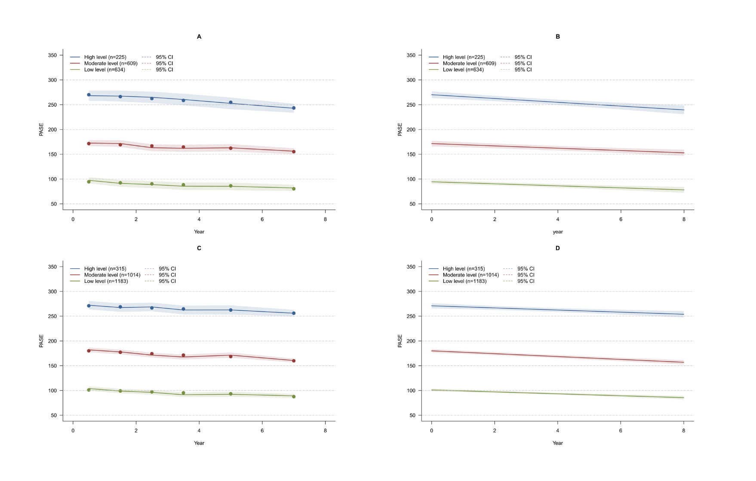
Supplementary Figure 1
Estimated and observed mean trajectory for baseline with pain (Supplementary Figure 1A) and baseline with radiographic osteoarthritis (Supplementary Figure 1C) and the predicted mean trajectories for baseline with pain (Supplementary Figure 1B) and baseline with radiographic osteoarthritis (Supplementary Figure 1D).
Solid lines show class-specific mean predicted levels as a function of 8 years estimated from the best fitting growth mixture model (3-class linear latent class growth mixture modeling), shaded areas indicate estimated 95% confidence intervals

Supplementary Figure 2
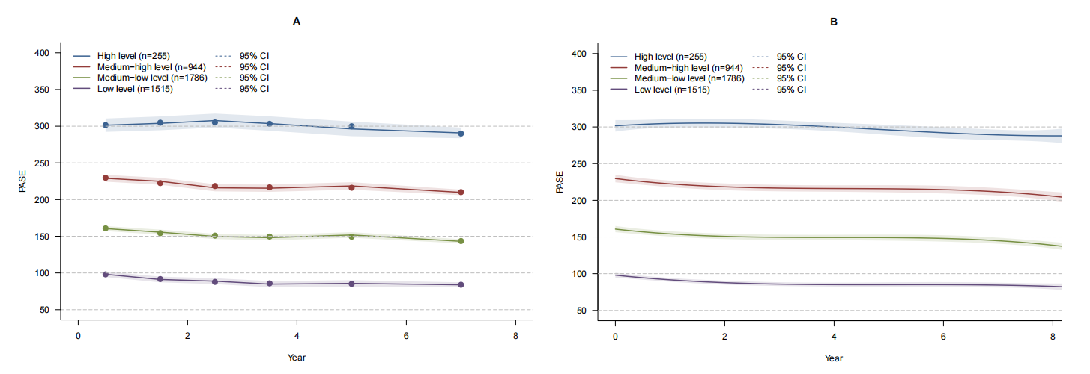
Estimated and observed mean trajectory in total participants (Supplementary Figure 2A) and the predicted mean trajectories in total participants (Supplementary Figure 2B) excluding individuals with only 1 visit. Solid lines show class-specific mean predicted levels as a function of 8 years estimated from the best fitting growth mixture model (4-class cubic latent class growth mixture modeling), shaded areas indicate estimated 95% confidence intervals

Adjusted for sex, age, body mass index, race, education, marital, income, Kellgren-Lawrence grade, WOMAC pain score, the use of medications, history of knee injury and knee surgery, sf12 physical score, the month baseline visited;
Risk ratio;
confidence interval;
WOMAC pain score≥5 (5-20) at baseline;
At least one knee with radiographic osteoarthritis (KL-grade≥2) at baseline.

