NORDIC QUESTIONNAIRE

Please answer by putting an "X" in the appropriate box - one "X" for each question. You may be in doubt as to how to answer, but please do your best anyway. Note that column 1 of the questionnaire is to be answered even if you have never had trouble in any part of your body; columns 2 and 3 are to be answered if you answered yes in column 1.

To be answered by everyone | To be answered by those who have trouble
Have you at any time during the last 12  months had trouble (ache, pain, discomfort, numbness) in: | Have you at any time during the last 12  months been prevented from doing your normal work (at home or away from home) because of the trouble? |  | Have you had trouble at any time  during the last 7 days?
Neck  - No ⇨ Yes | - No | - Yes | - No | - Yes
Shoulders  - No ⇨ Yes, right shoulder  - Yes, left shoulder  - Yes, both shoulders | - No | - Yes | - No | - Yes
Elbows  - No ⇨ Yes, right elbow  - Yes, left elbow  - Yes, both elbows | - No | - Yes | - No | - Yes
Wrist/Hands  - No ⇨ Yes, right wrist/hand  - Yes, left wrist/hand  - Yes, both wrists/hands | - No | - Yes | - No | - Yes
Upper Back  - No ⇨ Yes | - No | - Yes | - No | - Yes
Lower Back (small of back)  - No ⇨ Yes | - No | - Yes | - No | - Yes
One or Both Hips/Thighs  - No ⇨ Yes | - No | - Yes | - No | - Yes
One or Both Knees  - No ⇨ Yes | - No | - Yes | - No | - Yes
One or Both Ankles/Feet  - No ⇨ Yes | - No | - Yes | - No | - Yes

SCORING

Picture: In this picture you can see the approximate position of the parts of the body referred to in the table. Limits are not sharply defined, and certain parts overlap. You should decide for yourself in which part you have or have had your trouble (if any).
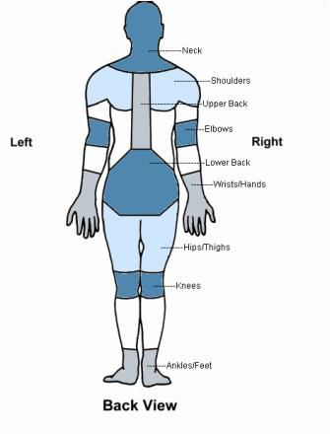

INTERNET ADDICTION TEST

This questionnaire consists of 20 statements. After reading each statement carefully, based upon the 5-point Likert scale, please select the response (0, 1, 2, 3, 4 or 5) which best describes you. If two choices seem to apply equally well, circle the choice that best represents how you are most of the time during the past month. Be sure to read all the statements carefully before making your choice. The statements refer to offline situations or actions unless otherwise specified.

0 = Not Applicable
1 = Rarely
2 = Occasionally
3 = Frequently
4 = Often
5 = Always

1. How often do you find that you stay online longer than you intended?
2. How often do you neglect household chores to spend more time online?
3. How often do you prefer the excitement of the Internet to intimacy with your partner?
4. How often do you form new relationships with fellow online users?
5. How often do others in your life complain to you about the amount of time you spend online?
6. How often do your grades or school work suffer because of the amount of time you spend online?
7. How often do you check your email before something else that you need to do?
8. How often does your job performance or productivity suffer because of the Internet?
9. How often do you become defensive or secretive when anyone asks you what you do online?
10. How often do you block out disturbing thoughts about your life with soothing thoughts of the Internet?
11. How often do you find yourself anticipating when you will go online again?
12. How often do you fear that life without the Internet would be boring, empty, and joyless?
13. How often do you snap, yell, or act annoyed if someone bothers you while you are online?
14. How often do you lose sleep due to being online?
15. How often do you feel preoccupied with the Internet when off-line, or fantasize about being online?
16. How often do you find yourself saying "just a few more minutes" when online?
17. How often do you try to cut down the amount of time you spend online and fail?
18. How often do you try to hide how long you've been online?
19. How often do you choose to spend more time online over going out with others?
20. How often do you feel depressed, moody, or nervous when you are off-line, which goes away once you are back online?

SCORING
The IAT total score is the sum of the ratings given by the examinee for the 20 item responses. Each item is rated on a 5-point scale ranging from 0 to 5. The maximum score is 100 points. The higher the score is, the higher is the severity of your problem. Total scores that range from 0 to 30 points are considered to reflect a normal level of Internet usage; scores of 31 to 49 indicate the presence of a mild level of Internet addiction; 50 to 79 reflect the presence of a moderate level; and scores of 80 to 100 indicate a severe dependence upon the Internet.

